Paul Fralix, CSD440, Assignment 7.2, 04/26/2026
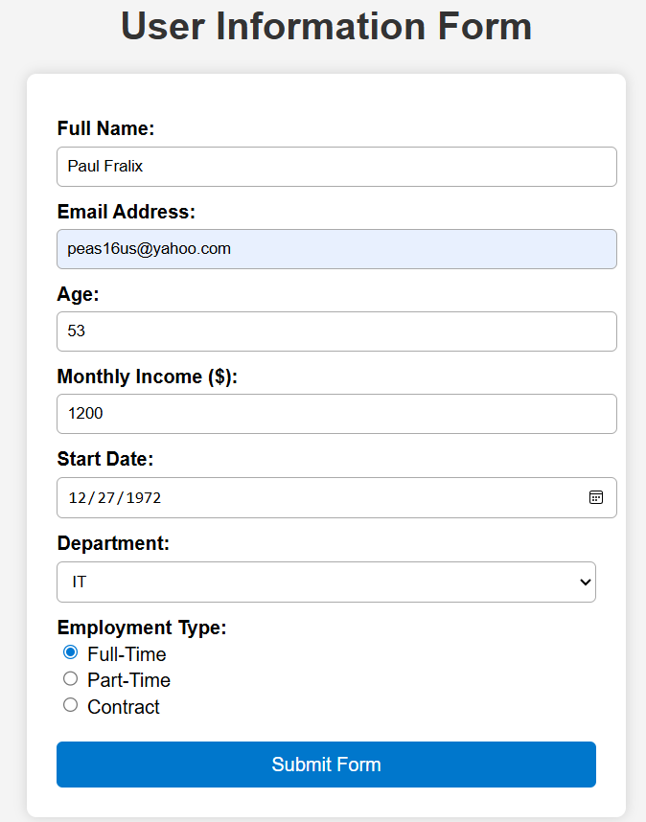
GitHub: https://github.com/Peas16/csd-440.git
