Solar Car Performance Modeling Application

User Guide

**Introduction** **3**

**System Overview** **3**

**Points of Contact** **3**

Programmers 3

**Usage** **4**

Car Configuration 4

Loading the Route File 4

Downloading route file 4

Selecting route file 4

Selecting leg file 5

Main screen 6

Map 6

Overrides 6

Detailed Route Information 6

Time (Start/End) 6

Speed 6

Distance 7

Bat Charge 7

Total Charge 7

Graphs 7

Energy 7

Cloud Cover 7

Speed Limit Tool 8

# 

# Introduction

This document aims to describe the Solar Car Modeling Application in sufficient detail so that a non-technical user can run the software.

# System Overview

The Solar Car Modeling Application is designed to assist with energy management during the American Solar Challenge. The application takes the Google Maps route file provided by the ASC and simulates solar car performance over legs of the race, incorporating location data along with weather and elevation along the route to estimate energy usage. The application runs in the lead car during the race and assists with race strategy that can be communicated to the solar car driver.

# Points of Contact

## Programmers

Aaron Brainard - [aaron.c.brainard@wmich.edu](mailto:aaron.c.brainard@wmich.edu)

Adam Hubbell - [adam.s.hubbell@wmich.edu](mailto:adam.s.hubbell@wmich.edu)

Broderick Hyman - [broderick.a.hyman@wmich.edu](mailto:broderick.a.hyman@wmich.edu)

# 

# 

# Usage

## Car Configuration

The car configuration file was meant to adjust the application’s models to your particular solar car. The various constants used in the configuration file should have been specified by engineers on the team. The configuration file goes in the “carconfig” folder. More details about the car configuration are specified in the maintenance document.

## Loading the Route File

### Downloading route file

The route file for the American Solar Challenge will be made available on their website. The ASC 2016 Google map route file has been included with the application for reference. Here is a link where that file can be found:

<http://americansolarchallenge.org/the-competition/ascfsgp-2016/>

The file for the 2018 competition will be made available in the future. The .kml file goes into the kml folder in the directory of the application .jar file.

### Selecting route file

When the application is opened, you will be prompted to choose a race file. These are read from the kml folder. Use the dropdown box to select the appropriate file: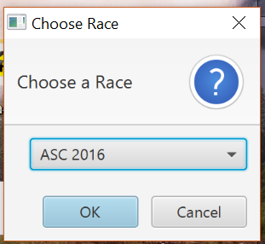

### Selecting leg file

After choosing the race file, the application will parse the .kml into separate files for each leg of the race. You will be prompted to choose which leg to use:

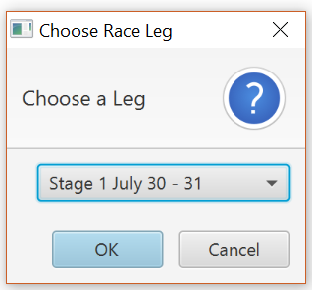

The program will take a moment to run its calculations and get weather and elevation data. You will then be taken to the main interface.

## 

## 

## Main screen

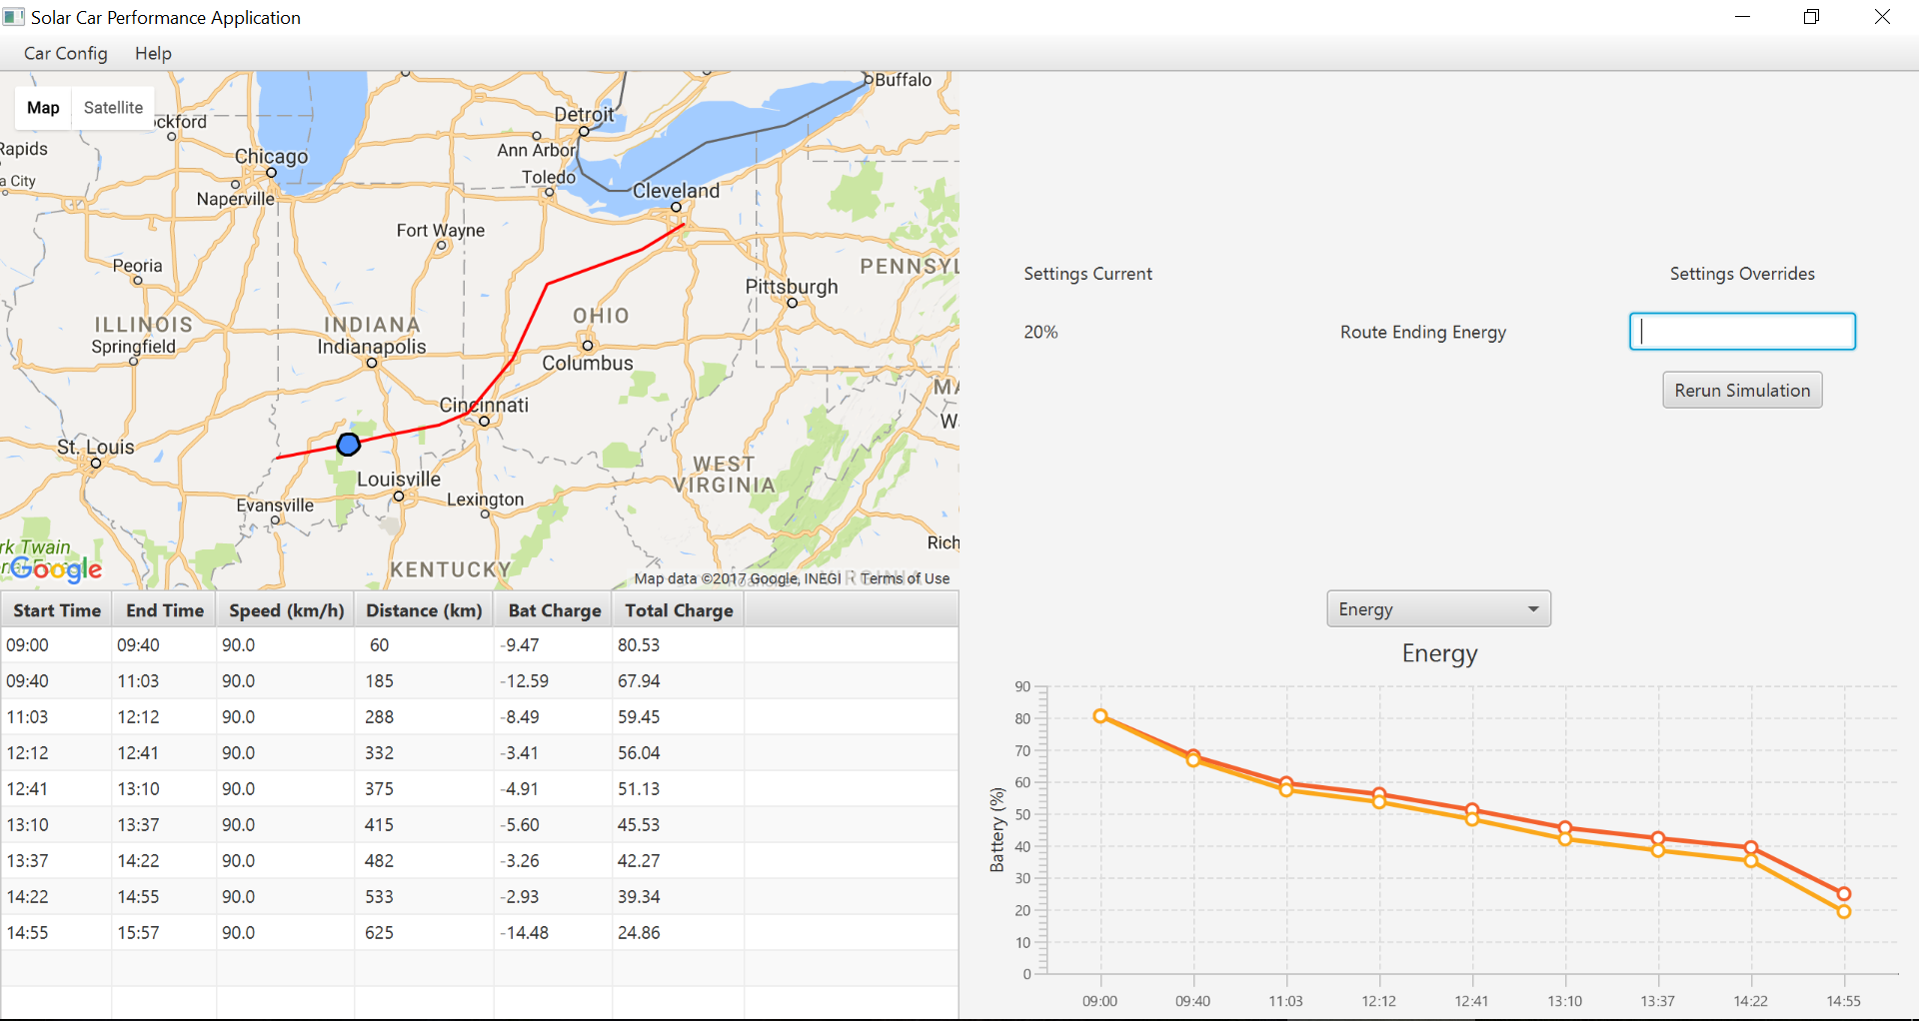

### Map

This map shows the current leg of the route, with the route drawn with a red line.

Your current position is denoted by the blue circle. This will be updated by the GPS software.

### Overrides

Use this section if you need to change the ending energy for the route. Simply enter a numeric value and hit the Enter key, the route should automatically re-run.

### Detailed Route Information

#### Time (Start/End)

These values show the start and end time for each segment of calculations, which should usually be between turns.

#### Speed

This section shows the calculated optimal speed at each time along the day. This number is the speed that should be relayed to the lead car driver as well as the solar car driver.

#### Distance

The distance should be referenced against the lead car odometer to help with positioning against the route.

#### Bat Charge

This value is the calculated energy expenditure for the current segment of the leg.

#### Total Charge

This value reflects the total battery percentage of the solar car at each point along the race.

### Graphs

#### Energy

This is a graph of the total battery percentage of the solar car at each point along the race. (These are the same values that are used in the Total Charge column of the table)

#### Cloud Cover

This is a graph of the cloud cover percentage that is retrieved from the weather service over the course of the day.

## 

## Speed Limit Tool

Run the speed limit tool jar.

File -> Open and select the csv for the appropriate leg in the file selector.

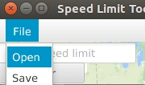

Right click to add start and end markers at in the places specified in the race booklet.

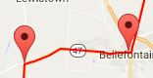

Enter the speed specified in the race booklet into the textbox in the map and press enter or hit the enter button.

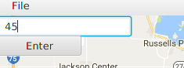

Repeat for all speeds specified in the map booklet.

File -> Save to save the data.

