Medicyc Protontherapy Software
Reference Manual

Table of Contents
GUI 2
Beam delivery procedure 5
Beam delivery safety checks 6
Dose calculation 7
Database design 9

GUI

Top Bar
Reconnect to Sesame &
Automates (click)
Print Dosimetry or Treatment
Load/create dossier

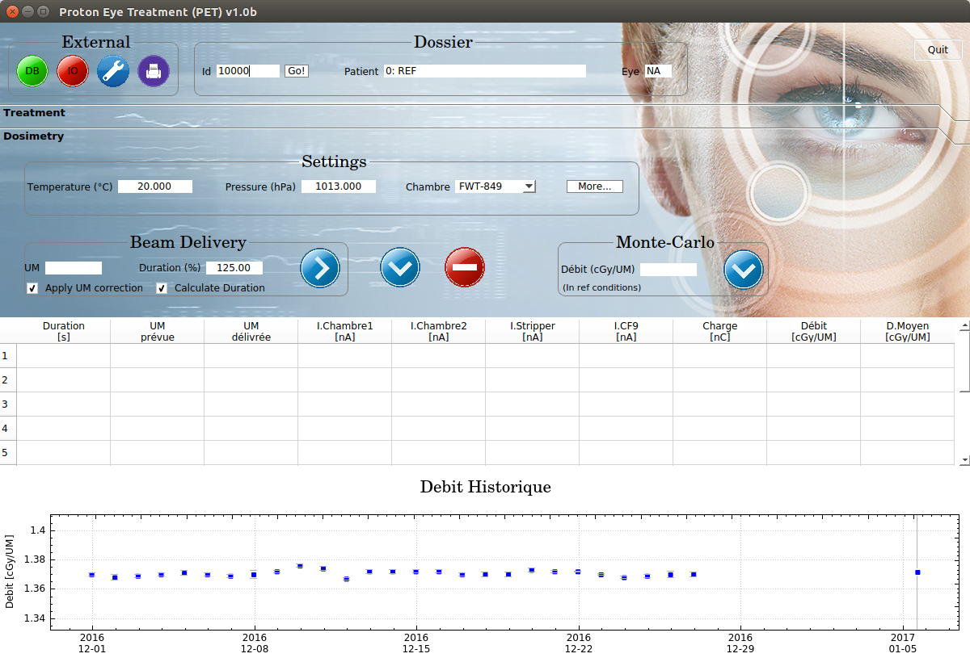
Reconnect to DB (click)
Edit configuration

Notes
- DB button is green = connection to database ok. DB button is red = connection failed.
- IO button is green = connection and configuration of/to sesame and automates ok. Red = connection or configuration of sesame / automates failed.
- By clicking on the DB / IO button, the connection and configuration of the DB / IO is redone

Configuration Window

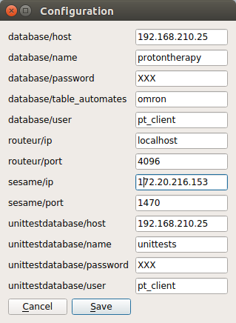
Notes
- 192.168.210.25 is the ip of the medicyc server. If this server goes down (and its backup), the local database can temporarily be used to be able to continue the treatments until the server has been restored. Change the field “database/host” to “localhost”. Note that the local db is empty.

- If the database is changed, press the DB button on the top bar to reconnect.

- 172.20.216.153 is the ip of the primary sesame unit. If the spare one is used, change the ip to 172.20.216.152. Press the IO button on the top bar afterwards to reconnect.

Dosimetry Tab
Start measurement
Save dosimetry
Delete all
measurements
Save MC dosimetry
Delete single
measurement
Notes:
- The debit and d.moyen columns are recalculated if any of the parameters temperature / pressure / chambre are changed, or if one of the measurements is deleted.
- A dosimetry must be saved to the database (by clicking the arrow down button) for it to be used in the beam calibration (see treatment tab).

Treatment Tab

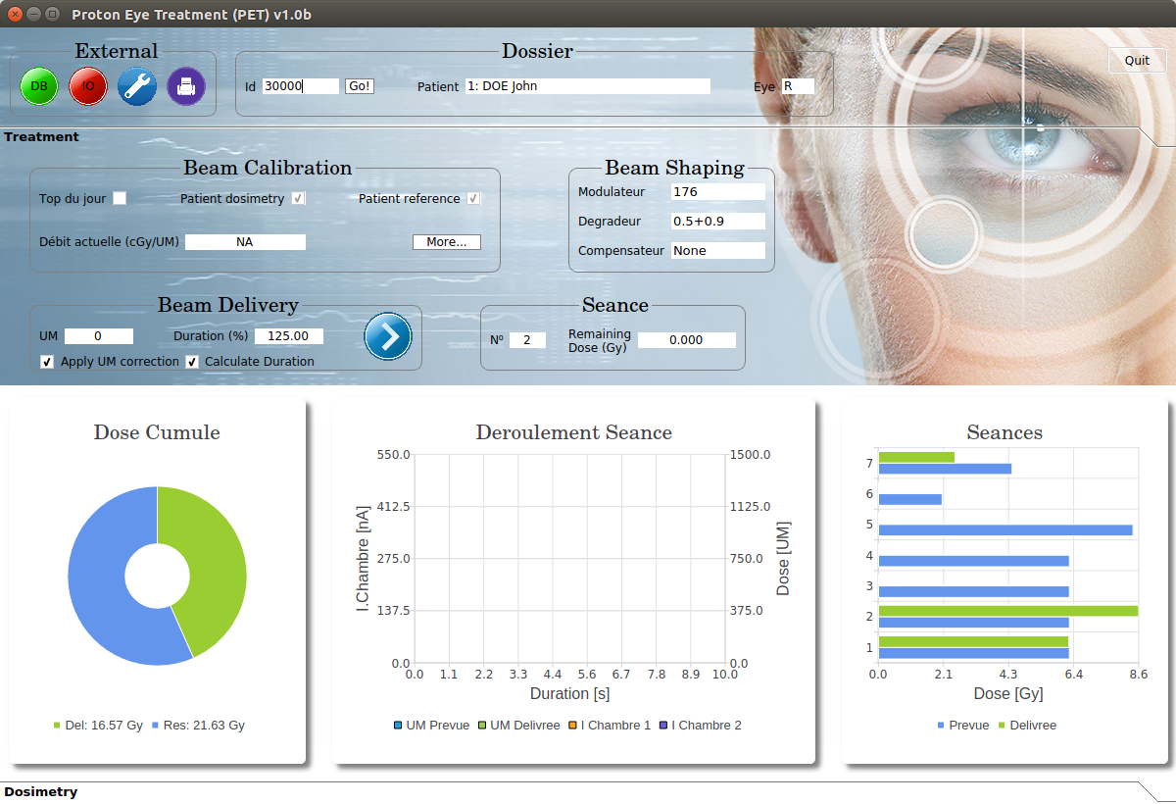
Start treatment
Show seance info (click on seance)
Edit calculated dose
Go to dosimetry tab

Notes
- If the tick box “Apply UM correction” is ticked, the dose written to Sesame will be reduced with an amount depending on the current on CF9. This reduction will compensate for the dose overshoot that results from the time it takes to close CF9. The number written in the GUI is always the desired dose.
- If the tick box “Calculate Duration”, the software will estimate the duration of the treatment from the current on chambre1 and chambre2 and the desired dose. If the duration exceeds this time multiplied by the factor (in percent) written in the box “Duration” (adjustable by the user), the software will abort the treatment.
If the box is not ticked, the user can her/him-self enter the time in seconds in the box “Duration”.

Beam delivery procedure

- The physicist makes a demand by pushing the button “demande faisceau”

- The cyclotron operator delivers the beam up until CF9.

- The physicist starts the treatment by clicking on the right-arrow button on the GUI (on the Dosimetry tab or the Treatment tab). This triggers the actions below by the software. If any of the checks fails, the treatment is aborted.
  - Checks if the desired dose in UM is allowed (see section Safety Checks)
  - Checks that the chambre calibration is correct (500).
  - Checks if there is a non zero current on CF9
  - Writes the desired dose in UM to Sesame
  - Writes the estimated duration to Sesame
  - Checks that the automate signal “Attente Ouverture Cage” is 0
  - Checks that the sesame signal “IsBeamStopped” is false.

- The physicist pushed the button “Ouverture Cage”

- The software delivers the beam by opening CF9.

Beam delivery safety checks

- If the current on chambre1 or chambre2 exceeds 500 nA at any point during the treatment, the treatment is aborted.

- If the chambre calibration is different from 500 nA, the treatment will not be started.
- If the dose counter stops incrementing during a treatment, the treatment is aborted.

- If the duration of the treatment exceeds the expected duration, the treatment is aborted
The expected duration is calculated continuously during the treatment as : t = UM_prevu / (0.422 * max(mean(I_chambre1), mean(I_chambre2)), where the constant 0.422 has been measured from test treatments

- If the requested dose (UM) > 4000, the treatment will not be started

- If the delivered dose in UM > the requested dose in UM, the treatment is stopped.

- If the requested dose in UM is 0, the treatment will not be started.

Dose calculation

The desired dose in Gy to give in a given seance s is calculated as:

Note that the dose for a given seance can be lower or higher than the planned dose for that seance if more or less dose than expected was delivered during seances preceding the current one.

The desired dose in UM is derived from this value and the beam calibration (‘debit_{actuelle}’) for the given patient on the given day

UM is always rounded down to the nearest integer.

Debit_{patient} is the beam calibration for a specific patient (specific choice of modulateur, degradeur and compensateur) for a specific beam configuration (settings of the day, current temperature and pressure, etc). Debit_{patient} is normally measured once. To calculate debit_{actuelle} for a patient, a scaling factor is applied to debit_{patient} which takes into account daily variations of the beam and atmospheric changes. This scaling factor is the ratio of a reference debit (‘top de jour’) on the day in question and the top de jour the day where the beam calibration for the patient was done.

Thus, the debit actuelle is calculated as

Debit_{patient} can also be calculated. This is then done for a set of reference beam conditions where top de jour equals 1.37 cGy/UM. This so called reference top de jour is called debit_{ref}. In this case, the debit actuelle is calculated as

Important
- The last top de jour made on the day in question is used for the calculation of the beam calibration.
- The last debit_{patient} ever made is used for the calculation of the beam calibration.
- The beam calibration is calculated when the treatment is launched to ensure that the most up to date debit_{patient} and top de jours are used.

The debit (patient or top de jour) is calculated as

where charge is the measured charge in nC, nd and kqq0 parameters of the chambre being used for the measurement, UM the measured dose on CT1 and f(t, p) a function of the temperature (t) and pressure (p)

Database design
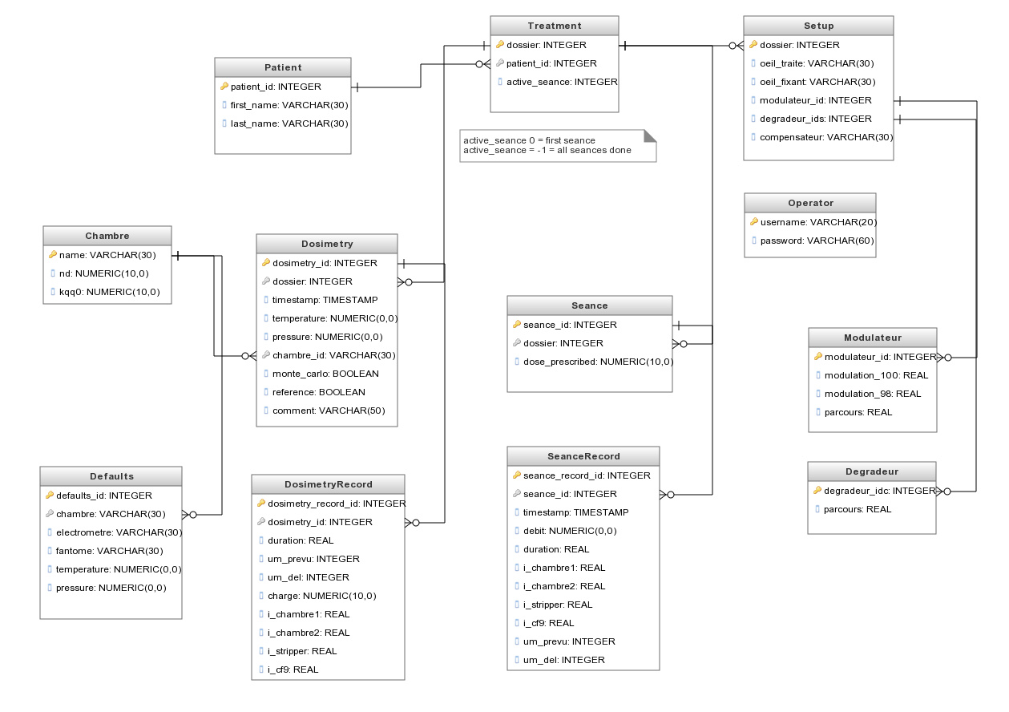

Notes
- Treatment::active_seance indicates the current seance (starting from 0, meaning that active_seance 0 is the first seance. Active_seance = -1 indicates that all seances have been done).

- To change a delivered dose, change the parameter SeanceRecord::um_del (= delivered UM). Use the debit SeanceRecord::debit, in case the new dose is only known in Gy.

- To add a seance to an existing dossier, insert a new row in the “Seance” table. The first parameter in this table is auto-incrementing and should never be set by hand. If all previous seances were finished, remember to set the parameter Treatment::active_seance so that it points to the new séance.

