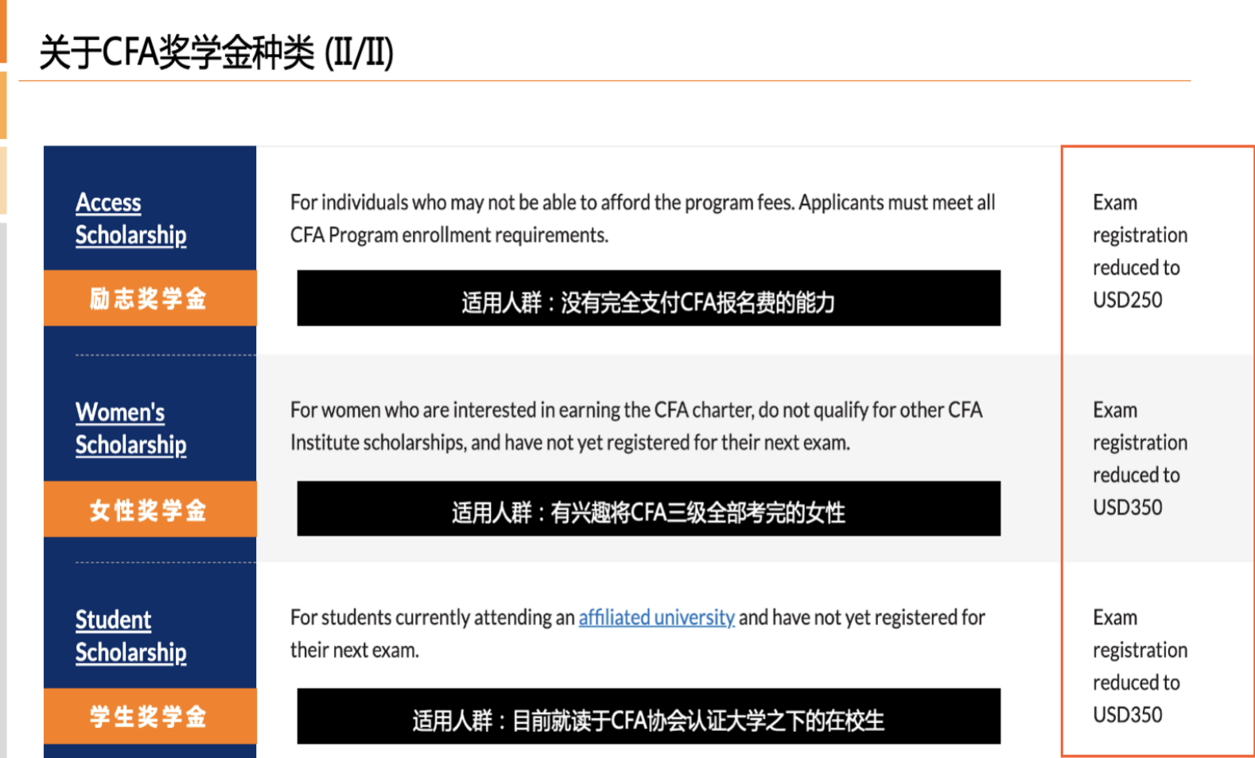

**励志奖学金：需要近三个月银行流水，经济来源主要来自家庭，自己暂无稳定收入，近70%的流水全部在高昂的国际生学费上，需要提交CV，以及一篇statement。**

**女性奖学金：CV（突出求职和实习简历，尤其是金融相关的实习）**

**学生奖学金：（每个高校要求不一）**

**模版分享**

* **模版一**

Dear sir or madam,

Thank you for reading my email. As a CFA Level one candidiate for 20xx exam, I strongly agree with the value which CFA Exam can be inspired me for my future career path.The woman soclarship can largely incentive me to finish my CFA study, and I believe that my eligibility can meet the reqirement by my various experience.

The CFA exam has provided a sysematic network that I can use this to restructuring my financial knowledge in a short time. The exam contents can well link my basic knowledge leared at school and try to apply different concepts into the reallistic situation. For example, I can use the cost model or revaluation model to quickly analysis the company’s long-lived assets, and I can base on some relevant IFRS principles to apply the real situation of company’s assets. This analytical skill can help me to well operate my business case competition, and further increasing my ability for the multi-tasks in the future. In addition, I also discover that CFA exam can help me to know how to well work at the real business situation. My last experience for applying business development internship needs to require some analyslitic skills such as data analysis, but I cannot use a reliable tool to prove that I can fully handle with this task at the beginning. However, I have obtained a similar internship when the operator knows that I am the candidatite for CFA Level one exam. Therefore, I can fully realise that how CFA is really matter me, and matter with my future career path.

My strong business skills can become the best proof for the obtaining the CFA female soloarship. As metioned before, my analytical skills is fully based on my periodic preperation for CFA Level one exam, which means that I can quickly finish my CFA study if this soloarship can be obtained. At the same time, my university grade also can become the evidence that I can handle the complicated study work. In addition, my various case competition experience can indicate that I am not only can well working with my teammates, but also can conduct my well time management. my internship experience not only helped me to gain insight into the financial markets, but also made me realize that there is no perfect analytical method that can be applied to all enterprises. I also recognize my insufficiency of financial knowledge in actual application, which stimulates me to take the CFA exams.

I believe that this soclarship opportunity will largely engage me to learn CFA exam in the future, and hope to hear from you soon for my applicaition! Thank you and have a good day!

* **模版二**

Dear sir or madam,

I am very glad to have the opportunity to participate in the CFA Exam scholarship application. I believe my past achievements are evidence of my eligibility to receive this scholarship, and it would be an immense help to me during my future studies.

I decided to take the CFA exam in my undergraduate period when I realized that that I used to observe and behave from an accounting standpoint, and there was a lack of finance prospective for me. Take my internship in the SL Financial Group of AXA as an example, I met real problems when forecasting the future performances of firms in the HK markets: how to analyze the market value of high-tech companies like Tencent? If only seen from the financial statements, Tencent has very good profitability ratios, but the possibility that the company's stock price was overestimated is also higher due to its higher PE ratio. I soon figured out that different analysis indicators are needed for companies in different industries and situations. In this case, non-financial data such as the number of monthly active users (MAU) can play an important role in assessing its reasonable intrinsic value. This internship experience not only helped me to gain insight into the financial markets, but also made me realize that there is no perfect analytical method that can be applied to all enterprises. I also recognize my insufficiency of financial knowledge in actual application, which stimulates me to take the CFA exams.

The CFA exam perfectly meets my needs to the greatest extent. I also have full confidence that I can achieve excellent performance in the exam. First of all, my excellent academic performance demonstrates my active learning attitude and outstanding academic ability. I have achieved satisfying GPA during my undergraduate period as well as in my graduate period. In 2017, I proposing two mathematical models and getting a paper published in the series Advances in Intelligent Systems and Computing as one of the main authors. In addition, I passed FRM I exam not long ago, which gains me a better understanding of the financial systems and also motivates me to further supplement related knowledge .Last but not the least, the financial industry is inseparable from practice, thus my rich internship experiences in the financial areas contributed to be one of my merits to win your support.