Cobra HOY
Secured Lending Facility | Spanish Private Healthcare | Investment Overview
7–8%  Target Net Return |  | 15–60d  Capital Cycle |  | €900M+  Addressable Flow |  | 60+  Insurer Obligors
INVESTMENT THESIS
Cobra HOY is a secured lending facility that provides early payment to Spanish private healthcare centers against their expected insurance company payouts. Hospitals perform medical procedures for insured patients under framework agreements (convenios) with insurers who pay in batch cycles 15–60 days later. No financial product exists to bridge this gap at the individual claim level.
The facility is powered by proprietary data from SEOGA, the dominant claims processing platform in Spain’s private healthcare sector, processing ~€900M annually across 1,000+ centers and 60+ insurers. SEOGA’s claim-level intelligence transforms conditional payment obligations into quantifiable, risk-adjustable expected cash flows — the foundation for a first-of-its-kind lending product with no direct competition.
DEAL OVERVIEW
Product | Secured lending facility — advances against expected insurer payment flows
Underlying Asset | Conditional claims under hospital–insurer convenios, scored by SEOGA’s data engine
Security | Notarized Umbrella Pledge over credit rights + tripartite control agreement (Double Lockbox)
Lending Vehicle | Single SPV — sole lender of record, pledgee, and control agreement counterparty
Revenue Streams | Hospital advance (~0.65%/advance) + Physician advance (~1.25%/advance)
Capital Deployment | €2–5M facility; €3M deploys €20M+ annualized via 15–60 day recycling
Regulatory | No financial license required (B2B lending); no CIRBE impact to borrower
MVP Timeline | 2–3 months to operational readiness; 5–10 pilot hospitals
COMPETITIVE MOAT
- Not invoice factoring — convenio-based claims are conditional payment obligations, not discrete assignable invoices. Traditional factoring does not apply.
- Data barrier to entry — replicating SEOGA’s position requires processing millions of claims across 60+ insurers and 1,000+ hospitals. Multi-year, relationship-intensive effort no competitor has undertaken.
- Bank credit lines are generic — lend against balance sheet, not specific insurer flows. Slow, rigid, consume CIRBE borrowing capacity, and lack domain-specific pricing.

STRUCTURE — DOUBLE LOCKBOX
The SPV advances cash to hospitals. Insurers pay into a pledged bank account in the hospital’s name — the insurer sees no change. A tripartite control agreement governs daily automated sweeps: advance repayment flows to the SPV first, surplus returns to the hospital’s operating account. The notarized Umbrella Pledge grants the SPV privilegio especial (special privilege) in bankruptcy, enforceable ahead of unsecured creditors.
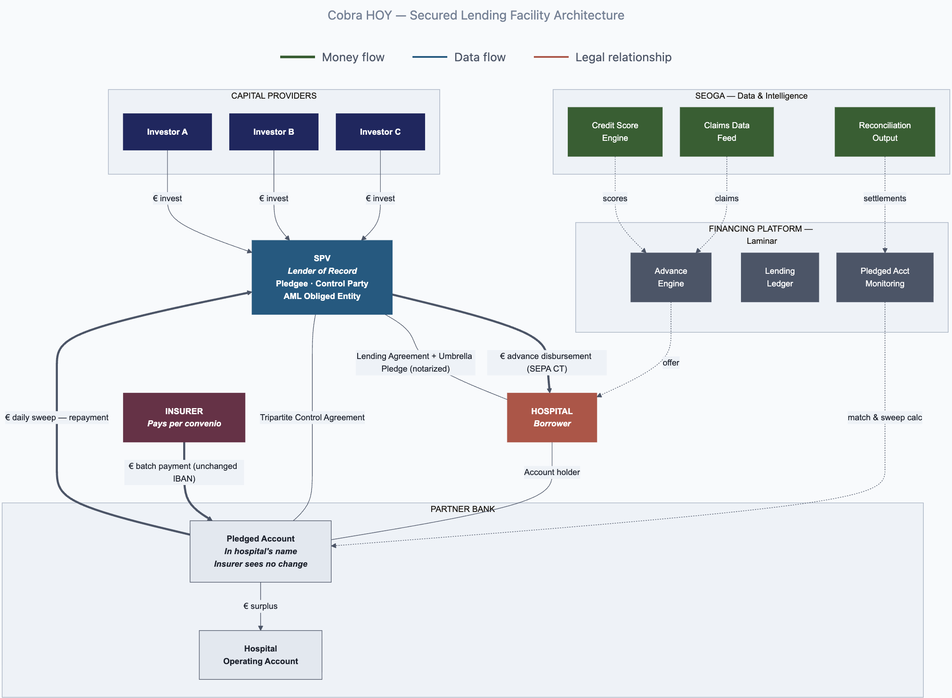
COMPARABLE POSITIONING
Product | Net Return | Duration | Obligor Quality
EUR money market | 2.5–3% | <90 days | Sovereign / bank
Supply chain finance fund | 4–8% | 30–90 days | Corporates
Cobra HOY (unlevered) | 7–8% | 15–60 days | Spanish insurers
Trade finance fund | 9–12% | 30–90 days | SME receivables
Cobra HOY (2x levered) | 9–12% | 15–60 days | Spanish insurers
European private credit | 9–13% | 2–5 years | Mid-market corporates
RISK MITIGATION
- Dual recourse: Contractual claim against hospital (B2B loan) + notarized pledge with special privilege in bankruptcy
- Short duration: 15–60 day cycle caps exposure; portfolio de-risks within 60 days if origination paused
- Institutional obligors: Regulated Spanish insurers (Sanitas/Bupa, Adeslas/CaixaBank, Mapfre, DKV/Munich Re) under Solvency II
- Data-driven underwriting: 5M+ historical medical acts enable per-claim risk pricing and continuous haircut back-testing
KEY PARTIES
SEOGA Data, credit scoring, insurer liaison, hospital distribution | Laminar Financial structure design, technology platform, capital sourcing | SPV Single lending vehicle; sole lender of record | Bank Partner Pledged accounts, daily sweep execution, SEPA payment rails (TBD)
Contact Laminar for the full investment memorandum, data room access, and term sheet discussion.
This document is confidential and intended for qualified investors. It does not constitute an offer to sell or solicitation of an offer to buy any securities.

