A nonlinear model, with uneven time steps and missing data

We previously considered a nonlinear model, the logistic equation, which we wrote as a difference equation. Often we will want to work directly with a discretized form of a differential equation. Here we consider the logistic again, and include uneven sample intervals, as well as another technique to speed up the algorithm.

A nonlinear model such as the logistic

can be discretized and written to include process and observation errors as

The process error variance is scaled with the time increment. A function for f(n) = dn/dt is

dn_logistic <- function(n,pars){pars[1]*n*(1-n/pars[2])}

Note that the time intervals could be of differing durations. The code that follows allows for an arbitrary growth function. For simplicity, I have assumed Gaussian errors.
The full model I will describe here is

Note the truncated normal prior on parameters and on states n_{t}, which allows for symmetric proposals that will not go below zero. I will infer the population densities and the variances. A Metropolis step will be used for the densities and direct sampling for the variances, with these conditionals.
For the parameters, I propose new values of (r, K) and predict the n's for both current and proposed parameters. I then accept as a block:

update_pars_logistic <- function(){

prop <- tnorm(2,c(0,0),c(10,1000),c(rg,kg),c(.01,1))
rp <- prop[1]; kp <- prop[2]

nnow <- xg[-nt] + fx(xg[-nt],c(rg,kg))*dt #predicted n
nnew <- xg[-nt] + fx(xg[-nt],prop)*dt

pnow <- sum(dnorm(xg[-1],nnow,sqrt(sg*dt),log=T)) +
sum(dnorm(c(rg,kg),c(mur,muk),c(sdr,sdk),log=T))
pnew <- sum(dnorm(xg[-1],nnew,sqrt(sg*dt),log=T)) +
sum(dnorm(c(rp,kp),c(mur,muk),c(sdr,sdk),log=T))
atmp <- acceptMH(pnow,pnew,c(rg,kg),prop,BLOCK=T)
rg <- atmp$x[1]
kg <- atmp$x[2]

list(rg = rg, kg = kg, aa = atmp$accept)

}

For the states n, I propose new values, for all at once and accept as a block. This avoids the loop over time:

update_x_logistic <- function(){ #propose/accept x as a block

xprop <- tnorm(nt,0,1000,xg,.2) #proposed x
xpnew <- xprop[-nt] + fx(xprop[-nt],c(rg,kg))*dt #mean proposed
xpnow <- xg[-nt] + fx(xg[-nt],c(rg,kg))*dt #mean current

pnow <- sum(dnorm(xg[-1],xpnow,sqrt(sg*dt),log=T)) +
sum(dnorm(y[-wm],xg[-wm],sqrt(tg),log=T))
pnew <- sum(dnorm(xprop[-1],xpnew,sqrt(sg*dt),log=T)) +
sum(dnorm(y[-wm],xprop[-wm],sqrt(tg),log=T))

atmp <- acceptMH(pnow,pnew,xg,xprop,BLOCK=T)
xg <- atmp$x

list(xg = xg, aa = atmp$accept)

}

The conditions for the variances are
Note that for the process error I include the uneven time step. Here is a function:

update_svar_dt <- function(){

xp <- xg[-nt] + fx(xg[-nt],c(rg,kg))*dt #mean current
u1 <- s1 + (nt-1)/2
u2 <- s2 + .5*sum( ((xg[-1] - xp)^2)/dt )
1/rgamma(1,u1,u2)
}

First I use a simulated data set. Here I simulate the process and data:

nt <- 100 #no. time intervals
nm <- 20 #number of missing values
wm <- sort(sample(c(2:nt),nm)) #which are missing
r <- .1 #parameter values
k <- 100
sig <- 10 #process err variance
n0 <- 20 #1st value
n <- rep(n0,nt)
fx <- dn_logistic #logistic function from file
dt <- runif(nt,.4,2) #random time increments
time <- cumsum(dt); dt <- dt[-nt] #observation times
tau <- 20 #obs error variance

for(t in 1:(nt-1)){ #data simulation
n[t+1] <- tnorm(1,.1,1000,( n[t] +
fx(n[t],c(r,k))*dt[t]),sqrt(sig*dt[t]))
}

y <- rnorm(nt,n,sqrt(tau)) #simulate observations
y[wm] <- NA

plot(time,y)
lines(time,n)

To simulate values, note that because we are no longer working logs, the n's could conceivably go negative. For this reason, I have used the truncated normal to simulate from:
Here are informative priors for process and observation error, based on moments of the inverse gamma, and some less informative priors for r and K:

mus <- 5 #mean for process error variance
s1 <- 2 #weak prior
s2 <- mus*(s1 - 1)

mut <- 20 #mean for obs error variance
v1 <- 2*nt #wt comparable to data
v2 <- mut*(v1 - 1)

mur <- .2 #prior means and sd's for parameters
sdr <- 10
muk <- 100
sdk <- 100

To initialize the state vector x, I use the observations y, filling in the gaps with a spline prediction:
library(stats)
xg <- y
xg[wm] <- predict(smooth.spline(time[-wm],y[-wm]),time)$y[wm]

Here is a Gibbs loop:

sg <- mus #initialize
tg <- mut
rg <- mur
kg <- muk

ap <- 0 #acceptance rates for (r,K)
ax <- 0 #acceptance rates for x

ng <- 10000
pgibbs <- matrix(0,ng,2); colnames(pgibbs) <- c('r','K')
vgibbs <- matrix(0,ng,2); colnames(vgibbs) <- c('sigma','tau')
xgibbs <- matrix(0,ng,nt)
cvar <- matrix(c(.0001,.03,.03,100),2,2)

for(g in 1:ng){

#sample r,k
ptmp <- update_pars_logistic()
rg <- ptmp$rg
kg <- ptmp$kg
ap <- ap + ptmp$aa

#sample n's
xtmp <- update_x_logistic()
xg <- xtmp$xg
ax <- ax + xtmp$aa

#sample variances
sg <- update_svar_dt()
tg <- update_tvar()

pgibbs[g,] <- c(rg,kg)
vgibbs[g,] <- c(sg,tg)
xgibbs[g,] <- xg

}

gibbs_pars(cbind(pgibbs ,vgibbs),xtrue=c(r,k ,sig,tau),
CPLOT=T,DPLOT=T)

gibbs_states(time,xgibbs,y,n)

The early part of some Gibbs chains are shown in Figure 8.1. Despite the fact that 30% of the observations are missing, the estimates of most parameters are good. In this example, the observation error was given a stronger prior than the process error. Repeated simulations show that the process error is sometime overestimated and sometimes underestimated.

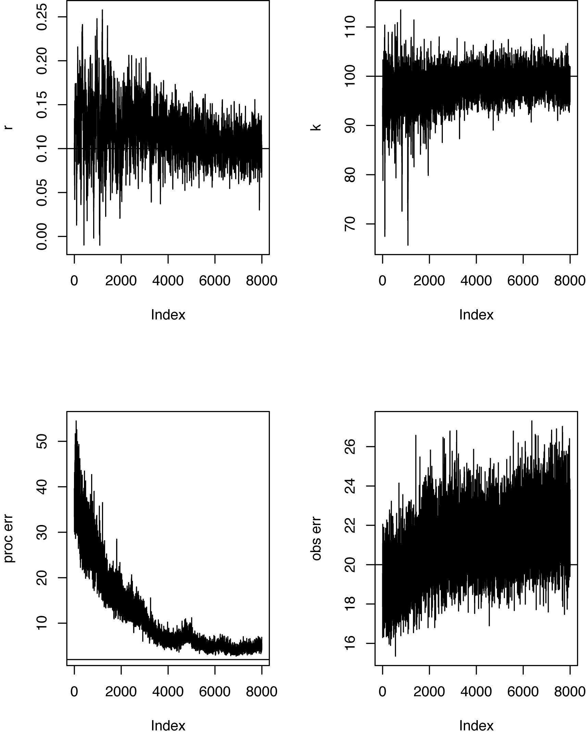
Figure 8.1. Gibbs chains from simulated data. Values used to simulate data are indicated by horizontal lines.

The predictions for data are shown in Figure 8.2.
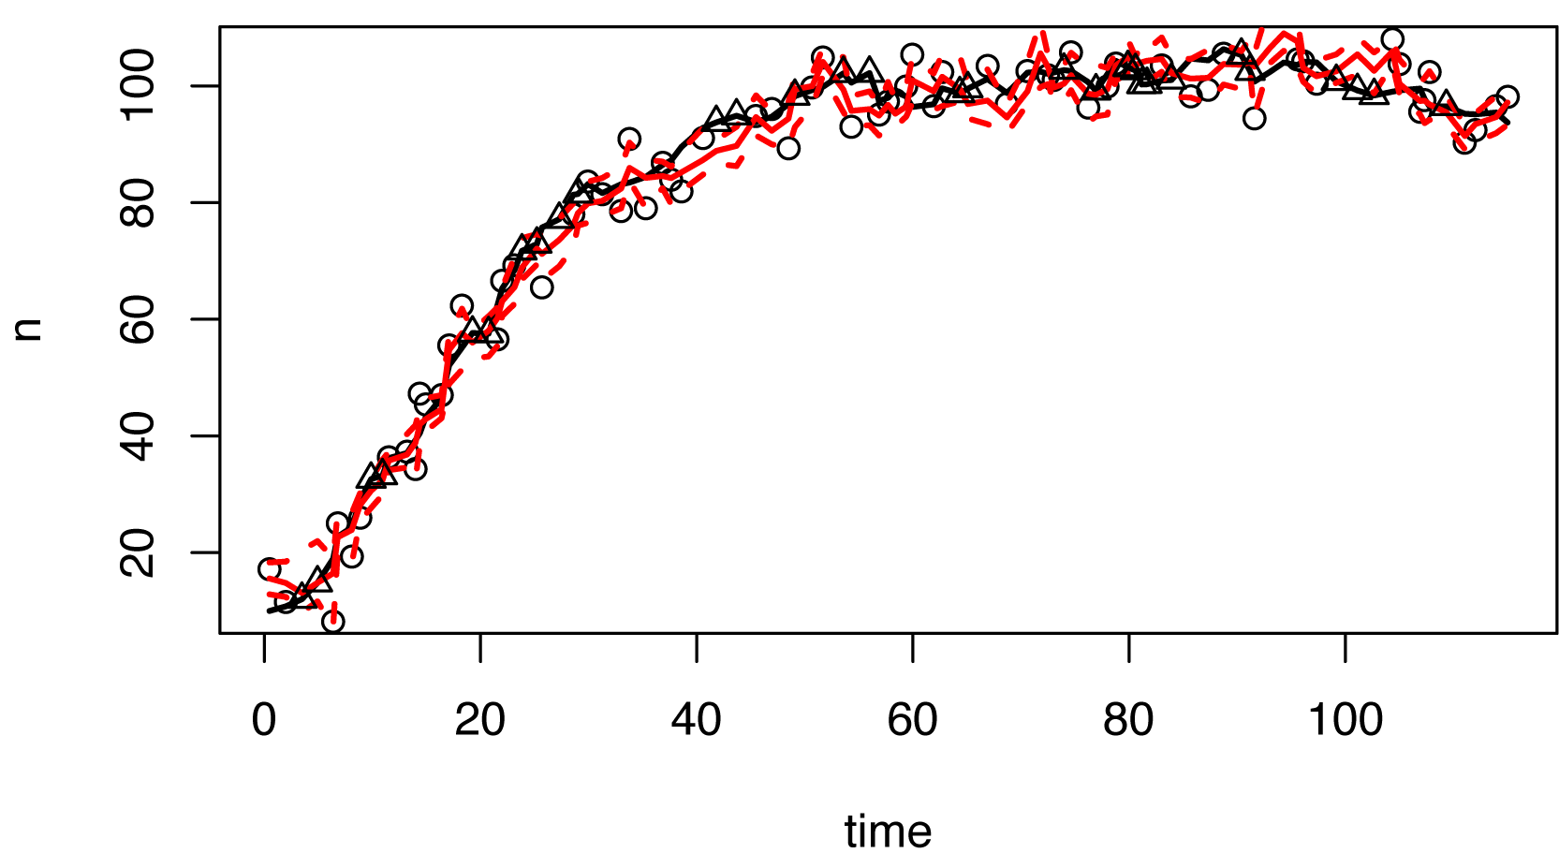
Fig. 8.2. The simulated values are shown as a black line. The predictions, with 95% CIs are in red. The observations are indicated by circles, and the true values for missing observations are triangles.

Here is a comparison of the two algorithms for the moose data:

time <- moosedata[,'year']
y <- moosedata[,'density']
nt <- length(time)
xg <- y

wm <- which(is.na(y),arr.ind=T)
nm <- length(wm)
xg[wm] <- predict(smooth.spline(time[-wm],y[-wm]),time)$y[wm]
dt <- diff(time)
fx <- dn_logistic

mus <- 4^2 #mean for process error variance
s1 <- 2*nt #weak prior
s2 <- mus*(s1 - 1)

mut <- 10^2 #mean for obs error variance
v1 <- nt #wt comparable to data
v2 <- mut*(v1 - 1)

Note the speed up in the algorithm over the previous one that loops over time:
> system.time(update_x()) #1st algorithm
user system elapsed
0.041 0.001 0.069

> system.time(update_x_logistic()) #2nd algorithm
user system elapsed
0.003 0.000 0.005

Many series, two data sources, both sparse
In this example I examine growth rates of a large number of trees, each being a state space model, but sharing information within an individual over time, among individuals within a given year, and across the whole population in terms of an overall mean growth rate and variances associated with process, observations, and errors. The interesting features include not only the large number of times series, one for each individual, but also the fact that there are two different data sources, but both are sparse. The code can be structured in such a way to provide efficient sampling, without resort to loops over individuals or time. The example comes from Clark et al. (2007).
The two sources of information include census data, where a tree diameter is measured at 1 to 4 yr intervals, and increment core data, where a core is extracted from some trees and ring widths are meticulously measured. Because data are sparse, I will combine them in a way that 'borrows' information within an individual over all years and within years over all individuals. The 'process' equation is
where
is the growth increment that accrues for individual i between year t-1 and t, and D_{i,t} is the tree diameter, both in cm. There are random individual effects β_{ij}, random plot effects, p_{j}, and fixed year effects κ_{t}. The observation equation for diameter data is
The observation equation for increment data is
where the indicator has limits set by plausible errors that can occur in measurement of diameter increments. In the example that follows I set these limits at 1 mm below and above that observed. These are in fact broad, in light of the precision possible and the fact that average growth rates are only about 2 mm. The priors are:
where k_{t} = μ + κ_{t}. Direct sampling is possible for some of these conditionals. For the fixed effects, we have , with
where n_{t} is the number of observations available for yr t. Out of personal preference I extract the mean μ and represent year effects as departures from this mean. The function that does this is f.update.
The individual effects are sampled from , where
The plot effects are sampled from , where

where where n_{j} is the number of trees in plot j, and m_{j} is the total number of observations for plot j.
Observation errors are drawn from
where n_{D} and n_{G} are numbers of diameter and increment observations, respectively, and the summations are taken only over years and individuals for which there are observations. The variances for process and random effects are

where n_{IT} is the total number of tree-years (increments) in the data set, and n_{P} is the number of plots.
The sampling of diameter increments is done in blocks, one per tree, within the function di.update. All trees can proposed done simultaneously, but accepted on a tree-by-tree basis, because, conditioned on parameters discussed above, the sequence for any given tree is independent of all others. The Metropolis step begins with a proposal for the diameter in the 1st year, which is done with a truncated normal around plausible values for the 1st year. This interval is set in the function diamint, where it is given a width of 4 cm. After proposing an initial value dstart, a new increment is proposed for all tree years dnew. Using dstart and dnew I calculate the proposed new diameters in diamnew. I then sequentially include up to three factors that can contribute to each tree-year, including the regression (all increment years), increment observations, and diameter observations. Within di.update I also sample variances for errors. Separate functions sample for process and random effects variances.
Code for this example is contained in the file diametergrow.r. A sample data set is obtained using

load('litu.Rdata')

From the file diametergrow.r begin by setting the error for diameter increments. For a 2 mm window centered on the observed increment,

ierr <- .1 #1/2 width (in cm) of error window for increments

Functions to initialize and sample from conditionals are obtained using

source('diametergrow_functions.r')

To apply this code to other data sets note that it requires several objects, which you can after loading litu.Rdata, using the command objects(). The structure of these objects can be viewed from the data set provided. First are several lists, having one row per tree and years as columns:
diameters - a list of matrices, each n by T, containing the diameter measurements for each plot
increment - a list of matrices, each n by (T - 1), containing the growth increment data
surviv - a list of matrices, each n by T, containing a NA for years when an individual was not under study, a 1 when it was studied and alive, and a zero when it was studied but dead.
yrvec - a vector containing the years during which the study was conducted

For this example, here are the first 5 trees on plot 2:
> diameters[[2]][1:5,]
1992 1993 1994 1995 1996 1997 1998 1999 2000 2001 2002 2003 2004 2005 2006 2007
[1,] NA NA 43.8 NA NA 45.4 NA 46.5 NA NA NA 47.9 NA 48.2 NA 48.8
[2,] NA NA 1.8 NA NA 2.1 NA 2.1 NA NA NA 2.2 NA 2.5 NA NA
[3,] NA NA 10.4 NA NA 10.6 NA 10.8 NA NA NA 10.9 NA 11.0 NA 11.3
[4,] NA NA 20.1 NA NA 20.9 NA 20.7 NA NA NA 20.9 NA 21.1 NA 21.3
[5,] NA NA 21.4 NA NA 21.5 NA 21.5 NA NA NA 21.5 NA 21.6 NA 21.8
2008
[1,] 49.3
[2,] NA
[3,] 11.4
[4,] 21.4
[5,] 21.7
[5,] 21.8
> increment[[2]][1:5,]
[,1] [,2] [,3] [,4] [,5] [,6] [,7] [,8] [,9] [,10] [,11]
[1,] NA NA NA NA NA NA NA NA NA NA NA
[2,] NA NA NA NA NA NA NA NA NA NA NA
[3,] 0.1876 0.1076 0.3124 0.5328 0.3352 0.2908 0.1756 0.3340 0.2164 0.0824 NA
[4,] 0.3796 0.3016 0.3996 0.4024 0.4648 0.5096 0.3024 0.2880 0.3800 0.3568 NA
[5,] 0.0108 0.0144 0.0272 0.0148 0.0200 0.0120 0.0068 0.0128 0.0100 0.0132 0.0148
[,12] [,13] [,14] [,15] [,16]
[1,] NA NA NA NA NA
[2,] NA NA NA NA NA
[3,] NA NA NA NA NA
[4,] NA NA NA NA NA
[5,] 0.0164 0.0156 0.0116 NA NA
> surviv[[2]][1:5,]
[,1] [,2] [,3] [,4] [,5] [,6] [,7] [,8] [,9] [,10] [,11] [,12] [,13] [,14] [,15]
sd 1 1 1 1 1 1 1 1 1 1 1 1 1 1 1
sd 1 1 1 1 1 1 1 1 1 1 1 1 1 1 0
sd 1 1 1 1 1 1 1 1 1 1 1 1 1 1 1
sd 1 1 1 1 1 1 1 1 1 1 1 1 1 1 1
sd 1 1 1 1 1 1 1 1 1 1 1 1 1 1 1
[,16] [,17]
sd 1 1
sd 0 0
sd 1 1
sd 1 1
sd 1 1
> yrvec
[1] 1992 1993 1994 1995 1996 1997 1998 1999 2000 2001 2002 2003 2004 2005 2006 2007
[17] 2008

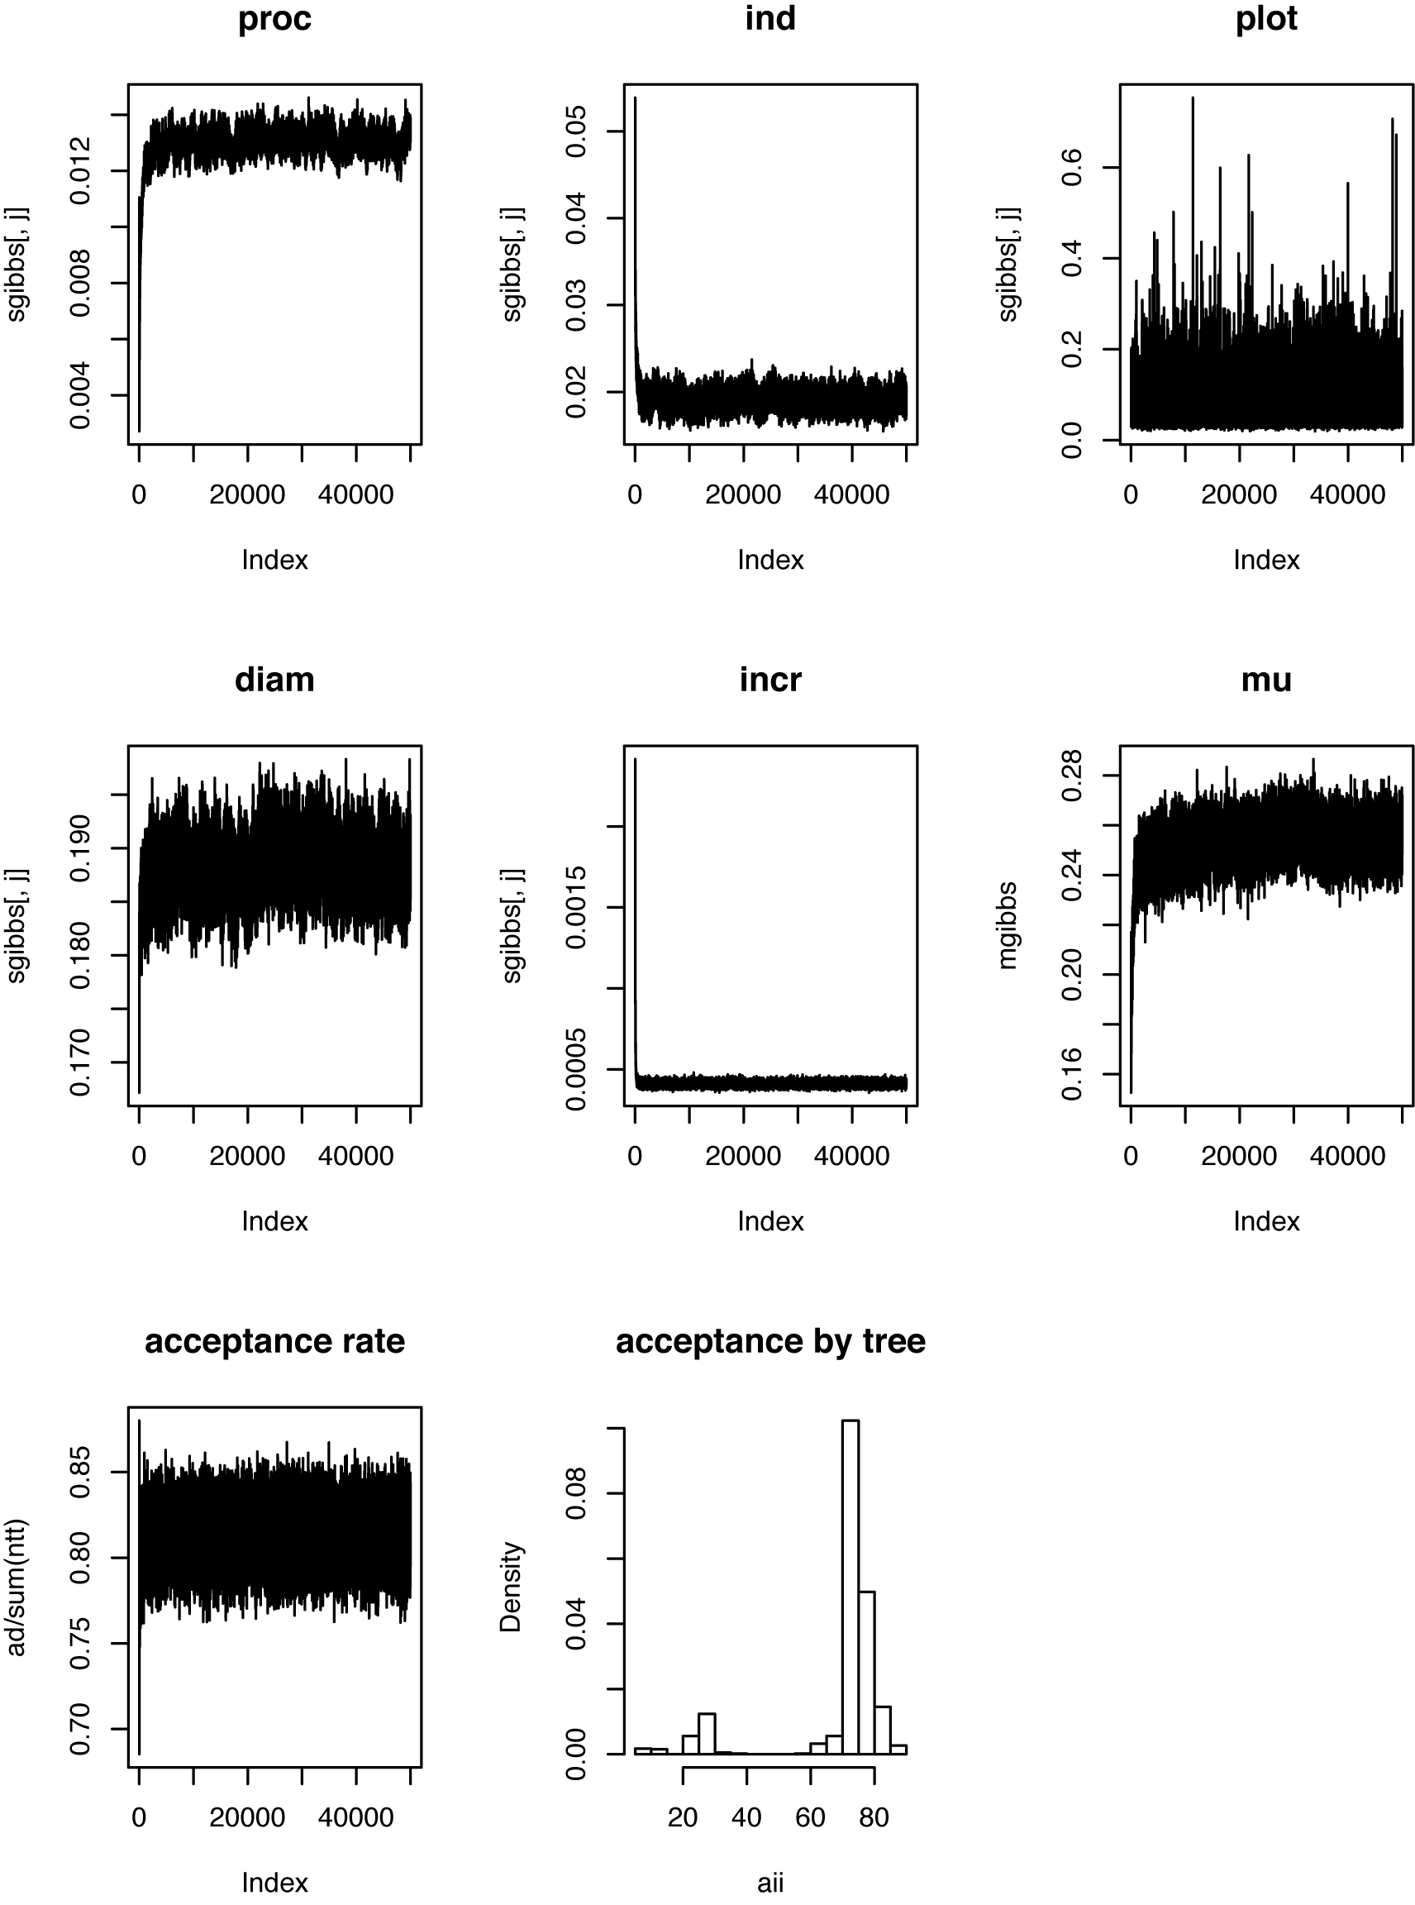
Fig. 8.3. MCMC chains for some of the parameters and acceptance rate, the latter also separated out by individual trees.

In the code diametergrow.r you can set up priors. For the variances these have the form

mus <- 1 #process error
s1 <- 10
s2 <- mus*(s1 - 1)

which begin with a mean value for the variance, the 1st inverse gamma parameter (large values give high prior weight), and the 2nd parameter that will give the desired mean. There subsequent code initializes parameter values and arrays to hold Gibbs output.

Chains for parameters are shown in Figure 8.3. Several thousand iterations are needed to achieve good convergence, slowed by the indirect sampling of latent states (diameters). The acceptance rate (bottom left) can be adjusted by changing the variance on the proposal distributions for first year diameters and growth rates. Also shown are the acceptance rates by tree, showing that a few individuals are not updating frequently.

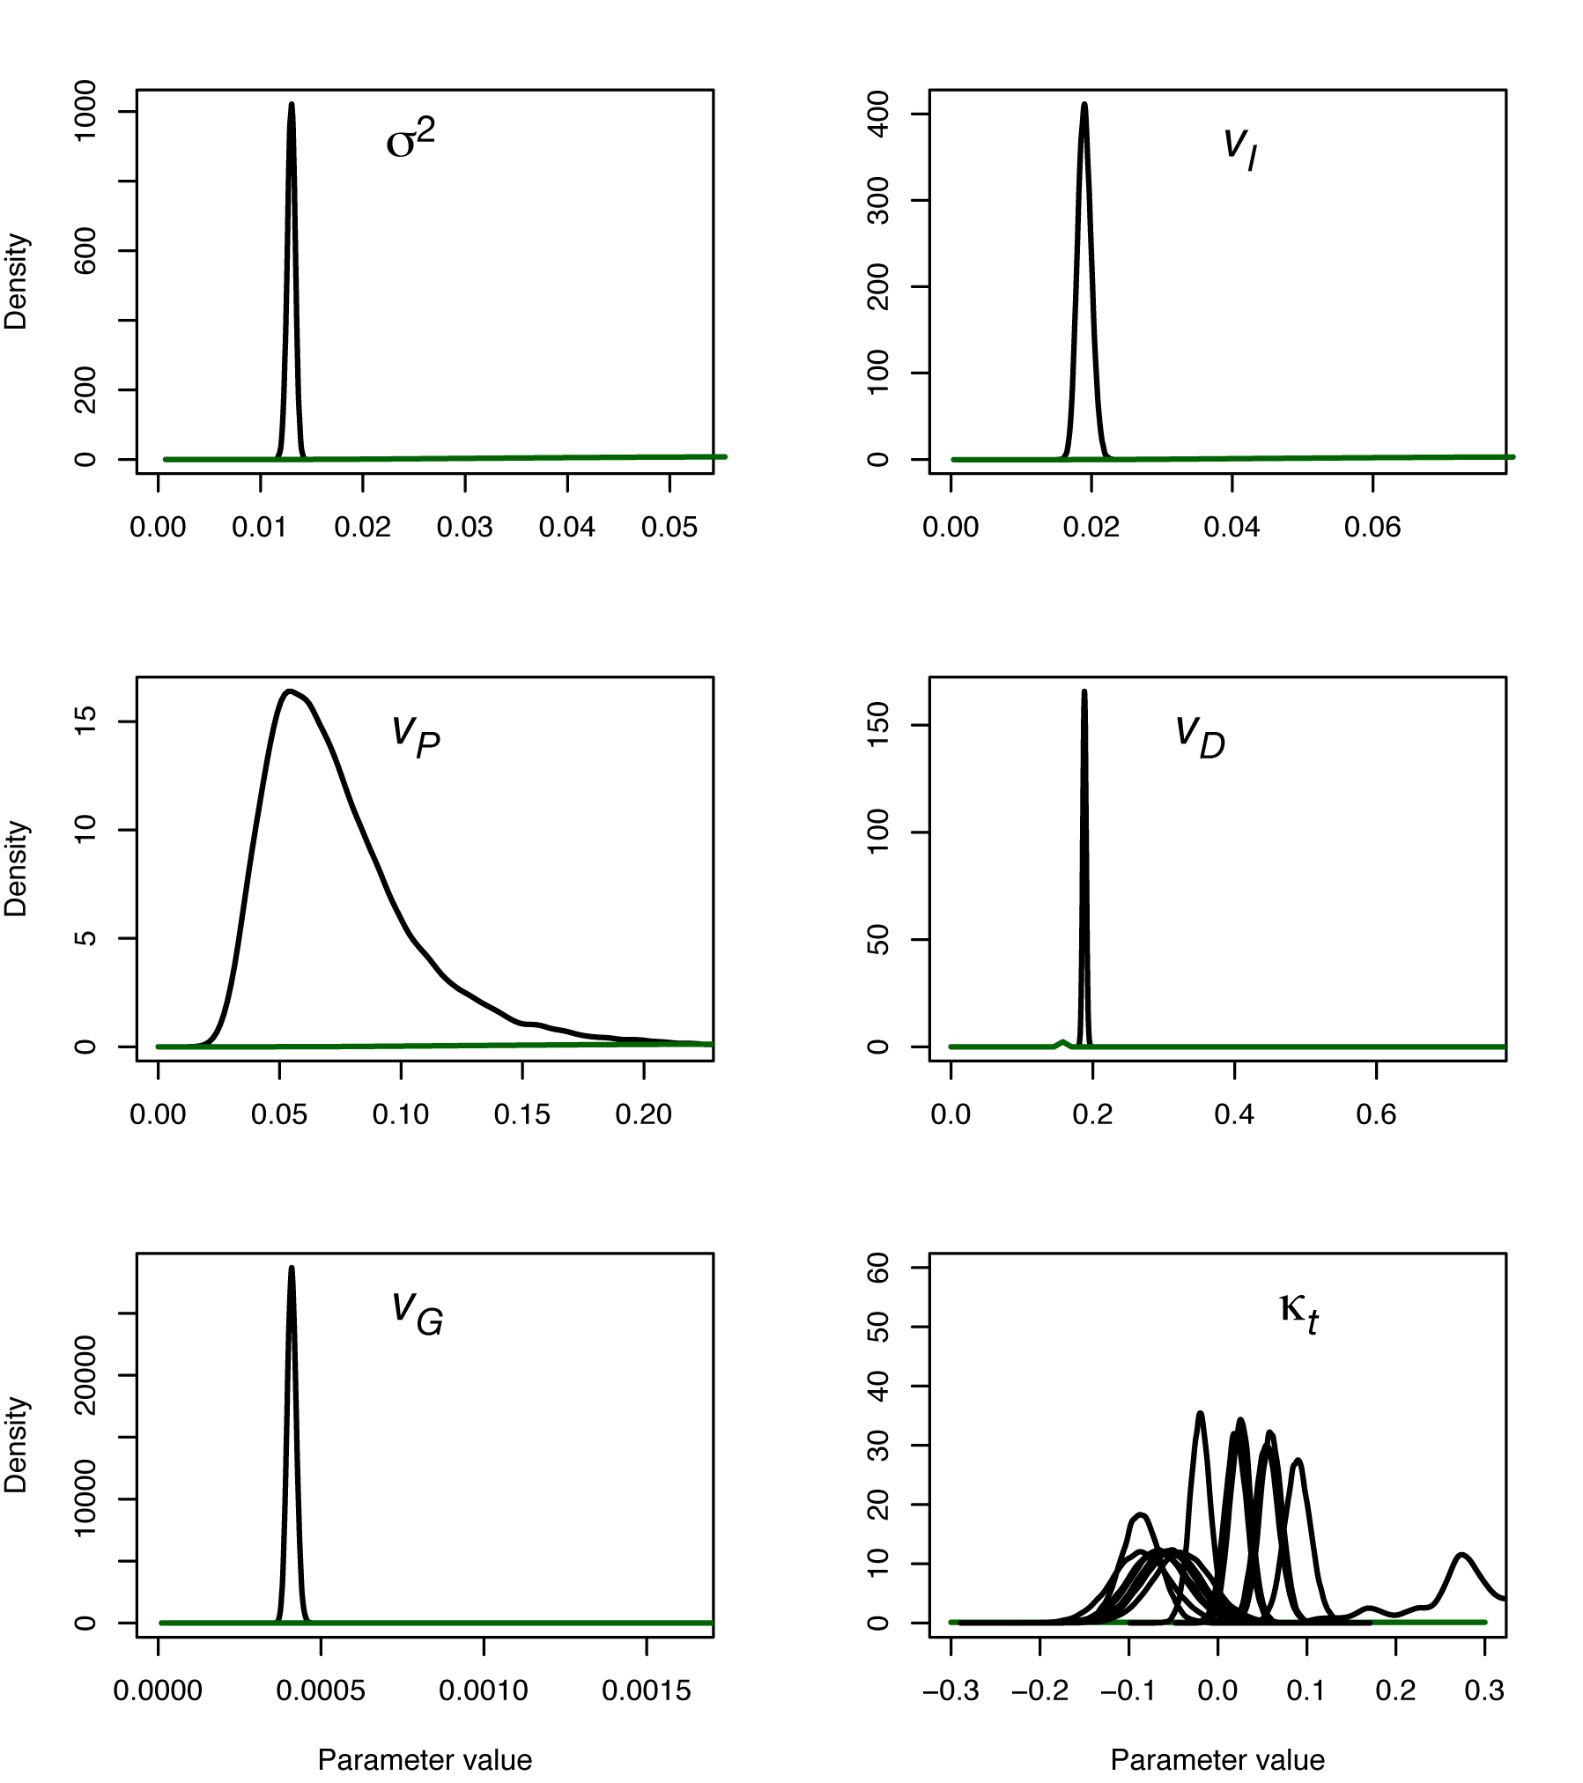
Figure 8.4. Posteriors (black) and priors (green) for parameters. The wide year effect (lower right) comes from the final year for which there are no increment data.

The posteriors in Figure 8.4 indicate that there is substantial information in the data, despite its sparcity, indicated by the comparisons of posteriors and priors. Plotting standard deviations on a common scale provides a sense of the magnitudes of different sources of variation (lower panel of Figure 8.5). Plot differences are large as is the error on diameter measurements. The total variation among individuals is substantial, labeled 'population' in Figure 8.5. The large source of variation is evident in the upper panel of Figure 8.5, where variation among growth sequences for each individual is striking relative to that between individuals.

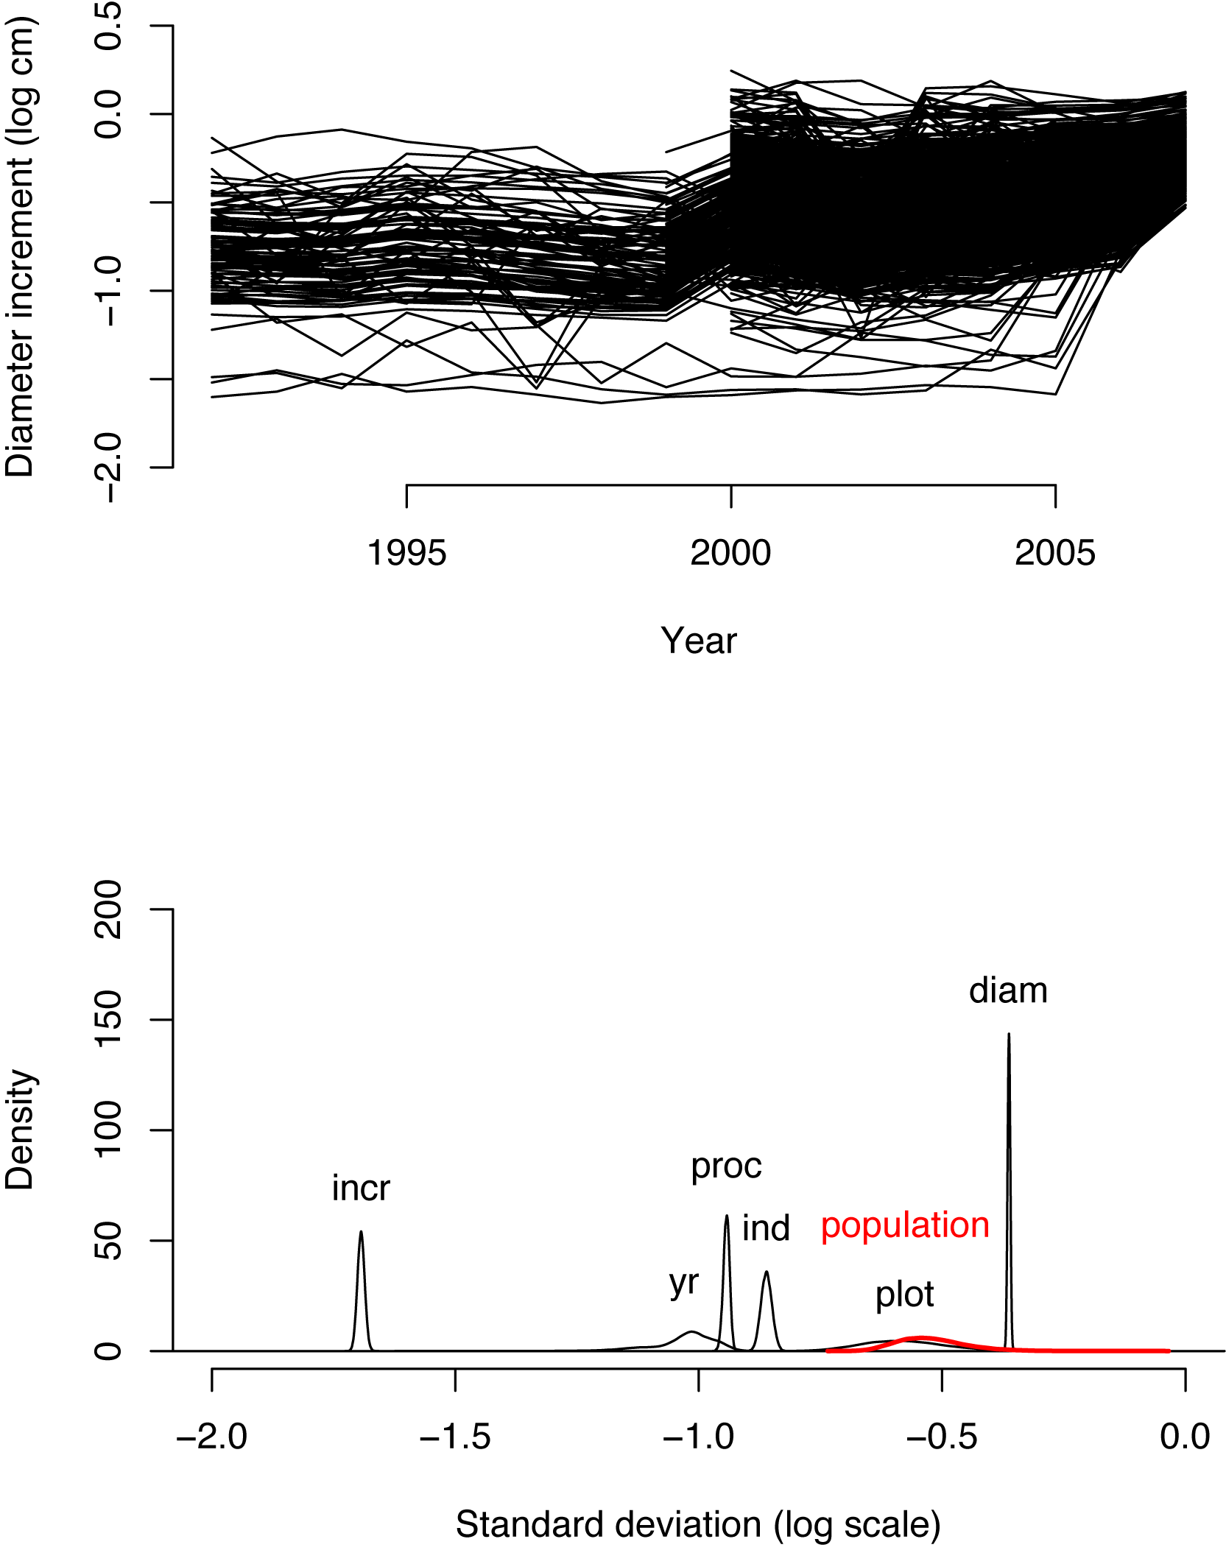
Figure 8.5. Posterior mean growth rates for each tree (upper panel) and posteriors for standard deviations (lower panel). Several plots where measurements began in 1999 and 2000 are evident in the upper panel. The plot effect and individual effect variances are combined in the lower panel as , labeled 'population'.

The data are well predicted by the model (Fig. 8.6). For the increment data, the truncated priors are shown as two parallel lines having width 2*ierr, which is the interval . The predictions for missing observations 'fill in', are wider, but still tight enough to be useful (Fig. 5). These predictive intervals borrow information within years, among individuals, and within individuals, across years.

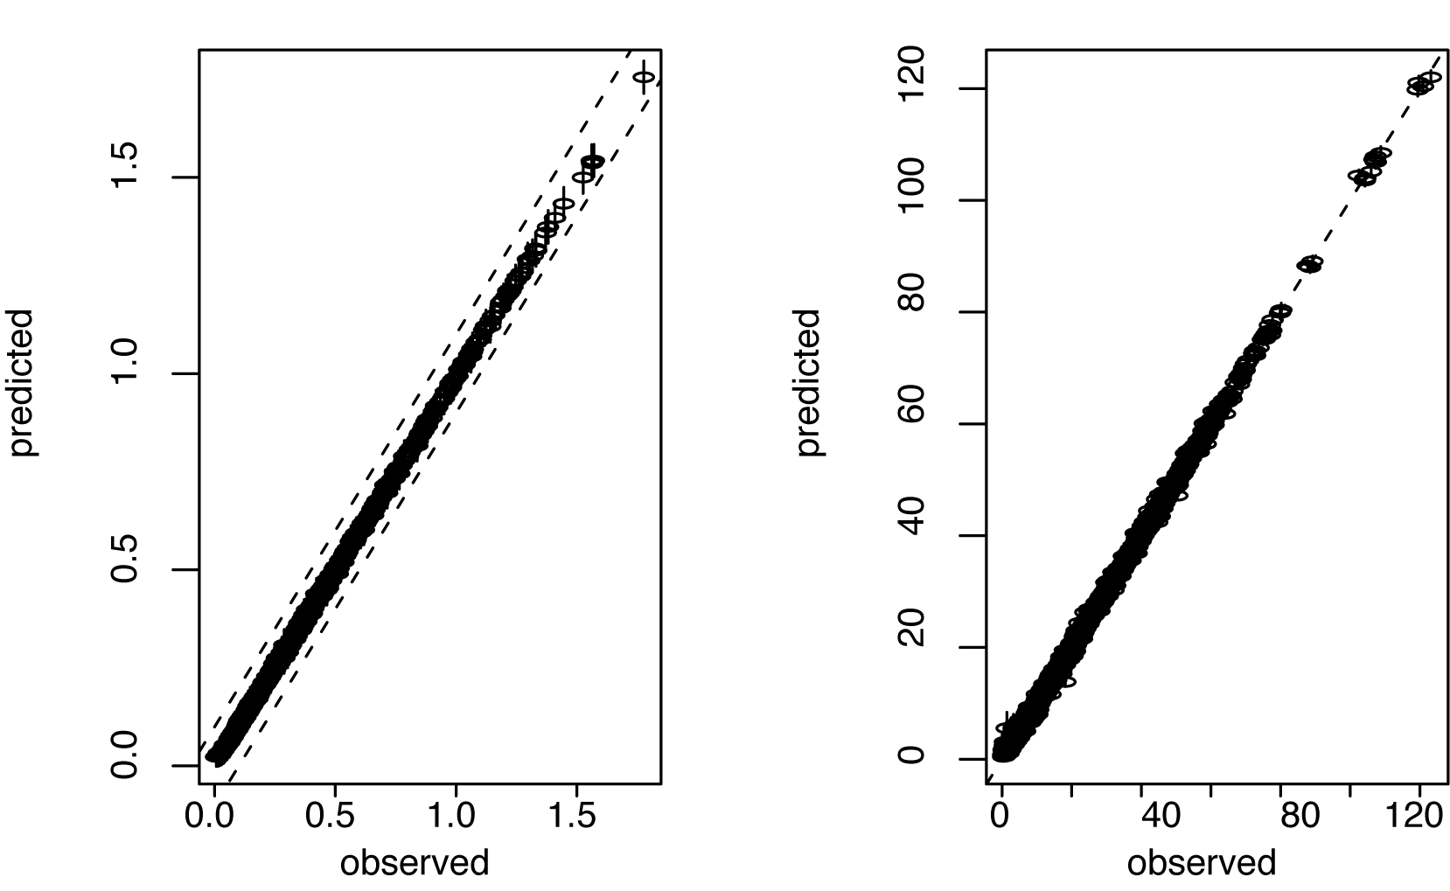
Fig. 8.6. Observations (horizontal axis) and predictions (vertical axis) for increment data (left panel) and diameters (right panel) with 95% CIs.
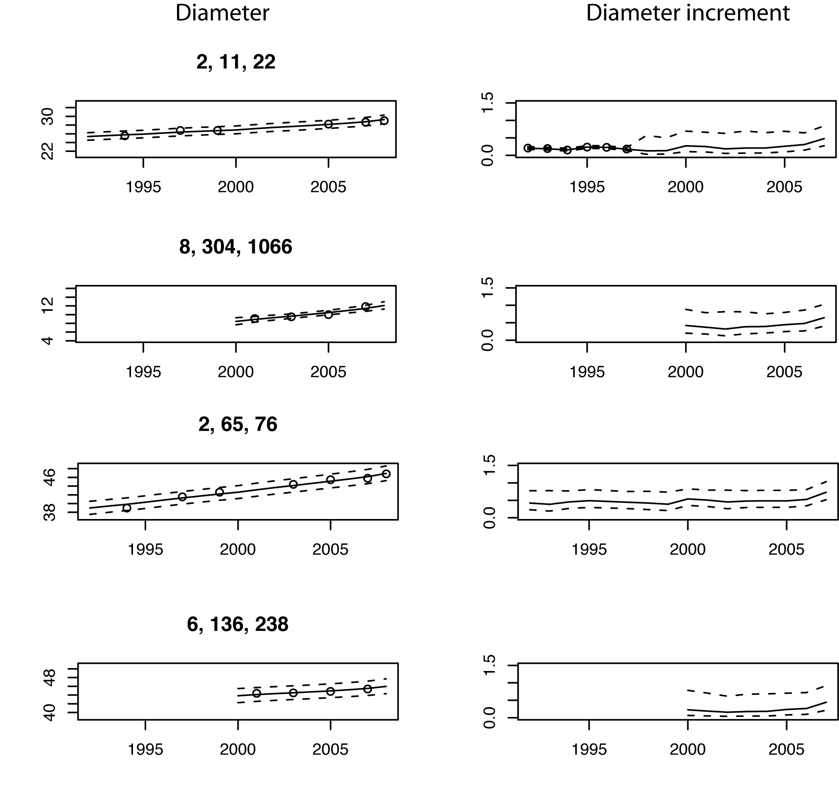
Fig. 8.7. Prediction intervals for diameter (left panels) and diameter increments (right panels) for several individuals having different levels of missingness. For example, the upper panels show individual 22 (tree 11 on plot 2), having six diameter measurements and an increment core obtained in 1998. The remaining three individuals shown here have increment core data and wider predictive intervals.

