Manuscript results

compare survival curves (input and output)

time from 1st progression to model start (diagnosis to 1st prog or 1st prog to 2nd prog)

time to death

survival curves best/2nd best: choose the one that best reflects clinicians input (rather than AIC/BIC), use Exponential (force things to go down quicker, as clinicians don’t expect the flattening)

discounting scenarios and 2nd-best distribution

## Data location

The files are spread out over 5 folders.

## Table 2 & Abstract

Coding the following:

Table 2:Estimates of life-years after diagnosis, QALYs (Discounted) and Costs (Discounted) Estimates reported with 95% Confidence Interval in brackets. All costs are given in Canadian dollars.

Abstract results

**Table 2**:

Table continues below

| Variable | intervention |
| --- | --- |
| Life-years | 29.63 (19.5;38.16) |
| QALY | 13.19 (8.89;16.79) |
| Total Cost | $2,698,305 ($1,866,948;$3,397,022) |
| Non-Targeted PLGG related costs | $223,956 ($164,660;$275,894) |
| AE related costs | $130,264 ($61,210;$199,507) |
| Targeted costs | $2,344,086 ($1,536,732;$3,024,149) |
| Radiation costs | $0 ($0;$0) |

| control | Delta |
| --- | --- |
| 29.17 (18.71;37.96) | 0.46 (-0.17;1.19) |
| 12.61 (8.3;16.24) | 0.58 (0.24;1.06) |
| $394,517 ($368,238;$419,239) | $2,303,788 ($1,497,916;$2,983,128) |
| $260,478 ($202,621;$318,205) | $-36,522 ($-46,411;$-26,540) |
| $134,039 ($48,097;$206,633) | $-3,775 ($-8,297;$1,462) |
| $0 ($0;$0) | $2,344,086 ($1,536,732;$3,024,149) |
| $0 ($0;$0) | $0 ($0;$0) |

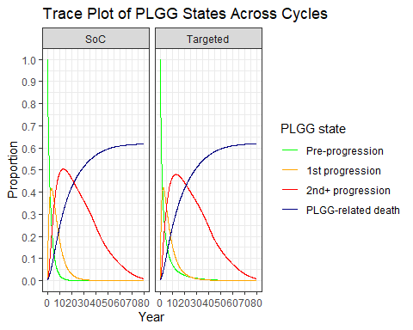

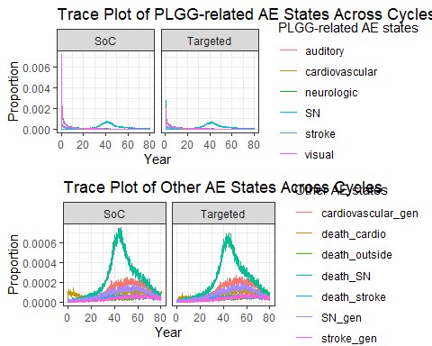

## Supplementary Table 1

Supplementary Table 1: Estimates of life-years after diagnosis, QALYs (Discounted) and Costs (Discounted), for fused patients, and fused patients who progressed.