CSci 435: Formal Languages and Automata

Instructor: Dr. M. E. Kim Name: Pedro Schmidt ______________________

**Home Assignment 1: 100 points + 10 points (optional)**

Q1. [25] For Σ = {a, b}, construct the minimal DFA that accept the language consisting of

1. [8] all strings with an even number of *a*’s and an odd number of *b*’s.

1. [8] every ‘*aa’* is followed immediately by a ‘*b’*. For example, the strings *aab*, *aaba*, *aabaabbaab* are in the language, but *aaab* and *aabaa* are not. Construct a DFA with 4 states.A picture containing drawing, clock

   Description automatically generated
2. [9] L = {w | ( *na*(*w*) – *nb*(*w*) ) mod 3 = 0 }. Construct a DFA with 3 states.A close up of a clock

   Description automatically generated

Q2. [10] Show that the language L = { *a****n***| *n* ≥ 0, *n* ≠ 3 } is regular.

The DFA will accept a string with any number of a’s except for aaa.

Q3. [15] For the language L = {*an* | *n* ≥ 1 } ∪ {*bmak* | *m* ≥ 0, *k* ≥ 0}

1. [8] Construct an NFA with three states that accepts L. 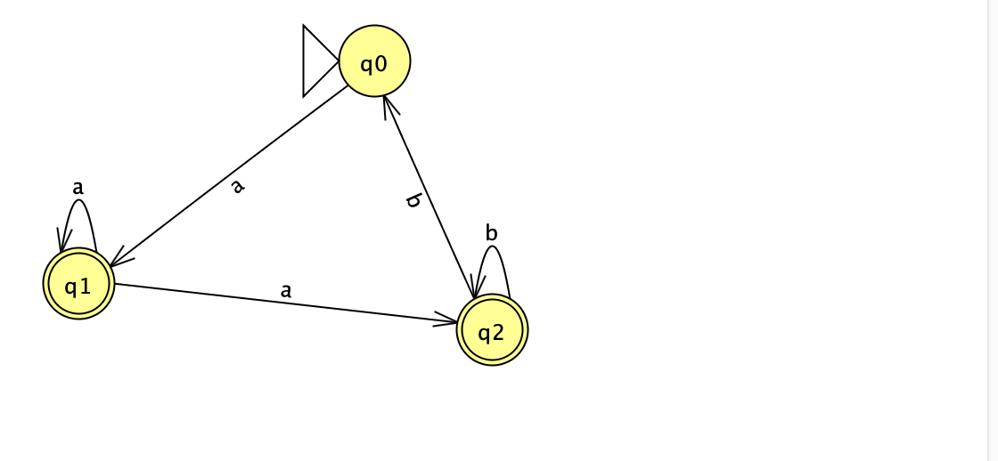
2. [7] Can you construct an NFA with the fewer states that accepts L? If so, construct it; otherwise, justify why your NFA in 1) is the minimal NFA.

Q4. [20] For a given NFA in the figure,

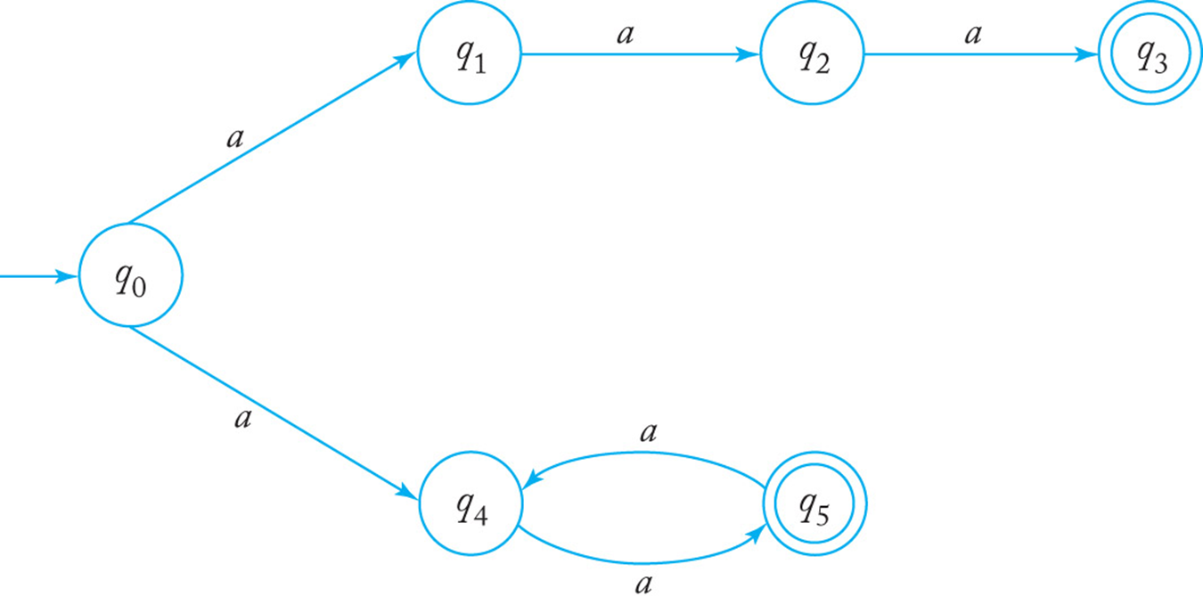

1. [10] Give a language *L* that is accepted by the NFA. Describe L in the proper mathematical format, not in the verbal English description. E.g.) L = { *a****n***| *n* ≥ 0, *n* ≠ 3 }

{ *a****n***| *n* =3 or n ≥ 2k , where k ≥ 1 }

1. [10] Find a *DFA* that accepts the ***complement*** of the language defined by the NFA, i.e. .

Q5. [10] Construct an NFA with the ***minimum*** number of states that accepts

*L* = { *an* | *n* ≥ 0 } ∪ { *bna* | *

Q6. [10] Convert the NFA defined by the transitions below with the initial state *q0* and the final state *q2* into an *equivalent DFA*. Draw the transition graph of the DFA.

δ(*q0, a*) = { *q0, q1* }, δ(*q1, b*) = { *q1, q2* }, δ(*q2, a*) = { *q2* }, δ(*q1,* λ) = { *q1, q2* }.

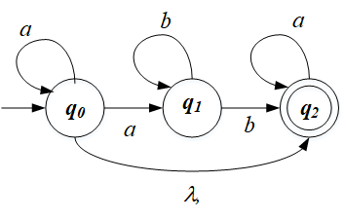

Q7. [20] For a given language, L = { *anb* | *n* ≥ 1 } ∪ { *bna* | *n* ≥ 1},

1. [10] Construct a *minimal DFA* with the minimum number of states that accepts L.

L = { *anbm* | *n* ≥ 2 ,*m* ≥ 1}

1. [10] Prove that your DFA in 1) is minimal. Hint: Check if any pair of the states are indistinguishable to be merged in the same class so that the number of states are minimized A picture containing map, different, skiing, table

   Description automatically generatedA picture containing drawing

   Description automatically generated

Q8. [10, optional] Prove or disprove the following conjecture: If L is regular, so is LR.

If it is true, construct a NFA MR s.t. L(M’) = LR , from a NFA M that accepts L, i.e. L(M) = L. Then, show that L(M’ ) = LR .

Otherwise, give a counter example.

M = Q,Σ,δ,qn,F)

MR =(Q∪{q0},Σ,δr,qr,{qn})

qr = start state of MR

If L(M’) = LR

is a minimal DFA for regular language L then L(M’) is a minimal DFA for L

Assume

Let L(M’) = {a^n|n=/1}

DFA

Being L(M’) = {a^n|n=/1}

With DFA

**Transition:**  
δr(q,a) = {q1 : δ(q1,a) = q}

δr(qr,λ) = F

δr(qr,a) = ∅, if a\neq λ

L(M’) is the minimal DFA

If m’ is a minimal DFA regular language L , M is a minimal DA for L is true