CSci 435: Formal Languages and Automata

Instructor: Dr. M. E. Kim Name: ___Pedro Schmidt _______________________

**Home Assignment 2: 100 points + 10 points (optional)**

Q1. [10] Find all strings in L((*ab* + *b*)* b (*a* + *ab*)*) of length ***less than*** four.

{b}

{ab,bb,ba}

{aab,abb,bab,bbb,aba,bba,bab}

{b,ab,ba,bb,aab,bbb,abb,bab,baa,aba,bba}

Q2. [10] Give a ***regular expression*** for the language

1. [10] L = {*anbm* | (*n*+*m*) is odd}.

n is even and m is odd {(aa)*b(bb)*}

n is odd and m is even {a(aa)*(bb)*}

(aa)∗(bb)∗+a(aa)∗b(bb)∗

1. [10, optional] L = {*w* ∈ {*a, b*}* | ( *na*(*w*) - *nb*(*w*) ) mod 3 = 0}. Hint: Apply Thm 3.2. .

{a,b}

Q3. [10] Using the construction in Theorem 3.1, construct an NFA that accepts the complement of the

Language L(*ab*\**aa* + *bba*\**ab*).

Q4. [20] Construct a ***minimal DFA*** that accepts the following language

1. [10] L(*ab*(*a*+*ab*)*(*a*+*aa*))

Combining C and G we can make this a min DFA.

1. [10] L((*aa*\*)\**b*)*)

Hint: Start with constructing an NFA (by Theorem 3.1), convert it to DFA, then get the minimal DFA by mark & reduce procedures.

By combining A,B, and D to get the min DFA

Q5. [20] Find ***regular expressions*** for the languages accepted by the following automaton.

1. [10]

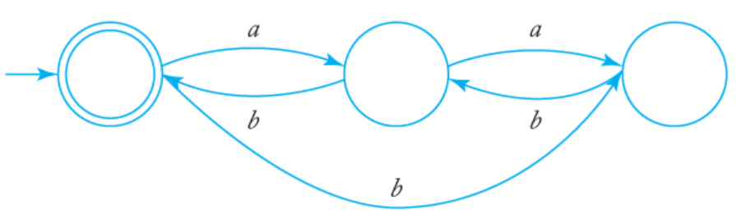  
{L(a)}

1. [10]

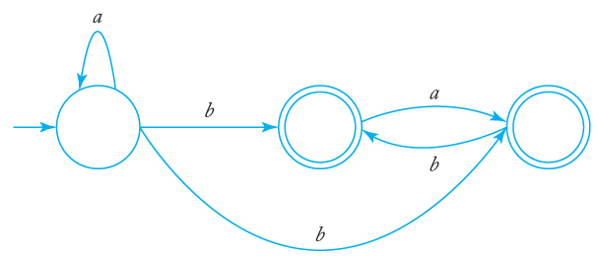

{a∗ba∗}

Q6. [10] Construct a ***DFA*** that accepts the language generated by the *grammar*

S → *ab*S | B, A → *a*B | *bb,* B → *ba*A.

Q7. [20] Find a ***regular grammar*** that generates the language on Σ={a, b}

1. [10] *L*(*aa*\*(*ab*+*a*)*)

G=(V;T;S;P),where

V={S;A;B};

T={a;b}

P={S!aA;A!aAjaBj;B!bA}

The derivation of a string aaaababa: S)aA)aaA)aaaA)aaaaB)aaaabA)aaaabaB)aaaababA)aaaababaA)aaaababa:

1. [10] the language consisting of all strings with no more than two *a*’s.

{(b+c)+(b+c)((a+aa)(b+c)+)(a+aa)(b+c)}