**RUMBA ROBOT**

**A PROJECT REPORT**

*submitted by*

**PEDAKOLIMI HARISH**

*In partial fulfilment for the award of the degree*

*of*

**BACHELOR OF TECHNOLOGY**

**In**



**DEPARTMENT OF MECHANICAL ENGINEERING**

**GANDHI INSTITUTE OF TECHNOLOGY AND MANAGEMENT**

**(DEEMED TO BE UNIVERSITY)**

**(Approved by AICTE & NAAC ‘A+’)**

**Gandhi Nagar, Rushikonda, Visakhapatnam, Andhra Pradesh DIST.(A.P.)**

**APRIL / JUNE of 2019**

**GANDHI INSTITUTE OF TECHNOLOGY AND MANAGEMENT**

**(DEEMED TO BE UNIVERSITY)**

**(Approved by AICTE & NAAC ‘A+’)**

**Gandhi Nagar, Rushikonda, Visakhapatnam, Andhra Pradesh DIST.(A.P.)**



**CERTIFICATE**

This is to certify that this project report entitled **“RUMBA ROBOT”** has been submitted by **PEDAKOLIMI HARISH** in partial fulfilment of the requirements for the award of “Bachelor of Engineering “in **MECHANICAL ENGINEERING** of **GITAM (DEEMED TO BE UNIVERSITY)**

is a record of bonafide work carried out under my guidance and supervision.

**HEAD OF THE DEPARTMENT MECHANICAL**  **PROJECT GUIDE**

**Dr. Narayana Rao S Mr Kunduru Ashok Reddy**

**Ph D B. TECH**

**SPECIMEN COVER PAGE**

**DESIGNING AND BUILDING ARDUINO UNO BASED OBSTACLE**

**AVOIDING ROBOT**

**RUMBA ROBOT**

**A PROJECT REPORT**

*Submitted by*

PEDAKOLIMI HARISH

*As an Intern Trainee of*

**INDUSTRIAL ROBOTICS**

**In**



**Centre of Excellence in Maritime and Shipbuilding – CEMS**

Visakhapatnam, (A.P.)

**APRIL / JUNE of 2019**

**ACKNOWLEDGEMENT**

I wish to express my profound and sincere gratitude to **Mr** **Kunduru Ashok Reddy, Mr Prasanna Kumar** who guided me into the intricacies of this project nonchalantly with matchless magnanimity.

I thank **Cdr. Gopi Krishna Sivvam (Retd.), COO/CEO** for extending their support during the Course of this investigation.

I am highly grateful to **GITAM** Management who evinced keen interest and invaluable support in the progress and successful completion of my project work.

I am indebted to **Dr. Narayana Rao S, Head of The Department Mechanical Engineering** for their constant encouragement, co-operation and help. Words of gratitude are not enough to describe the accommodation and fortitude which they have shown throughout my endeavour.

**PROJECT STUDENT**

**PEDAKOLIMI HARISH**

**TABLE OF CONTENTS**

**CHAPTER NO. TITLE PAGE NO.**

1. **CHAPTER-1 INTRODUCTION 9**

**1.1 ABOUT Arduino**

**1.2 ABOUT KUKA**

1. **CHAPTER-2 ABOUT RUMBA ROBOT 13**

**2.1 Technical requirements for the Robot to be achieve**

**2.2 Software used for the programming of the robot**

**2.3 CAD Design of the robot in 2D**

**3. CHAPTER-3 ASSEMBLY 16**

**3.1 Materials required for the robot**

**3.2 Assembly**

**3.3 Rumba robot program**

**3.4 Conclusion**

**3.5 References**

**ABSTRACT**

The 21st century is a century for robotics. Robots have long borne the potential to bridge the gap between the cybernetic world (the internet of things) and the physical world. As the most promising candidate to theme the next major industrial revolution succeeding the present third (digital) industrial revolution, robotics is set to play an ever increasingly important role in society for its influence in every aspect of life in Hong Kong, including medicine and healthcare, building service, manufacturing, food production, logistics and transportation.

The 21st century is also the century for Asia or greater China in particular. China has become the biggest and fastest-growing country in the global industrial robot market for its changing manufacturing environment and improving quality-of-living standards, with foreseeable demand of robots not only in the manufacturing industry but also other service and societal sectors. With its strong tradition in innovation and close ties to global research frontiers, Hong Kong currently holds a leading edge in sectors such as medical, logistics, and domestic service robots. However, with its sheer size, financial commitment, and strong industrial foundation, the Mainland is rapidly picking up speed, especially in the industrial and entertainment sectors. It is hence a critical moment for Hong Kong researchers to join efforts and form a critical mass in robotic research to maintain the regional, and towards global lead in service robotic research. Hong Kong researchers, working on the cutting-edge of robotics that is closely associated with the future economy of Hong Kong, have many top-level work for robotic surgical assistance, cell manipulation, manufacturing, and warehousing management, leading to highly translational and profitable outcomes that would help establish and thrive the Hong Kong unique industry in medical and service robots, complemented by a vast fabrication hub and grand market in the Mainland.

Intelligent service robots are currently being developed to cater to demands in emerging areas of robotic applications, ranging from entertainment to health care. These service robots are intended to be operated by non-expert users, and their service tasks involve direct interaction between these robots and their human users. Thus, human-friendly interactive features are generally preferred for such service robots. Humans prefer to use voice instructions, responses, and suggestions to convey ideas to their peers. However, the information conveyed through natural language communication is imprecise because it tends to contain uncertain/qualitative information instead of precise quantitative information. Therefore, the ability to cope with uncertain information in natural language instructions is mandatory for human-friendly service robots. This paper presents a review of service robots and systems that can cope with uncertain information in natural language instructions. The available literature has been investigated and analysed to identify the limitations of the existing methods and possible improvements. The identified limitations and possible improvements are presented as the outcomes of the review.

**List of Figures**

Fig 1.1 Arduino Uno 11

Fig 1.2 KUKA logo 12

Fig 2.1 The base plate of the robot 14

Fig 2.2 Sensor plate 15

Fig 2.2 Top plate 15

Fig 2.4 Motor clamps 15

Fig 3.1 Robot used for plasma cutting 17

Fig 3.2 Bottom plate assembly 18

Fig 3.3 middle plate assembly 19

Fig 3.4 Wiring 19

Fig 3.5 assembly after wiring 20

Fig 3.6 complete assembly 20

**Chapter-1**

INTRODUCTION

* 1. ABOUT Arduino
  2. ABOUT KUKA

**1.1 ABOUT Arduino**

Project Rumba Robot is based on **Arduino**, Arduino is an open-source hardware and software company, project and user community that designs and manufactures single-board microcontrollers and microcontroller kits for building digital devices and interactive objects that can sense and control both physically and digitally. Its products are licensed under the GNU Lesser General Public License (LGPL) or the GNU General Public License (GPL), permitting the manufacture of Arduino boards and software distribution by anyone. Arduino boards are available commercially in preassembled form or as do-it-yourself (DIY) kits.

Arduino board designs use a variety of microprocessors and controllers. The boards are equipped with sets of digital and analog input/output (I/O) pins that may be interfaced to various expansion boards or breadboards (*shields*) and other circuits. The boards feature serial communications interfaces, including Universal Serial Bus (USB) on some models, which are also used for loading programs from personal computers. The microcontrollers are typically programmed using a dialect of features from the programming languages C and C++. In addition to using traditional compiler toolchains, the Arduino project provides an integrated development environment (IDE) based on the Processing language project.

The Arduino project was started at the Interaction Design Institute Ivrea (IDII) in Ivrea, Italy. At that time, the students used a BASIC Stamp microcontroller at a cost of $50, a considerable expense for many students. In 2003 Hernando Barragán created the development platform *Wiring* as a Master’s thesis project at IDII, under the supervision of Massimo Banzi and Casey Reas. Casey Reas is known for co-creating, with Ben Fry, the Processing development platform. The project goal was to create simple, low-cost tools for creating digital projects by non-engineers. The Wiring platform consisted of a printed circuit board (PCB) with an ATmega168 microcontroller, an IDE based on Processing and library functions to easily program the microcontroller. In 2003, Massimo Banzi, with David Mellis, another IDII student, and David Cuartielles, added support for the cheaper Atmega8 microcontroller to Wiring. But instead of continuing the work on Wiring, they forked the project and renamed it, *Arduino*.

The initial Arduino core team consisted of Massimo Banzi, David Cuartielles, Tom Igoe, Gianluca Martino, and David Mellis, but Barragán was not invited to participate.

Following the completion of the Wiring platform, lighter and less expensive versions were distributed in the open-source community.

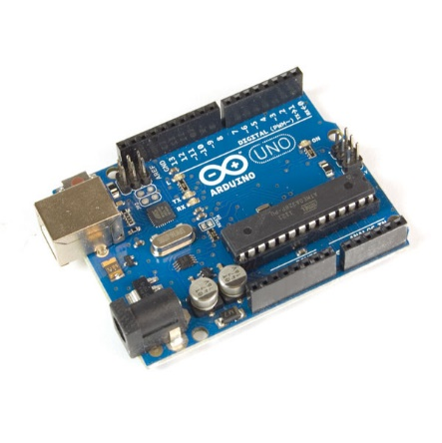

Fig 1.1 Arduino Uno

For the making of this Robot, we also used **KUKA KR16 R2010** Industrial Robot which was fitted with a plasma cutting tool from **Hypertherm.**

* 1. **ABOUT KUKA**

**KUKA** is a Chinese-owned manufacturer of industrial robots and solutions for factory automation. It is owned by Chinese company Midea Group.

The KUKA Robotics Corporation has 25 subsidiaries worldwide, mostly sales and service subsidiaries, including in the United States, Australia, Canada, Mexico, Brazil, China, Japan, South Korea, Taiwan, India, Russia and most European countries. The company name, KUKA, is an acronym for ***Keller und Knappich Augsburg***.

The company was founded in 1898 in Augsburg, Germany, by Johann Josef Keller and Jacob Knappich. At first, the company focused on house and street lights, but soon expanded to other products (welding equipment and solutions; big containers), to become the market leader in public vehicles in Europe by 1966. Keller & Knappich GmbH merged with part of Industrie-Werke Karlsruhe AG to become Industrie-Werke Karlsruhe Augsburg Aktiengesellschaft, eventually KUKA (Keller und Knappich Augsburg) for short.

In 1973, KUKA created its own industrial robot FAMULUS. At that time, the company belonged to the Quandt group. However, in 1980, the Quandt family withdrew and a publicly owned firm was established. In 1995, the company was split into KUKA Robotics Corporation and KUKA Schweißanlagen (now KUKA Systems), now both subsidiaries of KUKA AG. The company is a member of the Robotics Industries Association (RIA), of the International Federation of Robotics (IFR) and the German engineering association VDMA. Today, KUKA concentrates on solutions for the automation of industrial manufacturing processes.

In June 2016, Midea Group offered to buy Kuka for about €4.5 billion ($5 billion). Midea completed the takeover bid in January 2017 by taking 74.55% voting stake in the company.

Most robots are finished in “KUKA Orange” (the official corporate colour) or black.

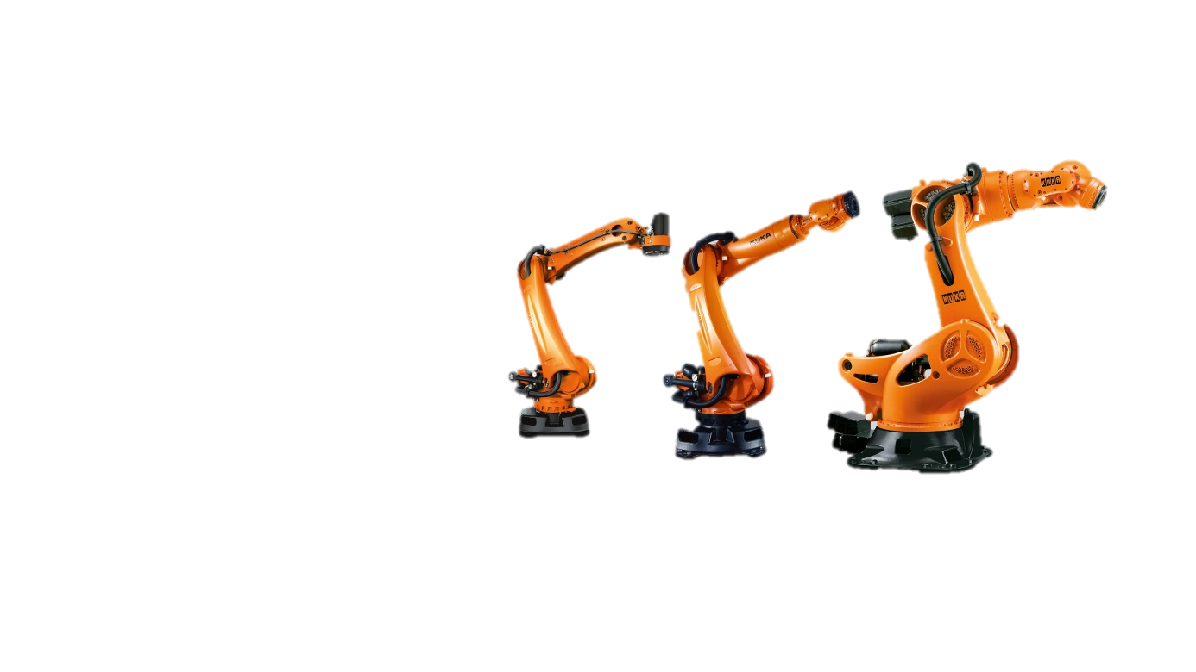 

Fig 1.2 KUKA logo

**Chapter-2**

ABOUT RUMBA ROBOT

2.1 Technical requirements for the Robot to be achieve

2.2 Software used for the programming of the robot

2.3 CAD Design of the robot in 2D

**2.1 Technical requirements for the Robot to be achieve**

1. The robot should carry payload up to 2 kg.
2. The robot speed should not exceed 100 rpm.
3. The ground clearance of the robot should more than 3 cm.
4. The robot should work for 1 hour continuously.
5. The robot should avoid obstacles.
6. It should work with Bluetooth and autonomously.
7. It should be lightweight.
8. The robot height can be under 50 cm.
9. The robot should cost under 7000₹.
10. It should be user-friendly.

**2.2 Software used for the programming of the robot**

1. Arduino IDE
2. MasterCam
3. Robotmaster

**2.3 CAD Design of the robot in 2D**

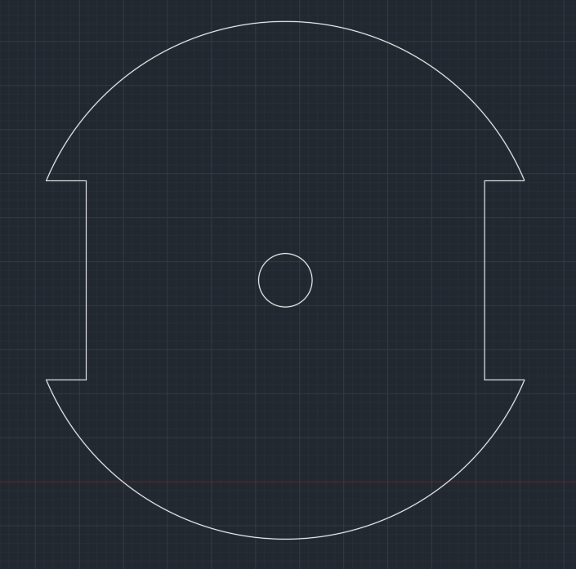

Fig 2.1 The base plate of the robot

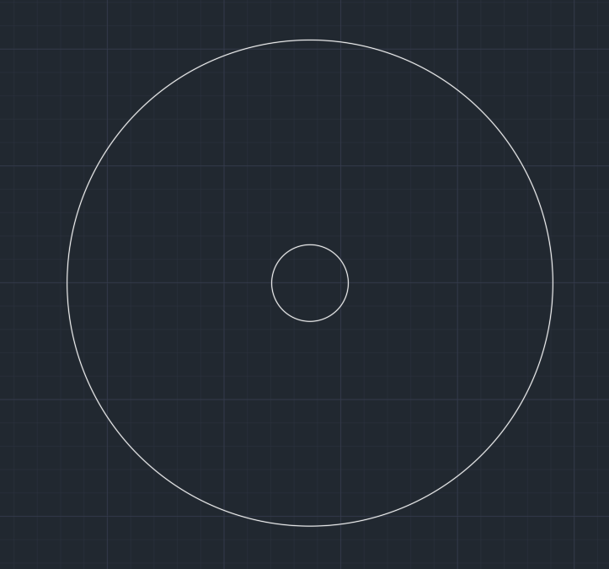

Fig 2.2 Sensor plate



Fig 2.2 Top plate

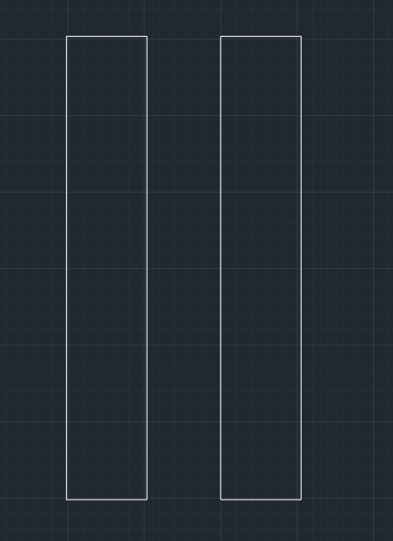

Fig 2.4 Motor clamps

**CHAPTER 3**

ASSEMBLY

3.1 Materials required for the robot

3.2 Assembly

3.3 Rumba robot program

3.4 CONCLUSION

3.5 REFERENCES

**3.1 Materials required for the robot**

1. Arduino Uno v3 x1
2. Motor 100rpm x2
3. Motor drive x1
4. Bluetooth HC-05 x1
5. Sensors x5
6. Breadboard x1
7. Wheels 9 cm x2
8. Caster wheels x2
9. Jump wires
10. Aluminium sheet
11. Screws, nuts and standoffs
12. Battery’s and holders

**3.2 Assembly**

After getting all the required material, now it’s time to cut the prices for the base, sensor and top plate using Kuka plasma cutting robot

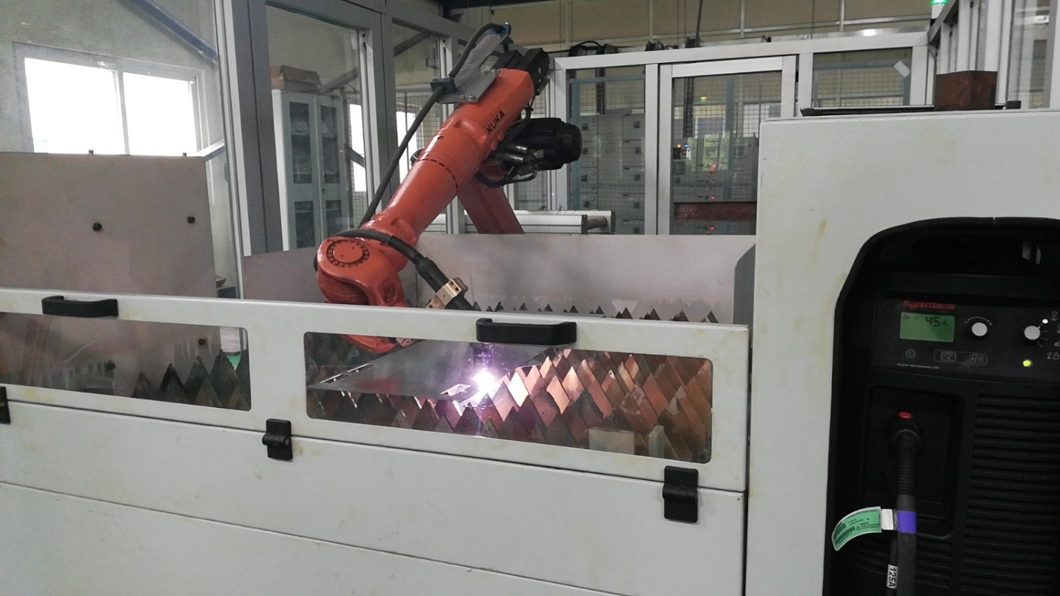

Fig 3.1 Robot used for plasma cutting

First, we have to assemble the base plate by drilling holes for the attaching clamps and supporters. This will also hold the batteries in place on top of the plate

It will look like the image given below.

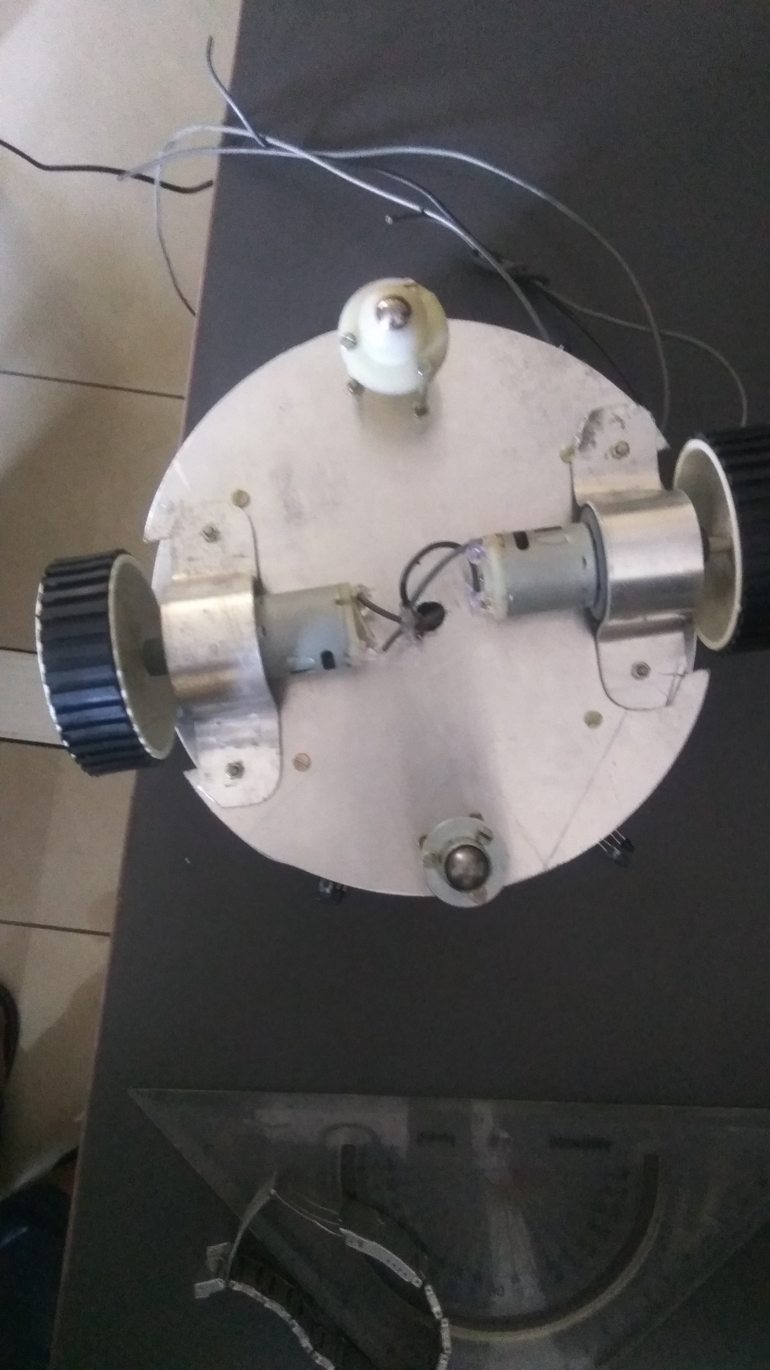

Fig 3.2 Bottom plate assembly

Then for the sensor plate, in which we will be adding 5 sensors, Arduino UNO and motor driver on it

Make sure to insulate the top of the plate with some transparent tape to avoid short circuit, by using double-sided tape stick sensors and other boards on to the plate. 3 sensors in the front and 2 on the back of the robot, HC-05 Bluetooth will be stick on the top plate’s back side.

After sticking it would look like this.

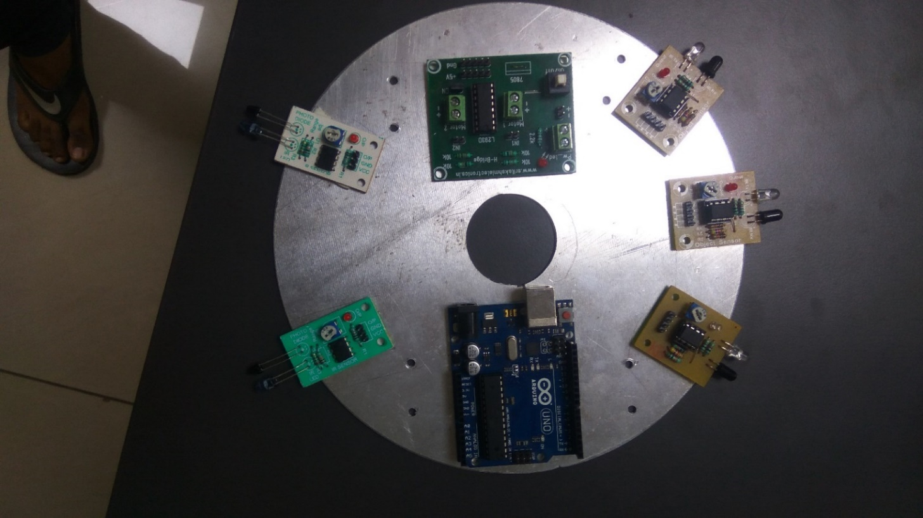

Fig 3.3 middle plate assembly

And the then comes the wiring part for the robot, do the wiring according to the diagram given below.

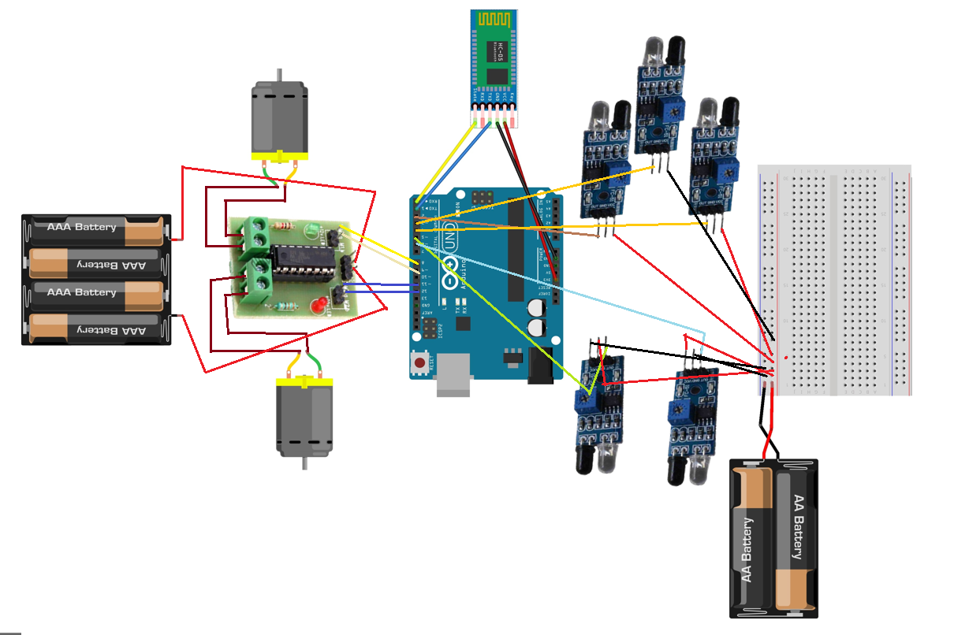

Fig 3.4 Wiring

After completing it will look like this.

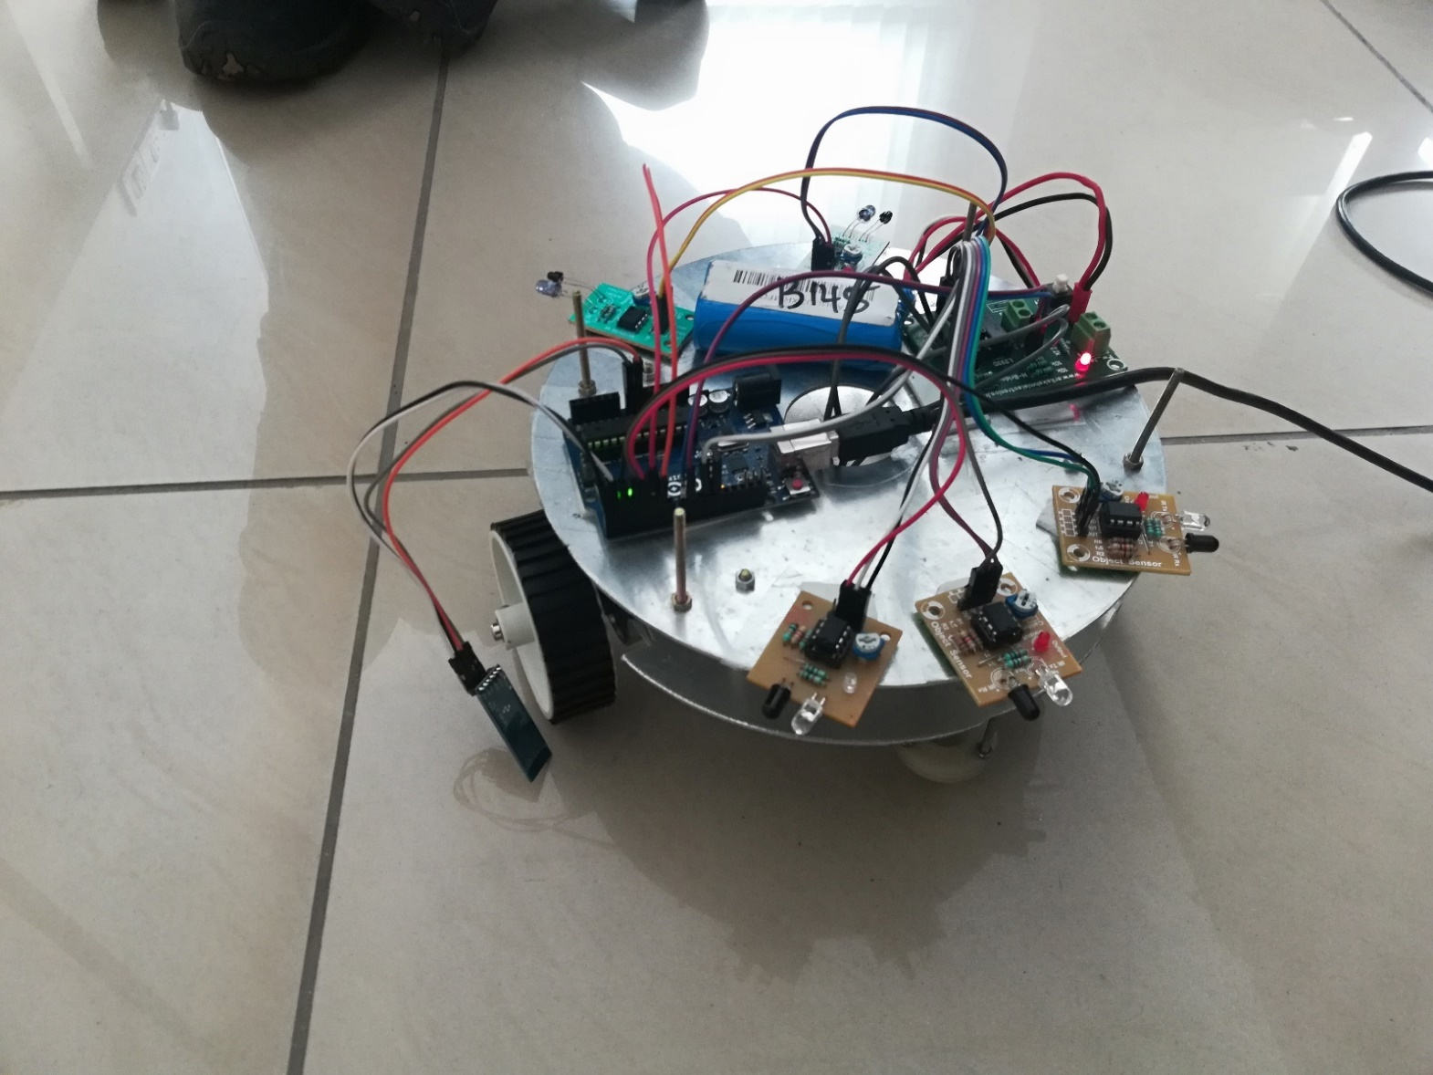

Fig 3.5 assembly after wiring

In the end, we have to assemble the top plate for the robot and tighten the whole robot so it won’t vibrate.

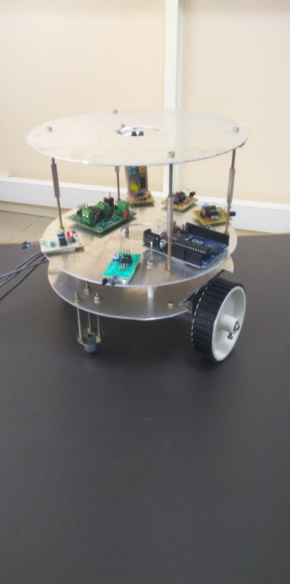 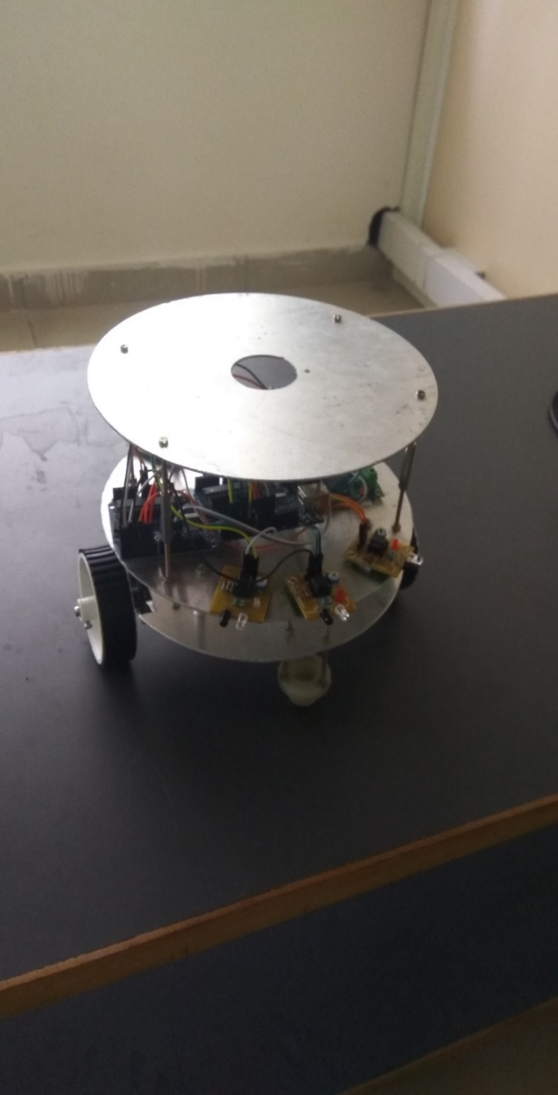

Fig 3.6 complete assembly

**3.3 Rumba robot program**

After the final assembles, we have to upload the program to the Arduino board you can get the program for the link given below.

<https://github.com/PedakolimiHarish/Rumba-Robot/blob/master/Rumba%20Robot>

After uploading the program to Arduino, download the app from the Play store or Appstore (any app which is related to Bluetooth Arduino) and pair it with your HC-05 whose password will be “1234” or “0000”

And the rumba robot is ready to use.

**3.4 CONCLUSION**

This robot is a services robot, like to carry weight or to bring something from one place to another. There are more advancements that can be done on this robot like attaching a camera or a digital screen or making it completing IoT(Internet of Thing) by which it can be operated from anywhere from the country or by using the camera we can teach it to recognize faces or thighs or places and many.

**3.5 REFERENCES**

Wikipedia