School of Computer Science and Artificial Intelligence

Lab Assignment # 6.5

Program : B. Tech (CSE)
Specialization :
Course Title : AI Assisted coding
Course Code :
Semester : II
Academic Session : 2025-2026
Name of Student : P Abhinav
Enrollment No. : 2403A51L38
Batch No. : 52
Date :23-01-2026

Task 1: Use an AI tool to generate eligibility logic.
Prompt: Generate Python code to check voting eligibility based on age and citizenship.
Code Screenshot:
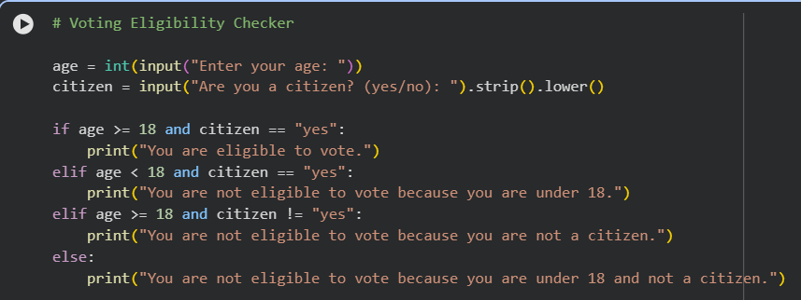
Code Output:
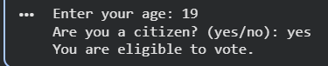
Code Explanation:
· This program checks whether a person is eligible to vote based on given conditions.

· It takes the input age from the user and converts it into an integer.
· It takes citizenship status as input and converts it into lowercase for uniform comparison.
· The main decision is made using an if-else conditional statement.
· The condition age >= 18 ensures the person is at least 18 years old.
· The condition citizen == "yes" ensures the person is a citizen.
· The logical operator and is used because both conditions must be true.
· If both conditions are true, the program prints that the person can vote.
· If either age is below 18 or citizenship is not yes, the else block executes.
· This produces a correct eligibility decision based on the combined conditions
Task 2: Use an AI tool to process strings using loops.
Prompt: Generate Python code to count vowels and consonants in a string using a loop.
Code Screenshot:
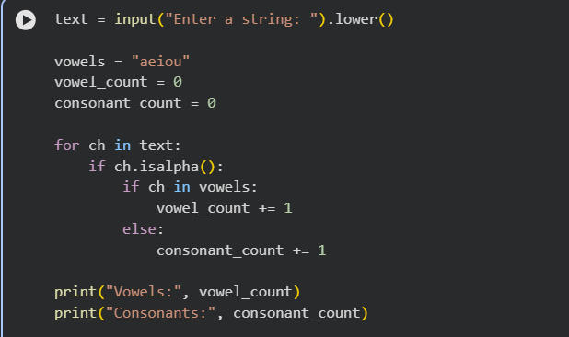
Output Screenshot:


Explanation:
· This program counts the number of vowels and consonants in a given string.
· The input string is converted to lowercase to simplify vowel checking.
· A variable vowels stores all vowel characters (a, e, i, o, u).
· Two counters vowel_count and consonant_count are initialized to zero.
· A for loop is used to traverse each character in the string.
· The condition ch.isalpha() ensures only alphabetic letters are counted.
· If the character is a letter and exists in the vowel set, vowel count is increased.
· Otherwise the character is treated as a consonant and consonant count increases.
· Numbers, spaces, and symbols are ignored because they are not alphabets.
· Finally, the program prints the total vowel and consonant counts correctly.
Task 3: Use an AI tool to generate a complete program using classes,
loops, and conditionals.
Prompt: Generate a Python program for a library management system using classes, loops, and conditional statements.
Code Screenshot:

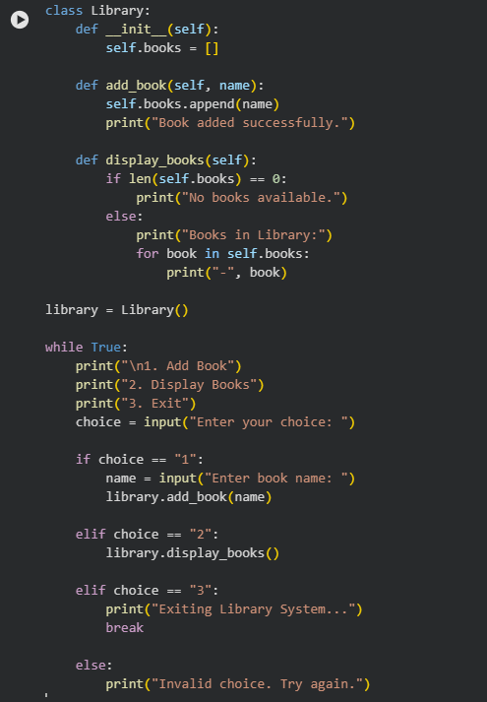
Output Screenshot:

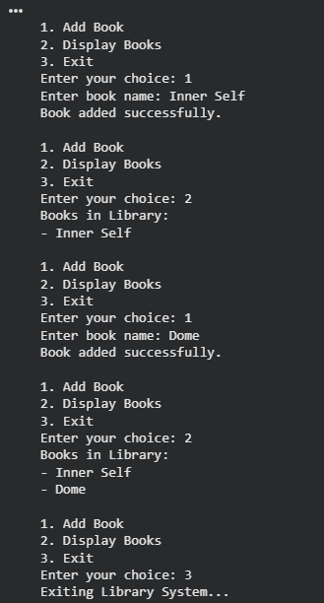
Explanation:
· This program simulates a simple library management system using Python.
· The Library class is created to store and manage books in the library.
· The constructor (__init__) initializes an empty list to store book names.
· The method add_book() adds a new book name into the list of books.
· The method display_books() prints all books currently available in the library.

· A condition checks whether the book list is empty before displaying books.
· A loop (while True) is used to repeatedly show the menu until the user exits.
· Conditional statements (if-elif-else) choose the correct operation from menu input.
· The program is interactive and allows multiple operations without restarting.
· This demonstrates usage of classes, loops, and conditions in one complete program.
Task 4: Use an AI tool to generate an attendance management class.
Prompt: Generate a Python class to mark and display student attendance using loops.
Code Screenshot:
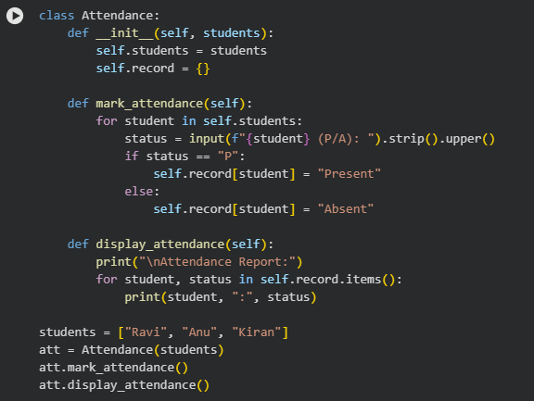
Code Output:

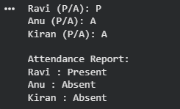
Explanation:
· This program builds an attendance management system using a Python class.
· The Attendance class accepts a list of students and stores it in self.students.
· Attendance status is stored in a dictionary self.record with student names as keys.
· The function mark_attendance() loops through each student one by one.
· For every student, it asks the user to enter P for Present or A for Absent.
· The input is converted to uppercase for correct comparison.
· A condition checks whether the entered status is "P" or not.
· If input is "P", it marks the student as Present, otherwise Absent.
· The display_attendance() function prints the final attendance list.
· This task shows AI-generated class logic with loop processing and conditions.
Task 5: Use an AI tool to complete a navigation menu.
Prompt: Generate a Python program using loops and conditionals
to simulate an ATM menu.
Explanation:
· This program simulates an ATM system using a menu-driven approach.
· The program starts with an initial account balance stored in balance.
· A while True loop keeps displaying the ATM menu until the user exits.
· The program provides options like check balance, deposit money, withdraw money, and exit.

· Conditionals (if-elif-else) are used to execute the correct option based on user choice.
· Option 1 displays the current balance directly.
· Option 2 accepts a deposit amount and adds it to the balance.
· Option 3 checks withdrawal amount using the condition amt <= balance.
· If sufficient balance exists, it deducts amount, otherwise prints insufficient balance.
· Option 4 exits the program using break, and invalid inputs are handled properly.
Code Screenshot:
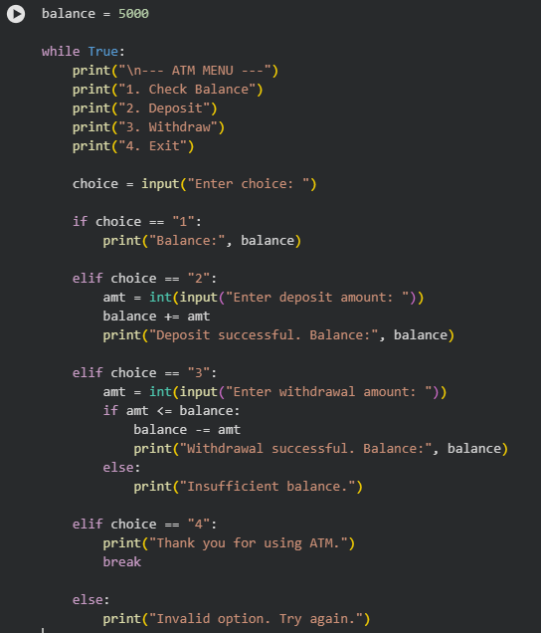

Code Output:
