School of Computer Science and Artificial Intelligence

Lab Assignment # 4.2

Program : B. Tech (CSE)
Specialization :
Course Title : AI Assisted coding
Course Code :
Semester : II
Academic Session : 2025-2026
Name of Student : P Abhinav
Enrollment No. : 2403A51L38
Batch No. : 52
Date :20-01-2026
#Task1
Write a python program for palindrome without using function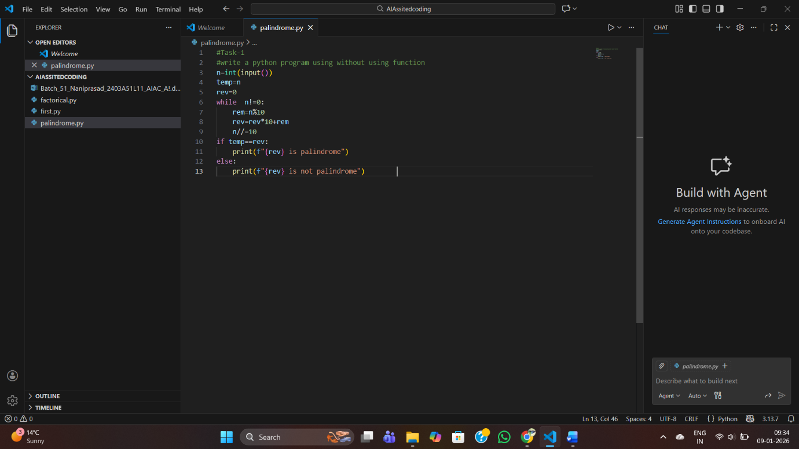
Output:
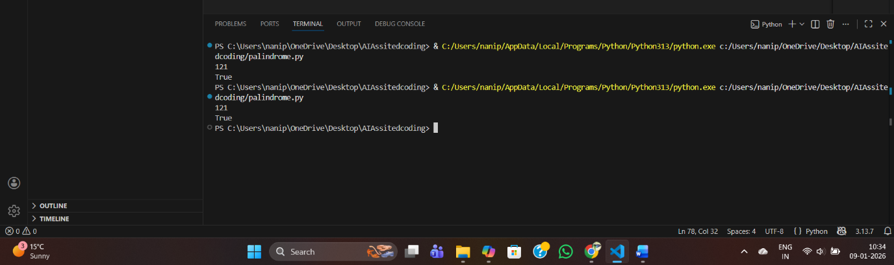
Palindrome check steps for the given code
- Read input:
  - Take an integer from the user and store it in n.
- Store original number:
  - Copy n into temp so you can compare later after reversing.
- Initialize reverse:
  - Set rev = 0. This will be built digit by digit into the reversed number.
- Loop until n becomes 0:
  - Keep extracting the last digit and removing it from n using integer division.
- Extract last digit:
  - rem = n % 10
  - This gives the rightmost digit of n.
- Append digit to reversed number:
  - rev = rev * 10 + rem
  - Shifts existing digits in rev left and adds the new last digit.
- Remove last digit from n:
  - n //= 10
  - Drops the rightmost digit from n to process the next one.
8. End of loop:
  - When n becomes 0, rev now holds the full reversed number.
9.Compare original with reversed:
  - If temp == rev, the original number reads the same backward → it’s a palindrome.
  - Otherwise, it’s not a palindrome.
10.Output result:
  - Print “rev is palindrome” if equal, else “rev is not palindrome”.
#Task2:
Write optimal solution for palindrome solution
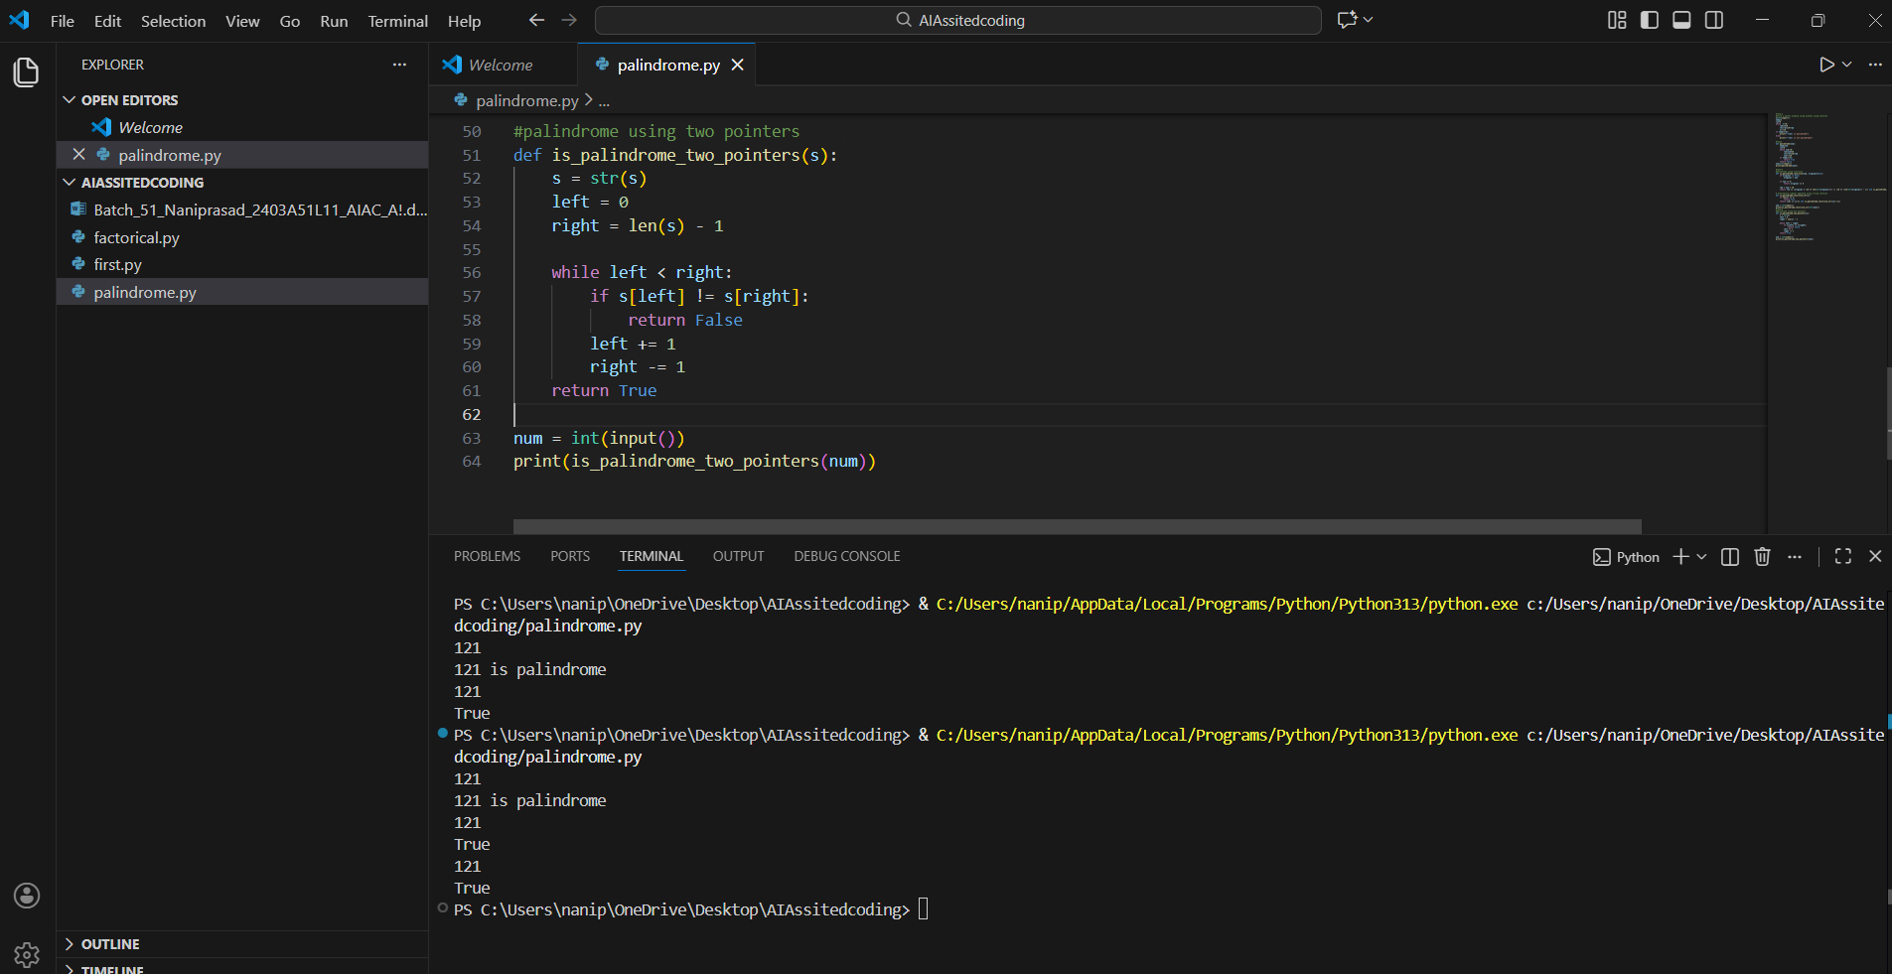
Output:
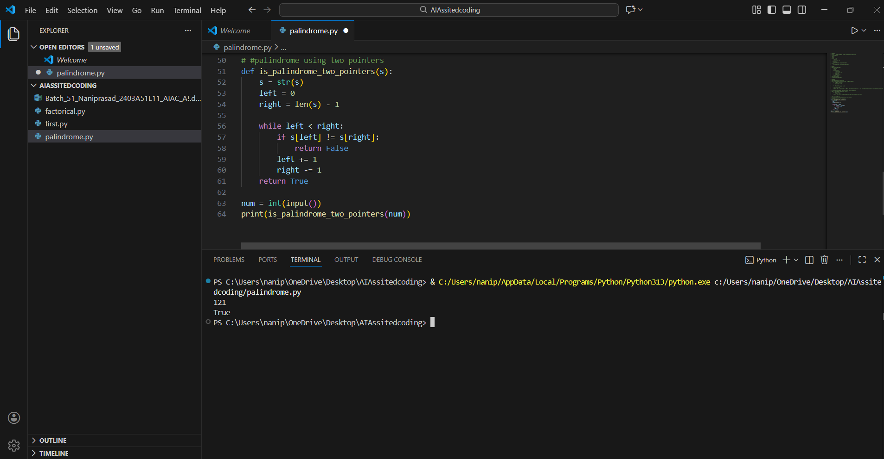
Explaination:
Create function
Pass the input with some value
In two pointer if last and first value are equal then
Last-=1
And first+=1
So if all index values are equal checking the last and first return True
If not return False
#Task 3
Write python program for palindrome using function
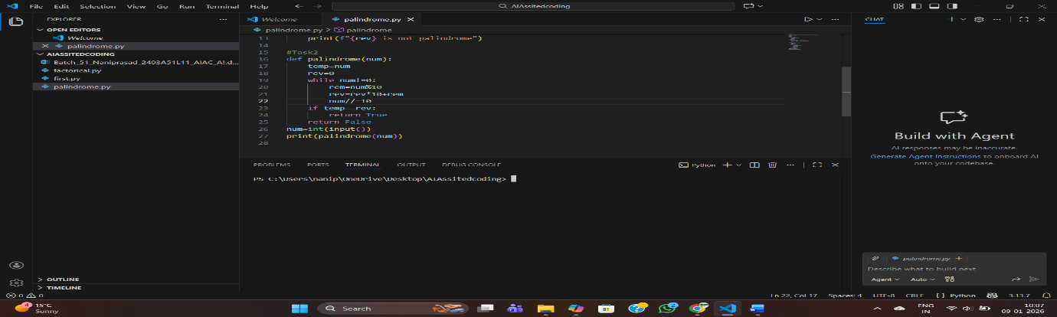

Output:
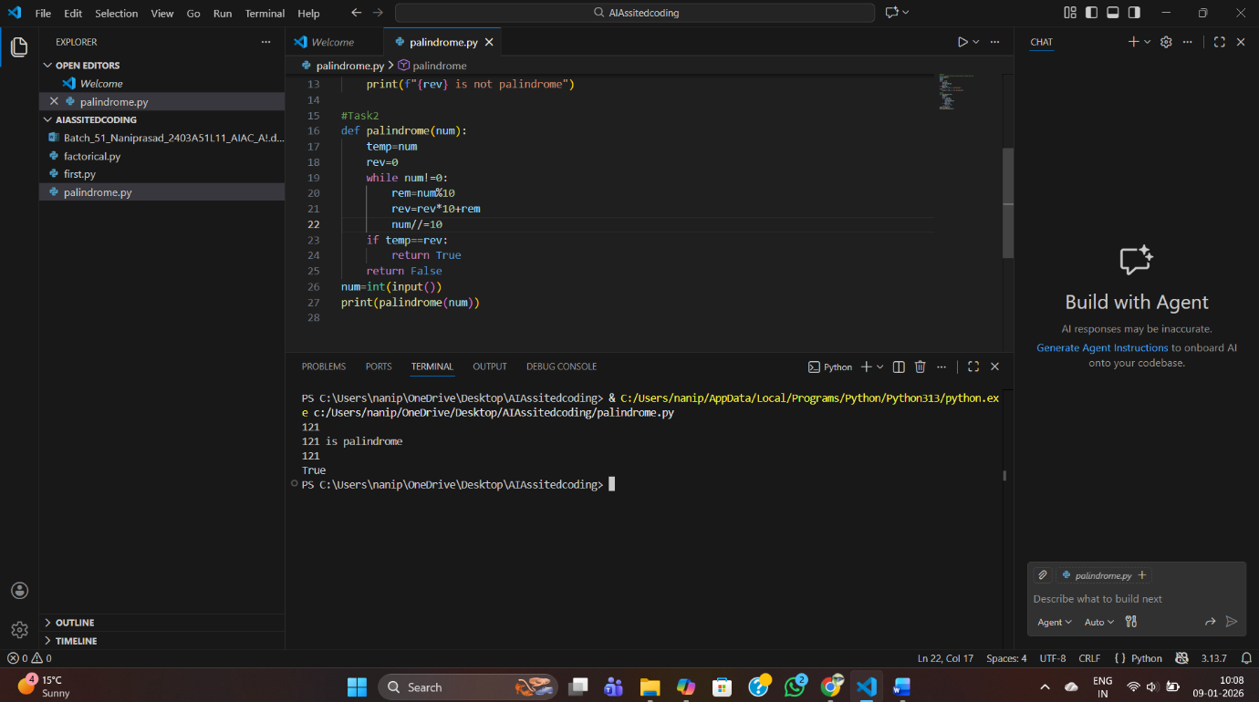
Explaination:
Step-by-Step Explanation
- Function Definition
  - def palindrome(num):
  - A function named palindrome is created that takes one argument num.
- Store Original Number
  - temp = num
  - The original number is stored in temp so we can compare later.
- Initialize Reverse
  - rev = 0
  - This variable will hold the reversed number.
- Loop to Reverse Number
  - while num != 0: → keep looping until num becomes 0.
  - Inside the loop:
  - rem = num % 10 → extract the last digit.
  - rev = rev * 10 + rem → build the reversed number digit by digit.
  - num //= 10 → remove the last digit from num.
- Check Palindrome
  - After the loop ends, rev contains the reversed number.
  - Compare temp (original number) with rev.
  - If they are equal → return True.
  - Otherwise → return False.
• Main Program
- num = int(input()) → take user input.
- print(palindrome(num)) → call the function and print the result (True or False).
Example Walkthrough
Suppose input is 121:
- temp = 121, rev = 0
- Loop:
  - Iteration 1: rem = 1, rev = 1, num = 12
  - Iteration 2: rem = 2, rev = 12, num = 1
  - Iteration 3: rem = 1, rev = 121, num = 0
- Loop ends → rev = 121
- Compare: temp == rev → 121 == 121 → True
- Output: True
If input is 123:
- Reverse becomes 321
- Compare: 123 != 321 → False
- Output: False
#Task4:
Write Python program with using function and without using function
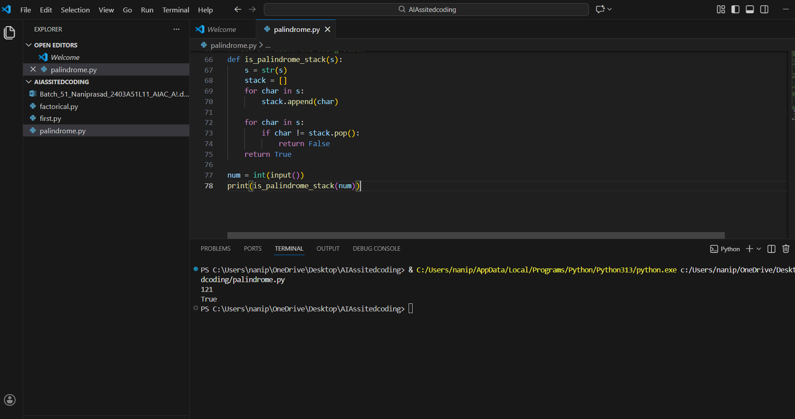
Output:
Step-by-Step
- Input: User enters a number → stored in n.
- Save original: temp = n keeps the original number safe.
- Reverse logic:
  - Extract last digit using rem = n % 10.
  - Build reversed number: rev = rev * 10 + rem.
  - Remove last digit: n //= 10.
  - Repeat until n becomes 0.
- Compare: If temp == rev, the number is palindrome.
- Output: Prints directly whether palindrome or not.
Step-by-Step
- Function defined: palindrome(num) encapsulates the logic.
- Inside function:
  - Store original number in temp.
  - Reverse the number using same loop logic.
  - Compare temp with rev.
  - Return True if palindrome, else False.
- Main program:
- Take input from user.
- Call the function: palindrome(num).
- Print the returned result (True or False).

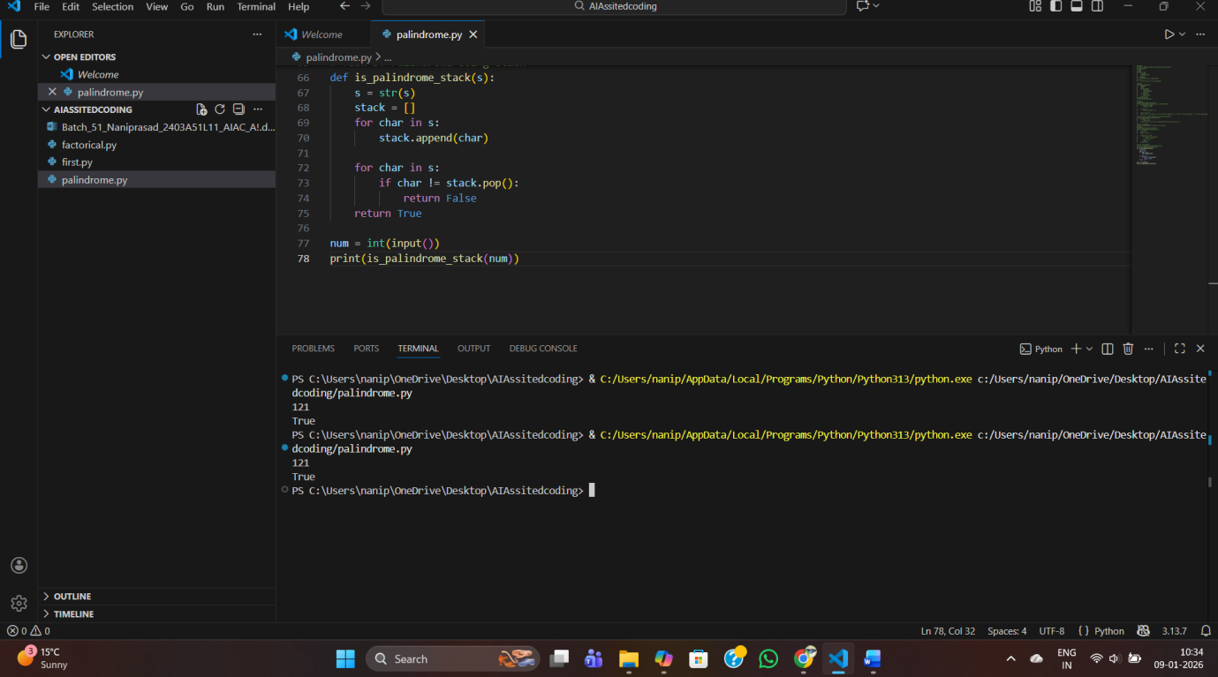

#Task5:
Write python program for palindrome using recursion
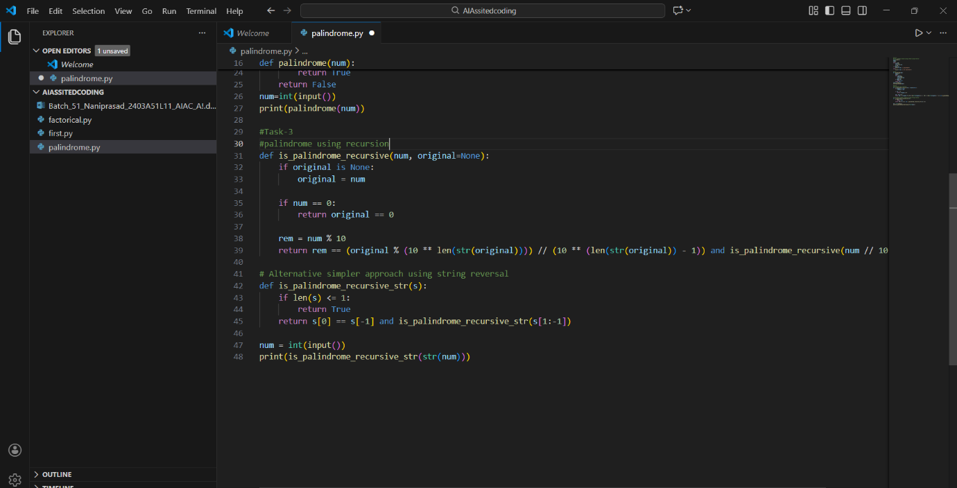

Output:
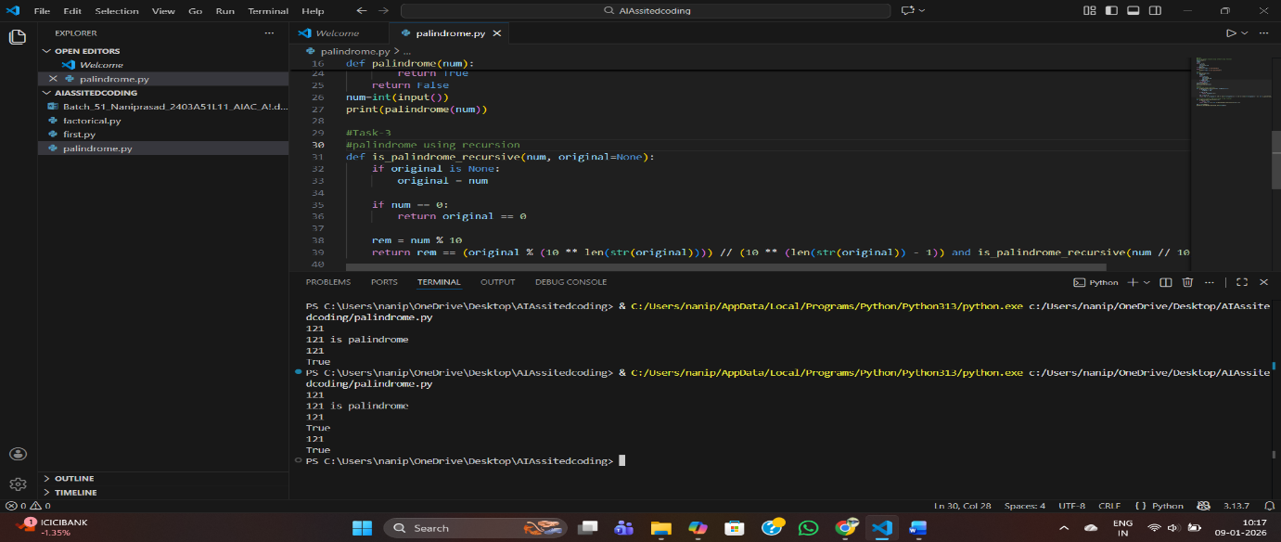
Step-by-Step Explanation
- Convert number to string
  - str(num) turns the input number into a string.
  - Example: if user enters 121, then s = "121".
- Recursive function logic
  - is_palindrome_recursive_str(s) checks if the string s is a palindrome.
3 Execution Example: Input = 121
  - s = "121"
  - Step 1: Compare "1" (first) and "1" (last) → equal → recurse on "2".
  - Step 2: "2" has length 1 → base case → return True.
  - Final result: True.

