

School of Computer Science and Artificial Intelligence
Lab Assignment # 2.2

Program | : B. Tech (CSE)
Specialization | :
Course Title | : AI Assisted coding
Course Code | :
Semester | : II
Academic Session | : 2025-2026
Name of Student | : P Abhinav
Enrollment No. | : 2403A51L38
Batch No. | : 52
Date | :013-01-2026

Task -1: Cleaning Sensor Data

Prompt : Generate a Python function that filters out all negative numbers from a list.

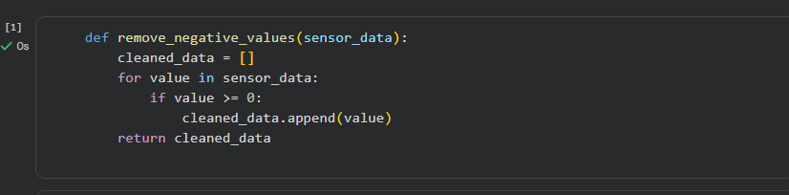

Output

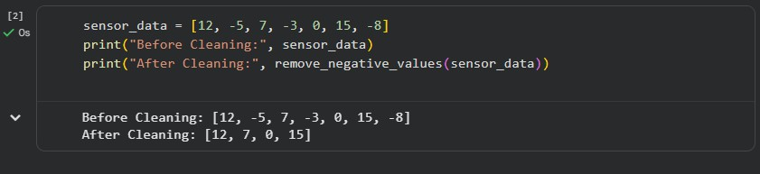

Code Explanation

The function checks each value in the list.

Negative values are ignored.

Only valid non-negative values are stored and returned.

Comments

Gemini generated correct and simple logic. The code is easy to understand and reusable.

Task 2: String Character Analysis

Prompt : Generate a Python function that counts vowels, consonants, and digits in a string.
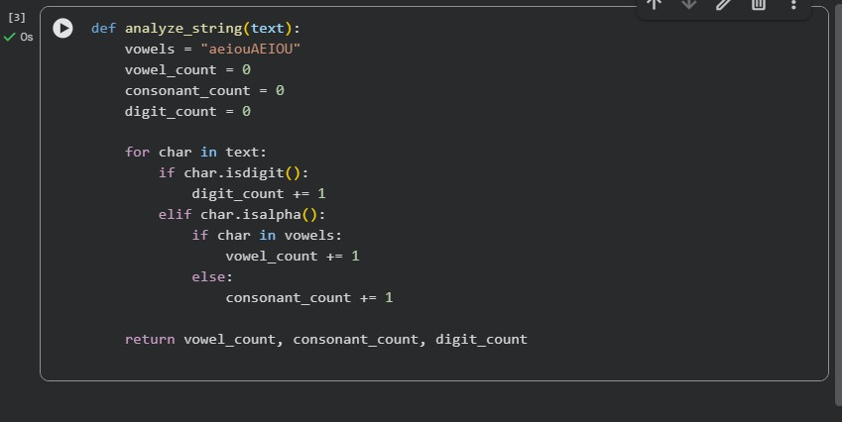

Output:
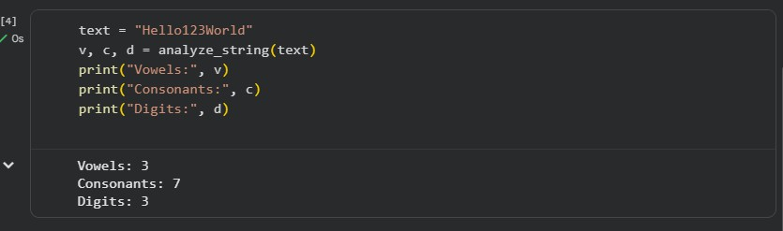

Code Explanation:

The function checks each character.

Digits, vowels, and consonants are counted separately.

Uses built-in string methods like isdigit() and isalpha().

Comments:

Gemini helped understand string handling. Code is well structured and efficient.
Task 3: Palindrome Check – Tool
Comparison Gemini Generated code
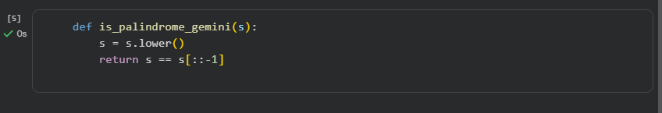

Copilot Generated Code:
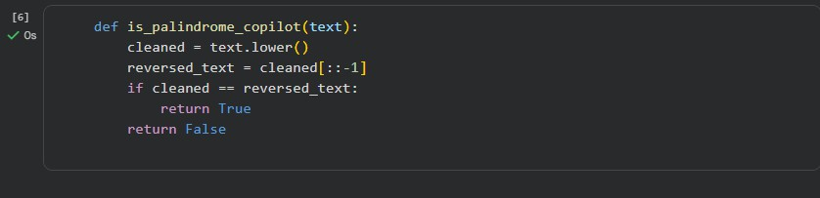

Code Explanation:

Both codes check whether a string reads the same forward and backward. Gemini uses a shorter, optimized approach.
Copilot uses step-by-step logic for better readability.

Comments:

Gemini is concise and fast.

Copilot is easier to understand for beginners.

Task 4: Code Explanation Using AI

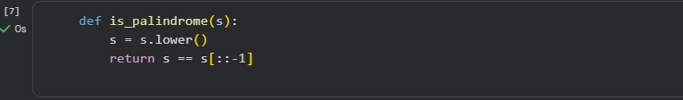

AI Explanation
- The function defines a palindrome check.

- Converts input to lowercase.

- Compares the string with its reversed version.

- Returns True or False.
Student Understanded:

Gemini clearly explained slicing ([::-1]). Helpful for quick code review.

Cursor AI – Explanation
What is Cursor AI?
- Cursor AI is an AI-powered code editor.

- It helps generate, refactor, and explain code.

- Useful for debugging and improving code quality.

Student Comments on Cursor AI
Good for editing large code files. Helpful in understanding existing code. Improves productivity.

Final Conclusion:
This lab helped me understand how AI tools like Gemini, Copilot, and Cursor AI assist in coding, explanation, and optimization. Each tool has its own strengths and improves learning efficiency.

