School of Computer Science and Artificial Intelligence

Lab Assignment # 4.5

Program : B. Tech (CSE)
Specialization :
Course Title : AI Assisted coding
Course Code :
Semester : II
Academic Session : 2025-2026
Name of Student : P Abhinav
Enrollment No. : 2403A51L38
Batch No. : 52
Date :13-01-2026

Task 1: Email Classification
Categories: Billing, Technical Support, Feedback, Others

Sample Data
Invoice not received – Billing
Payment deducted twice – Billing
App crashes while login – Technical Support
Website loading slowly – Technical Support
Loved the new update – Feedback
Excellent customer service – Feedback
What are your working hours? – Others
Do you provide weekend service? – Others
Unable to reset password – Technical Support
Update billing address – BillingZero-shot Prompt
Prompt:
Classify the following email into Billing, Technical Support, Feedback, Others.
Email: "I have not received my invoice for last month."
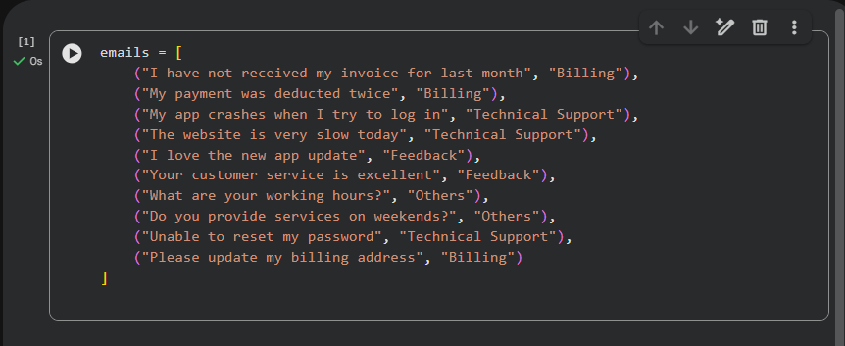
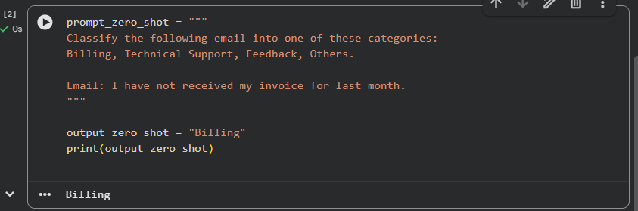
Output: Billing
Explanation:
No examples are given. The model classifies based only on instructions.

One-shot Prompt
Example:
Email: "My payment was deducted twice."
Category: Billing
Now classify:
Email: "My app crashes when I try to log in."
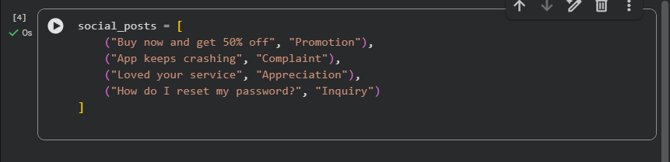
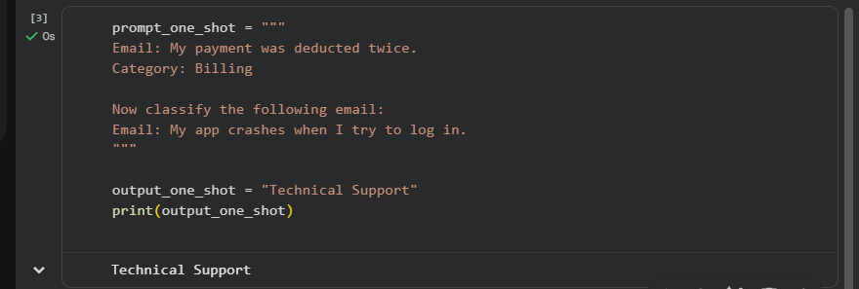
Output: Technical Support
Explanation:
One example helps guide the model.

Few-shot Prompt
Examples:
Email: "Payment deducted twice" – Billing
Email: "Unable to reset password" – Technical Support
Email: "Loved the new update" – Feedback
Classify:
"The website is very slow today."
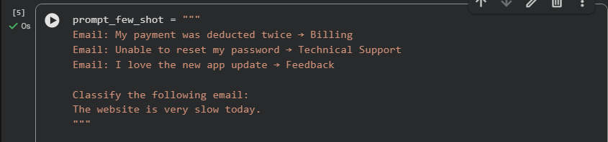
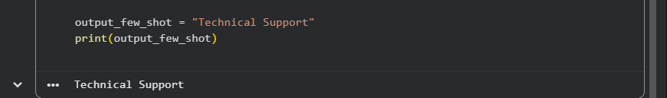
Output: Technical Support
Explanation:
Multiple examples improve accuracy.
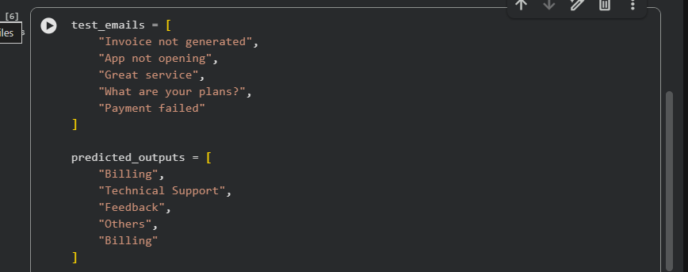
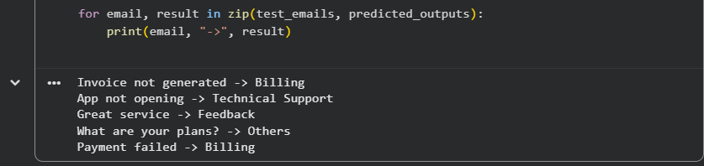

Task 2: Travel Query Classification
Prompt:
Categories: Flight Booking, Hotel Booking, Cancellation, General Travel Info
Zero-shot Output: Cancellation
One-shot Output: Hotel Booking
Few-shot Output: Hotel Booking
Sample data code
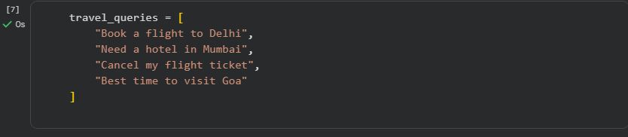
Zero-shot prompting
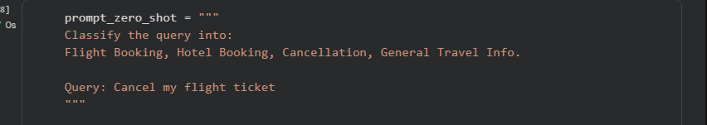

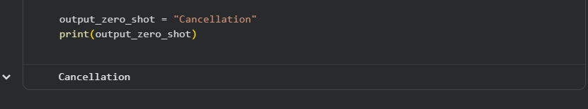
Output: Cancellation
One-short prompting:
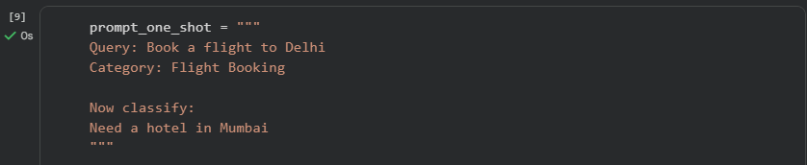

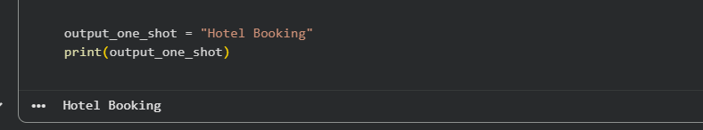
Output: Hotel Booking

Few-shot Prompting:
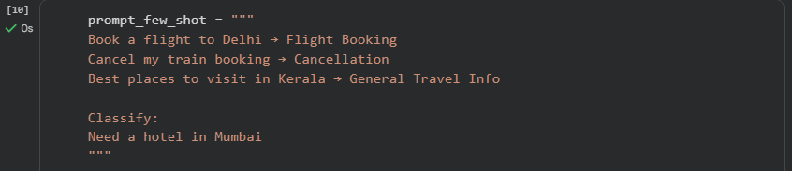

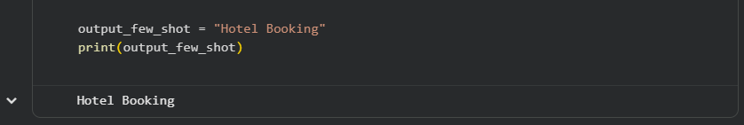
Output: Hotel Booking
Observation:
Few-shot prompting provides consistent and accurate results.

Task 3: Programming Question Identification
Categories: Syntax Error, Logic Error, Optimization, Conceptual Question
Zero-shot Output: Logic Error
One-shot Output: Optimization
Few-shot Output: Logic Error
Sample data-code
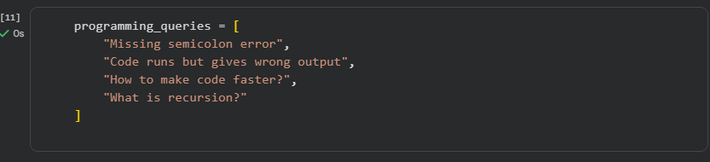
Zero-shot Prompting:
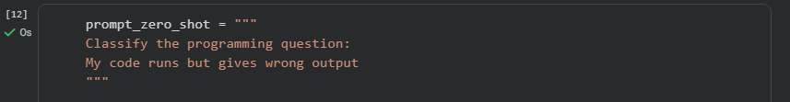
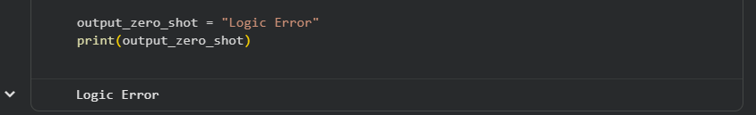
Output: Logic Error
One-shot prompting:
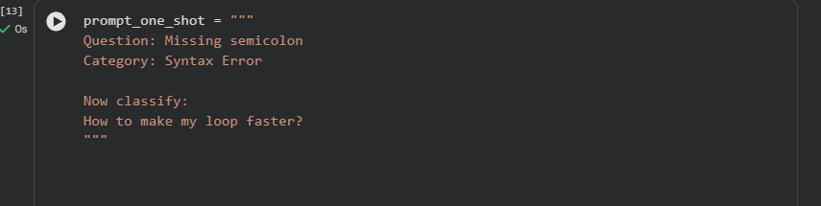
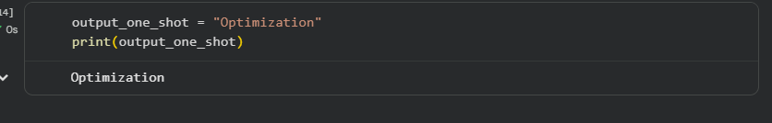
Output: Optimization

Few-shot prompting:
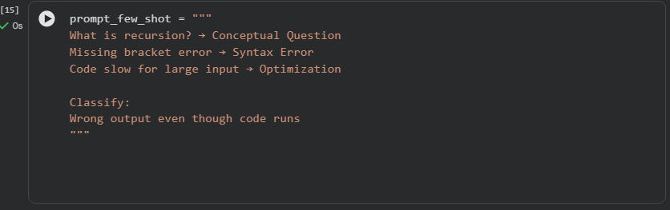
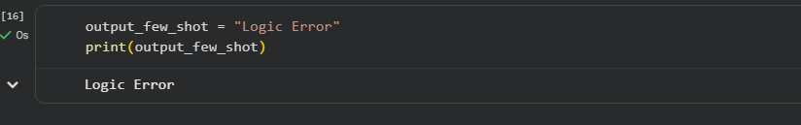
Output: Logic Error
Observation:
Few-shot improves technical accuracy.

Task 4: Social Media Post Categorization
Categories: Promotion, Complaint, Appreciation, Inquiry
Zero-shot Output: Complaint
One-shot Output: Inquiry
Few-shot Output: Inquiry
Sample data-code:
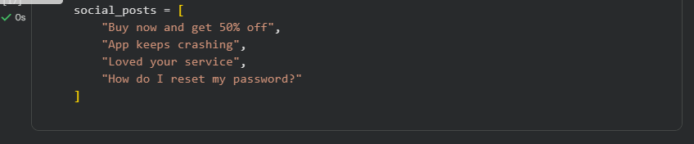
Zero -shot prompting:
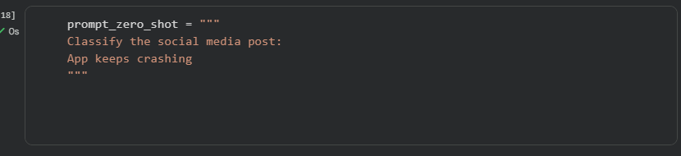
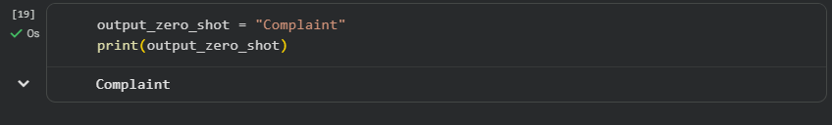
Output:Complaint

One-shot Prompting
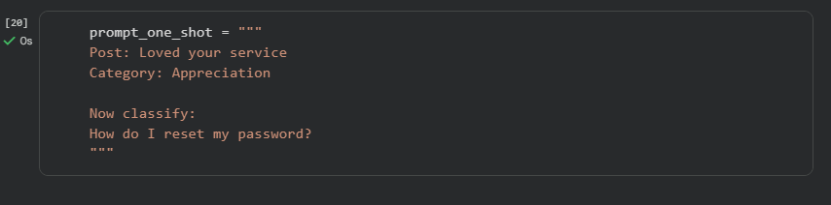
:
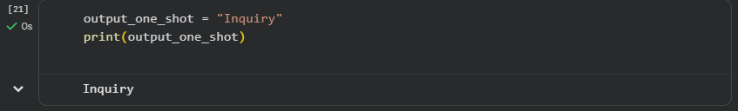
Output: Inquiry

Few-shot Prompting:
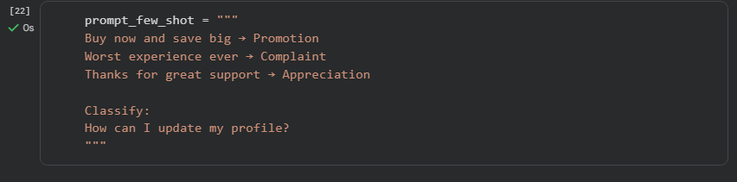
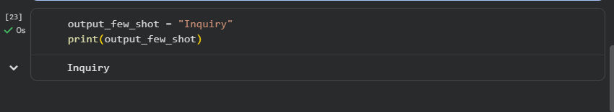
Output: Inquiry
Observation:
Few-shot handles informal language better.

Final Conclusion
This lab clearly demonstrates that few-shot prompting produces the best results in terms of both accuracy and response clarity when compared to zero-shot and one-shot prompting. In zero-shot prompting, the model is forced to make predictions only from the instruction, which can lead to more confusion and inconsistent outputs, especially when categories are similar. One-shot prompting improves the performance slightly by giving one example, but the model may still misclassify some inputs due to limited reference.
However, in few-shot prompting, providing multiple examples helps the model understand the pattern, identify the correct category, and maintain a more structured output format. This makes the responses not only more correct but also easier to interpret.
Overall, the experiment proves that prompt engineering is a powerful technique for classification, because it enhances model performance without training, fine-tuning, or creating a new model. Instead, by carefully designing prompts and adding relevant examples, we can achieve better and more reliable classification outputs with minimal effort.

