- a.Kantor utama-penjualan
! Konfigurasi di 'kantor-penjualan-1'
Switch> enable
Switch# configure terminal
Switch(config)# vlan 10
Switch(config-vlan)# name PENJUALAN
Switch(config-vlan)# exit

! Masukkan semua port (ke PC, ke router, ke switch-2) ke VLAN 10
Switch(config)# interface range FastEthernet0/1-24
Switch(config-if-range)# switchport mode access
Switch(config-if-range)# switchport access vlan 10
Switch(config-if-range)# exit
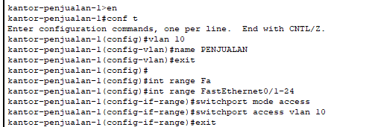

! Konfigurasi di 'kantor-penjualan-2'
Switch> enable
Switch# configure terminal
Switch(config)# vlan 10
Switch(config-vlan)# name PENJUALAN
Switch(config-vlan)# exit

! Masukkan semua port (ke PC dan ke switch-1) ke VLAN 10
Switch(config)# interface range FastEthernet0/1-24
Switch(config-if-range)# switchport mode access
Switch(config-if-range)# switchport access vlan 10
Switch(config-if-range)# exit
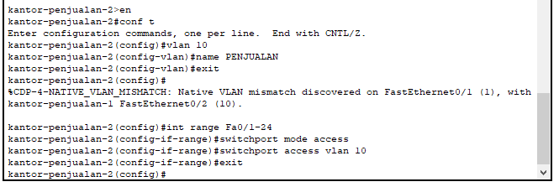

! Konfigurasi di router 'ruang kantor utama'
Router> enable
Router# configure terminal
Router(config)# interface Eth0/3/0
Router(config-if)# ip address 192.168.10.1 255.255.255.192
Router(config-if)# no shutdown
Router(config-if)# exit
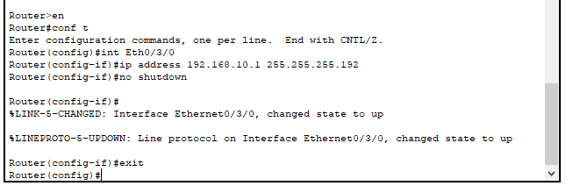
! Konfigurasi di router 'ruang kantor utama'
Router(config)#
! --------- DHCP UNTUK PENJUALAN (VLAN 10) ---------
Router(config)# ip dhcp pool PENJUALAN
Router(dhcp-config)# network 192.168.10.0 255.255.255.192
Router(dhcp-config)# default-router 192.168.10.1
Router(dhcp-config)# exit
Router(config)# ip dhcp excluded-address 192.168.10.1
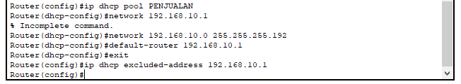
1.b sdm
Switch> enable
Switch# configure terminal
Switch(config)# vlan 20
Switch(config-vlan)# name SDM
Switch(config-vlan)# exit
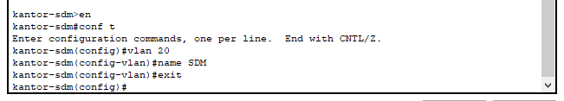

! Masukkan semua port (ke PC dan ke router) ke VLAN 20
Switch(config)# interface range FastEthernet0/1-24
Switch(config-if-range)# switchport mode access
Switch(config-if-range)# switchport access vlan 20
Switch(config-if-range)# exit
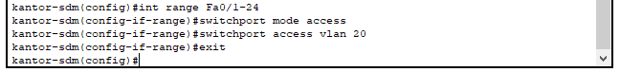

! --------- KONFIGURASI INTERFACE SDM (VLAN 20) ---------
Router(config)# interface Fa1/1
Router(config-if)# ip address 192.168.10.65 255.255.255.224
Router(config-if)# no shutdown
Router(config-if)# exit
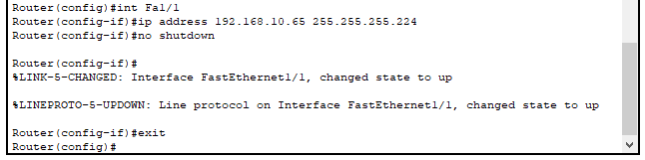
Router(config)# ip dhcp pool SDM
Router(dhcp-config)# network 192.168.10.64 255.255.255.224
Router(dhcp-config)# default-router 192.168.10.65
Router(dhcp-config)# exit
Router(config)# ip dhcp excluded-address 192.168.10.65
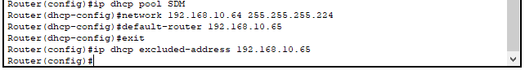

- Router-Ruang Server, switch kantor-it
Switch> enable
Switch# configure terminal
Switch(config)# vlan 30
Switch(config-vlan)# name IT
Switch(config-vlan)# exit
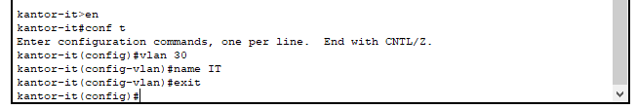

! Masukkan semua port (ke PC dan ke router) ke VLAN 30
Switch(config)# interface range FastEthernet0/1-24
Switch(config-if-range)# switchport mode access
Switch(config-if-range)# switchport access vlan 30
Switch(config-if-range)# exit
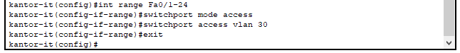
! Konfigurasi di router 'ruang server'
Router(config)#
! --------- KONFIGURASI INTERFACE IT (VLAN 30) ---------
Router(config)# interface Fa1/1
Router(config-if)# ip address 192.168.10.97 255.255.255.224
Router(config-if)# no shutdown
Router(config-if)# exit
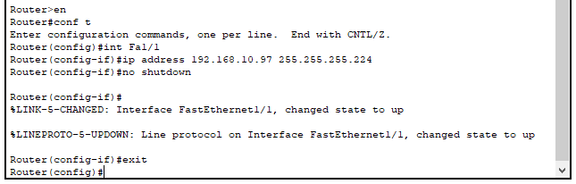
! --------- DHCP UNTUK IT (VLAN 30) ---------
Router(config)# ip dhcp pool IT
Router(dhcp-config)# network 192.168.10.96 255.255.255.224
Router(dhcp-config)# default-router 192.168.10.97
Router(dhcp-config)# exit
Router(config)# ip dhcp excluded-address 192.168.10.97
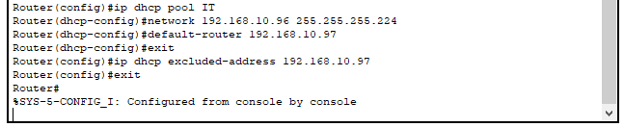

- Ruang gudang
Switch> enable
Switch# configure terminal
Switch(config)# vlan 40
Switch(config-vlan)# name GUDANG
Switch(config-vlan)# exit
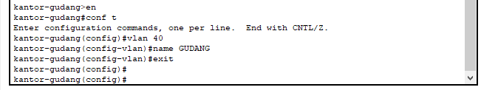

! Masukkan semua port (ke PC dan ke router) ke VLAN 40
Switch(config)# interface range FastEthernet0/1-24
Switch(config-if-range)# switchport mode access
Switch(config-if-range)# switchport access vlan 40
Switch(config-if-range)# exit
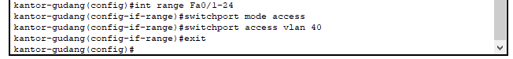

! Konfigurasi di router 'ruang gudang'
Router(config)#
! --------- KONFIGURASI INTERFACE GUDANG (VLAN 40) ---------
Router(config)# interface Fa1/1
Router(config-if)# ip address 192.168.10.129 255.255.255.240
Router(config-if)# no shutdown
Router(config-if)# exit
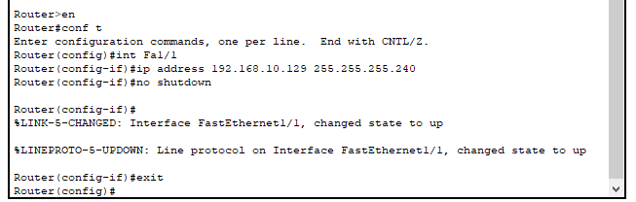

! --------- DHCP UNTUK GUDANG (VLAN 40) ---------
Router(config)# ip dhcp pool GUDANG
Router(dhcp-config)# network 192.168.10.128 255.255.255.240
Router(dhcp-config)# default-router 192.168.10.129
Router(dhcp-config)# exit
Router(config)# ip dhcp excluded-address 192.168.10.129
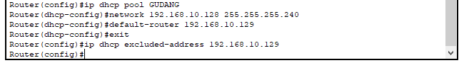

- Ruang Manajemen
Switch> enable
Switch# configure terminal
Switch(config)# vlan 50
Switch(config-vlan)# name MANAJEMEN
Switch(config-vlan)# exit
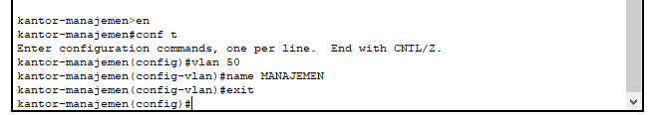
! Masukkan semua port (ke PC dan ke router) ke VLAN 50
Switch(config)# interface range FastEthernet0/1-24
Switch(config-if-range)# switchport mode access
Switch(config-if-range)# switchport access vlan 50
Switch(config-if-range)# exit
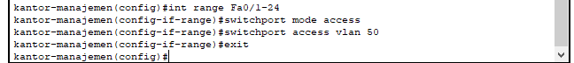

! Konfigurasi di router 'ruang manajemen'
Router(config)#
! --------- KONFIGURASI INTERFACE MANAJEMEN (VLAN 50) ---------
Router(config)# interface Fa1/1
Router(config-if)# ip address 192.168.10.145 255.255.255.224
Router(config-if)# no shutdown
Router(config-if)# exit
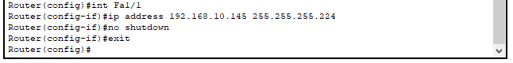

! --------- DHCP UNTUK MANAJEMEN (VLAN 50) ---------
Router(config)# ip dhcp pool MANAJEMEN
Router(dhcp-config)# network 192.168.10.144 255.255.255.224
Router(dhcp-config)# default-router 192.168.10.145
Router(dhcp-config)# exit
Router(config)# ip dhcp excluded-address 192.168.10.145
