

Website Evidence Collection

https://elpais.com

Evidence collection organisation
Target web service | https://elpais.com
Automated evidence collection end time | 21/07/2026, 21:27:13
Software version | v3.10.0-92-g9957bbe

Automated evidence collection
The automated evidence collection is carried out using the tool website evidence collector, WEC (also on Code Europa EU) in version v3.10.0-92-g9957bbe on the platform Linux in version 6.8.0-124-generic. The tool employs the browser Chromium in version Chrome/145.0.7632.77 for browsing the website.
The evidence collection tool simulates a browsing session of the web service, capturing traffic between the browser and the Internet, along with any persistent data stored in the browser. While browsing, the tool gathers evidence and performs a number of checks.
It captures screenshots from the browser to identify potential cookie banners. It also tests HTTPS/SSL usage to determine whether the website enforces a secure connection. Then, the evidence collection tool scans the first web page for links to common social media and collaboration platforms, gathering data on the overall use of potentially privacy-intrusive third-party web services.
The recorded traffic between the browser, the target web service, and involved third-party web services, as well as the browser’s persistent storage, will be analysed in a subsequent section.
Generally, the tool browses a random subset of the target web service pages starting from the initial web page. However, the browsing can also include a set of predefined web pages. The exhaustive list of browsed web pages for this specific evidence collection is given in the Annex: Browsing history.

Web page visit

On 21/07/2026, 21:26:58, the evidence collection tool navigated the browser to
https://elpais.com
. The final location after potential redirects was
https://elpais.com/
. The evidence collection tool took two screenshots
to cover the top of the web page
and
the bottom
.
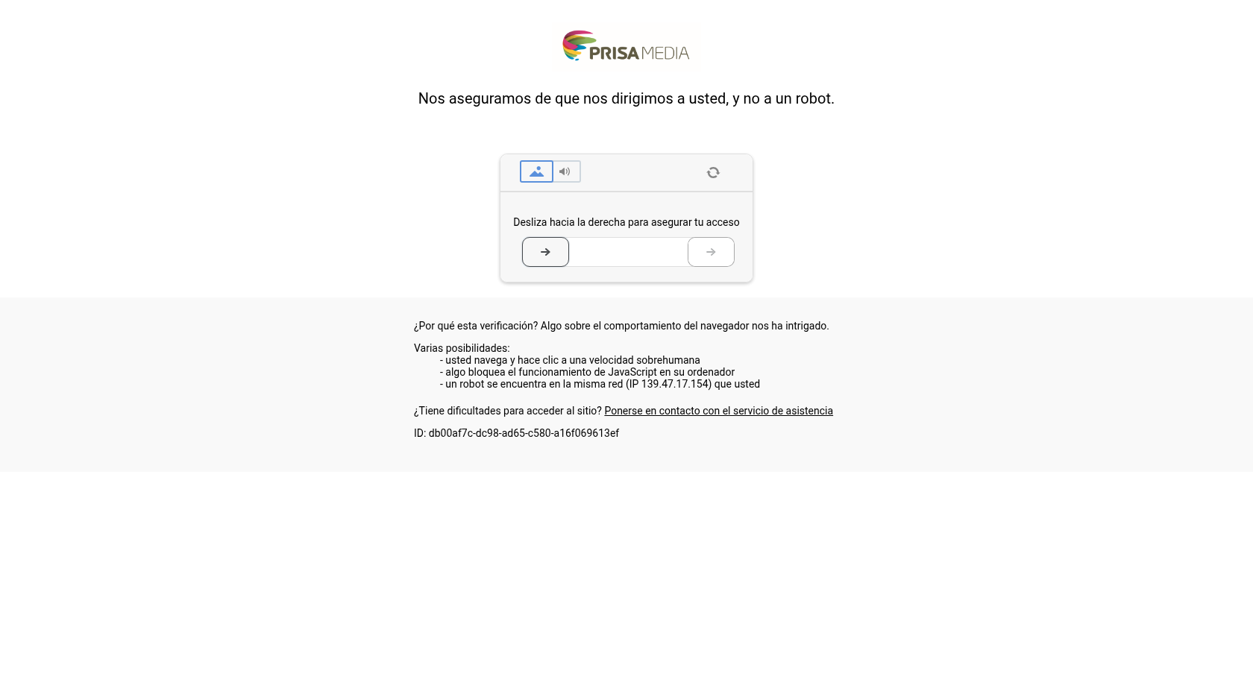

Use of HTTPS/SSL
HTTP (Hypertext Transfer Protocol) is a communication standard that transmits data between a website and a user’s browser in an unencrypted format, making it vulnerable to interception and eavesdropping. In contrast, HTTPS (Hypertext Transfer Protocol Secure) extends HTTP by adding an extra layer of security through encryption, which protects the confidentiality and integrity of the data exchanged between a website and a user’s browser.
The evidence collection tool assessed the behaviour of elpais.com with respect to the use of HTTPS.
Allows connection with HTTPS | false
HTTP redirect to HTTPS
Error when connecting with HTTP | HTTPError: Request failed with status code 403 (Forbidden): GET http://elpais.com/
Error when connecting with HTTPS | HTTPError: Request failed with status code 403 (Forbidden): GET https://elpais.com/

Use of content security policies (CSPs)
Upon a browser's request for a web page, websites can specify a whitelist of mechanisms, domains, and subdomains in the Content Security Policy (CSP) metadata sent along with the requested page. Browsers must respect this whitelist when embedding components such as styles, fonts, beacons, videos, and maps.
No CSP metadata related to first-party URLs was found.
No third-party content security policy hosts were whitelisted.

Use of social media and collaboration platforms
The website evidence collection tool found links from https://elpais.com/ to the following common social media and collaboration platforms.
No corresponding links were found.

Traffic and persistent data analysis
First, the browser visited https://elpais.com/. The evidence collection navigated and collected evidence from no additional web service page(s).
The web page(s) were browsed consecutively between 21/07/2026, 21:26:58 and 21/07/2026, 21:27:13.
During the browsing, the HTTP Header Do Not Track was not set.
For the subsequent analysis, the following URLs (hosts with their paths) were defined as first-party:
- elpais.com

Traffic analysis
In the case of a visit to a very simple web page with a given URL (e.g. http://example.com/home.html), the browser sends a request to the web server configured for the domain specified in the URL (e.g. example.com). The web server, also called the host, then sends a response in the form of, e.g. an HTML file (e.g. the home.html file), which the browser downloads and displays. Most web pages nowadays are more complex and include content such as images, videos, and fonts, or embed elements like maps, tweets, and comments. To assemble and show the whole web page, the browser sends further requests to the same host (first-party) or even different hosts (potentially third-party) to download the required content. A web page is often composed of dozens of elements, and due to the complexity of website architecture, website administrators are often not fully aware of all third parties involved in the functioning of their websites.
The evidence collection tool extracted lists of distinct first- and third-party hosts from the browser requests recorded in each browsing session (with DNT signal set and without). These lists are presented below and aim to help by providing a comprehensive overview of all the hosts from which the browser requests elements. Note that subdomains (e.g. admin.example.com) of first-party domains (example.com) are, by default, considered third-party domains, whereas all URLs in the path (e.g. example.com/anysubpage) are treated as first-party by the automated evidence collection tool. More information about hosts and the distinction between first-party and third-party can be found in the glossary in the Annex: Glossary.
A number of techniques allow hosts to track browsing behaviour. A first-party host may instruct the browser to send requests solely for the purpose of providing information embedded in the request (e.g. cookies) to a given first-party or third-party host. These requests are often responded to with an empty file or a 1x1 pixel image. Such files requested for tracking purposes are commonly referred to as web beacons.
The evidence collection tool compares all requests against signature lists compiled to detect potential web beacons or annoyances such as in-page pop-ups. Positive matches with the lists EasyPrivacy (easyprivacy.txt) and Fanboy’s Annoyance (fanboy-annoyance.txt) from https://easylist.to are presented in the Annex: All potential web beacons. The list of web beacon hosts contains hosts of those requests that match the signature list EasyPrivacy. Note that the result may include false positives and may be incomplete due to inaccurate, outdated or incomplete signature lists.
Cookies are small text files stored on a user’s browser that allow websites to track and store information about the user’s interactions. However, they are limited in capacity and are transmitted with every HTTP request. Local storage objects, on the other hand, offer a more modern method for websites to store larger amounts of data locally on a user’s browser, with better control over data access and expiration. Both cookies and local storage objects can be used for tracking purposes.
Eventually, the evidence collection tool logged all identified web forms that potentially transmit web form data using an unencrypted connection.

First-party hosts
- elpais.com
Requests have been made to distinct first-party host(s).

Third-party hosts
- ct.captcha-delivery.com
- geo.captcha-delivery.com
- static.captcha-delivery.com
Requests have been made to distinct third-party host(s).

First-party potential web beacon hosts
No first-party potential web beacons were found.

Third-party potential web beacon hosts
No third-party potential web beacons were found.

Web forms with non-encrypted transmission
No web forms submitting data without SSL encryption were detected.

Persistent data analysis
The evidence collection tool analysed cookies after the browsing session. Web pages can also use the persistent HTML5 local storage. The subsequent section lists its content after the browsing.

Cookies linked to first-party hosts
# | Host | Path | Name | Expiry in days
1 | elpais.com | / | datadome | 365
2 | elpais.com | / | hpage | 365
3 | elpais.com | / | arc-geo | 0.01
4 | elpais.com | / | eptz | session

In total, 4 first-party cookie(s) were found.

Cookies linked to third-party hosts
# | Host | Path | Name | Expiry in days
1 | geo.captcha-delivery.com | / | dd_testcookie | session

In total, 1 third-party cookie(s) were found.

Local storage
The local storage was found to be empty.

Annex

Browsing history
For the collection of evidence, the browser navigated consecutively to the following 1 web page(s):
- https://elpais.com/

All potential web beacons
The data transmitted by beacons using HTTP GET parameters are decoded for improved readability and displayed beneath the beacon URL.

Glossary
Do Not Track (DNT for short, HTTP)
The Do Not Track header is the proposed HTTP header field DNT, which requests that a web service does not track its individual visitors. Note that this request cannot be enforced by technical means on the visitors’ side. It is upon the web service to take the DNT header field into account.
Filter Lists
Browser extensions commonly referred to as
Adblockers
have been developed to block the loading of advertisements based on filter lists. Over time, these filter lists have been extended to also block the loading of web page elements associated with tracking web page visitors. For this evidence collection, publicly available tracking filter lists are used to identify web page elements that may track the web page visitors.
First-Party
In this document,
first-party
is a classification for resource links, web beacons, and cookies. To be considered first party, the resource’s domain must match the domain of the inspected web service or other configured first-party domains. Note that the resource path must also be within the path of the web service to be classified as first-party.
Host (HTTP)
The HTTP
host
is the computer that receives and responds to browser requests for web pages.
Local Storage (HTML5)
Most web browsers allow web pages to store data locally in the browser profile. This
local storage
is specific to the website and persists through browser shutdowns. As embedded third-party resources may also have access to first-party local storage, it is classified both as first- and third-party.
Redirect (HTTP)
A request for a web page may be answered with a new location (URL) to be requested instead. These HTTP
redirects
can be used to enforce the use of HTTPS. When visitors request an HTTP web page, they are redirected to the corresponding HTTPS web page.
Request (HTTP)
To download and display a web page identified by a URL, browsers send HTTP
requests
with the URL to the host computer specified as part of the URL.
Third-Party
Links, web beacons and cookies that are not
first-party
(see above) are classified as
third-party
.
Web Beacon
A web beacon is one of various techniques used on web pages to unobtrusively (usually invisibly) track web page visitors. A web beacon can be implemented as a 1x1 pixel image, a transparent image, or an empty file requested alongside other resources when a web page is loaded.
Web Beacon Host
The
host
in the URL of a
request
of a
web beacon
is referred to as the
web beacon host
.

