3D TEXTURE ANALYSIS

STANDARD OPERATING PROCEDURE (SOP)

*note: SOP takes place after raw T-1 MPRAGE files are converted to NIfTI-1 format, ACPC-aligned, and placed in a single folder

*For an overview of the processing pipeline, scroll to the bottom.

Step 1: Downloading software

1.1 Install MATLAB v2017b from [www.mathworks.ca](http://www.mathworks.ca/)

1.2 Download SPM12 toolbox from <http://www.fil.ion.ucl.ac.uk/spm/software/>. Place the downloaded contents into C:\ Program files \ MATLAB \ 2017b \ toolbox

1.3 Download CAT12 toolbox from <http://www.neuro.uni-jena.de/cat/>. Place the downloaded contents into C:\ Program files \ MATLAB \ 2017b \ toolbox \ SPM12 \ toolbox

1.5 Retrieve “Nifti Application” folder, and place in C:\Program files\MATLAB\2017b\toolbox\SPM12

Step 2: Operating MATLAB

2.1 Open MATLAB, and set path to C:\ProgramFiles\MATLAB\R2017b\toolbox\spm12. This can be done by pressing “Set Path” under “environment” in MATLAB, then pressing “Add Folder” on the left of the new pop-up screen. After, choose the directory stated above.

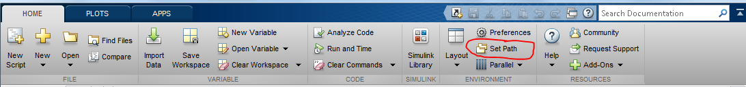

2.2 Save path for future use.

2.3 Type “SPM” into MATLAB, and a popup should appear. Press “PET & VBM”.

Step 3: Preprocessing data using CAT12

3.1 Open CAT12 expert mode through typing “cat12(‘expert’)

3.2 Click “Segment Data”

3.3 After the batch editor opens, double click “Volumes”, and select all the MPRAGE files to be processed

3.4 Click “Split job into separate processes” and change the item to 0

3.5 Begin scrolling down. Under “Extended options”, select “Spatial Normalization” and then choose “High-dimensional: DARTEL”.

3.6 Continue scrolling down until “Writing Options”. Change the following options:

3.61 Under “Grey matter”, change “Native space” to “yes”

3.62 Under “White matter”, change “Native space” to “yes”

3.63 Under “Bias Corrected”, change “Native space” to “yes” (either global or local bias correction works)

3.64 Under “Deformation fields”, change to “Image->Template(forward)”

3.6 Double check that everything is correct and hit the play button (green arrow) near the top right of the batch editor. If the arrow is not green, that means the volumes were not correctly chosen.

3.7 For a normal 1x1x1 mm image, processing of CAT12 takes approximately 20-30 minutes for each image. Expect larger processing times with smaller resolutions (i.e 0.8 x 0.8 x 0.8 mm).

3.8 After VBM, there will be several files placed in the same directory as the old files. Organize the files into individual folders with each folder containing all the output files for one subject.

3.9 The output files have special naming conventions – further information could be found at [http://www.neuro.uni-jena.de/cat12/CAT12-Manual.pdf on page 49](http://www.neuro.uni-jena.de/cat12/CAT12-Manual.pdf%20on%20page%2049).

Step 4: Creating Masks for Texture Analysis

4.8 The procedure above creates masks in an automated fashion to speed up the process. Alternatively, individual masks can be created manually with the following:

4.81 Open “ImCalc” on the SPM interface.

4.82 Select “Input Images” and submit the p1 and p2 images for an individual subject.

4.83 Change the output filename to mask_(insert subject name).nii

4.84 Change the output directory to a folder where you want to place all the masks.

4.85 Enter the following under “Expression”: (i1 + i2) > 0. This expression adds the p1 and p2 images together, and binarizes the sum image.

4.86 Press play – a mask should be created for the individual subject.

4.87 Repeat the process for each different subject.

4.9 (OPTIONAL) Check the masks in an MRI viewing software, such as ImageJ or MRIcron. The images should be binarized (completely white brain with a black background).

Step 5: Extracting texture maps using the Texture Analysis Toolbox

5.1 Open the folder with all the CAT12 output files and enter “y_” into the search bar. These files are deformation fields used to normalize the texture maps that will be created. Place all the “y_” files into the “Native volumes” folder containing the “m_____.nii” or “mi____.nii” files, depending on use of global versus local bias correction.

5.2 Rename all the “y_” files to “y_rm” or “y_rmi”, depending on use of global versus local bias correction. It is recommended to use “Bulk Rename Utility”.

5.3 Move all the y_rm(i).nii files into the same folder as the current MATLAB working folder. Alternatively, you can change the current MATLAB working folder to be the same as the folder with deformation fields. *If the files are not in the current MATLAB working folder, texture analysis will error out.*

Open MATLAB, remove spm12 and

- Download SPM8 toolbox from <https://www.fil.ion.ucl.ac.uk/spm/software/>. Place the downloaded contents into C:\ Program files \ MATLAB \ 2017b \ toolbox

- Retrieve “Texture Analysis” folder

- Set path to: C:\ProgramFiles\MATLAB\R2017b\toolbox\spm8.

5.3 Open SPM8 and select “Batch” again. In the batch editor, select SPM\Tools\Texture Analysis\Texture Analysis: VGLCM TOP 3D

5.4 In the Texture Analysis toolbox, select “Volumes”, and input all the volumes.

5.5 Next select “Mask(s)”, and input the masks created earlier **in the same order as the volumes.**

**Important:** make sure the ordering of the volumes matches the ordering of the masks. (i.e mSUBJECT3.nii and mask_SUBJECT3.nii are both the 3rd in their respective lists).

5.6 Select “Computational Space”. Change to “Original” from “MNI”. This tells the toolbox to apply the “y_rm(i)” deformation fields to the respective texture maps after they are extracted.

5.7 After ensuring all of the inputs in the batch are correct, press “play”. Each subject should take approximately one hour to calculate all twenty-two texture features. Expect longer processing times for high resolution images.

5.8 Twenty-two texture maps normalized to MNI space for each subject will be output into the “Native volumes” folder.

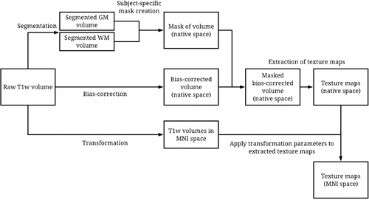

Figure is a visualization of 3DTA pipeline starting with “Raw T1w volume.” **Note:** image does not include ACPC alignment step.Taken from *Ta et al. 2020, JMRI.*

Step 6: Additional processing for FLAIRs

When processing texture analysis on FLAIRs, additional steps are needed. FLAIR volumes have to be coregistered to their corresponding T1 scans since segmentation is optimized for the T1 sequence.

6.1: Using the reslice and estimate function on SPM, coregister all FLAIR images to their T1 counterparts.

6.2: Segment T1 volumes to get the deformation of the volume to MNI space.

6.3: Create a mask comprised of grey and white matter volumes using the T1 segmented volumes on ImCalc.

6.4: Using SPM8, run medium bias field correction on the FLAIR scans.

6.5: With bias corrected FLAIRs, deformation fields, and volume mask, run texture analysis on SPM8.