Main Manuscript for
Near-Term Suicidality Risk Encoded in the Temporal Dynamics of the Death IAT

Pedram Rajaei¹, Pavan Kallam¹, Benito Garcia², Shreya Yadav², Aaron McInnes², Blair Brown³, Miriam Freedman³, Melanie D Goodman Keiser², Shahab Tavasoli¹, Sean Mullen⁴, Christian Kothe⁴, Sophia M Balint³, Michael Bronstein³, Alik S. Widge², Ali Yousefi¹
¹ Department of Biomedical Engineering, University of Houston, TX, USA
² Department of Psychiatry and Behavioral Sciences, University of Minnesota, MN, USA
³ Institute for Health Informatics, University of Minnesota, MN, USA
⁴ Intheon, La Jolla, CA, USA

*Ali Yousefi.
Email: aliyousefi@uh.edu

PNAS requires the corresponding author to provide an ORCID identifier at submission and strongly encourages all authors to use an ORCID ID. Do not include ORCIDs in the manuscript file; individual authors must link their ORCID account to their PNAS profile at www.pnascentral.org. For proper authentication, authors are not permitted to add ORCIDs on proofs. Learn more or register for ORCID.
Author Contributions: PR, PK, ASW, and AY contributed in manuscript preparation, data analysis, and algorithm development. Paste the author contributions here.
Competing Interest Statement: Disclose any competing interests here.
Classification: Biological Sciences, Psychological and Cognitive Science
Keywords: Suicide, Temporal Dynamics, Implicit Cognition, Brief Death IAT, Machine Learning.

This PDF file includes:
Main Text
Figures 1 to 4
@Alik:
Michael suggested using with active SI and without active SI. Should we use any acronym such as WA-SI vs NA-SI or keep it as complete words through the paper
Abstract
Suicide rates continue to rise in the United States and globally constitute the third leading cause of death among individuals. Identifying near-term suicide risk remains a major clinical challenge. The limited scalability and accessibility of current gold-standard assessments prevent clinicians from screening all potentially at-risk individuals. Many suicide decedents who undergo screening for intent deny it in the days or weeks preceding their deaths. In part, this occurs because imminent risk reflects cognitive processes that traditional self-report measures or markers of past suicidal behavior do not capture. Here, we demonstrate that temporal structure in reaction times (RTs) obtained from a modified Brief Death Implicit Association Test (BDIAT) encodes latent cognitive dynamics that track near-term suicide risk. Participants completed alternating blocks of conflict and non-conflict trials, while we independently assessed suicidal ideation (SI) using one week of 3x/day ecological momentary assessment (EMA). The conventional BDIAT D-score, which indexes the strength of implicit self-death associations, showed limited ability to distinguish participants with versus without active SI. By analyzing RTs as a time-varying signal, we found that participants with active SI exhibited attenuated sensitivity to task block alternation and faster habituation to conflict trials, whereas participants without active SI showed stronger and more persistent responses to block switches. We quantified these dynamics through descriptive statistics capturing trial- and block-level temporal dynamics and demonstrated that these dynamics enable individual-level prediction using a logistic regression–based classification model. After we trained the model on data from 77 participants (55 without active SI, 22 with active SI), it achieved 77% balanced accuracy and an area under the curve (AUC) of 0.79 using leave-one-out cross-validation (LOOCV). These results show that the temporal organization of behavior itself constitutes a scalable behavioral marker of short-term suicide risk and supports the development of scalable behavioral markers for near-term risk detection.
Significance Statement
Suicide related thoughts and behaviors area major public health concern. Millions of people per year have thoughts of suicide and suicide is a leading cause of death. Identifying people at-risk of suicide is difficult because assessment capacity does not match the size of at-risk populations and because individuals who are assessed have myriad incentives to deny suicidality. This study demonstrates that temporal patterns in reaction times from a task designed to index the strength of implicit death-self associations can be used to identify individuals experiencing active suicide ideation. These findings identify a previously unrecognized behavioral marker of near-term suicide vulnerability. Using this marker, one could theoretically screen any at-risk individual with access to a computer, making the problem of identifying who might need intervention to prevent suicide-related distress or death significantly more tractable.

Main Text

Introduction
Thoughts of suicide are extremely common, impacting over 10 million adults per year in the United States alone¹. Clinicians consider active Suicide ideation (SI)—thoughts of ending one’s life that include method, plan, and/or intent² —a particularly important marker of suicide risk³. Identifying people with active suicide ideation is therefore essential for risk mitigation but also difficult. Clinicians currently lack objective, behavior-based markers that can track near-term risk in real time, highlighting the need for tools that move beyond retrospective self-report. Current gold-standard assessment methods (e.g., the C-SSRS) depend on self-report and so are not robust to the myriad motivations people may have to not disclose their suicide-related thoughts and behaviors (e.g., concern about loss of autonomy)^{3,4}. These methods also cannot scale to meet demand, especially given that the rapid fluctuation of suicide ideation across short timescales (e.g., hours/days)^{3–7} often necessitates repeated assessment to ensure detection of suicidal individuals. Assessment methods that are more scalable, robust to purposeful non-disclosure, and compatible with the rapidly fluctuating nature of ideation could save lives by enabling delivery of timely interventions to more at-risk individuals⁵.
The Brief Death Implicit Association Test (BDIAT; Fig. 1) has emerged as a potential platform for objective, computerized, and behavior-based suicide assessment⁸. Traditionally, reaction times (RTs) on this task are used to produce a difference score (also known as a “D-score”) indexing the strength of implicit death-self associations⁸. This D-score shows a modest but meaningful ability to distinguish individuals with and without various histories of suicide-related thoughts and behaviors, including people who differ on levels of active suicide ideation^{9,10}. Nevertheless, the D-score’s utility for identifying near-term suicide risk or informing clinical decision-making remains limited and varies substantially across settings^{9,10}. The limited informativeness of D-score may be explained, in part, by the fact that they leverage average RTs across each BDIAT block type. This approach renders trial-by-trial variability in RTs inaccessible^{11,12}, even though we know such variability and its temporal dynamics carry meaningful information about underlying cognitive processes in psychophysical tasks^{13–14}. According to conflict monitoring theory, when a stimulus elicits incompatible responses—such as pairing “self” with “death” in an individual who is not suicidal and harbors no implicit association of these concepts—the brain detects this conflict and recruits cognitive control, producing a transient slowing of RT before performance returns to baseline¹⁵. This adaptive slowing, often referred to as conflict adaptation, has been demonstrated across a wide range of cognitive control tasks¹⁶. If suicidal ideation reflects weakened self–life associations or disrupted cognitive control, then it should manifest most strongly in aberrant patterns of performance during moment-to-moment transitions, rather than in aggregated RT measures derived from the BDIAT.
Advanced analytic tools for examining such patterns are not well-suited to the data typically available from studies of the BDIAT involving clinical populations. Sequence-to-sequence models for behavioral time series¹⁷ and transformer-based architectures for multivariate data¹⁸, for example, require training datasets much larger than those typically available. These models are also not readily interpretable, decreasing their utility for clinical decision making¹⁹. Notably, concerns about liability and personal/professional consequences of inaccurate suicide assessment render the implications of this black-box quality for trust in model outputs extremely salient to clinicians. Alternative’s solutions are therefore needed to render the information contained in temporal dynamics of IAT performance clinically useful.
With this in mind, in order to examine whether suicidality is indeed reflected in the temporal dynamics of BDIAT behavior, and whether modeling these dynamics might provide more information about suicidality than traditional D-scores, the present study paired estimates of near-term active suicide ideation derived from repeated assessments delivered as individuals go about their daily lives with trial and block-level analyses of RTs from a modified BDIAT. Through this examination, we aimed to not only move toward improved suicide assessments but also to advance cognitive theory by testing whether conflict adaptation and implicit self-referential processing exhibit distinct temporal signatures in individuals with elevated SI. Results indicate that near-term SI is encoded in the temporal structure of RT patterns of our modified BDIAT²⁰ Specifically, we developed a logistic regression model in which temporal encoding and parameter estimation are learned simultaneously. This is achieved through a bilinear architecture that integrates trial-level and block-level reaction time data. During training, an alternating optimization procedure extracts latent projections that map both fine-grained within-block dynamics and broader block-to-block transitions. We demonstrate that the inferred temporal patterns align with broader conflict adaptation mechanisms while also achieving meaningful predictive power in distinguishing individuals with active versus without active SI.. Despite the small and imbalanced dataset (77 participants; 55 without active SI, 22 with active SI), the proposed modeling pipeline exhibits robust performance and yields interpretable features relevant for near-term assessment of active suicide ideation.
Results
D-Score Shows No Distinction Between Participants with and without Active SI For each participant, we computed the D-score⁸, a single composite index reflecting the relative strength of association between “self” with “life” versus “death.” The D-score was defined as the standardized difference in mean RT between “Death + Me” and “Life + Me” blocks, assuming the former reflects greater conflict (particularly for people without suicide ideation):
$D={μ_{d}-μ_{l}}/{σ_{\text{all}}}$ (1)
where, $μ_{d}$ is the mean RT for trials in “Death + Me” blocks, $μ_{l}$ is the mean RT for trials in “Life + Me” blocks, and $σ_{\text{all}}$ is the pooled standard deviation of RTs across both block types. Missing or censored trials were excluded from the mean calculations. We defined missing trials as those with very fast RT (RT$< 350ms$) and censored trials as those with no response (RT $> 2000ms$). This formulation follows the “improved scoring algorithm” for IAT data, which remains the most widely used approach in the literature^{11,22}. Fig. 2A displays the resulting D-scores for each of the 77 participants across the two participant groups.
Prior studies have shown that D-scores from the death/suicide IAT can discriminate individuals with a past-year suicide attempt (PY-SA) from those experiencing past-week suicide ideation (PW-SI), demonstrating small-to-medium effect sizes with area under the curve (AUC) values typically ranging from 0.60 to 0.64 (Cohen's d ≈ 0.30–0.45)^{23,24}. In contrast, in our sample of 77 clinically stable outpatients and healthy controls, D-scores did not differ significantly between participants with and without active SI, and classification based solely on D-score yielded a balanced accuracy of 45.9% with a True Positive Rate (TPR) of 40.9% and a False Positive Rate (FPR) of 49.1% (Fig. 2B).
These null behavioral findings are consistent with emerging neurobiological evidence that suicide attempts and high-burden suicidal states are associated with more pronounced alterations in fronto-limbic circuitry— including medial and dorsolateral prefrontal cortex, anterior cingulate cortex, insula, hippocampus, amygdala, and striatum— than are present in non-attempters or individuals with lower, fluctuating levels of ideation^{23,24}. For example, changes in amygdala–prefrontal connectivity and salience-network organization have been linked to stronger suicidal self-associations on implicit tasks and to elevated risk for attempts^{36,37}. Taken together, this suggests that robust D-score differences may depend on relatively enduring or structurally embedded circuit abnormalities associated with suicide attempts or chronic high-risk states, whereas the present cohort may exhibit subtler, more state-like neural variations. This lower-burden presentation entails transient, short-term fluctuations in suicidal thoughts that can shift rapidly over hours or days, rather than chronic, fixed intent. Because this acute, fluctuating state is the most common manifestation of suicidality in daily life, relying on a single static summary metric like the D-score risks missing a vast segment of near-term vulnerability.
Rhythmic Entrainment to Block Structure Is Present in BDIAT and Differs Across SI Groups In our recent work²⁰, we reported preliminary evidence for a rhythmic pattern present in RTs that aligns with the frequency of block alternation. Using spectral analysis of trial-level RTs (27 participants; 18 without active SI, and 9 with active SI), we observed enhanced power across the block-switching frequency, with a more pronounced rhythmic signature in participants without active SI. This pattern was interpreted as heightened sensitivity to the task’s alternating structure—specifically, transitions between “Death + Me” and “Life + Me” blocks— and was associated with more temporally regular patterns of RT fluctuation across blocks. Here, we revisit this claim in a substantially larger sample and adopt another analytical approach that more directly targets block-level task structure. In our prior spectral analysis, estimation of frequency-specific power was constrained by the relatively short length of the RT time series and by statistical assumptions that may not fully hold for behavioral data. In particular, frequency-based analyses can be vulnerable to spectral leakage, a phenomenon in which power from a true oscillatory component spread into neighboring frequencies when the time series is short or does not contain complete cycles of the underlying rhythm. In practical terms, this effect can blur rhythmic peaks and reduce confidence that an observed frequency component reflects genuine task-locked structure rather than a sampling artifact. To address these limitations, we turned to an autocorrelation-based analysis at the block-level.
For each participant, RTs were summarized within each block by computing the mean RT-scale across the 20 trials in that block (18 blocks total), yielding a block-wise RT time series that directly matched the temporal structure of the task (see Materials and Methods, Preprocessing and Normalization). We then computed block-level autocorrelation functions (ACFs), which quantify similarity in block-averaged RTs across block lags without requiring strong assumptions of stationarity at the block-level. This representation allows direct assessment of whether RT fluctuations are synchronized with the alternating block structure of the task. Block-level ACFs revealed a clear oscillatory pattern consistent with the alternating block design in the task, characterized by negative autocorrelation at odd lags (representing transitions between differing block types, i.e., "Death + Me" vs. "Life + Me") and positive autocorrelation at even lags (representing comparisons between the same block types) (Fig 2.C). To quantify this effect across multiple lags, we computed a multi-lag Rhythm Index, defined as the mean difference between even-lag and odd-lag autocorrelations. This index provides a robust summary of rhythmic alignment to the block structure.
Across participants, the Rhythm Index was significantly greater than expected under a within-subject shuffle that destroyed the ABAB block order (where A represents “Death + Me” blocks and B represent “Life + Me” blocks), demonstrating that the observed rhythmic structure was tightly coupled to the task’s alternating design. Importantly, the rhythm was preserved under shuffles that maintained the ABAB structure while randomizing the order of blocks within each category, ruling out explanations based on slow drift, practice effects, or idiosyncratic block content. Critically, the strength of rhythmic entrainment differed reliably between groups. Participants without active SI exhibited a significantly larger Rhythm Index than with active SI participants (permutation test, p = 0.0287), indicating stronger behavioral alignment to the task’s block structure. This group difference persisted under structure-preserving shuffles (p = 0.007) but was significantly greater than the group differences generated by null models that destroyed the ABAB structure entirely (p < 0.001 ). This demonstrates that group differences were specific to task-locked rhythmic dynamics rather than generic autocorrelation in RTs (Fig 2.D). Stronger rhythmic entrainment reflects more stable or anticipatory encoding of task context across blocks, consistent with greater sensitivity to structured task demands in without active SI participants.
To examine whether these findings generalized to a new cohort and were not specific to block length, we administered an online version of the BDIAT using shorter blocks of 10 trials (36 blocks per participant). 100 participants enrolled via the online platform Prolific, six of whom failed to complete the BDIAT. Of the 94 participants who completed the task, 83 were included in the final analysis and 11 participants were excluded due to excessive missing or clipped reaction times (>10% of trials). Participants were classified into lower- and higher-suicidal-ideation groups based on their self-reported C-SSRS responses³. This classification served as an approximation of the with versus without active SI grouping used in the primary EMA-characterized cohort, although the assessment instrument and temporal resolution differed. Autocorrelation analyses of reaction times from these 83 participants again revealed a block-locked rhythmic structure consistent with that observed in the primary in-person sample (Fig. 2E). A within-subject shuffle that preserved the ABAB block structure confirmed a significant subject-level Rhythm Index at the task-defined alternation frequency—that is, the periodicity corresponding to the switching between “Death + Me” and “Life + Me” blocks (p = 0.036), indicating robust task-evoked rhythmicity in the online dataset. This rhythmic structure was evident across participants and was descriptively more pronounced in the lower–suicidal-ideation group. In contrast, between-subject group-label permutation tests did not show a reliable group difference in Rhythm Index (p = 0.56), nor did rhythm-destroying block permutations (p = 0.34). The absence of a significant group effect indicates that precise temporal control is necessary to reveal group differences in the online setting, mirroring findings in our initial in-person sample, and that differences in risk characterization persist when using different risk assessment instruments (here: the C-SSRS, versus EMA in the initial sample). Despite these differences, the block-level rhythmic structure closely replicates the pattern observed with 20-trial blocks, demonstrating that entrainment to block-level task context generalizes across task parameters and data collection environments.
Temporal Encoding of SI State Is Evident in RT Trials The previous section established the block-level encoding mechanism of near-term suicide risk; now, we turn to the trial level and probe how participant RTs change within blocks and in particular in response to switch cost. To characterize trial-wise adjustments in RTs, we first applied an adaptive filtering procedure to impute missing and censored RTs while estimating a participant-specific baseline RT (see Materials and Methods, Preprocessing and Normalization). Observed RTs were then factorized into two components: an individual baseline capturing typical response speed, and a trial-level scaling term (RT-scale) that quantifies proportional deviation from this baseline.
Figs. 3A and 3B show the group-level trajectories of RT-scale mean in “Death + Me” and “Life + Me” blocks across the 20 trials of each block. On the first trial, both groups exhibited a marked elevation in RT, with a mean scale value of approximately 1.25 in both blocks—corresponding to a ~25% increase over baseline. Neither effect was statistically significant after correction (q= 0.3875 for “Death + Me” and q= 1 for “Life + Me”. Here q-values are p-values corrected for multiple comparisons using the Benjamini–Hochberg false discovery rate (FDR) procedure²⁵, which controls the expected proportion of false positives among significant results.). In “Death + Me” blocks, for trials 2–3, mean RT-scale values returned to ~1 in both groups, indicating rapid recovery toward baseline RTs. Beginning at trial 4, however, the groups’ RT trajectories began to diverge, with participants from the without active SI group exhibiting lower RT-scale values at trials 4–6. In “Life + Me” block, mean RT-scale values return to baseline for the second trial followed by a subtle difference in RT-scale, similar to the pattern observed in the “Death + Me” block. Although these directional differences were suggestive, none survived Bonferroni correction²⁶ or Benjamini–Hochberg FDR procedure (all q-values > 0.05). Beyond this early window, the scale mean displayed fluctuations, and group-specific temporal patterns were not uniformly aligned across trials.
Given the absence of significant effects at individual trials, we next examined whether SI state influenced the overall temporal structure of RT adjustments across the block. To this end, we fit a linear mixed-effects model with Group, Trial, and their interaction as fixed effects and participant-level random intercepts. We fit this model independently for “death + me” and “life + me” blocks, which allows us to evaluate the group × trial interaction within each specific condition while avoiding more complex, higher-order interaction terms. In the “death + me” blocks, this analysis revealed a significant Group × Trial interaction within the “Death + Me” block (F (1,1536) = 4.70, p = 0.030), indicating that the temporal evolution of RT-scale dynamics differed between with and without active SI participants. No main effect of Group was observed. Planned contrasts conducted within this mixed-model framework did not reveal significant between-group differences at trials 1–6 after FDR correction (all q-values > 0.36), although the direction of effects was consistent with the descriptive divergence observed at later trials (trials 4–6). In contrast, no Group × Trial interaction was observed in the “Life + Me” blocks (all p > 0.55), despite a significant main effect of Trial, indicating that group differences in RT dynamics were specific to the “Death + Me” condition.
Although trial-wise and mixed-effects analyses characterize local and global temporal effects, they may fail to capture latent structure that emerges when RT trajectories are treated as multivariate time series. We therefore focused on the “Death + Me” block, where evidence for group-dependent temporal dynamics was strongest, and applied an uncentered principal component analysis (PCA) to RT-scale trajectories following a monotonic nonlinear transformation of the form RT-scale^{- α}, with α > 0 (see Materials and Methods, Uncentered Covariance Matrix Calculation and PCA in Trial). This transformation attenuates the influence of outliers while jointly incorporating information from both mean level and variability of RTs across blocks and trials. The first principal component (PC1; Fig. 3C) captured a temporal pattern closely resembling the early-trial divergence observed in the full RT trajectories (Fig. 3A). Group differences in PC1 loadings were most pronounced around trial 4 (p < 10⁻³; q ≤ 0.05), and this effect was stable across α values near unity, indicating that the combined contribution of mean and variance is critical for expressing this deviation. In intuitive terms, participants in the with active SI group tended to exhibit faster responses accompanied by increased variability, whereas without active SI participants returned toward baseline RTs with greater regularity. Together, these results provide a lower-dimensional representation demonstrating that SI state is reflected in distinct temporal profiles of RT-scale dynamics, beyond effects detectable at individual trials. To rule out the possibility that early-trial effects reflect stimulus-specific artifacts, we examined the distribution of stimulus words across trial indexes. Stimulus words were evenly distributed throughout the task, with no evidence of specific change in their presentation at early trials (SI Appendix, section 1 and Fig. S1).
Together, these findings indicate that SI state is reflected in the temporal organization of trial-by-trial RT adjustments, with effects most evident in the “Death + Me” blocks. Although both groups exhibited an initial RT cost followed by rapid normalization, participants with active SI showed a more prolonged deviation from baseline and a qualitatively different recovery trajectory. These results suggest that suicide ideation is associated not only with block-level differences, but also with fine-grained temporal dynamics of performance during decision-making under cognitive control.
SI State Can Be Robustly Predicted Using RT Time Series Motivated by evidence that SI state is temporally encoded in RTs, we show that temporal patterns in RT time series can be summarized into participant-level features that predict SI state. Using a classification model, we distinguish participants with active SI versus without active SI from their RT trajectories. We employed an extended logistic regression model that incorporates supervised dimensionality reduction, analogous to supervised PCA²¹. The model integrates both block-level and trial-level mappings and, in the training step, learns multiple sets of latent projections that extract informative features from RT for classification. This architecture is directly motivated by our empirical findings, which indicate that SI state is encoded both across task blocks and in latent temporal structure within RT trials. For classification, we focused on “Death + Me” blocks, where temporal encoding was strongest (Fig. 3C) and group differences in autocorrelation structure were most pronounced (Fig. 2C). Let $Z_{i}∈R^{9×20}$ denote the matrix of RT-scale for the $i$th participant, corresponding to the nine “Death + Me” blocks, each comprising 20 trials. The log-odds of active SI are then defined as:
$\log\left(\frac{p_{i}}{1-p_{i}}\right)=b_{0}+\sum_{j=1}^{J}{v_{j}^{T}Z_{i}^{(-α)T}b_{j}}$ (2)
where $b_{0}$ denotes the intercept, $b_{j}∈R^{9}$ are block-level weighting vectors, $v_{j}∈R^{20}$ are trial-level weight vectors and $α$ is set close to 1. The vectors $b_{j}$ are constrained to have unit norm to ensure identifiability of the bilinear decomposition and to prevent scale ambiguity between block- and trial-level contributions. For models with $J≥2,$the vectors $b_{j}$ are additionally orthogonalized to encourage distinct component representations. The integer $J$ controls the number of spatiotemporal components used to represent each participant’s reaction time matrix $Z_{i}$. Each term $v_{j}^{T}Z_{i}^{(-α)T}b_{j}$ defines a bilinear mapping, where $b_{j}$ determines how block-level responses are combined and $v_{j}$ specifies the relative contribution of individual trials within the corresponding representation. During training, sparse regularization is imposed on the trial-level weight vectors $v_{j}$, consistent with our empirical observation that SI-related effects are localized to specific trial indices and to mitigate overfitting given the limited sample size. The parameters $b_{j}$ and $v_{j}$ are estimated using an alternating optimization procedure (see Materials and Methods, Bilinear Logistic Regression Classifier), in which trial-level weights are updated via $l_{1}$-regularized logistic regression and block-level vectors are updated via gradient-based steps.
Fig. 4A shows the receiver operating characteristic (ROC) curves for classifiers with $J=1,2,$ and $3$ evaluated on 77 participants. Model performance was assessed using leave-one-out cross-validation (LOOCV); accordingly, the ROC curves were constructed by aggregating predictions from 77 classifiers, each trained on 76 participants and evaluated on the held-out subject. The model with $J=2$ achieved the best performance, yielding a balanced accuracy of 77% (specificity = 0.78, sensitivity = 0.77) and an AUC of 0.79. In contrast, models with $J=1$ and $J=3$ performed substantially worse, with AUCs of 0.559 and 0.526, respectively. Fig. 4B illustrates the joint distribution of the learned projections $v_{1}^{T}Z_{i}^{(-α)T}b_{1}$ and $v_{2}^{T}Z_{i}^{(-α)T}b_{2}$ across all 77 test folds, with the corresponding decision boundary shown. Using either projection alone results in reduced sensitivity or specificity, leading to lower classification accuracy. This observation is consistent with the inferior performance of the $J=1$ model and suggests that multiple distinct temporal encoding patterns jointly contribute to SI-state prediction. In contrast, increasing model complexity to $J=3$ appears to introduce overfitting, consistent with overfitting due to increased model complexity relative to sample size. We additionally evaluated baseline models in which the block-level vectors $b_{j}$ were fixed rather than learned. Specifically, $b_{j}$ were set to either the leading PC1 or the first two PCs of the uncentered covariance matrix estimated from the training data within each LOOCV fold. As shown in Fig. 4A, these fixed-PC models achieved AUCs of approximately 0.59 and 0.66, respectively. These results indicate that directions that capture maximal variance in block-level RTs do not reliably correspond to latent projections that optimally encode SI state. To assess statistical significance, we conducted a label-shuffling permutation test in which the entire LOOCV training and evaluation pipeline was repeated under randomly permuted SI labels. As shown in Fig. 4E, the empirical null distributions of balanced accuracy and AUC derived from 1,000 permutations were centered near chance levels. The observed balanced accuracy (77%) and AUC (0.79) strictly exceeded the empirical null distributions (p < 0.001), indicating that classifier performance captures genuine behavioral signatures of near-term suicide risk and is highly unlikely to arise from random label assignment.
Fig. 4C–D show the learned block-loading vectors $b_{j}$ and temporal weight vectors $v_{j}$ for the best-performing model ($J=2$). The first temporal component, $v_{1}$, places its strongest weights on early trials within each block, while the corresponding block-loading vector $b_{1}$ exhibits relatively uniform contributions across blocks. This pattern is consistent with a dominant, block-invariant temporal encoding component and aligns with the primary temporal structure identified in the autocorrelation and PCA analyses (Fig. 3C). In contrast, the second component captures a more heterogeneous spatiotemporal pattern. The temporal weights $v_{2}$ exhibit localized contributions at specific trials, while the corresponding block-loading vector $b_{2}$ varies substantially across blocks, including sign reversals and attenuated contributions for intermediate blocks, indicating a higher-order, block-specific temporal component. Projections onto this component, quantified by $v_{2}^{T}Z_{i}^{(-α)T}b_{2}$ and shown in Fig. 4B, indicate that without active SI participants occupy a more restricted region of the latent space, whereas with active SI participants exhibit broader dispersion. This pattern suggests that the block-dependent temporal dynamics captured by the second component are more stable and constrained in the without active SI group, whereas the increased magnitude and variability observed in with active SI participants reflect more heterogeneous and irregular block-to-block temporal modulation. Consistent with this interpretation, block-level autocorrelation analyses (Fig. 2C) show more regular switching patterns in without active SI participants, supporting the conclusion that SI state modulates sensitivity to evolving task context rather than overall task performance.
Thus, while earlier results established group-level differences in RT temporal structure, the present classification results demonstrate that these same dynamics also yield participant-level features predictive of SI state.
Discussion
This study establishes that near-term active suicide ideation is reflected in task-evoked behavior, specifically in the temporal dynamics of RTs during a modified BDIAT. A central contribution of this work is the demonstration that SI-related information is distributed across multiple temporal scales, manifesting both in block-to-block transitions and in fine-grained (latent) trial-level dynamics within blocks. By analyzing RTs as a time-varying signal rather than a static summary, we identify behavioral signatures of near-term SI that are not captured by conventional measures, including canonical D-score^{9,10}.
Consistent with this interpretation, the traditional D-score derived from the BDIAT did not discriminate between participants with active SI and without active SI. This result contrasts with prior studies in which the D-IAT showed modest but meaningful predictive value for identifying individuals with various histories of suicide-related thoughts and behaviors^{9,10}. We interpret this discrepancy as reflecting a distinction between trait-like implicit associations and state-dependent cognitive processes^{27,28}. Near-term suicidality, as indexed by EMA in the present study, reflects transient alterations in cognitive control and contextual sensitivity rather than stable self–death associations^{5,29}. Thus, the D-score may perform poorly here because our study targets near-term, state-dependent SI, whereas prior D-IAT studies largely examined more trait-like or history-defined suicide risk.
The more flexible block-structured analytic design we employed in this research and deviation from D-score enables direct interrogation of temporal dynamics that are otherwise inaccessible. We demonstrate a rhythmic pattern in RTs that is tightly locked to the alternating block structure of the task and differs reliably between SI groups. Using an autocorrelation-based framework, we show that participants without active SI exhibit stronger and more persistent alignment to task structure, whereas those with active SI show attenuated and short-lived encoding of block alternation. This rhythmic structure generalized across task variants, including an independent online dataset with shorter blocks, indicating that sensitivity to block-level context is a robust feature of the task even when group-level discriminability is reduced. Importantly, the rhythmic differences we identify are not due to the most obvious potential confounders (e.g., overrepresentation of certain stimuli in certain participants), suggesting that they are meaningfully related to SI.
At the trial level, our analyses reveal temporal dynamics consistent with conflict adaptation theory^{15,16}. Following block switches, both groups exhibit an initial RT cost, but participants without active SI show more regular and sustained recovery toward baseline, whereas those with active SI exhibit faster habituation and increased variability. These differences are not apparent at isolated trials but emerge when RT trajectories are analyzed as multivariate time series. Low-dimensional representations derived from these trajectories capture early post-switch dynamics that distinguish SI state, demonstrating that near-term suicidal risk is associated with altered context updating and reduced persistence of task-set encoding rather than uniform slowing or generalized performance deficits (e.g., attenuated practice effects).
Building on these findings, we developed a deliberately simple and interpretable classification framework that explicitly incorporates task structure and temporal dynamics. Despite being trained on a modest sample size, this approach achieved reliable participant-level discrimination of SI state. Comparisons with alternative classifiers, as discussed and illustrated in SI Appendix, section 2, indicate that models lacking explicit temporal structure fail to capture the patterns revealed by our analyses, highlighting the value of mechanistically-informed temporal modeling in this domain. While classification performance is not the primary focus of this work, these results establish a foundation for future studies integrating larger samples, longitudinal outcomes, and additional physiological modalities.
For this discovery-oriented effort, several limitations should be acknowledged. SI state was defined using a binarized variable reflecting the presence/absence of active suicide ideation across the EMA period. This approach obscures potential heterogeneity in the severity of ideation in the active SI group while making the learning problem more tractable at a small sample size. In addition, the modest sample size limits the complexity of models that can be robustly trained and the extent of independent validation that can be performed. As discussed in SI Appendix, section 3, we confirmed that the identified temporal features are specific to near-term SI rather than broad diagnostic categories. When the model was trained to distinguish major depressive disorder from healthy controls, predictive performance was substantially reduced, suggesting that the captured dynamics reflect state-sensitive fluctuations in risk rather than stable trait differences. An important direction for future research is the incorporation of multimodal signals, such as electroencephalography (EEG) and facial expression data—both collected in the present study—which will be critical for developing a more holistic and mechanistic understanding of near-term suicidality and its modulation over time.
A key advantage of behavior-based assessment for probing near-term SI lies in the simplicity and scalability of the task. Requiring only a standard computer or smartphone, this approach supports repeated, low-burden assessment in settings with limited access to highly trained assessors or other specialized clinical resources. By capturing task-evoked temporal dynamics that are difficult to assess through self-report alone, this framework offers a promising path toward more accessible and timely evaluation of near-term suicide risk at scale, which would facilitate targeted intervention and could thereby prevent suicide deaths.

Materials and Methods
Participants
Participants were recruited as part of a larger research effort focused on identifying neurobehavioral markers of suicide risk. To be generally eligible for the study, participants needed to be age 18-65, be fluent in English, and be able to read computer-presented text (with corrective lenses if necessary). Exclusion criteria included neurological disorders, contraindications to EEG (e.g., scalp sensitivity or gel allergy), pregnancy, recent psychiatric hospitalization, or active military or Department of Defense employment (due to funders’ requirements). Participants with treatment-resistant depression and histories of suicidality who met these criteria were recruited from interventional psychiatry clinics. These participants were required to have current or planned treatment with transcranial magnetic stimulation (TMS) or ketamine, to support potential analyses focused on clinical change. A comparison group consisting of community members, who did not have any psychiatric condition and were therefore less likely to report suicidality, were recruited via StudyFinder. All participants provided written informed consent under a protocol approved by the Advarra Institutional Review Board (IRB) and the U.S. Navy Human Research Protection Office (HRPO) under Defense Advanced Research Projects Agency (DARPA) cooperative agreement No. N660012324016.
After screening for data quality (e.g., BDIAT instructions were understood and followed) and protocol adherence (e.g., completion of the BDIAT and EMAs), the final sample included n=55 people with depression and n=25 comparison group members. These participants were sorted into two groups using a binarized variable representing the level of suicidality endorsed during the EMA period (active SI present/absent).
Of the 80 included participants, 57 reported no active suicidal ideation across all EMA prompts (and thus formed the group without active SI), while 23 endorsed active SI on at least one occasion (and were included in the active SI group). These EMA-derived labels were used as the primary ground truth for all behavioral and machine learning analyses described in this paper.
Behavioral Task: Brief Death Implicit Association Test
The BDIAT, which measures implicit associations between the self and life/death, was administered approximately one week after the EMA period. The BDIAT consisted of 360 trials, organized into 18 alternating blocks (9 “Life + Me” and 9 “Death + Me” blocks), with 20 trials per block. The category pairs (Life + Me or Death + Me) remained on-screen throughout each block. In each trial, participants sorted stimuli as quickly and accurately as possible according to whether the presented stimulus belonged to either category label. Stimulus response mappings alternated between blocks accordingly with the alternating category labels, and the assignment of response keys (left/right) was counterbalanced across participants to minimize motor biases.
On each trial, a fixation cross appeared for $500 ± 50 ms$, followed by the presentation of a single word stimulus at the center of the screen. Stimuli included self-related words (e.g., me, myself, I) and other-related words (e.g., they, them, other), along with either death-related words (dead, suicide, lifeless, buried) or life-related words (alive, living, breathe, survive). The word remained on screen for up to $2,000 ms$ or until a response was made. To ensure participants understood the lexical meaning of each stimulus word, prior to beginning experimental trials, participants completed a word sorting task in which they sorted the task stimuli into Death/Life/Me/Other categories. Following the word sorting task, participants completed 10 practice trials of the BDIAT task, in which feedback regarding correct/incorrect responses was displayed at the end of each trial. No feedback was displayed in experimental trials.
Reaction times and accuracy were recorded for every trial which translates to 360 trial per participants. The full task lasted approximately 12–14 minutes. The BDIAT provided high-temporal-resolution behavioral data. In this study, BDIAT performance served as the primary behavioral measure to investigate whether temporal dynamics of reaction times could reveal markers of acute suicidal ideation.
EMA and Clinical Measures
To obtain a ground-truth measure of suicidal ideation in daily life, participants completed EMA surveys delivered to their smartphones three times per day for seven consecutive days prior to the BDIAT session. EMA has been shown to reliably capture short-term fluctuations in suicidal thoughts and reduce recall bias compared to retrospective clinical assessment^{4,28–31}. Each survey included items assessing passive suicidal ideation (e.g., “I wish I were not alive”), active suicidal ideation (e.g., “I am thinking about killing myself”), rated on a 0–4 Likert scale (0 = not at all, 4 = extremely), and theoretically meaningful contributors to such ideation (e.g., psychological pain). Membership in the group of suicide ideators was assigned to any participant whose mean EMA active SI score across the week was greater than zero, indicating at least one endorsement of active suicidal thoughts during the monitoring period^{6,29}. Participants with a mean score of zero (no endorsement of active SI across all EMA prompts) were labeled as non-ideators. This binary EMA-derived label was used as the primary outcome variable for all classification models, which maps to our two categories: with active SI and without active SI.
In addition to EMA, participants completed the C-SSRS during the laboratory visit. The C-SSRS was administered by trained research assistants³. The C-SSRS assesses recent and lifetime suicidal ideation, intent, and behavior. However, consistent with prior work, several participants who denied SI during the C-SSRS reported suicidal thoughts on EMAs, illustrating that single timepoint assessments may miss transient ideation captured by repeated real-time self-report^{5,28}. Therefore, C-SSRS scores were used only as a secondary clinical benchmark, whereas the EMA-based active SI label served as the primary indicator of acute ideation.
Preprocessing and Normalization
RT sequences were preprocessed to address skewness, censoring, and missing or physiologically implausible responses prior to temporal analysis. For each participant $i$, we denote the raw RT sequence as
$r_{i}=\{r_{it}\}_{t=1}^{T},$ (3)
where $T$ is the total number of trials. Trials with no recorded response were treated as right-censored observations (RT exceeding a fixed upper bound), while extremely fast responses below a conservative threshold were considered physiologically implausible. These trials were excluded from direct analysis.
Following standard practice for reaction time data, RTs were log-transformed to stabilize variance and reduce skewness. Let $y_{it}$ denote the transformed observation, defined as
$y_{it}=\left\{\begin{matrix}\text{censored}, & r_{it}>τ_{\text{max}}, \\ \text{missing}, & r_{it}<τ_{\text{min}}, \\ log⁡(r_{it}), & \text{otherwise},\end{matrix}\right.$ (4)
where $τ_{\text{max}}$ and $τ_{\text{min}}$ denote upper and lower RT thresholds, respectively. RT data can be preprocessed in multiple ways, each with their own strengths and limitations. Because RT sequences in this task include censoring, physiologically implausible responses, and temporal non-stationarity, we evaluated two complementary preprocessing strategies to ensure that our findings were not dependent on a particular modeling assumption. The first approach uses a state-space formulation that explicitly accounts for censoring and missingness within a probabilistic framework and assumption of a state-like RT³². The second approach applies a threshold-aware local imputation procedure designed to preserve short-range temporal structure with minimal model assumptions. The state-space method served as our primary preprocessing pipeline, while the local imputation approach was used as a robustness check. Across analyses, results were qualitatively consistent across preprocessing strategies.
Our primary analyses were conducted using the state-space formulation, where we modeled the log-RT sequence using a state-space formulation that explicitly accounts for censoring and missing data. Specifically, the observed signal was assumed to arise from a latent dynamic process,
$y_{it}=c_{i}+x_{it}+ϵ_{it}, ϵ_{it}∼N(0,σ_{y,i}^{2}),$ (5)
with latent state evolution
$x_{it}=x_{i,t-1}+v_{it},{ v}_{it}∼N(0,σ_{x}^{2}),$ (6)
and prior $x_{i0}∼N(0,σ_{0}^{2})$. Here, $c_{i}$ represents a participant-specific baseline, $σ_{x}^{2}$ controls the smoothness of the latent trajectory, and $σ_{0}^{2}$ is set to a large, fixed value to reflect weak prior information. Censored observations contributed to the likelihood through their censoring bounds, while missing observations were handled using a flat likelihood. Model fitting was performed independently for each participant using a Bayesian filtering approach implemented in the COMPASS toolbox, as described previously³³. The posterior mean of the latent process $x_{it}$ was then used as the preprocessed RT signal for subsequent analyses.
As an alternative preprocessing strategy, missing values in the log-transformed RT sequences were imputed using a threshold-aware local estimation procedure. In this approach, each missing value was replaced using statistics computed from a local temporal window centered on the missing trial (±15 trials), with censoring information used to modulate the imputation rule. An upper bound corresponding to the log-transformed task response limit was applied during imputation to prevent unrealistically large values for censored trials. This procedure preserves local temporal structure while limiting the influence of extreme or censored observations. The resulting imputed log-RT sequences were used for all downstream temporal analyses and modeling.
For preprocessing and filtering, the initial state variance was set to $σ_{0}^{2}=1$, and the state noise variance was set to $σ_{x}^{2}=0.12$. RTs below $t_{min}=350$ms were treated as physiologically implausible given the speed with which visual information enters conscious awareness, and trials exceeding the response window ($t_{max}=2000$ ms) were treated as right-censored. Within the state-space formulation, participant-specific baseline offsets $c_{i}$ and observation noise variances $σ_{y,i}^{2}$ were estimated from the data to achieve an optimal fit for each participant. We exponentiated the posterior mean of the latent state $x_{i}=\{x_{it}\}_{t=1}^{T}$ to obtain the RT-scale signal $z_{i}$, where $z_{it}=\exp\left(x_{i}\right)$. This quantity specifies how each trial is scaled multiplicatively relative to the participant-specific baseline RT. Alternative parameter settings and preprocessing variants were examined to assess robustness, and results were consistent across choices.
Participants with excessive proportions of censored or missing trials were excluded prior to preprocessing to ensure reliable estimation of temporal dynamics.
Group Comparisons Across Trials
For visualization and exploratory assessment, trial-wise two-sample t-tests were conducted to compare RT-scale means and variances between with active SI and without active SI groups for each of the 20 trials within a block. Because these comparisons constitute repeated tests over temporally ordered data, P-values were adjusted using both Bonferroni correction (α = 0.05/20 = 0.0025) and the Benjamini–Hochberg FDR procedure. A trial was considered statistically reliable only if it survived at least one of these corrections. Although both adjustments were computed, we focus on Benjamini–Hochberg FDR results because it better balances error control and statistical power.
Mixed-Effects Modeling
To formally evaluate group differences across the full temporal profile of reaction time dynamics, we employed a linear mixed-effects model of the form:
$x_{ij} = β₀ + β₁·Group_{i} + β₂·Trial_{j} + β₃·(Group_{i} × Trial_{j}) + u_{i} + ε_{ij}$, (7)
where $i$ indexes participants and $j$ indexes trial position within a block. The dependent variable, $x_{ij}$, is the latent state variable estimated from pre-processing pipeline discussed above for participant $i$ at trial $j$. This quantity represents the logarithm of RT changes relative to the participant-specific baseline. Fixed effects include Group (active vs. without active SI), Trial (trial index), and their interaction. The term $u_{i}$ represents participant-level random intercepts, assumed to be normally distributed with mean zero, and $ϵ_{ij}$denotes residual error. To allow block-specific effects while avoiding higher-order interactions across block types, we fit the model separately for the “Death + Me” and “Life + Me” blocks.
Significance of fixed effects was assessed using likelihood-ratio tests comparing nested models ²¹. Planned contrasts were conducted at trials 4, 5, and 6 to probe early post-switch dynamics, focusing on the initial adaptation period following the block transition; trial 1 was excluded because it primarily reflects the immediate switch cost. To account for multiple comparisons within this predefined subset, P-values were adjusted using the Benjamini–Hochberg FDR procedure²⁵.
Uncentered Covariance Matrix Calculation and PCA in Trial
Given our preliminary analysis, we applied uncentered PCA to infer the latent representation embedded in RT time series. Within the uncentered PCA, principal components (PCs) are aligned in directions that reflect maximal variance due to both the mean and the covariance of RTs. Each participant’s RT-scale time series across “Death + Me” blocks define elements of matrix $Z∈R^{9×20}$; thus, this matrix presents 9 realizations of 20-dimensional RT time series. The first PC (PC1), $\overline{v}$, is obtained by the following optimization:
$\underset{\left\|v\right\|=1}{\overline{v}=argmax}{v^{T}Sv}=\underset{\left\|v\right\|=1}{argmax}{v^{T}\tilde{Σ}v}+v^{T}\tilde{μ}{\tilde{μ}}^{T}v$ (8)
where $S$, $\tilde{μ}$ and $\tilde{Σ}$ are defined by:
$S=\tilde{Σ}+\tilde{μ}{\tilde{μ}}^{T}$ (9.a)
$\tilde{μ}=\frac{1}{9}\sum_{j=1}^{9}{Z_{j,:}}$ (9.b)
$\tilde{Σ}=\frac{1}{9}\sum_{j=1}^{9}{Z_{j,:}^{T}Z_{j,:}}$ (9.c)
with $Z_{j,:}$ is the $j^{th}$ row of $Z_{j}$. The quantity ${\overline{v}}^{T}S\overline{v}$ represents the total variance along PC1, which decomposes into a covariance contribution defined by ${\overline{v}}^{T}\tilde{Σ}\overline{v}$ and a mean contribution set by ${\overline{v}}^{T}\tilde{μ}{\tilde{μ}}^{T}\overline{v}$. We applied the uncentered PCA, defined in Equations (8) and (9), to each participant’s RT-scale trajectories. The PC1 explained $95.3±1.7\%$ of total variance, suggesting RTs are strongly aligned along with this PC. For the variance captured along PC1, the mean contribution derives $98.5±1.1\%$ of it. Such a strong contribution suggests PC1s to be a robust latent representation of the $Z_{j}$s, and we examine its attributes to see if it could serve as a behavioral marker of active SI state. Trial-level analysis of PC1s using and two-sample t-tests did not provide evidence for SI-state encoding (minimum q-value = 0.36 at trial 4). Although t-tests provide localized comparisons at individual RT trials, they treat each trial independently and do not account for repeated measurements within participants. Accordingly, we fitted Mixed-Effect Modeling to the PC1 trajectories to evaluate group differences while accounting for within-participant trial dependence. For each participant, the linear model from PC1 is derived from Equation (7). However, likelihood-ratio tests did not reveal statistically significant effects of Group, Trial, or Group × Trial interaction (all p-value > 0.05). We therefore explored nonlinear transformations of the RT scale, including logarithmic and power law transformations. Logarithm of RT-scale which turns into $x_{i}$s as defined in Preprocessing and Normalization section; we saw a shift in PC1’s explained variance. The explained variance dropped to $35.2±9.4\%$, suggesting loss of its dominant directionality within RTs. Within PC1, only $22.9±22.8\%$ of variance comes from the mean contribution, reflecting a shift toward covariance-driven representation of RTs. The minimum q-value across trials is the lowest at trial 4; however, it is still larger than 0.05. We then checked the $z_{i}^{α}$ for different values of $α$ and in particular $α<0$ . For the case $α=-1$, the uncentered PCA processes the reciprocal of RT-scale and its PC1 explains $96.7±1.2\%$ of total variance. This number is slightly stronger than uncentered PCA on $Z$, and the mean contribution in PC1 increases to $99.2±0.6\%$. Under this transformation, the trial-level analysis of PC1 showed statistically significant difference with the strongest evidence at trial 4 (q-value=0.05). This finding indicates a group level difference in RTs, and in particular, when we take the mean at the reciprocal of RT-scale. We also examined the $α$ from $-0.5$ to $-2$; the strongest evidence of group level encoding is present for value of $α$ around 1. The effect of the reciprocal function can be reasonably explained with the range of values RT-scale takes; RT-scale across trials and participants fluctuates around 1; thus, ${\tilde{μ}}_{Y}=\frac{1}{9}\sum_{j=1}^{9}{Z_{j,:}^{-1}}$ remains close to $\tilde{μ}$as defined in Equation (9.b) – here, $Y$ is element wise reciprocal of $Z$. With a first-order Taylor approximation, the covariance of $Y$ (${\tilde{Σ}}_{Y}$) can be written as ${{\tilde{Σ}}_{Y}=D\tilde{Σ}}_{x}D$ where${ \tilde{Σ}}_{x}$ is the covariance of $x_{i}$ and $D=diag({\tilde{μ}}_{Y})$ (same rationale can be applied to covariance of $Z$). By applying the inverse transformation, large magnitudes of RT-scale are more suppressed. Such compression of RT time series leads to preservation of the covariance contribution (${\tilde{Σ}}_{Y}$) into a more stable structure since ${\tilde{μ}}_{Y}$ and therefore diagonal elements of $D$ are around 1. Consequently, inverse scaling prevents single-trial noise from dominating the objective function (8), allowing the stable, mean contribution and revealing underlying group-level differences observed at trial 4.
To assess whether SI state is extended beyond the dominant latent dimension (PC1), we examined other PCs and in particular the second principal component (PC2). In contrast to PC1, PC2 did not exhibit reliable early-trial separation, and trial-wise differences observed at later trials did not reach statistical significance after Bonferroni correction for multiple comparisons. SI Appendix, section 4 and Fig. S4 shows PC2 trajectories and associated trial-wise p- and q-values to provide further information on PC1 and PC2 encoding of SI state.
Bilinear Logistic Regression Classifier
Here we describe how the parameters of the bilinear logistic regression model were estimated and how predictive performance was evaluated. For each participant $i$, RT data from the “Death + Me” blocks were represented as a matrix $Z_{i}∈R^{9×20}$, and SI state was encoded as a binary outcome variable $y_{i}∈\{0,1\}$, corresponding to without active SI versus with active SI.
The model parameters $Θ= \{b_{0}, b_{\left\{1:J\right\}}, v_{\left\{1:J\right\}}\}$were learned by maximizing the penalized log-likelihood function:
$\hat{Θ}=\underset{Θ}{argmax}{ \sum_{i=1}^{N}{ω_{i}\left[y_{i}log⁡(p_{i})+(1-y_{i}) log⁡(1-p_{i})\right]}}$ (10)
$subject to \left\{\begin{aligned}b_{j}^{T}b_{j}=1 j=1, …, J \\ b_{j}^{T}b_{k}=0 j≠k , J≥2 \\ \sum_{j=1}^{J}{{\left\|v_{j}\right\|}_{1}}≤C\end{aligned}\right.$ (11)
where $p_{i}$ denotes the predicted probability of being in the with active SI group, $ω_{i}$ represents class-specific sample weights applied to class likelihood to correct for group size imbalances, $b_{j}$ are the block-level loading vectors, $v_{j}$ are the trial-level weight vectors, and $b_{0}$is the intercept term which is estimated jointly with other parameters. The parameter $C$ sets the bound on $v_{j}$s norm 1 and thus the $l_{1}$ penalty which promotes sparsity in temporal weights. This regularization reflects our empirical observation that SI-related effects are localized to specific trial indexes, and it also mitigates overfitting given our dataset small sample size. Block-level weight vectors $b_{j}$ were constrained to have unit norm to prevent scale indeterminacy between block and trial contributions, and were orthogonalized for models where $J≥2$ to ensure distinct component representations.
Parameter estimation proceeded via an alternating two-step optimization procedure. First, holding $b_{j}$ fixed, we constructed standardized features and estimated $v_{j}$and $b_{0}$ using $l_{1}$-regularized logistic regression (GLM-LASSO)³⁴, with the regularization strength selected by K-fold cross-validation within the training data (1-SE rule³⁵ by default). Specifically, a regularization path corresponding to different levels of $l_{1}$ constraint strength was computed within each training fold, and the optimal regularization level was selected based on cross-validated deviance. This subproblem is convex in $v_{j}$ for fixed $b_{j}$ and therefore provides a unique optimum at each alternation. Second, holding $v_{j}$and $b_{0}$ fixed, we updated each $b_{j}$using gradient-ascent steps on the weighted likelihood function, followed by renormalization and (when $j≥2$ ) Gram-Schmidt orthogonalization. A fixed number of outer alternations and gradient steps per alternation were performed using a constant step size, without adaptive stopping criteria. Because the overall bilinear objective is non-convex, the alternating procedure converges to a local optimum.
The number of bilinear components $J$ was treated as a model hyperparameter and evaluated using cross-validation. Candidate values of $J$ were compared based on LOOCV performance, and the value yielding the highest balanced accuracy was selected. Predictive performance was assessed using LOOCV, in which each participant was held out in turn, the model was trained on the remaining $N-1$ participants, and SI state was predicted for the held-out participant. Classification metrics, including balanced accuracy, sensitivity, specificity, and AUC, were computed by aggregating predictions across all folds. This procedure provides an estimate of generalization to unseen participants while maintaining a compact and interpretable parameterization.
To assess whether classification performance exceeded chance, we conducted a nonparametric label-shuffling permutation analysis ($n = 1,000$ iterations). For the primary analysis under true labels, optimization parameters (e.g., number of gradient steps and step size) were fixed a priori. In contrast, for each permuted dataset, we evaluated a predefined grid of optimization settings and retained the best-performing configuration within that grid. For each shuffle, SI labels were randomly reassigned across participants and the entire LOOCV training and evaluation pipeline—including regularization selection within each fold—was repeated from scratch. Balanced accuracy and AUC were computed for each shuffled run to generate empirical null distributions that reflect both model fitting and hyperparameter selection. Empirical P-values were calculated as the proportion of permuted runs achieving performance equal to or greater than that observed under the true labels.
Software
All analyses were conducted in MATLAB and Python using the Statistics and Machine Learning Toolbox and the lme4/mixedlm implementations.

Acknowledgments

This project is sponsored by the Defense Advanced Research Projects Agency (DARPA) under cooperative agreement No. N660012324016. The content of the information does not necessarily reflect the position or the policy of the Government, and no official endorsement should be inferred.

References
- Jobes, David A., and Thomas E. Joiner. "Reflections on suicidal ideation." Crisis (2019).
- Turecki, Gustavo, and David A. Brent. "Suicide and suicidal behaviour." The Lancet 387, no. 10024 (2016): 1227-1239.
- Posner, K. et al. The Columbia–Suicide Severity Rating Scale: Initial Validity and Internal Consistency Findings From Three Multisite Studies With Adolescents and Adults. American Journal of Psychiatry 168, 1266–1277 (2011).
- Sedano-Capdevila, A., Porras-Segovia, A., Bello, H. J., Baca-García, E. & Barrigon, M. L. Use of Ecological Momentary Assessment to Study Suicidal Thoughts and Behavior: a Systematic Review. Curr. Psychiatry Rep. 23, 41 (2021).
- Coppersmith, D. D. L. et al. Mapping the timescale of suicidal thinking. Proceedings of the National Academy of Sciences 120, (2023).
- Czyz, E. K., Horwitz, A. G., Arango, A. & King, C. A. Short-term change and prediction of suicidal ideation among adolescents: a daily diary study following psychiatric hospitalization. J. Child Psychol. Psychiatry 60, 732–741 (2019).
- Harmer, B., Lee, S., Rizvi, A. & Saadabadi, A. Suicidal Ideation. (2025).
- Greenwald, A. G., McGhee, D. E. & Schwartz, J. L. K. Measuring individual differences in implicit cognition: The implicit association test. J. Pers. Soc. Psychol. 74, 1464–1480 (1998).
- Sohn, M. N., McMorris, C. A., Bray, S. & McGirr, A. The death-implicit association test and suicide attempts: a systematic review and meta-analysis of discriminative and prospective utility. Psychol. Med. 51, 1789–1798 (2021).
- Nock, M. K. et al. Measuring the Suicidal Mind. Psychol. Sci. 21, 511–517 (2010).
- Kvam, P. D., Irving, L. H., Sokratous, K. & Smith, C. T. Improving the reliability and validity of the IAT with a dynamic model driven by similarity. Behav. Res. Methods 56, 2158–2193 (2023).
- O’Shea, B. A., Glenn, J. J., Millner, A. J., Teachman, B. A. & Nock, M. K. Decomposing implicit associations about life and death improves our understanding of suicidal behavior. Suicide Life. Threat. Behav. 50, 1065–1074 (2020).
- Ratcliff, R. & Rouder, J. N. Modeling Response Times for Two-Choice Decisions. Psychol. Sci. 9, 347–356 (1998).
- Smith, A. C. et al. Dynamic Analysis of Learning in Behavioral Experiments. The Journal of Neuroscience 24, 447–461 (2004).
- Botvinick, M. M., Braver, T. S., Barch, D. M., Carter, C. S. & Cohen, J. D. Conflict monitoring and cognitive control. Psychol. Rev. 108, 624–652 (2001).
- Kerns, J. G. et al. Anterior Cingulate Conflict Monitoring and Adjustments in Control. Science (1979). 303, 1023–1026 (2004).
- Malhotra, Pankaj, Lovekesh Vig, Gautam Shroff, and Puneet Agarwal. "Long short term memory networks for anomaly detection in time series." In Proceedings, vol. 89, no. 9, p. 94. 2015.
- Zerveas, George, Srideepika Jayaraman, Dhaval Patel, Anuradha Bhamidipaty, and Carsten Eickhoff. "A transformer-based framework for multivariate time series representation learning." In Proceedings of the 27th ACM SIGKDD conference on knowledge discovery & data mining, pp. 2114-2124. 2021.
- Rudin, Cynthia. "Stop explaining black box machine learning models for high stakes decisions and use interpretable models instead." Nature machine intelligence 1, no. 5 (2019): 206-215.
- Kallam, P. et al. A Modeling Pipeline for Inferring Hidden Rhythms in Behavioral Data: Application to the Death Implicit Association Test (DIAT). in 2025 47th Annual International Conference of the IEEE Engineering in Medicine and Biology Society (EMBC) 1–7 (IEEE, 2025). doi:10.1109/EMBC58623.2025.11253487.
- Nelder, J. A. & Wedderburn, R. W. M. Generalized Linear Models. J. R. Stat. Soc. Ser. A 135, 370 (1972).
- Greenwald, Anthony G., Brian A. Nosek, and Mahzarin R. Banaji. "Understanding and using the implicit association test: I. An improved scoring algorithm." Journal of personality and social psychology 85, no. 2 (2003): 197.
- Mann, J. John, Alan Apter, Jose Bertolote, Annette Beautrais, Dianne Currier, Ann Haas, Ulrich Hegerl et al. "Suicide prevention strategies: a systematic review." Jama 294, no. 16 (2005): 2064-2074.
- Schmaal, Lianne, Anne-Laura van Harmelen, Vasiliki Chatzi, Elizabeth TC Lippard, Yara J. Toenders, Lynnette A. Averill, Carolyn M. Mazure, and Hilary P. Blumberg. "Imaging suicidal thoughts and behaviors: a comprehensive review of 2 decades of neuroimaging studies." Molecular psychiatry 25, no. 2 (2020): 408-427.
- Benjamini, Yoav, and Yosef Hochberg. "Controlling the false discovery rate: a practical and powerful approach to multiple testing." Journal of the Royal statistical society: series B (Methodological) 57, no. 1 (1995): 289-300.
- Bonferroni, Carlo. "Teoria statistica delle classi e calcolo delle probabilita." Pubblicazioni del R istituto superiore di scienze economiche e commericiali di firenze 8 (1936): 3-62.
- Robinson, Michael D., and Gerald L. Clore. "Belief and feeling: evidence for an accessibility model of emotional self-report." Psychological bulletin 128, no. 6 (2002): 934.
- Kleiman, Evan M., and Matthew K. Nock. "Real-time assessment of suicidal thoughts and behaviors." Current Opinion in Psychology 22 (2018): 33-37.
- Czyz, E. K. et al. Ecological Momentary Assessments and Passive Sensing in the Prediction of Short-Term Suicidal Ideation in Young Adults. JAMA Netw. Open 6, e2328005 (2023).
- Kivelä, L., van der Does, W. A. J., Riese, H. & Antypa, N. Don’t Miss the Moment: A Systematic Review of Ecological Momentary Assessment in Suicide Research. Front. Digit. Health 4, (2022).
- Stinson, L., Liu, Y. & Dallery, J. Ecological Momentary Assessment: A Systematic Review of Validity Research. Perspect. Behav. Sci. 45, 469–493 (2022).
- Yousefi, Ali, Darin D. Dougherty, Emad N. Eskandar, Alik S. Widge, and Uri T. Eden. "Estimating dynamic signals from trial data with censored values." Computational Psychiatry (Cambridge, Mass.) 1 (2017): 58.
- Yousefi, Ali, Angelique C. Paulk, Ishita Basu, Jonathan L. Mirsky, Darin D. Dougherty, Emad N. Eskandar, Uri T. Eden, and Alik S. Widge. "COMPASS: an open-source, general-purpose software toolkit for computational psychiatry." Frontiers in Neuroscience 12 (2019): 957.
- Friedman, Jerome H., Trevor Hastie, and Rob Tibshirani. "Regularization paths for generalized linear models via coordinate descent." Journal of statistical software 33 (2010): 1-22.
- Hastie, Trevor, Robert Tibshirani, Jerome H. Friedman, and Jerome H. Friedman. The elements of statistical learning: data mining, inference, and prediction. Vol. 2. New York: springer, 2009.
- Li, Weicheng, Chengyu Wang, Xiaofeng Lan, Ling Fu, Fan Zhang, Yanxiang Ye, Haiyan Liu, Yanling Zhou, and Yuping Ning. "Resting-state functional connectivity of the amygdala in major depressive disorder with suicidal ideation." Journal of psychiatric research 153 (2022): 189-196.
- Just, M. A., L. Pan, V. L. Cherkassky, D. L. McMakin, C. Cha, M. K. Nock, and D. Brent. Machine learning of neural representations of suicide and emotion concepts identifies suicidal youth. Nature Human Behaviour, 1 (12), 911–919. 2017.

Figures and Tables
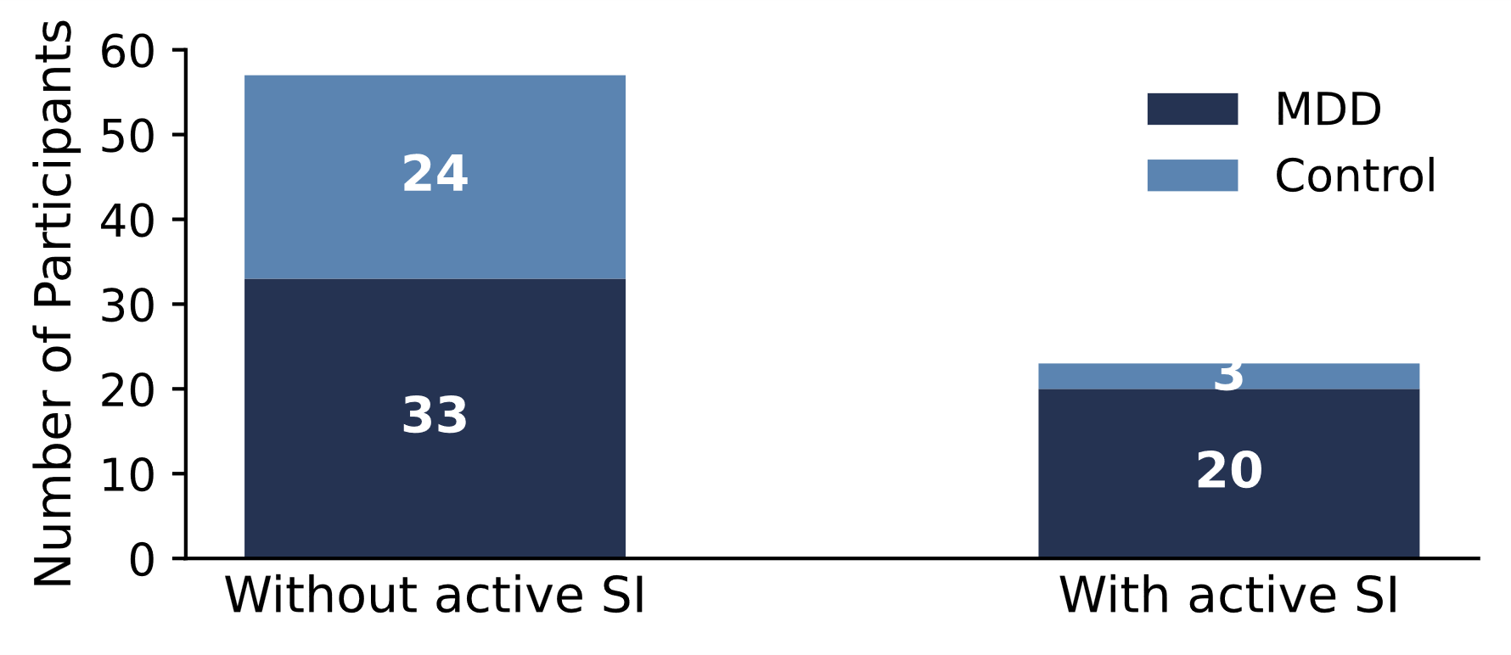
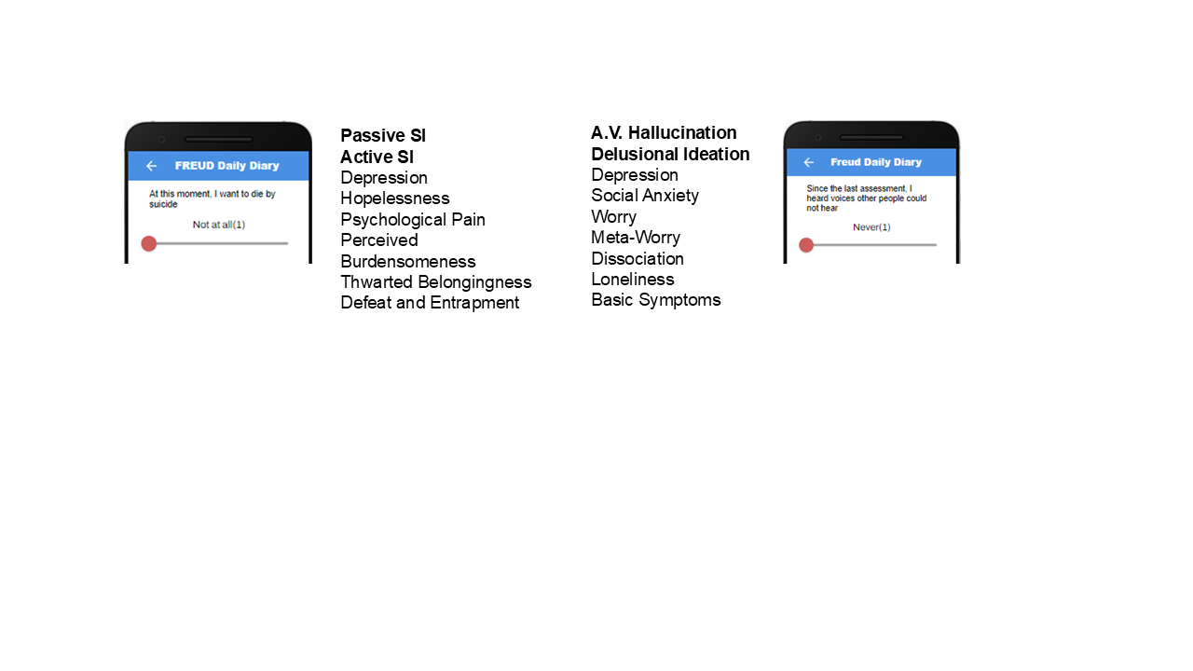
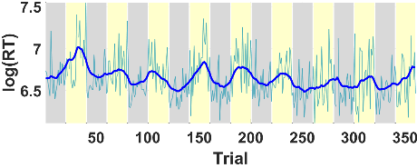
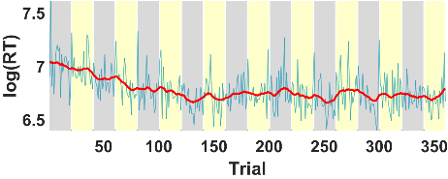
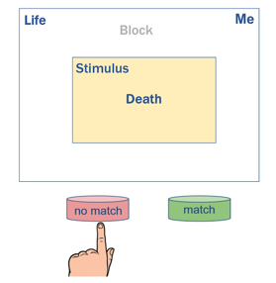
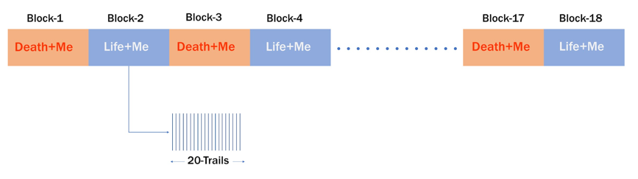
Figure 1.
C
Figure 1. Brief Death Implicit Association Task (BDIAT) and Ecological Momentary Assessment (EMA). (A) The BDIAT consists of 360 trials partitioned into 18 blocks of 20 trials, alternating between conflict (“Death + Me”) and non-conflict (“Life + Me”) blocks. Each trial lasts approximately 2.0 sec, with a 1.0 sec inter-trial interval, resulting in a total task duration of approximately 18 minutes. (B) Example trial from a “Life + Me” block. The category labels (“Life” and “Me”) appear at the top of the screen and remain fixed throughout the block, while the stimulus word changes on each trial. In this example, the stimulus is the word “Death”. Participants indicate whether the stimulus is semantically associated with either category label by responding “match” or “no match” using designated keyboard keys. In this case, the correct response is “match.” Reaction time (RT) and response accuracy are recorded on each trial. Participants are given up to 2.0 s to respond before the task advances to the next trial. Stimulus words (e.g., “I”, “They”, “Death”, “Life”) are randomly presented across trials. (C) EMAs, depicted here, were administered 3x/day and assessed suicidal ideation and related psychological symptoms (e.g., psychological pain). (D) Distribution of participants by suicidal ideation (SI) status and diagnostic group. Bars show the number of participants classified as with active SI or without active SI, stratified by major depressive disorder (MDD) and control groups. One participant from the without active SI group and two participants from the with active SI group were excluded from the analysis due to missing or censored data. A trial with very fast RT (RT < 350msec) is considered missing and a trial without response (RT > 2000msec) is considered censored. (E) Representative RT profiles from low-SI and high-SI participants. Log-transformed single-trial RTs are shown in light cyan, with the filtered RT trace shown in bold blue (in without active SI group) and bold red (in with active SI group). The filtering procedure imputes missing and censored data and attenuates noise arising from response jitter and motor variability. The RT patterns differ markedly between participants: the with active SI participant shows a clear modulation in RT at block transitions, consistent with altered conflict adaptation relative to the low-SI participant.

E
D
B
A
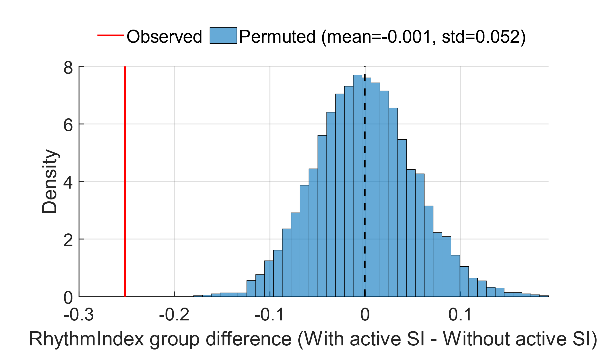
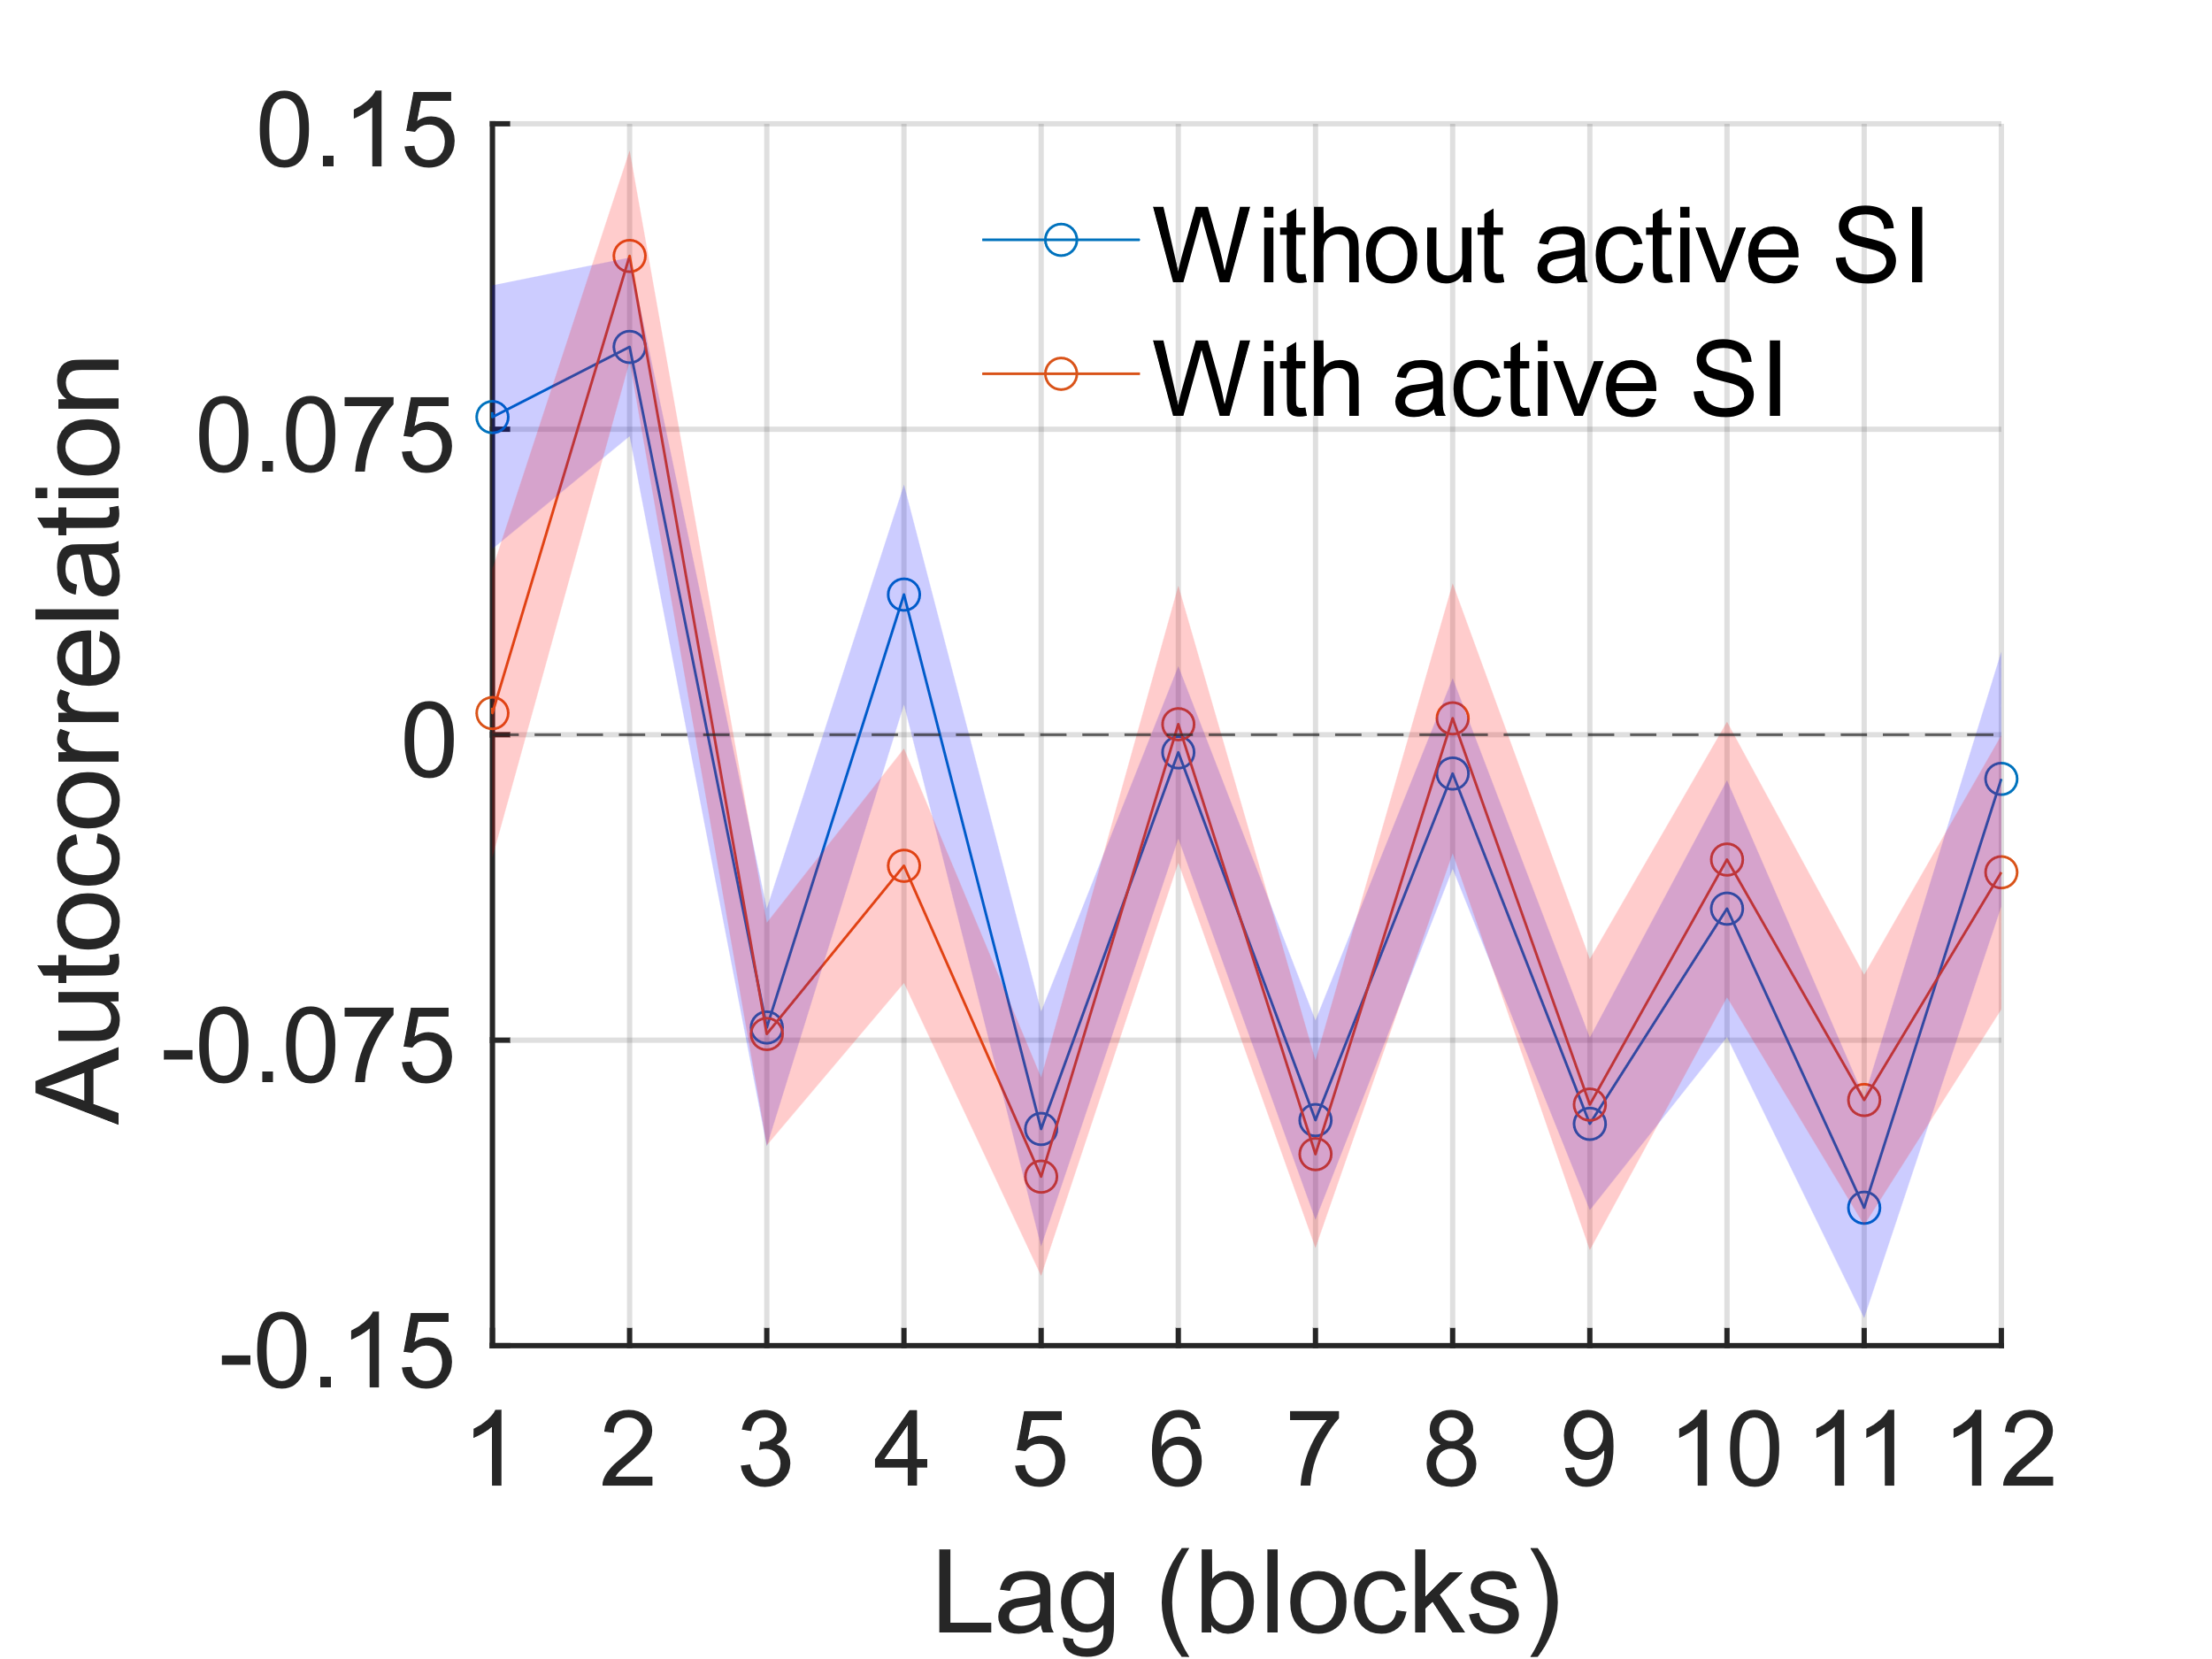
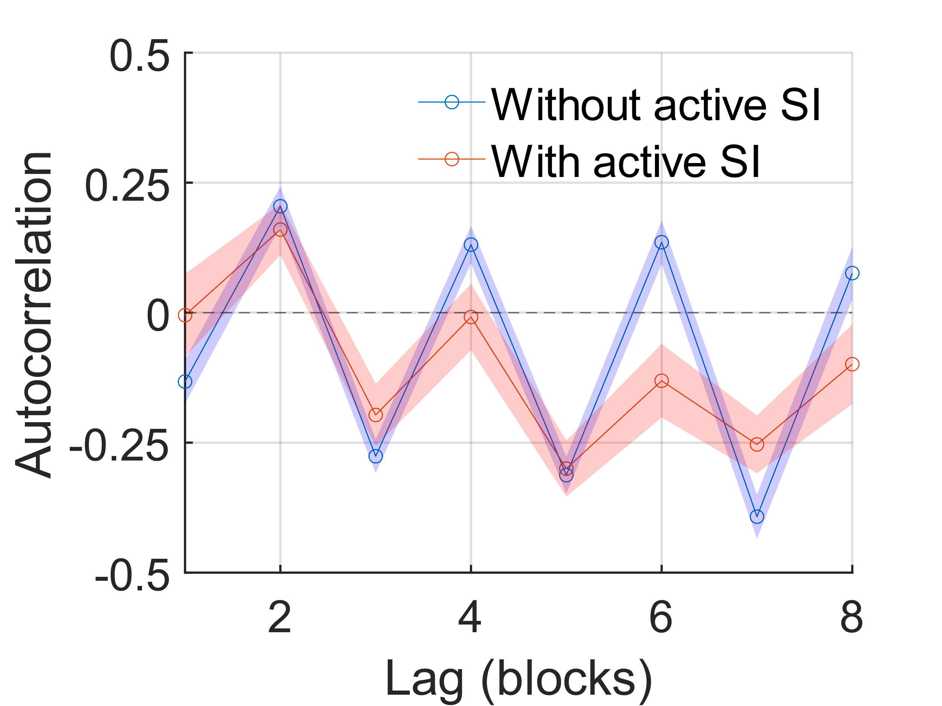
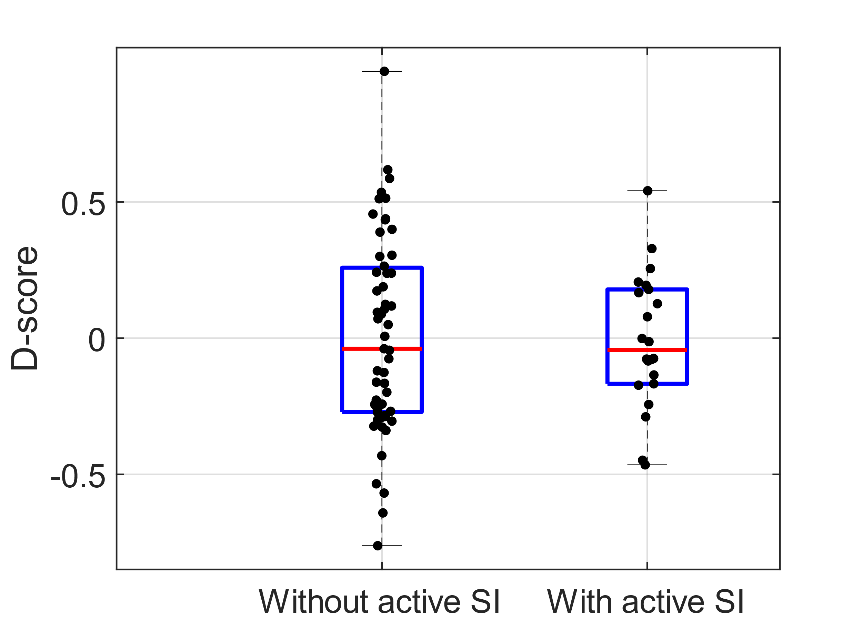
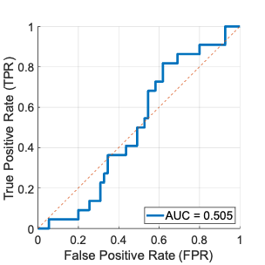
Figure 2.
E
Figure 2. D-score Prediction Performance and Block-level Temporal Structure. (A) Scatter plot (or bar plot?) of D-scores for participants with active versus without active suicidal ideation (SI). The substantial overlap between groups indicates minimal discriminative power. (B) Receiver operating characteristic (ROC) curve for SI classification based on the D-score. To evaluate the predictive utility of the traditional D-score, participants were classified as with active SI group if their D-score was greater than zero (D > 0). The area under the curve (AUC = 0.505) suggests near-chance predictive performance based on D-score statistics. These metrics include a True Positive Rate (Sensitivity) of 40.9% and a False Positive Rate (1 - Specificity) of 49.1%. (C) Block-level autocorrelation (ACF) across eight lags, computed using mean reaction time (RT) for each block RTs were mean-centered and linearly detrended at the participant level before autocorrelation step. Participants with without active SI show a pronounced rhythmic pattern, characterized by positive correlations at even lags and negative correlations at odd lags, consistent with entrainment to the alternating block structure. In contrast, participants with active SI exhibit weaker and short-lived autocorrelation, present for only one to two lags. (D) When block order is permuted, the group difference in the rhythm index falls within a null distribution centered near zero. The observed difference from the true data (red line) lies outside this distribution, confirming that the rhythmic structure seen in (C) depends on the task-defined block arrangement rather than nonspecific temporal dependencies. (E) ACF from an independent online implementation of the BDIAT using shorter blocks (10 trials per block, 36 alternating “Death + Me” and “Life + Me” blocks). Reaction times were detrended and mean-centered within participants prior to analysis. Despite differences in task length, experimental control, and the absence of EMA-based grouping, the block-level ACFs exhibit a similar oscillatory structure to the primary study, indicating robust rhythmic entrainment to block alternation across task variants and data-collection settings.
C
B
A
D
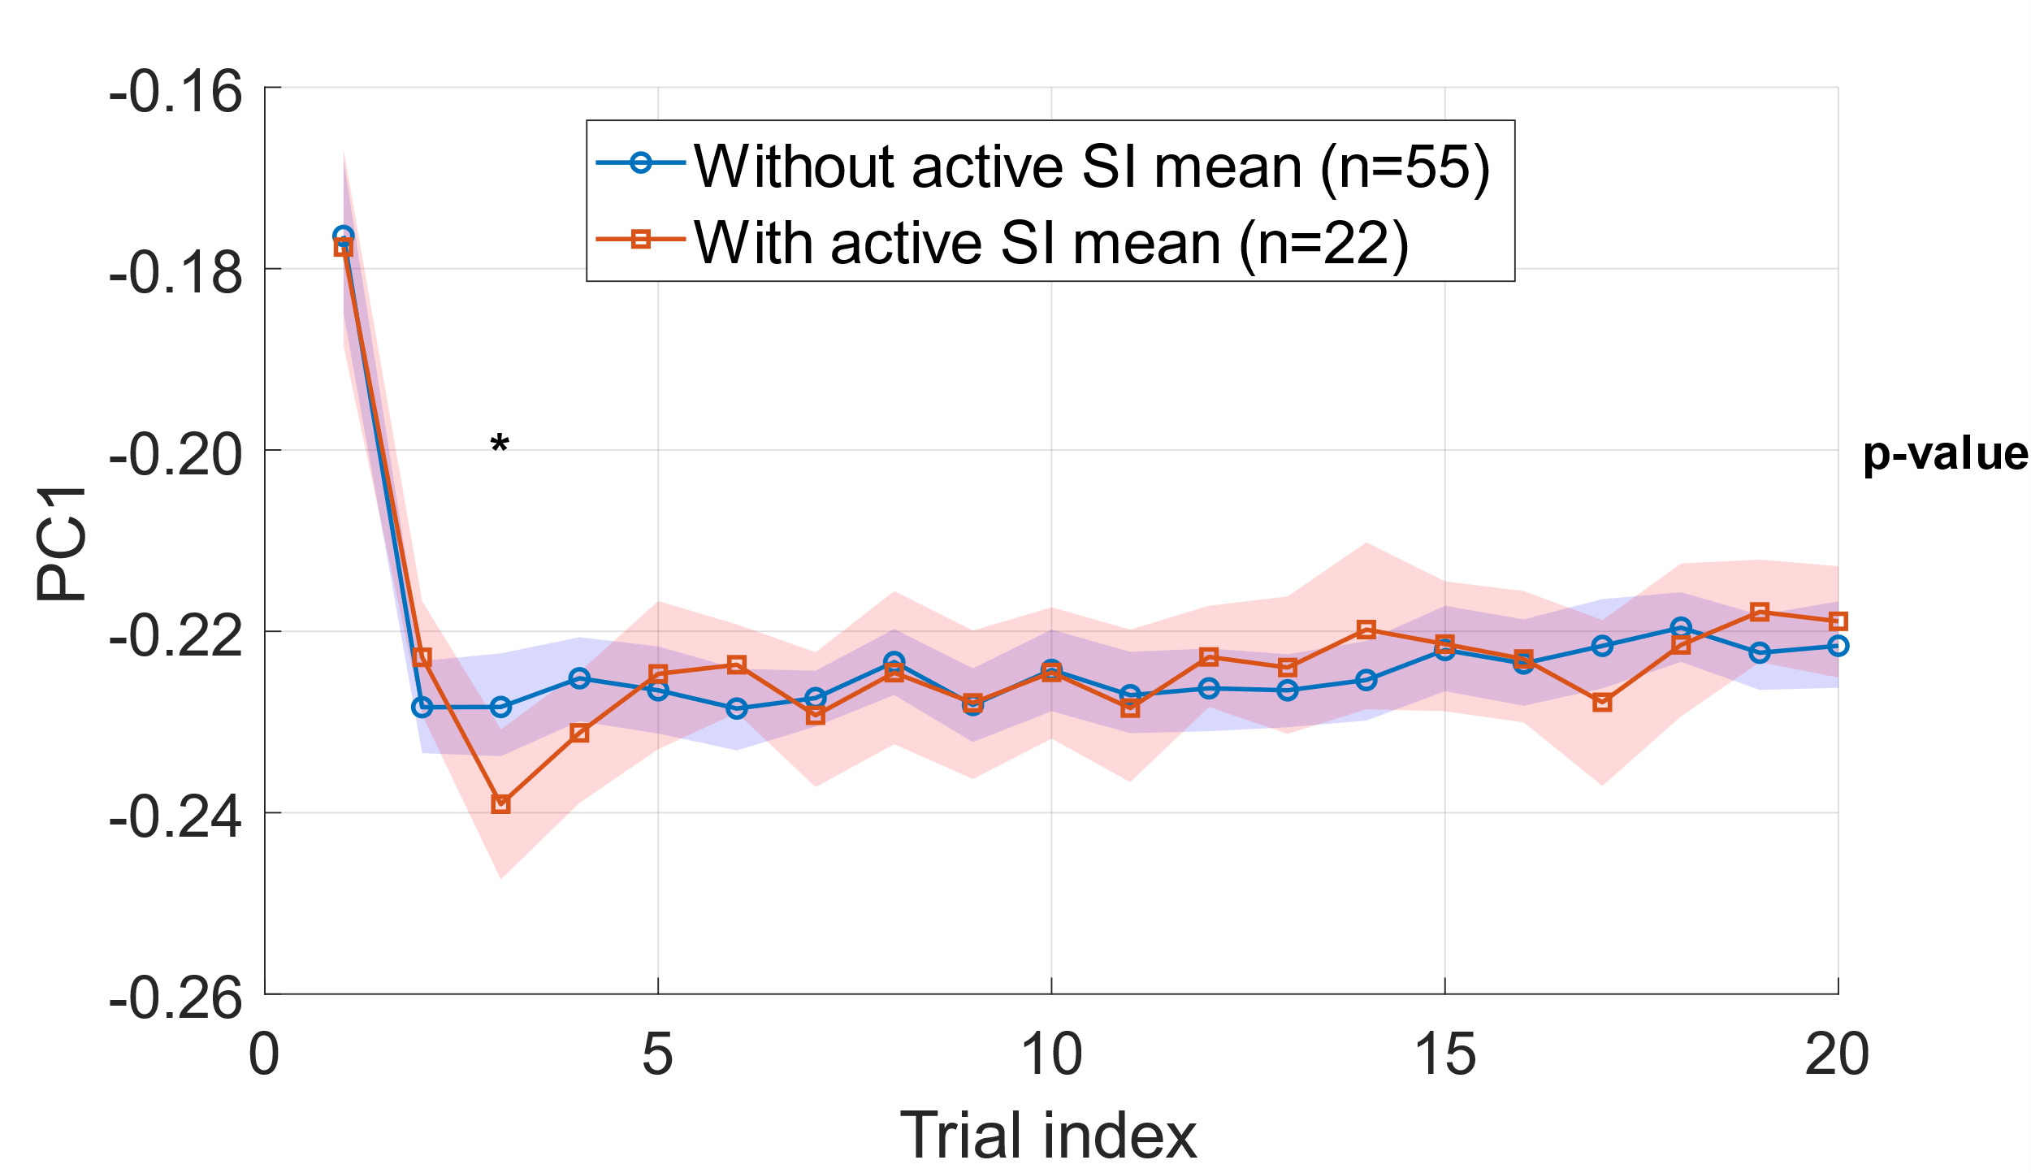
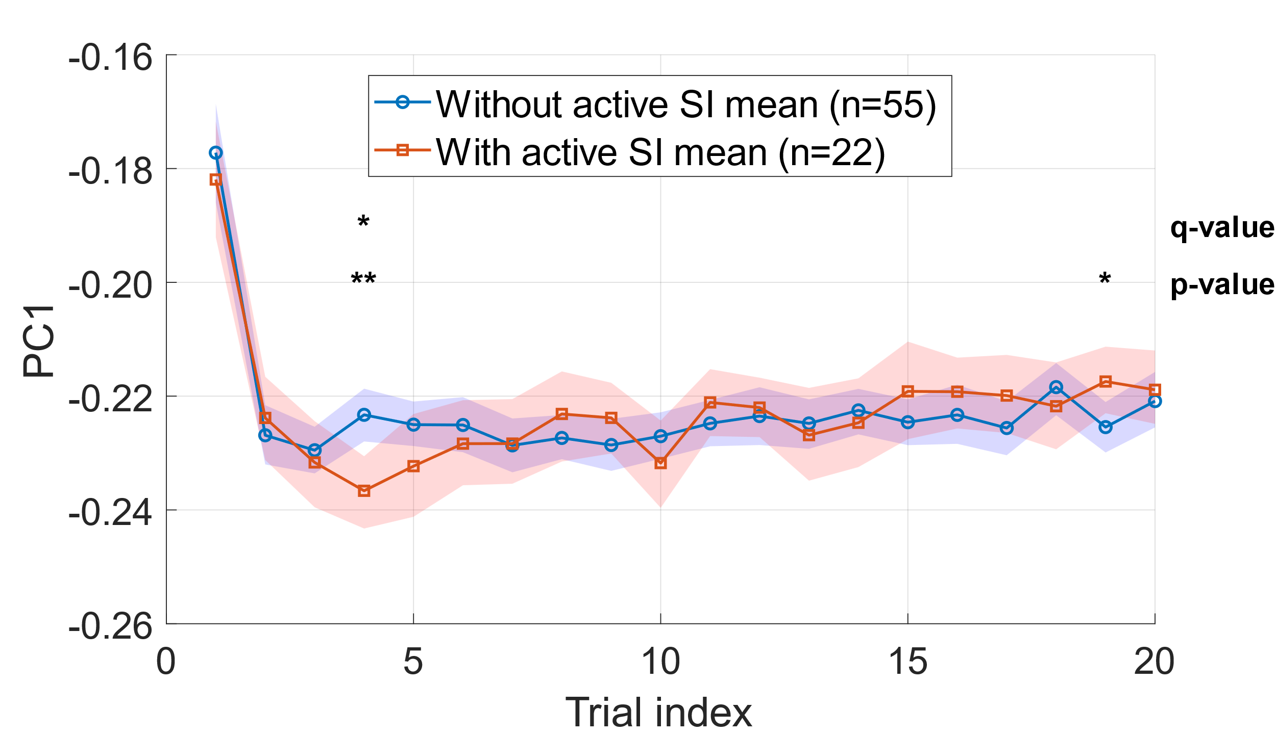
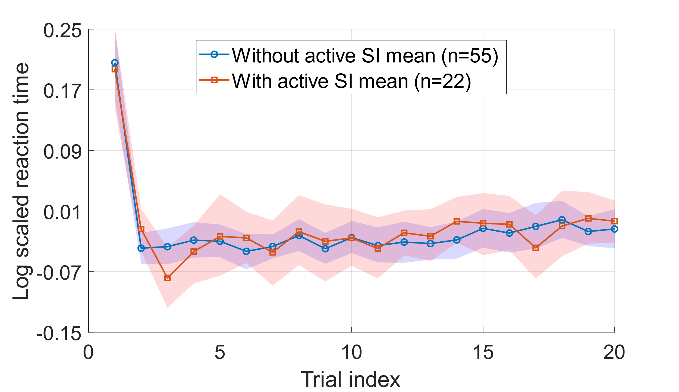
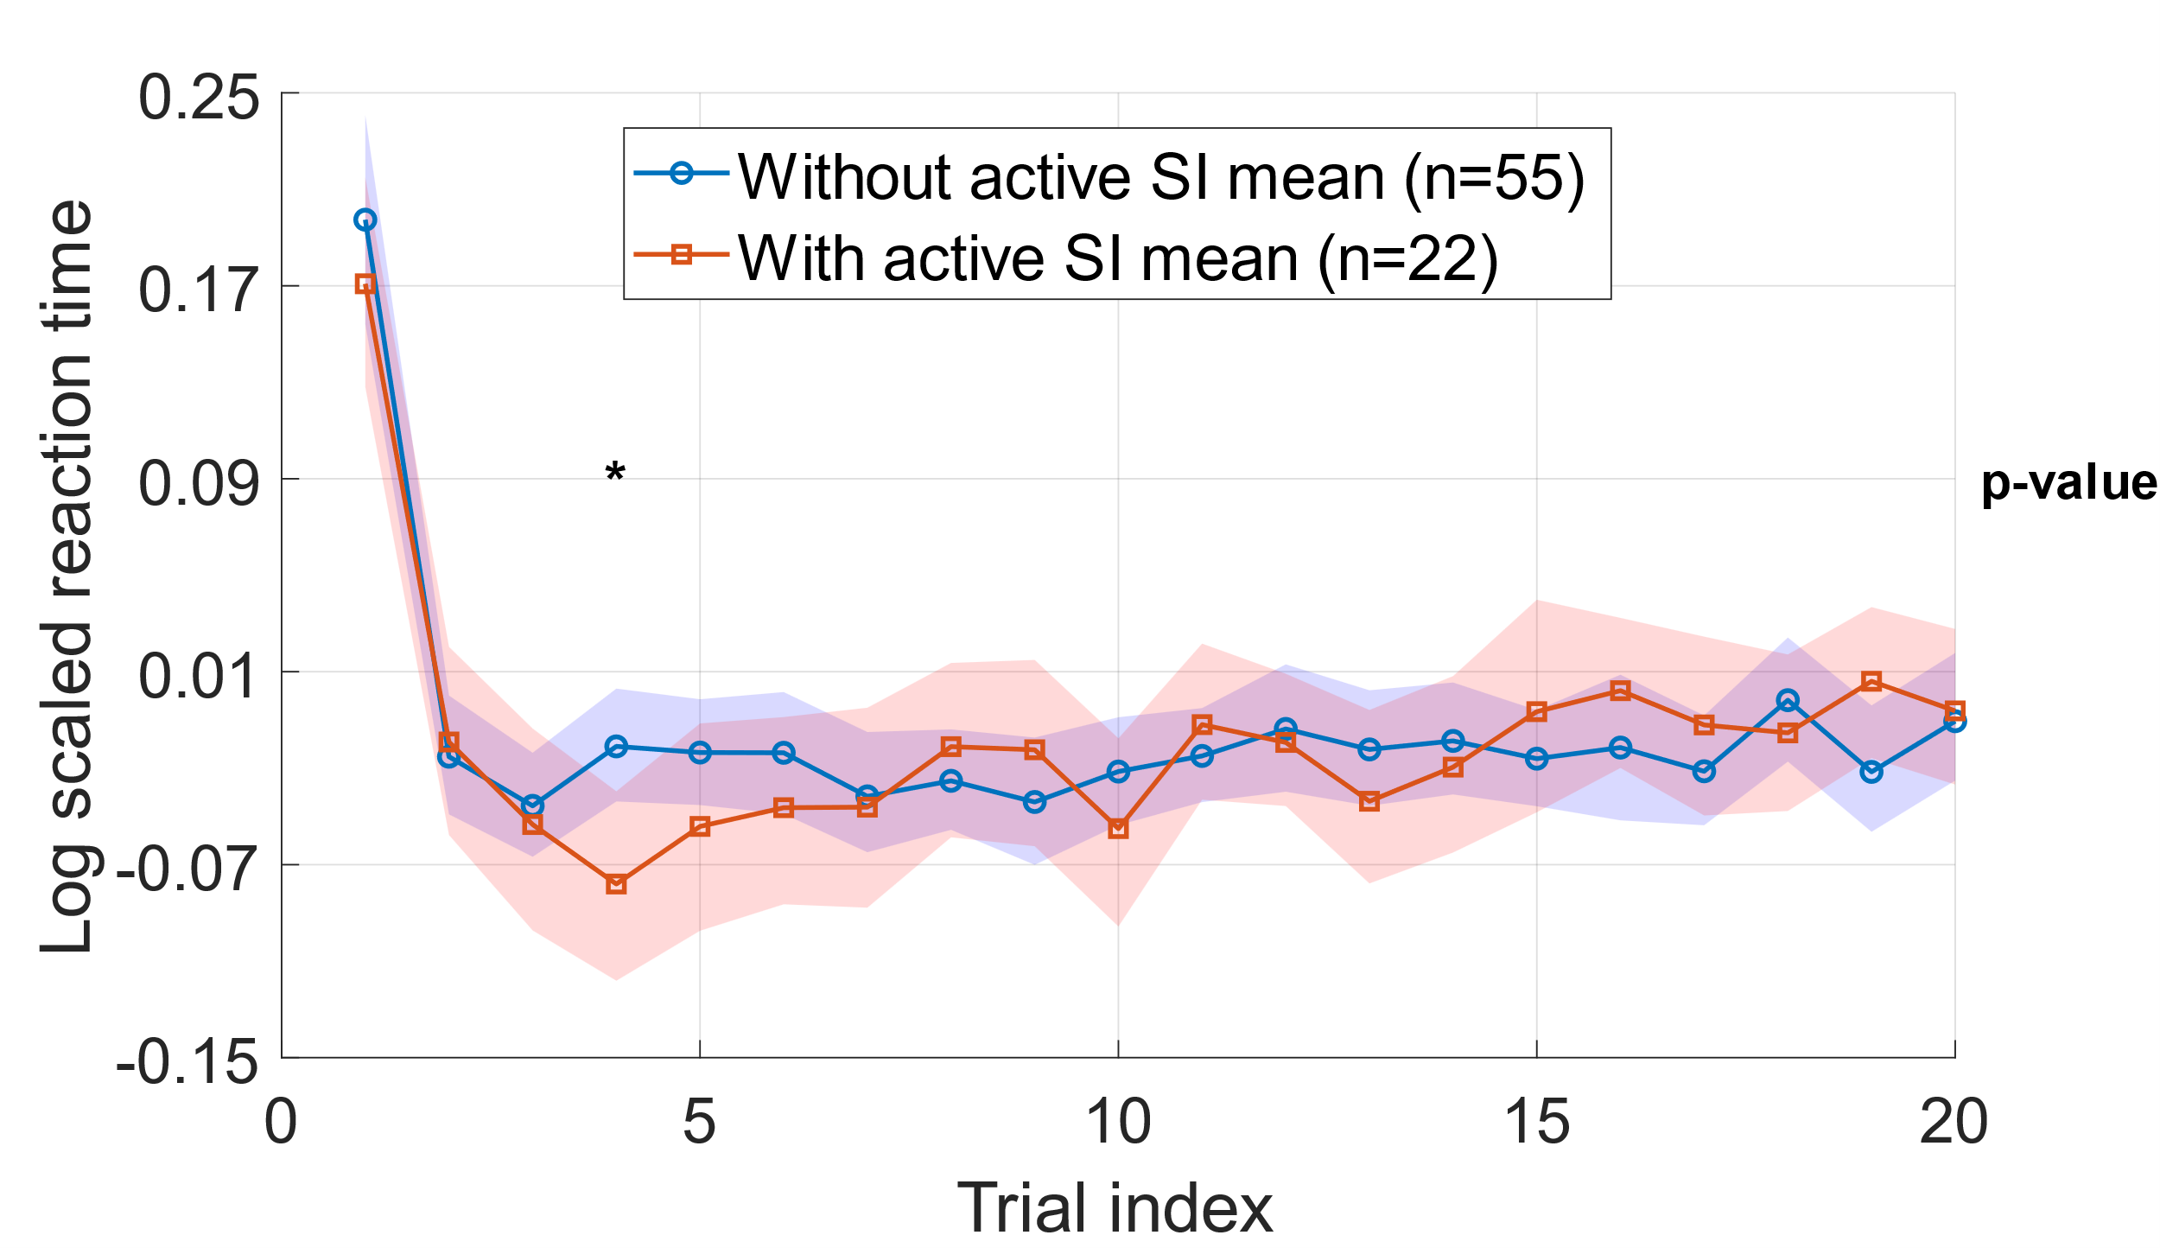
Figure 3.
B
D
C
A
Figure 3 Evidence for Temporal Encoding of Suicidal Ideation (SI) State in Reaction Time (RT). (A) Mean of log of RT-scale across trials in the “Death + Me” blocks, shown separately for with and without active SI groups. Both groups display a pronounced elevation on the first trial followed by rapid decay toward baseline, consistent with an initial switch cost. Although the trajectories show descriptive divergence at several positions, none of the trial-wise differences survive correction for multiple comparisons (see SI Appendix, Fig. S5D for corresponding p- and q-values). (B) Mean of log of RT-scale across trials in the “Life + Me” blocks, displayed in the same patten as in A. Here, both groups show a rapid normalization after the first trial, with little evidence for systematic separation across the remainder of the trials (see SI Appendix, Fig. S5B). (C) Mean of the first principal component (PC1) computed from trial trajectories in the Death + Me blocks after applying a monotonic nonlinear transformation and performing uncentered PCA. PC1 captures a coordinated temporal motif that closely mirrors the early-trial divergence suggested in A, with the largest group separation emerging around trial 4 (trial-resolved statistics are provided in SI Appendix, Fig. S5C) (D) Same analysis as in C but for the “Life + Me” blocks. In contrast to the “Death + Me” condition, the PC1 elements show weaker and less temporally localized group differentiation (SI Appendix, Fig. S5D). Note that positive values on the RT-scale indicate higher reaction times (slower responses) relative to the personalized baseline, while negative values indicate faster responses.
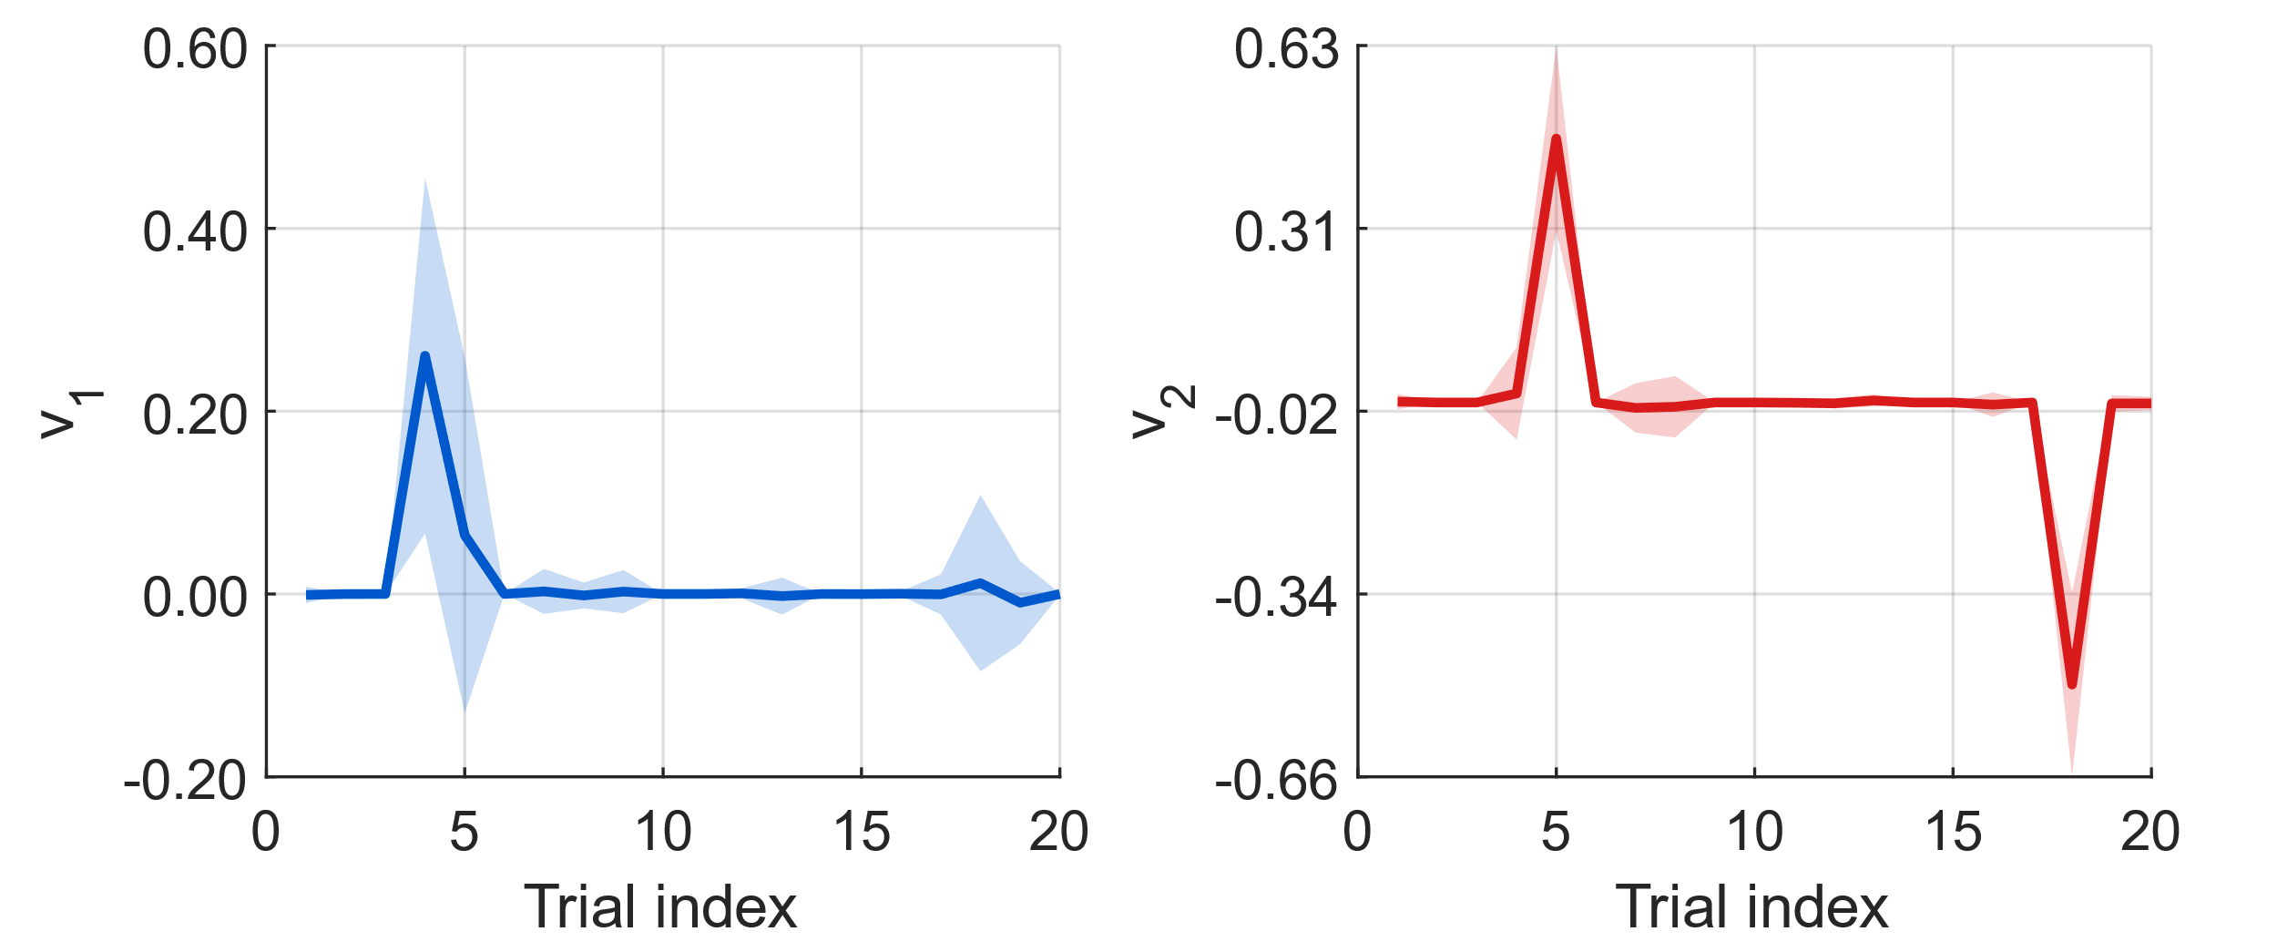
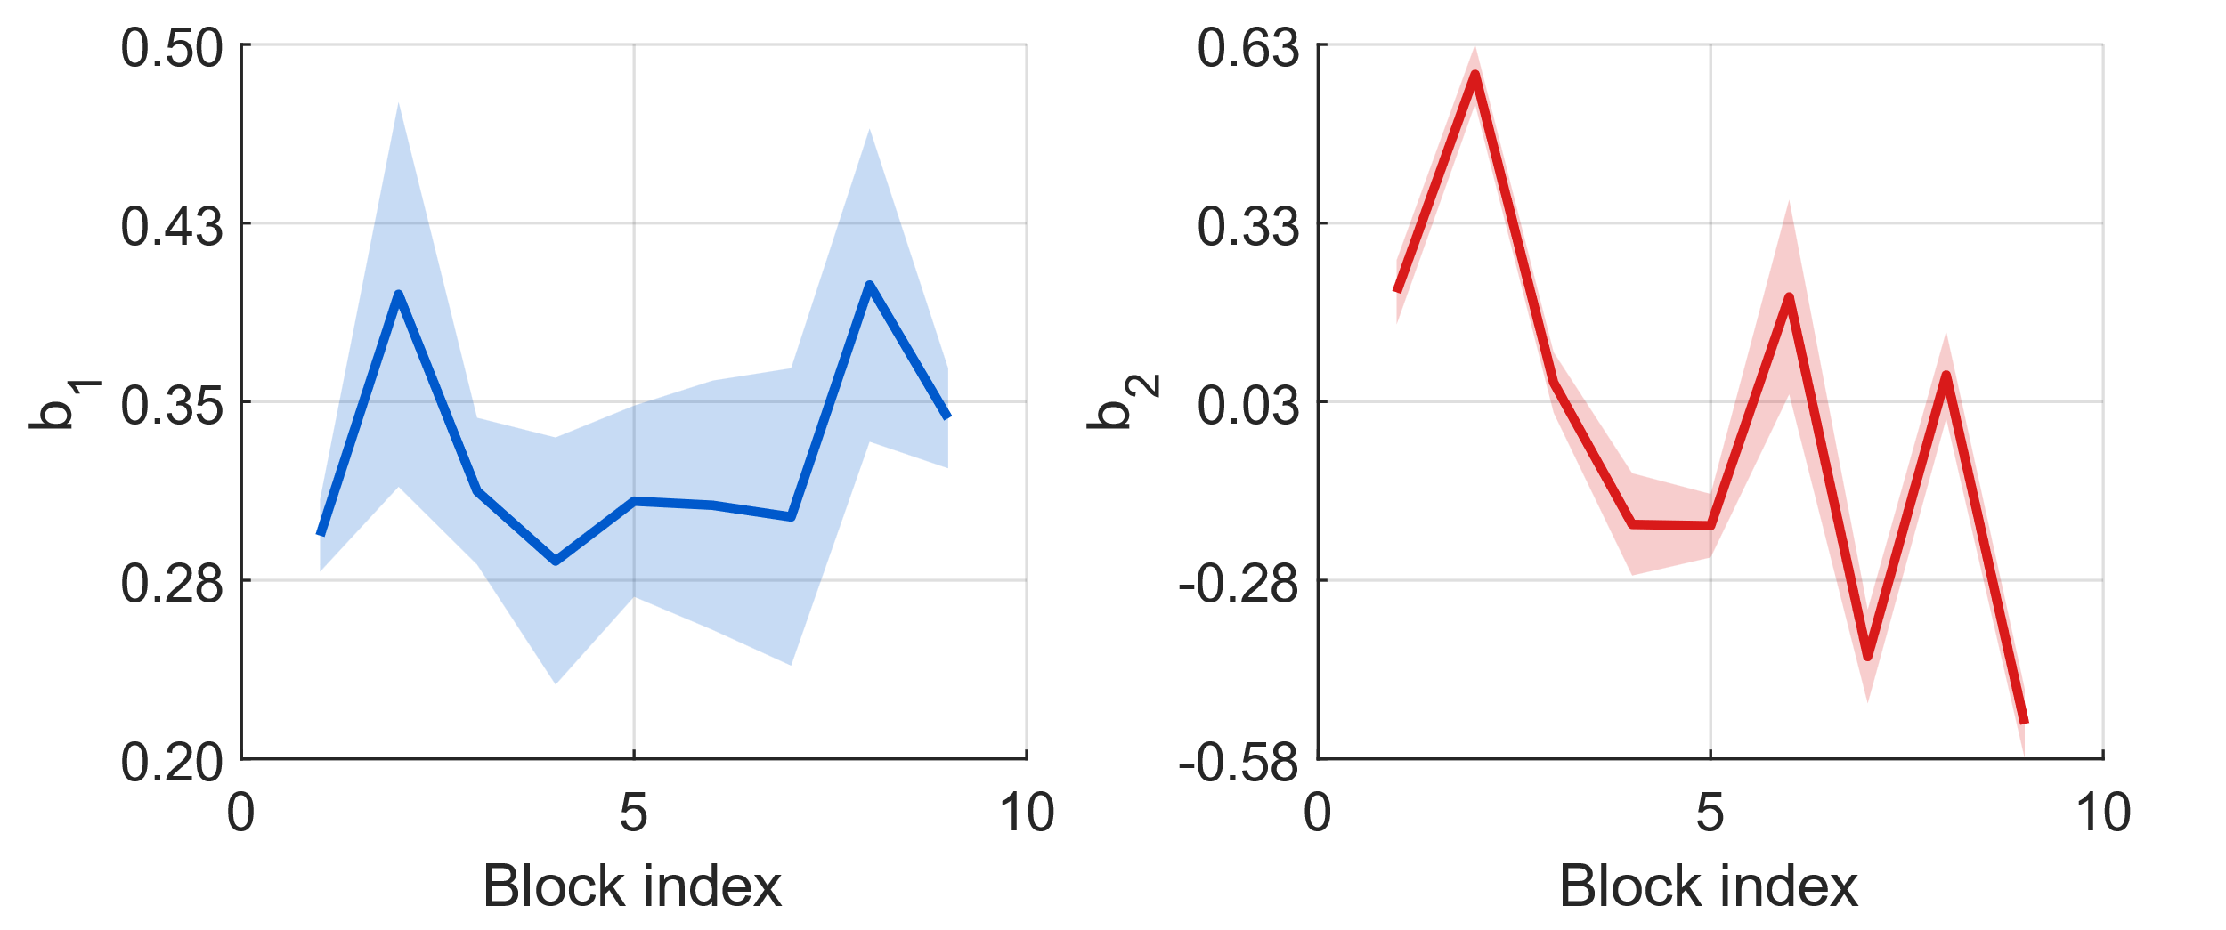
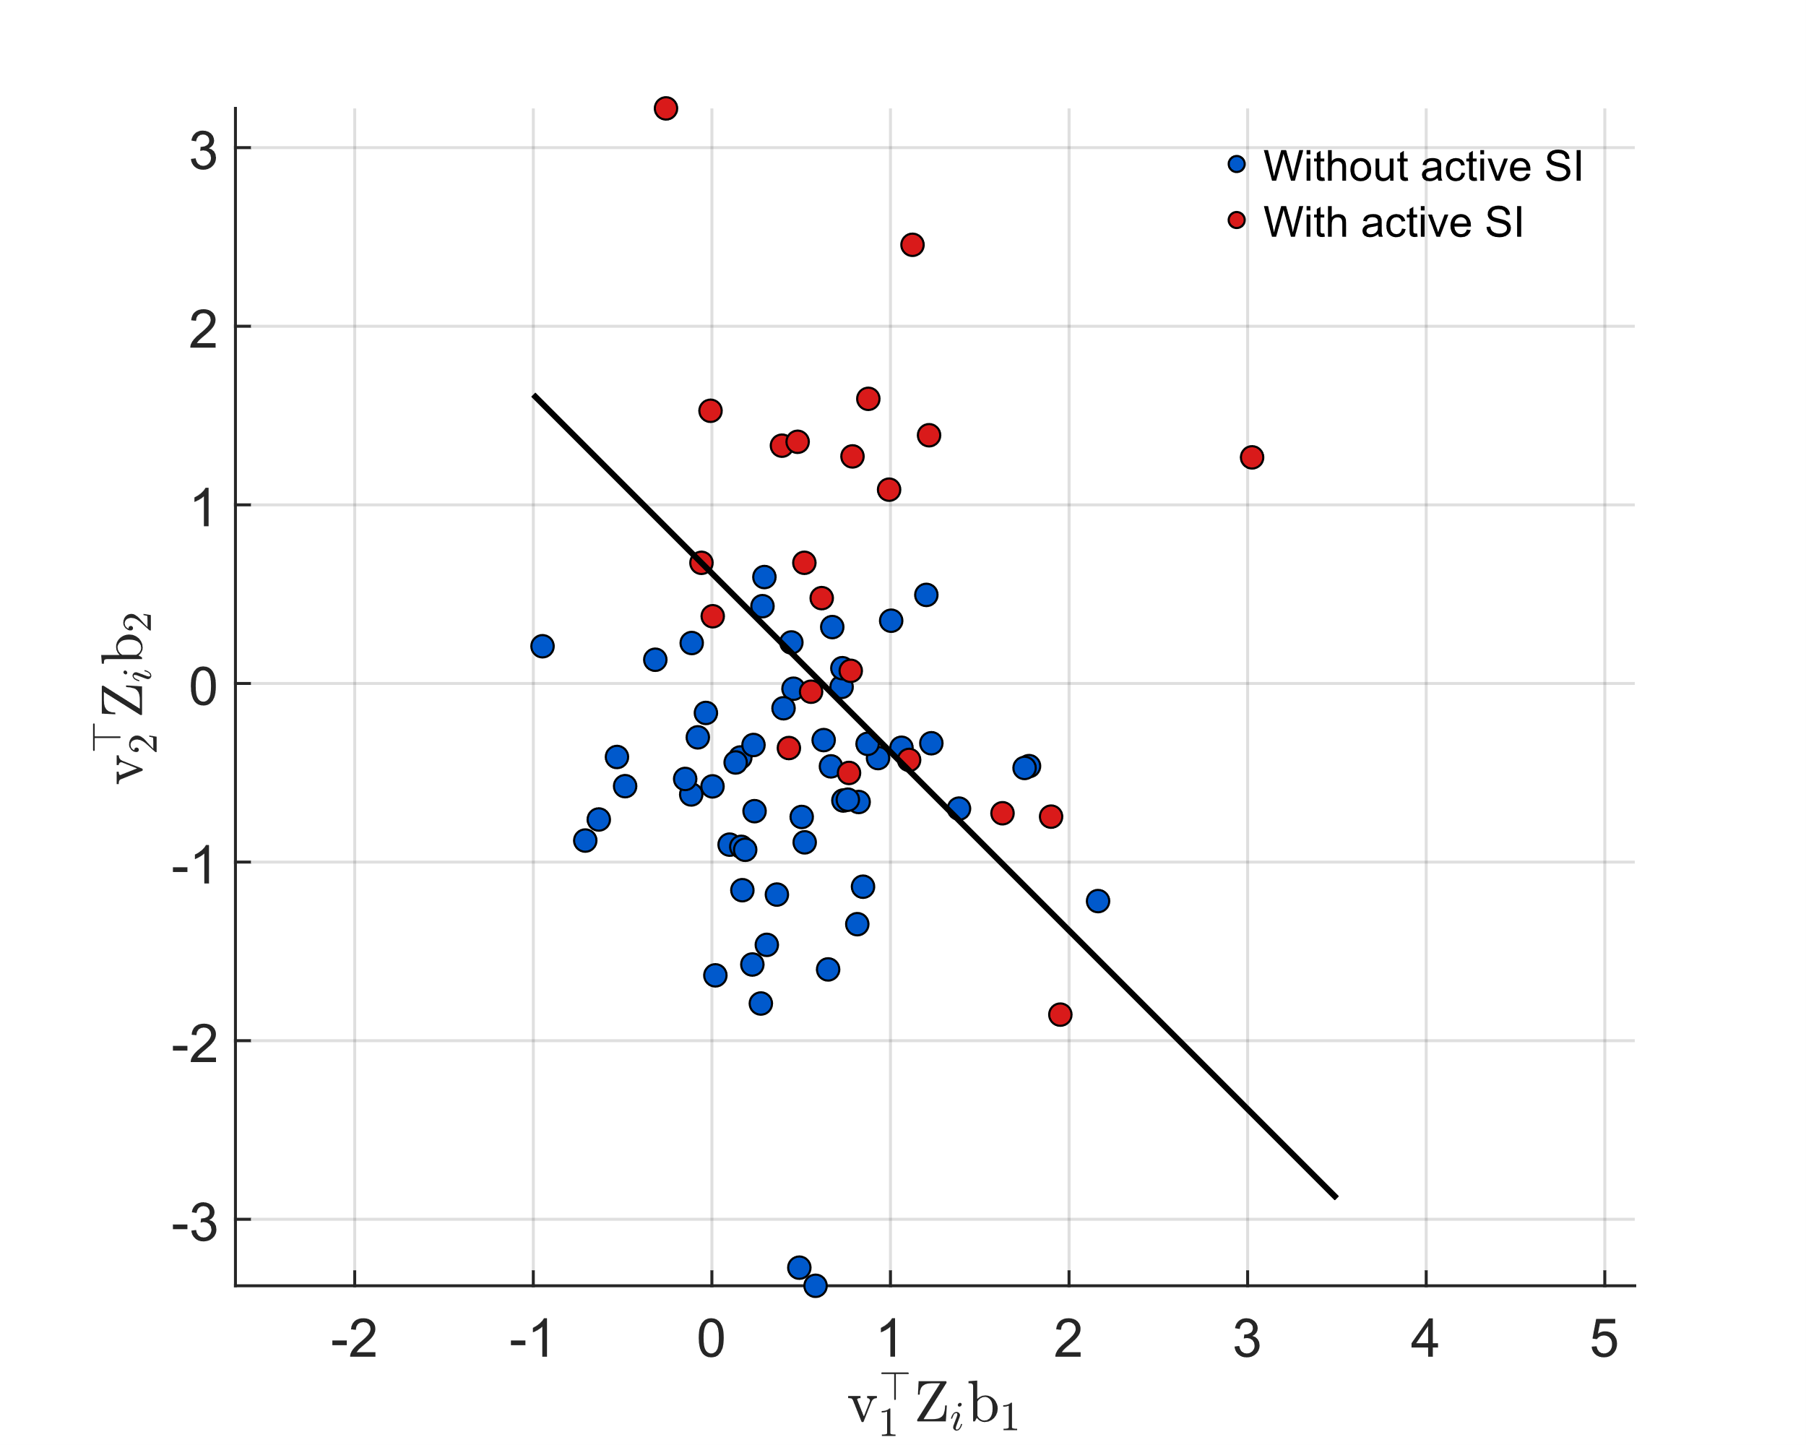
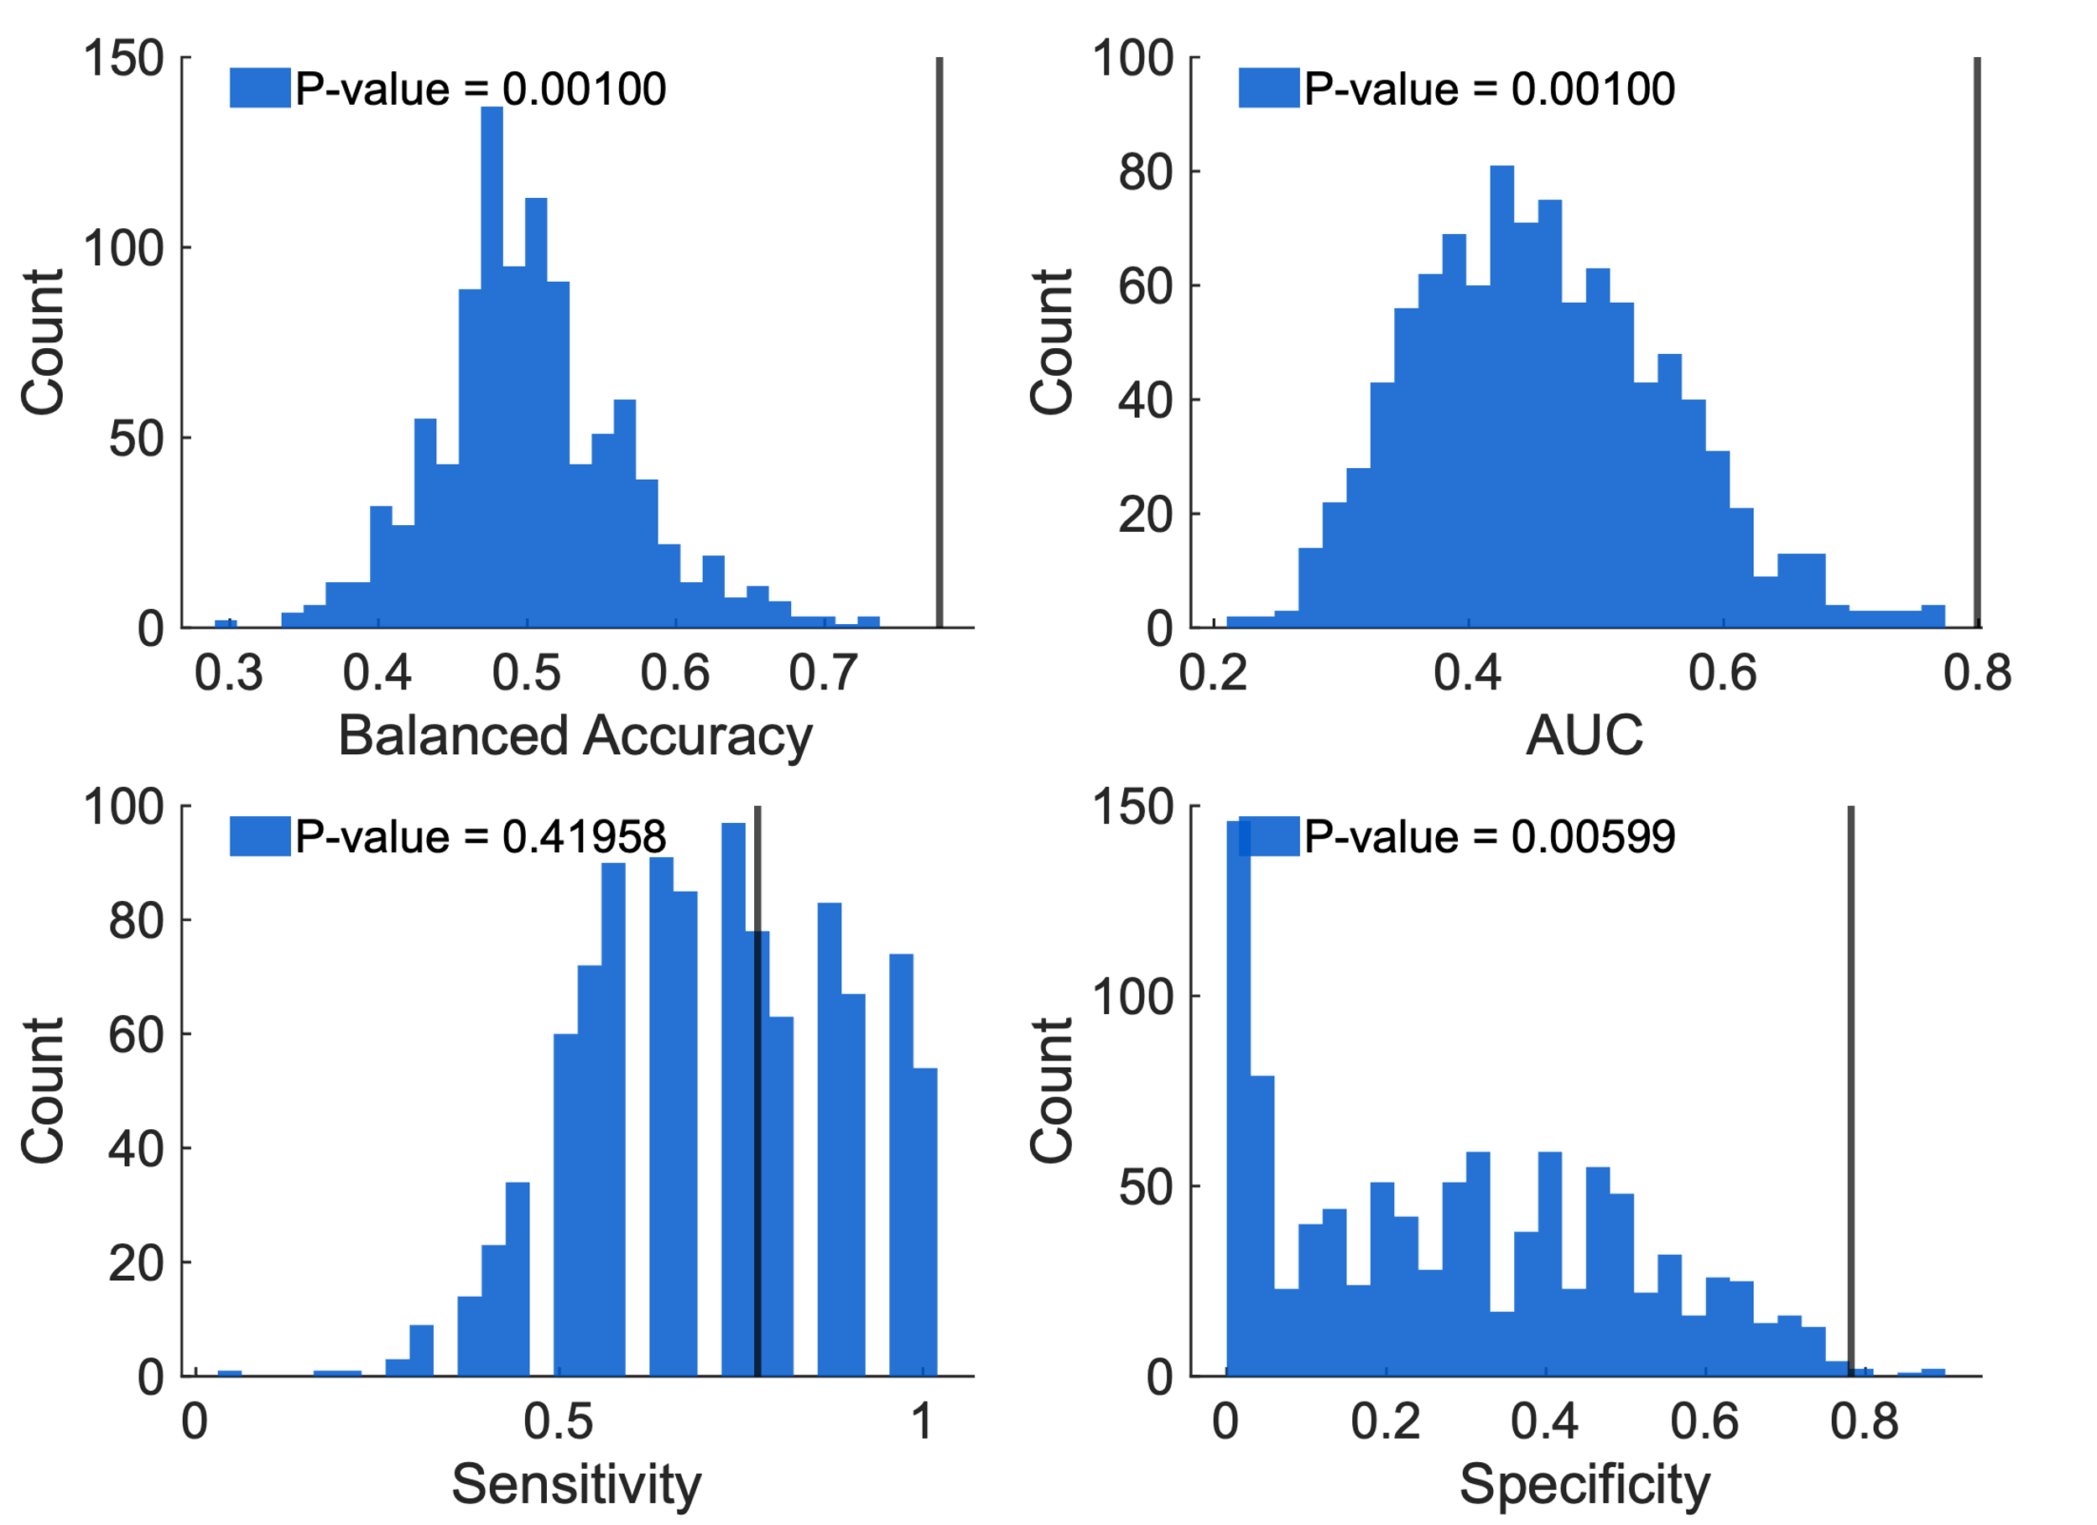
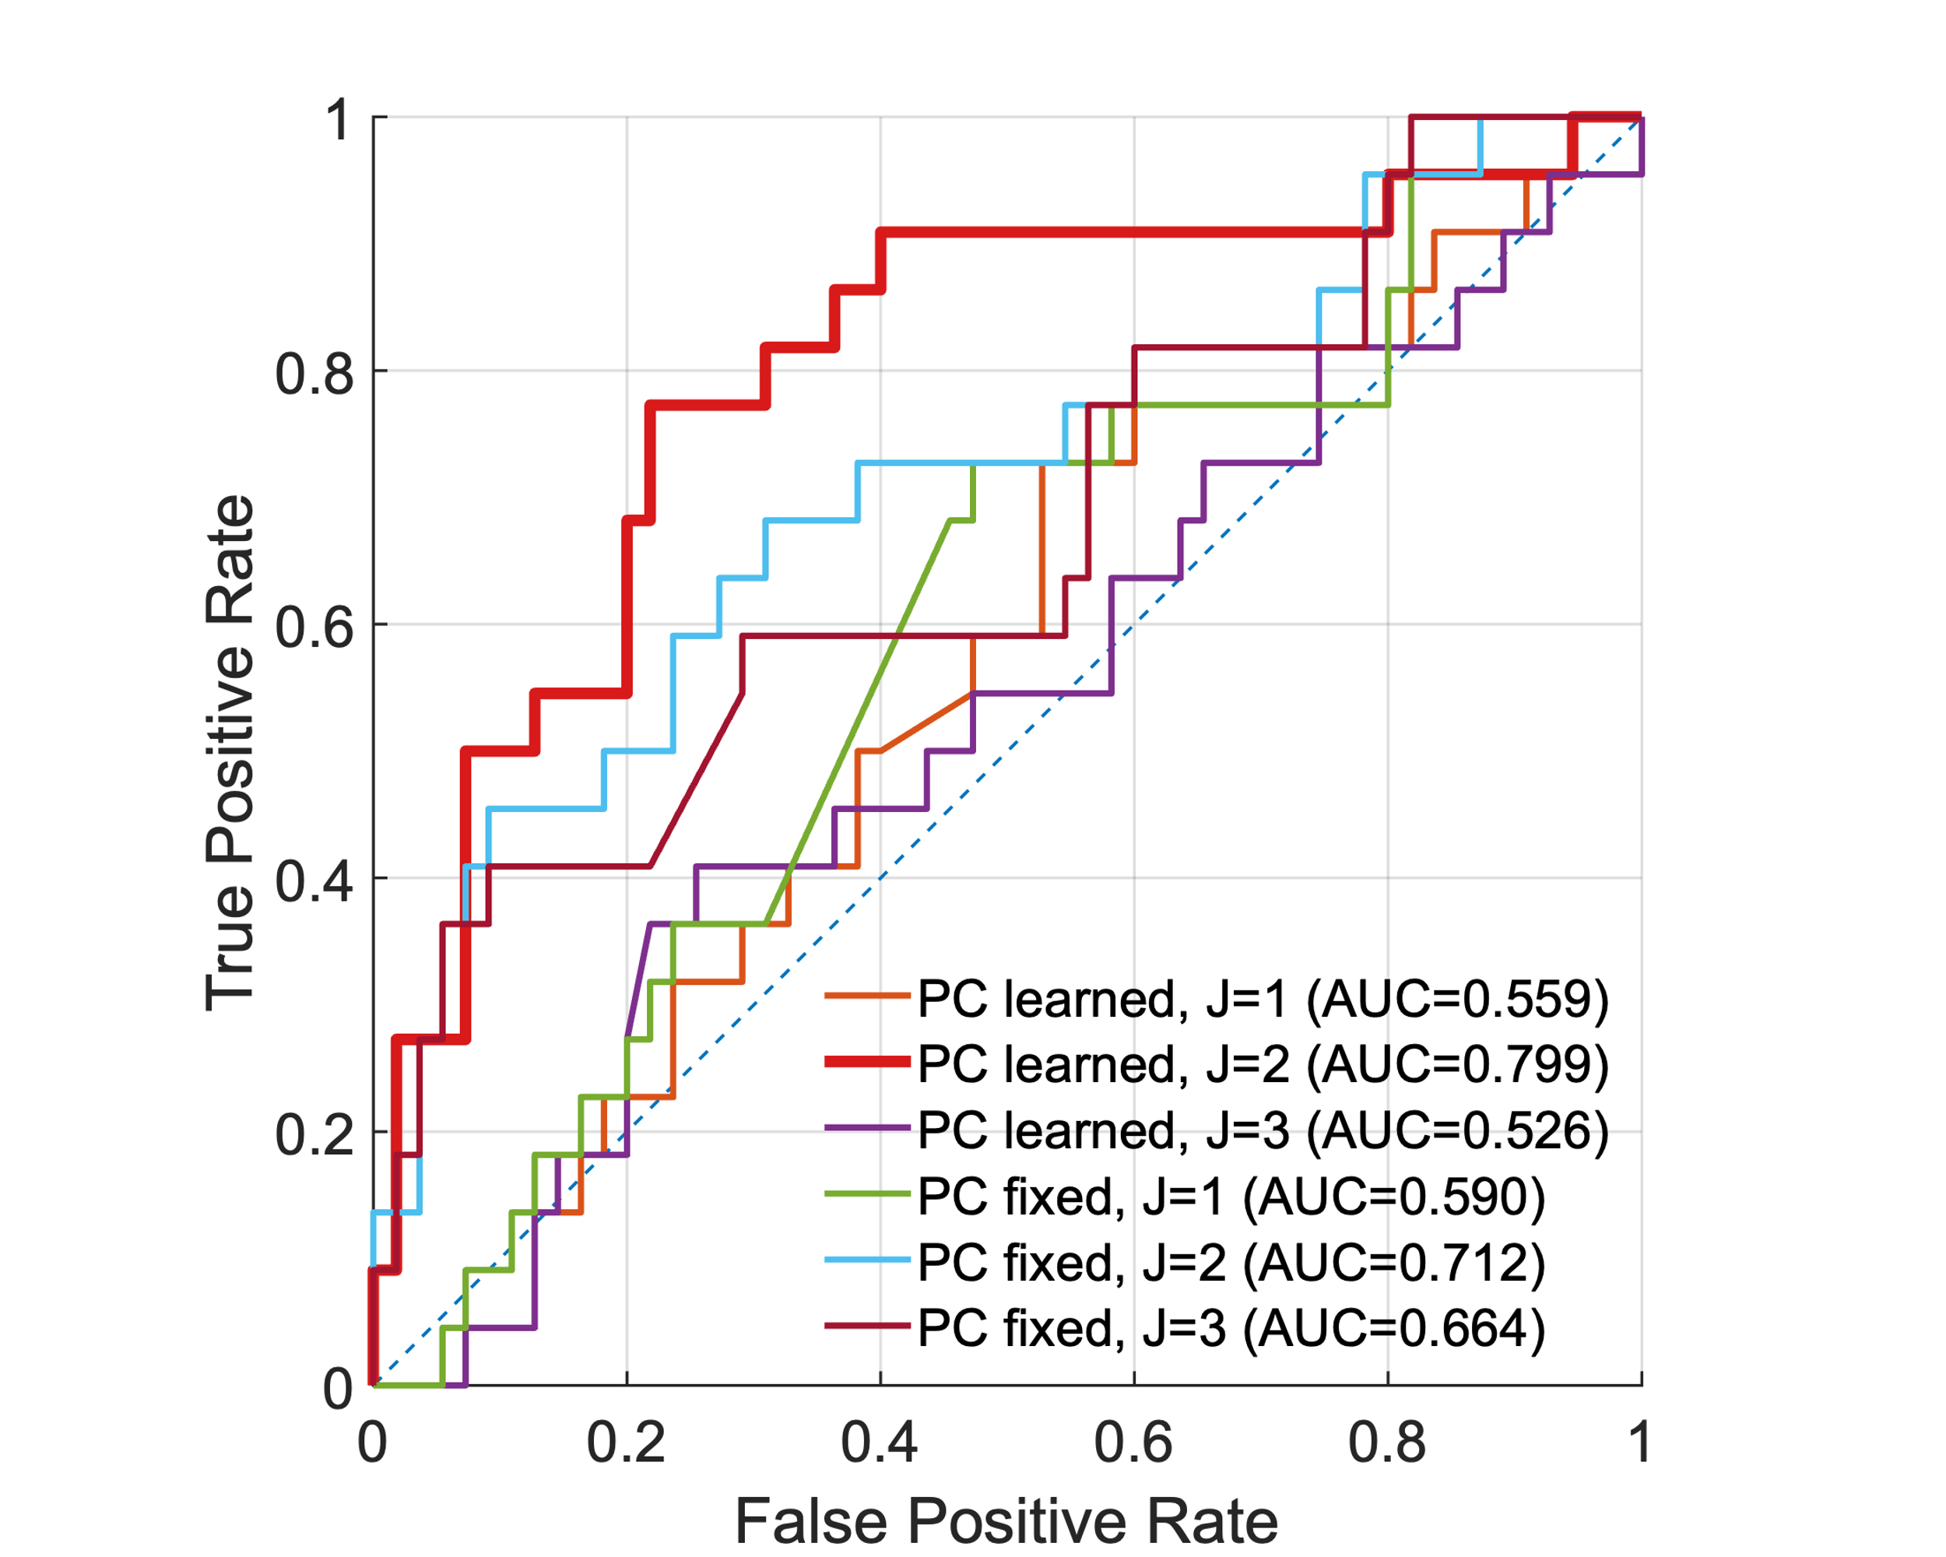
Figure 4.
D
C
E
A
B
Figure 4 SI State, With Active vs Without Active, Classification Using Spatio-Temporal Pattern in Reaction Time (RT) Series. (A) Receiver operating characteristic (ROC) curves for classifiers with $J=1,2,$and $3$ spatiotemporal components using the bilinear logistic regression classifier described in the Materials and Methods, Bilinear Logistic Regression Classifier. evaluated using leave-one-out cross-validation (LOOCV). The model with $J=2$ achieves the best performance (AUC = 0.79), while models with fewer or additional components perform substantially lower than the model with J=2. Baseline models using fixed principal component (PC) block-level weights are shown for comparison. These results indicate that directions capturing maximal variance in RTs (fixed PCs) do not reliably encode SI state, whereas the learned bilinear components yield a balanced accuracy of 77%. (B) Joint distribution of participant-level projections onto the two learned components, $v_{1}^{T}Z_{i}^{(-α)T}b_{1}$ and $v_{2}^{T}Z_{i}^{(-α)T}b_{2}$ aggregated across all LOOCV folds. Points are colored by SI state, with the corresponding decision boundary shown. (C) Learned temporal weight vectors ($v_{j}$): These vectors specify the relative contribution of individual trials (1–20) within a block. The first component ($v_{1}$) emphasizes early trials, specifically Trial 4, while the second ($v_{2}$) shows contributions from both early and late trials. (D) Learned block-loading vectors ($b_{j}$): These vectors represent the weighting across the nine "Death + Me" blocks. The first component ($b_{1}$) shows relatively uniform block contributions, while the second ($b_{2}$) varies substantially across blocks, indicating a block-specific temporal encoding pattern. (E) Null distributions for significance: Empirical distributions of balanced accuracy and AUC from 1,000 label permutations. Vertical lines denote observed performance under true labels, which exceed the 95th percentile of the null distributions ($p < 0.001$), confirming the model captures genuine behavioral signatures of near-term suicide risk.

