Singapore University
of
Social Siences

Name: | Date:
Course Code : | Title of the TMA :
SUSS PI No :

Tecnical Information

- Unity Version :

2021.3.21f1

- Target Platform:

Android 8.0+

- Packages/Plugins:

Vuforia Engine AR (10.14.4)
JetBrains Rider Editor (3.0.18)
Test Framework (1.1.31)
TextMeshPro (3.0.6)
UnityUI (1.0.0)
VersionControl (2.0.1)
VisualScripting (1.0.8)
VisualStudioCodeEditor (1.2.5)
VisualStudioEditor (2.0.17)

- Assets:

Statue model: https://sketchfab.com/3d-models/low-poly-statue-5e7b33ada6534c95a9bc3144e86daa5c

Painting frame model: https://www.cgtrader.com/products/pears-poster
Painting: https://upload.wikimedia.org/wikipedia/commons/thumb/e/ec/Mona_Lisa%2C_by_Leonardo_da_Vinci%2C_from_C2RMF_retouched.jpg/1200px-Mona_Lisa%2C_by_Leonardo_da_Vinci%2C_from_C2RMF_retouched.jpg

- Audio:

Generated with: https://www.voicebooking.com/en/free-voice-over-generator

- Target Images

Painting and Statue: Flaticon.com

- Scripts:

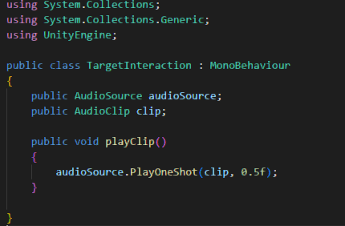
TargetInteraction.CS

- UML
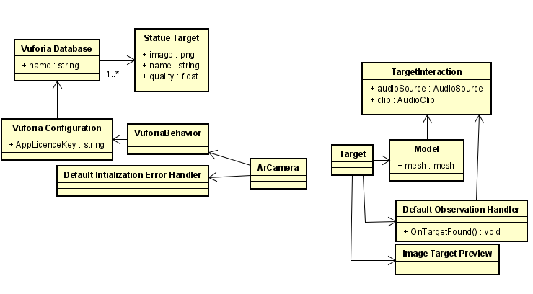
This app can be divided into two parts; target acquisition and target rendering. Target acquisition utilizes the ArCamera preset from the Vuforia SDK Package. The ArCamera checks the database generated on the Vuforia website for the targets registered in the database. Once a valid target is found, we can move to the target rendering section. When rendering the model, we can use models and additional scripts to add effects to the model. Once the model is rendered, the additional scripts can generate animations, lighting effects, sound effects and much more.

- Screenshots

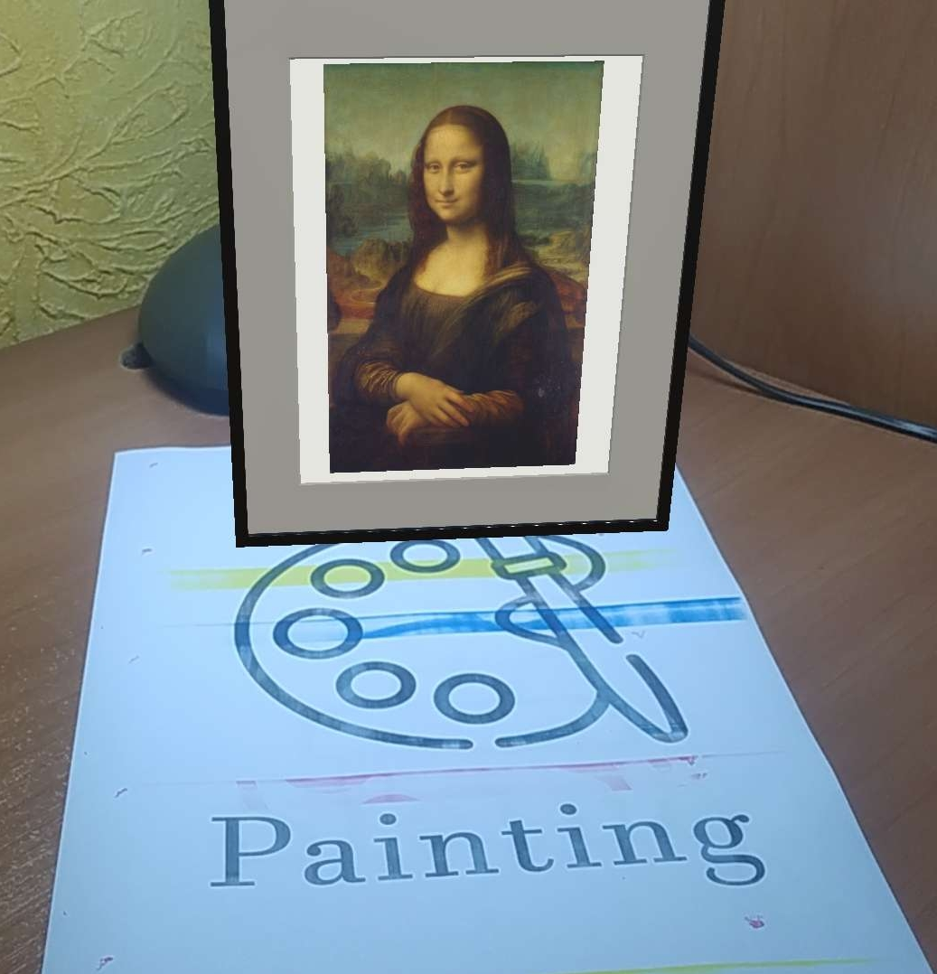

Image 1: This image is an in app screenshot showing a scan of the painting
target being made. A model of the Mona Lisa is being imposed over the
target.

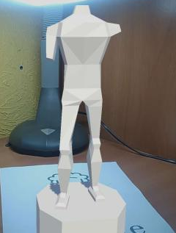
Image 2: This image is an in app screenshot showing a scan of the statue
target being made. A model of a low poly statue is being imposed over the
target.

