Singapore University
of
Social Siences

Name: | Date:
Course Code : | Title of the TMA :
SUSS PI No :

Tecnical Information

- Unity Version :

2021.3.21f1

- Target Platform:

Windows

- Packages/Plugins:

MockHMD XR Plugin (1.3.1-preview.1)
JetBrains Rider Editor (3.0.18)
OpenXR Plugin (1.6.0)
Test Framework (1.1.31)
TextMeshPro (3.0.6)
Tutorial Framework (3.1.1)
UnityUI (1.0.0)
VersionControl (2.0.1)
VisualScripting (1.0.8)
VisualStudioCodeEditor (1.2.5)
VisualStudioEditor (2.0.17)
XR Interaction Toolkit (2.2.0)
XR Plugin Management (4.2.1)
Cardboard XR Pluging (1.20.0)

- Assets:

Image for Room1:https://thumbs.dreamstime.com/b/grodno-belarus-december-full-seamless-hdri-spherical-panorama-degrees-angle-view-interior-museum-room-equirectangular-144576883.jpg

Image for Room2:https://upload.wikimedia.org/wikipedia/commons/8/85/D
auerausstellung_Museum_Europäischer_Kulturen_Berlin_360_Grad_017.jpg

Image for Room3: https://l13.alamy.com/360/RDFBP2/grodno-belarus-march-2-2017-360-panorama-view-in-interior-of-art-gallery-with-little-planets-pictures-full-360-by-180-degrees-seamless-panorama-RDFBP2.jpg

Image for Room2-1:https://l13.alamy.com/360/R07ABK/the-vatican-museum-vatican-city-italy-R07ABK.jpg

- SoundTrack:

SPANISH CROWD Museum - People Adults Talking | Sound Effect
https://www.youtube.com/watch?v=txb-haLZoM8&ab_channel=SoundFX

- Textures:

MarbleTexture -> (https://opengameart.org/content/beige-marble-tiles-texture-seamless)

- Scripts:

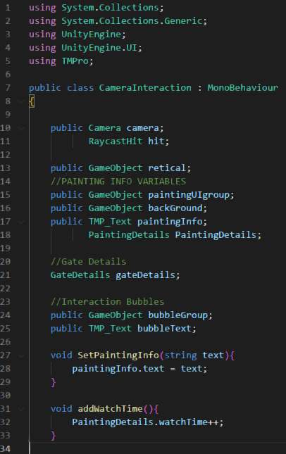
CameraInteraction.cs

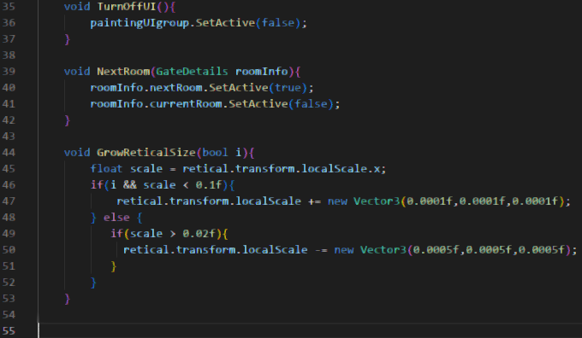
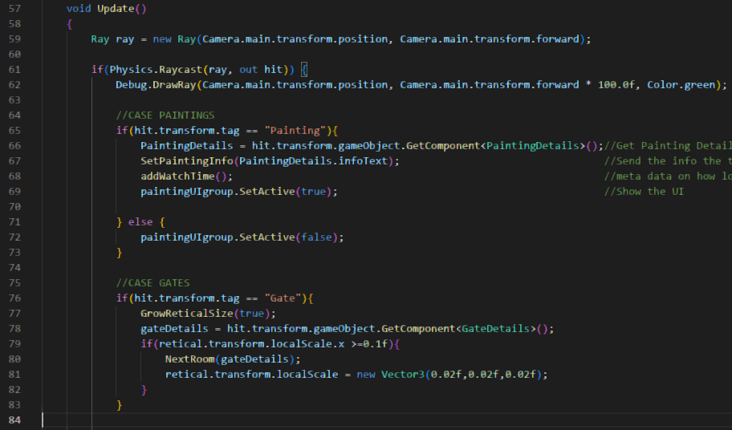

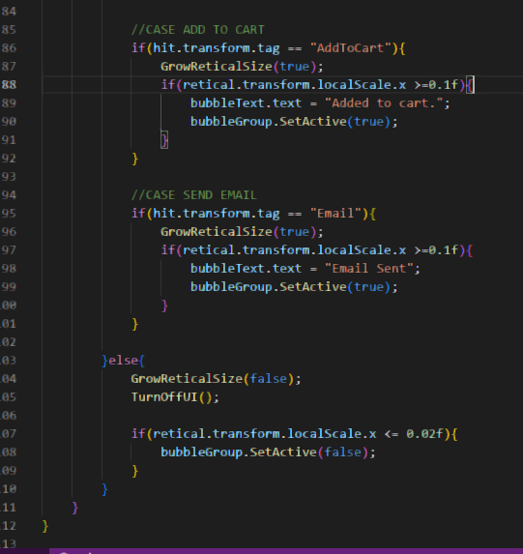

GateDetails.cs
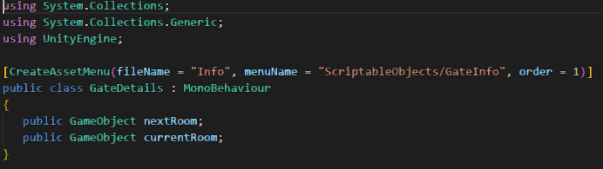

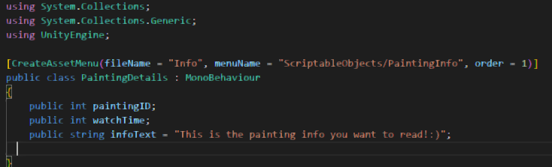
PaintingDetails.cs

SavePaintingScores.cs
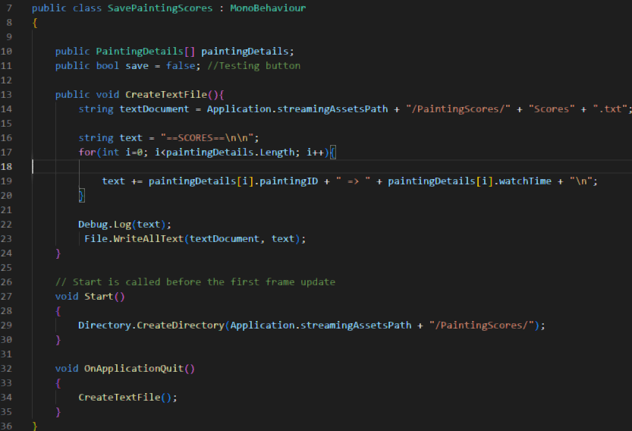

BubbleInfo.cs
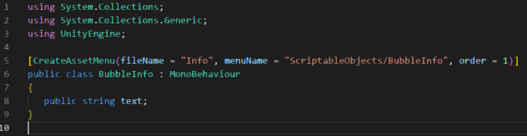

UML

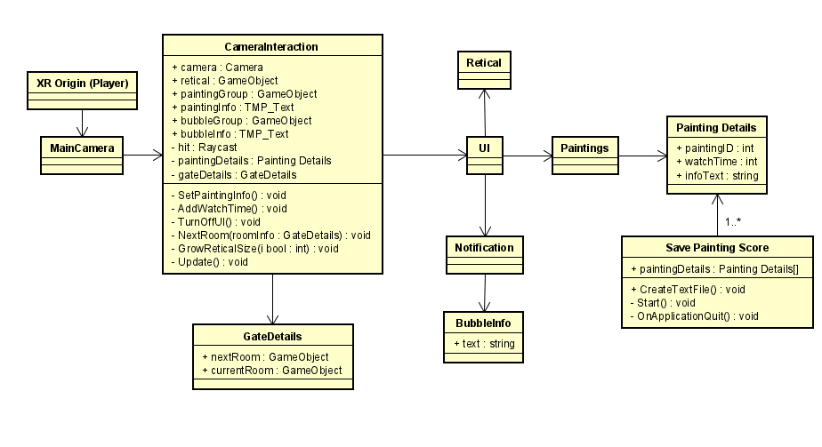
Game features:

- Room navigation
- Additional details related to the art piece
- Button interactions
- Email about art piece details
- Add to cart feature
- Map in initial area
- Motion tracking
- Splash screen identification

- Google Cardboard Compatible
- Painting metrics gathering

- Screenshots

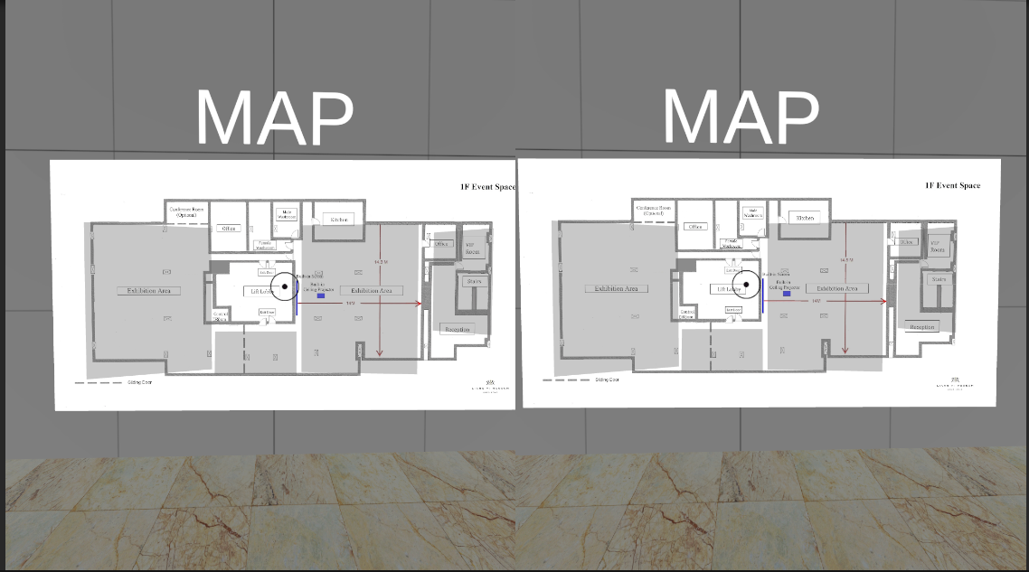
Image1: This image is present in the hub room of the museum. Here you can see a map, in each highlighted area the player can teleport to a room of the museum.

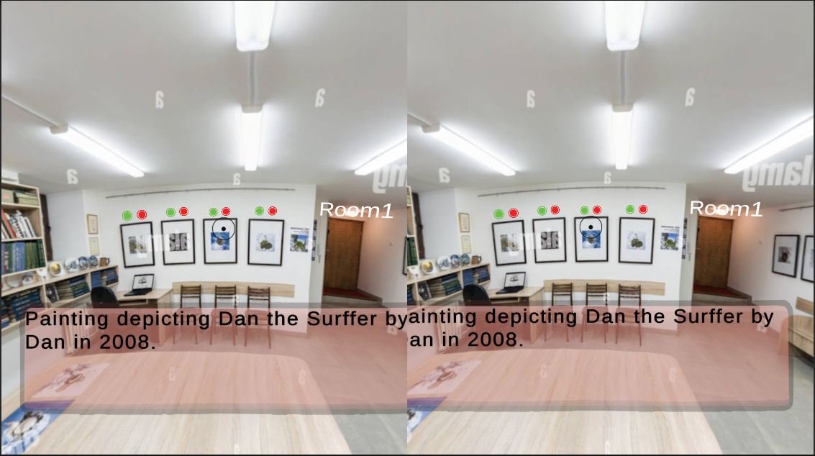
Image2: In this image you can see many paintings. Each painting has two buttons above them. The Green button adds the painting to your cart. The red button sends an e-mail with more info on the art piece. In adition there is also a text area where you can see some information about the art piece and the artist.

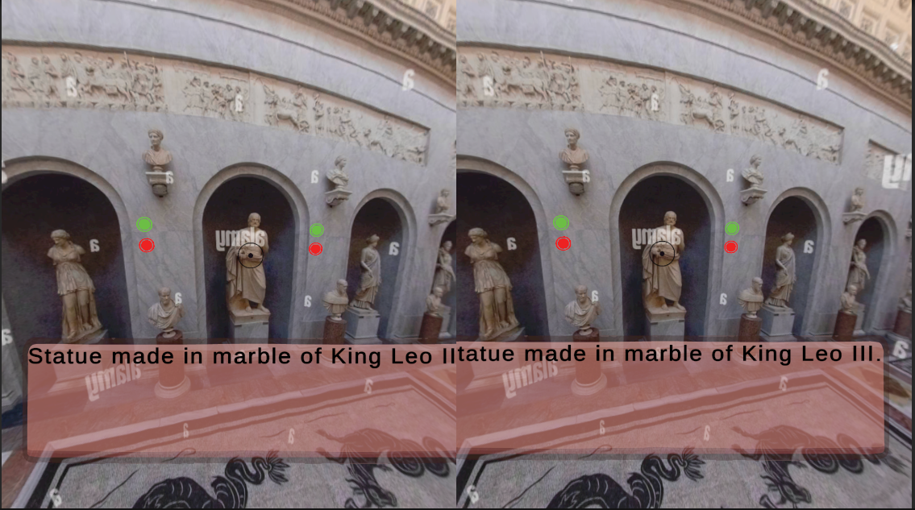
Image3: As you can see, this image contains the same ui elements as Image2, and works under the same principles.

