Singapore University

of

Social Siences

|  |  |
| --- | --- |
| Name: | Date: |
| Course Code : | Title of the TMA : |
| SUSS PI No : |  |

Tecnical Information

* Unity Version :

2021.3.21f1

* Target Platform:

Android 8.0 and higher.

* Packages/Plugins:

ARKit XR Plugin (4.2.7)

MockHMD XR Plugin (1.3.1-preview.1)

JetBrains Rider Editor (3.0.18)

Test Framework (1.1.31)

TextMeshPro (3.0.6)

Tutorial Framework (3.1.1)

UnityUI (1.0.0)

VersionControl (2.0.1)

VisualScripting (1.0.8)

VisualStudioCodeEditor (1.2.5)

VisualStudioEditor (2.0.17)

XR Interaction Toolkit (2.2.0)

XR Plugin Management (4.2.1)

Cardboard XR Pluging (1.20.0)

* Assets:

Ravenmore_fantasy_icon_pack_2017(<https://ravenmore.itch.io/fantasy-icon-pack>)

Wenrexa_Assets_GUI_DarkMiko(https://wenrexa.itch.io/darkmiko/download/eyJpZCI6MTI4MTQ3OCwiZXhwaXJlcyI6MTY4MDIwMzA2Nn0%3d.I%2ftDkKgEIhOmn8nMw%2f%2fba6qrxVU%3d)

* Aditional Icons:

Mask Icon (https://www.flaticon.com/free-icons/mask)

Vaccine Icon(https://www.flaticon.com/free-icons/vaccine)

VR Glasses Icon(https://www.flaticon.com/free-icons/vr-glasses)

* SoundTrack:

D&D / Video game Adventure Music - Rise Of A Champion (Loop) -> https://www.youtube.com/watch?v=jozPEJq5LkE&ab_channel=TabaxiBardMusic

* Textures:

WoodTexture -> (https://opengameart.org/content/wood-texture-tiles)

GrassTexture -> (https://opengameart.org/sites/default/files/grass123.jpg)

StoneWallTexture -> (https://opengameart.org/content/seamless-stone-wall-texture)

* Posters:

https://www.cdc.gov/coronavirus/2019-ncov/downloads/your-health/isolation-print-resource-final.pdf

https://www.cdc.gov/coronavirus/2019-ncov/downloads/communication/COVID-19_Using-Your-Home-Test-Kit-custom-print.pdf

https://www.cdc.gov/coronavirus/2019-ncov/downloads/communication/print-resources/Important-Steps-to-Choosing-Mask.pdf

https://www.cdc.gov/coronavirus/2019-ncov/downloads/communication/print-resources/Test-Soon-Treat-Early.pdf

* Scripts:

CamRayCast.cs

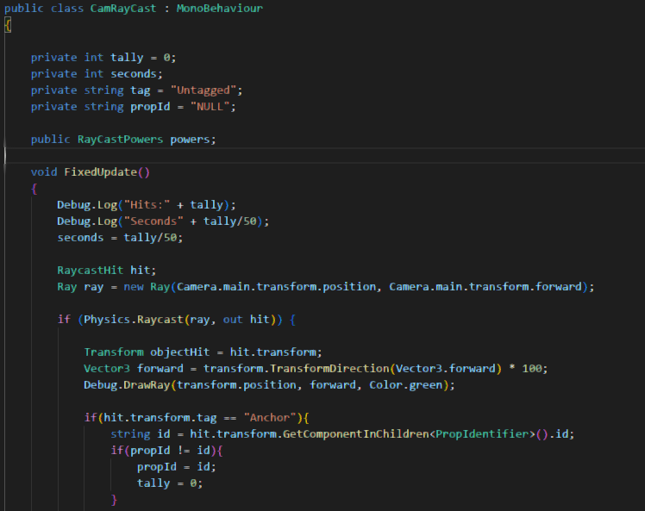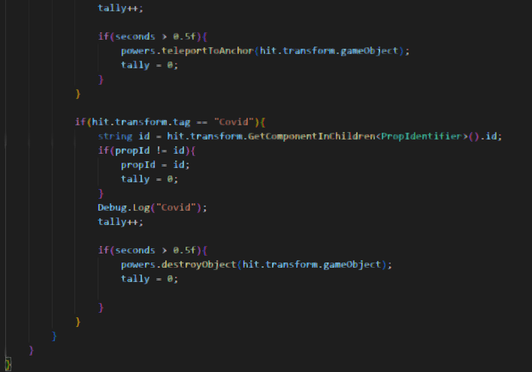

ExitMaze.cs

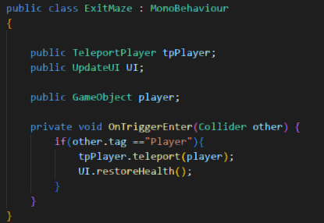

FakeLoadBar.cs

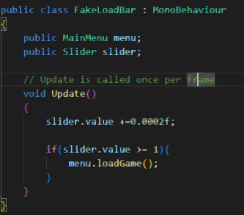

LevelManager.cs

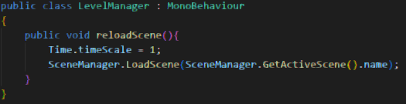

ManiMenu.cs

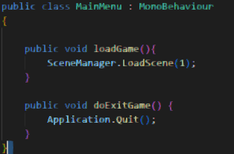

PickUp.cs

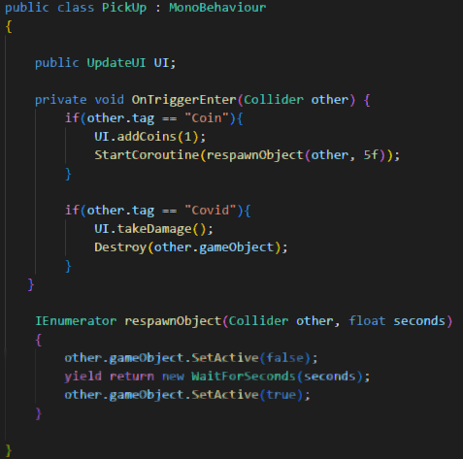

PropIdentifier.cs

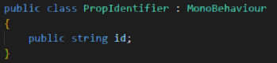

RayCastPowers.cs

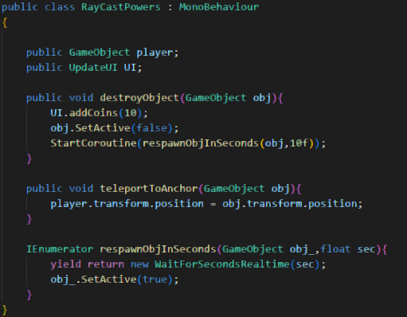

Store.cs

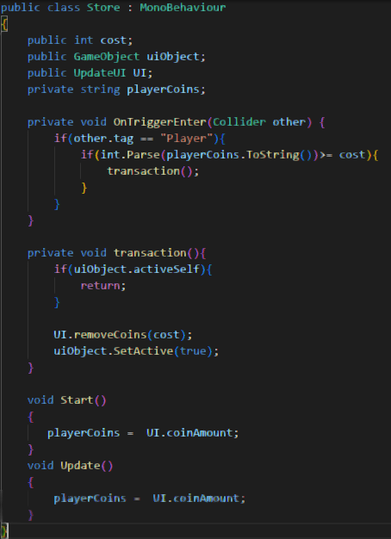

TeleportPlayer.cs

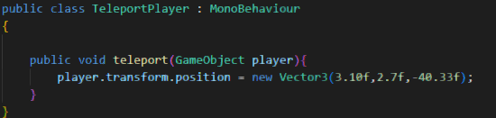

UpdateUI.cs

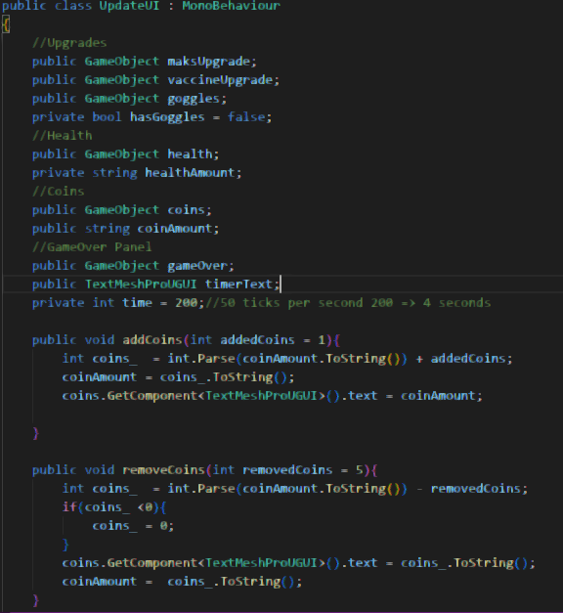

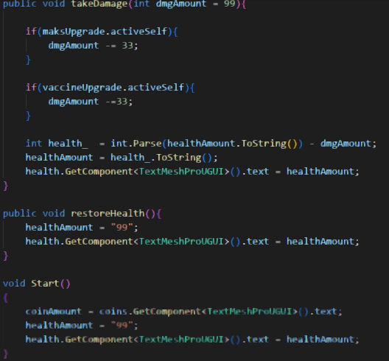

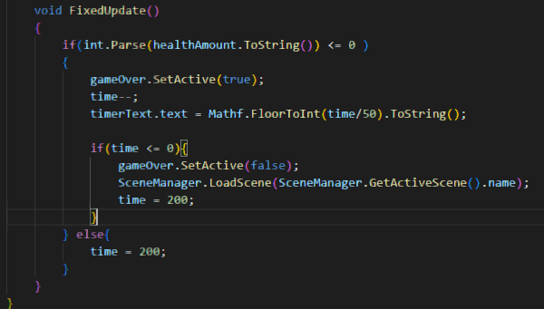

UML

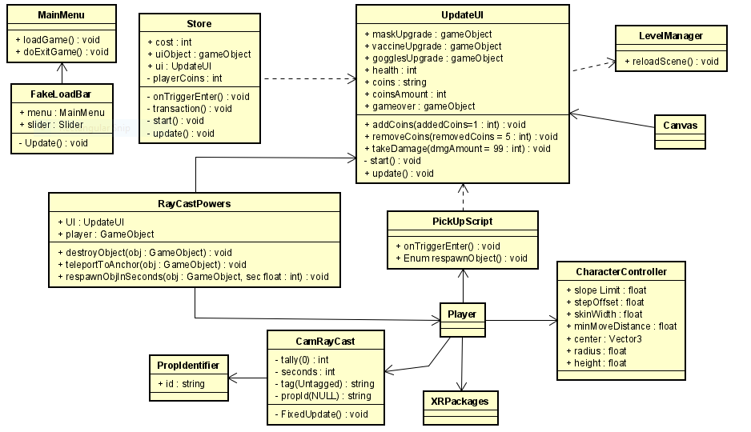

Screenshots

Img. 1: MainMenu/ Loading screen adapted for the google cardboard. Automaticly loads the game without needing to press play.

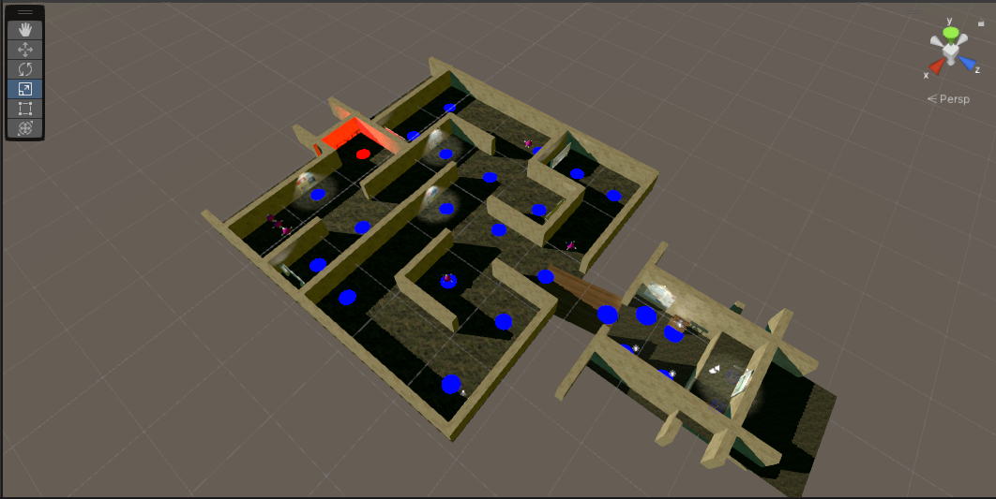Img. 2: Overview of the maze. You can see the virus roaming around the maze, the anchor points (marked in blue), and a hub area in the bottom right of the maze.

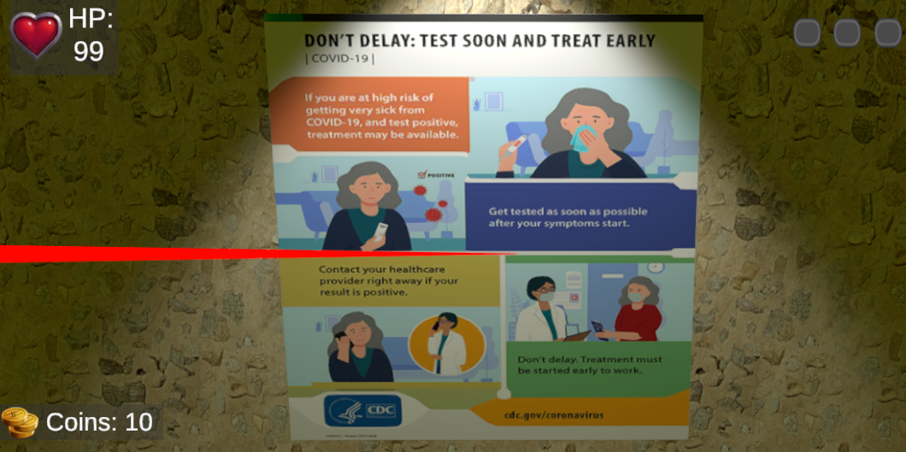Img. 3: As seen before the UI remains mostly the same. You may notice a red line on the screen. This “lazer” helps the player teleport and destroy the virus. Also visible are the new posters, to help with the educational element.

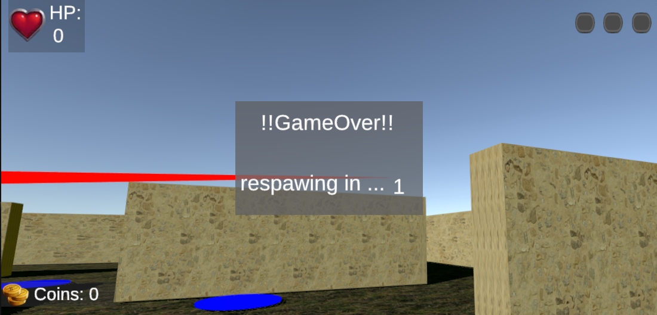Img. 4: After the player health reaches 0, they will automaticly respawn at the begging of the maze after 3 seconds.

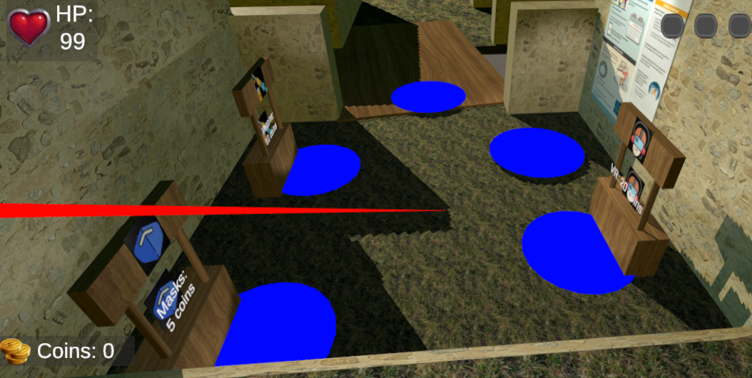Img. 5: This is a overview of the player hub. 3 of the anchors are shops. When the player teleports to them they will automaticly buy the upgrade if thy have the coins.