**Reddit Pocket Project Plan**

Summary

The goal of this project is to develop a simple interactive UI for Reddit using React and Redux.

The external data will be fetched using the JSON Reddit API. This method does not require user authentication and provides read-only data, which simplifies the logic necessary for the fetching but limits the functionality that the application can provide. Therefore, the application will feature subreddit browsing and displaying of posts and comments, but not the ability to post comments, rate posts and other features that would require a user account.

Implementation

The React library will be used to write the logic of the components that make up the UI, with the Redux library serving as the state management tool for the application. With Redux, the state is centralized on a single store and the data it manages is accessed by the React components as needed. The React Router library will also be used to provide the navigability of the application between pages.

A wireframe and CSS style specification will guide the development of the visual aspects of the UI, however most design decisions are intended to take place during development as the application takes shape, since this project is not intended for commercial deployment and is for education purposes only. The idea is to build a simple and elegant UI, with flat design and soft colors. Using CSS Grid and media queries, the application will be responsive and display appropriately on either desktop, tablets and smartphones.

Unit tests will be written with Jest and React Testing Library. End-to-end tests will be written using Selenium. Again, since this project is for educational purpose, the tests will be written with the intention of learning and practicing, so test coverage will not be a concern addressed in this project.

Development Methodology

No specific development methodology will be applied to this project. Rather a hands-on, trial and error approach will be used to provide rich opportunities to analyze and evaluate choices, make mistakes and re-think decisions along the way. Upon conclusion of the project, an assessment will be made to reflect on how different development methodologies could have helped to address and prevent mistakes and issues that were faced.

Wireframe

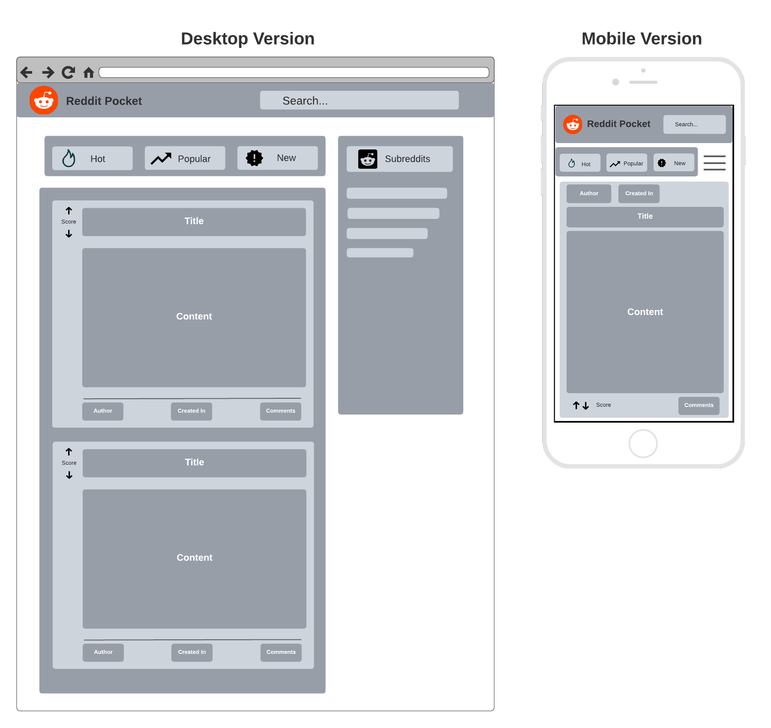

React UI Components Hierarchy

This is a tentative division of the UI in React components. Adjustments might be made during development.

> App

> Header

> Search Bar

> General Categories (hot, new, trending)

> Main Content

> Score

> Title

> Content

> Post details (author and creation date)

> Comments (can be toggled)

> Comment

> Side Bar (will need toggle function for mobile view)

CSS Style Guide

Font-family: Poppins

<https://fonts.google.com/specimen/Poppins?category=Sans+Serif#standard-styles>

Color palette:

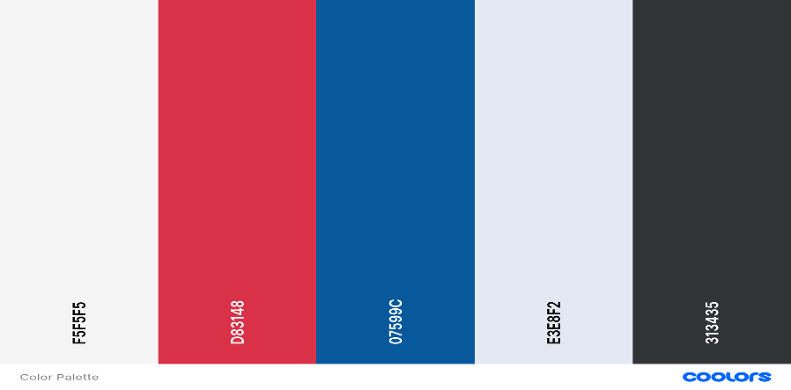

Cultured: #F5F5F5 (background)

Rusty Red: D83148

Lapis Lazuli: #07599C

Alice Blue: #E3E8F2

Onyx: 313435

General Purpose

International Orange: #FF5700 (reddit orange)

UFO Green: #3BCB56 (for up vote)

Cadmium Red: #ED001C (for down vote)