#### Degree in Informatics Engineering

#### Project III Curricular Unit

**Bot Incorporation**

**Pedro Poças, nº28976**

#### 2024 - 2025

#### Supervised by: Prof. Doutor. Sara Paiva | [sara.paiva@ipvc.pt](mailto:sara.paiva@ipvc.pt)

**Índex**

1. **Introduction and Objective**………………………………………………………………………3
2. **Project Management, technologies and tools**……………………………………………4  
   2.1 Project Management……………………………………………………………………………4  
   2.2 Technologies………………………………………………………………………………………5  
   2.2.1 BotPress………………………………………………………………………………………….5  
   2.2.2 WordPress……………………………………………………………………………………….5  
   2.2.3 Visual Studio Code…………………………………………………………………………….6  
   2.2.4 Android Studio………………………………………………………………………………….6  
   2.2.5 PHP…………………………………………………………………………………………………7  
   2.2.6 React Native…………………………………………………………………………………….7  
   2.2.7 GitHub…………………………………………………………………………………………….8
3. **BotPress Workflow**………………………………………………………………………………….9
4. **Developed Features**………………………………………………………………………………..10  
   4.1 MyIPVC……………………………………………………………………………………………..10  
   4.2 ON……………………………………………………………………………………………………11
5. **Project Developed**………………………………………………………………………………….12  
   5.1 MyIPVC……………………………………………………………………………………………..12  
   5.2 ON……………………………………………………………………………………………………13
6. **Difficulties & Future Features**………………………………………………………………….14  
   6.1 Difficulties…………………………………………………………………………………………14  
   6.2 Future Features………………………………………………………………………………….14  
   6.3 Final Thoughts……………………………………………………………………………………14
7. **Conclusions and Future Work**…………………………………………………………………15  
   7.1 Conclusions………………………………………………………………………………………15  
   7.2 Future Work………………………………………………………………………………………15
8. **Appendix**………………………………………………………………………………………………16  
   9.1 BotPress User Manual………………………………………………………………………..16

## 

Illustration List

Figure 1 – Illustrtion of the project management trello dashboard 6

Figure 2 – Illustration of the workflow botpress 11

Figure 3 – Illustration of the knowledge base chatbot 11

Figure 4 – Illustration of the integration chatbot in myipvc 12

Figure 5 – Illustration of the integration chatbot in myipvc 12

Figure 6 – Illustration of the integration chatbot in ON 13

Figure 7,8 – Illustration of the result the integration in myipvc 14

Figure 9 – Illustration of the result the integration in ON 15

**Introduction and objectives**

This project was developed associated with the curricular unit of Project III of the 3rd year of the Graduation Degree in Informatics’ Engineering (Computer Science) at the School of Technology and Management of the Polytechnique institute of Viana do Castelo, aims to explore and implement a functional chatbot. The chatbot is designed to integrate seamlessly with the "myipvc" mobile application and, potentially, the "ON" platform and portal, enhancing digital interaction within the educational ecosystem.

**Objectives:**

* **Primary Development:** Develop a fully-functional chatbot that facilitates efficient and intuitive communication for users of the myipvc application and, if feasible, the ON platform.
* **Educational Integration:** Leverage this project to bridge theoretical knowledge with practical application, providing hands-on experience in real-world software development within an educational setting.
* **Technical Scope:** This project was proposed to align with the needs of the IPVC community, under the guidance of the faculty, to address specific communicational inefficiencies identified within the existing digital framework.
* **User-Centric Design:** Design the chatbot to support diverse user interactions, enabling not just basic queries but also complex informational exchanges, thereby improving user engagement and satisfaction.
* **Research and Development:** Utilize a variety of resources, including open-source projects on GitHub and instructional content on platforms like YouTube, to inform the development process. The project also involves critical problem-solving through forums such as Stack Overflow to refine and optimize the implementation.
* **Documentation and Reporting:** The project documentation will include a detailed introduction, an architectural overview of the chatbot, and a comprehensive review of the technologies, tools, and methodologies employed.

**Project management****, technologies and tools**

**2.1Project Management**

For this project, Trello, a platform for project management, was utilized to monitor progress through task advancement. For better understanding, the board was divided into five columns: "Meets," "To do," "Doing," "Done," and "Documentation."

* **Meets**: This column lists the meetings held with the project coordinator to review development progress.
* **To do**: This column contains the various tasks that are planned but have not yet been initiated.
* **Doing**: This column displays the tasks that are currently being executed.
* **Done**: This column shows the tasks that have been completed.
* **Documentation**: A dedicated column containing all the necessary documentation for the project.

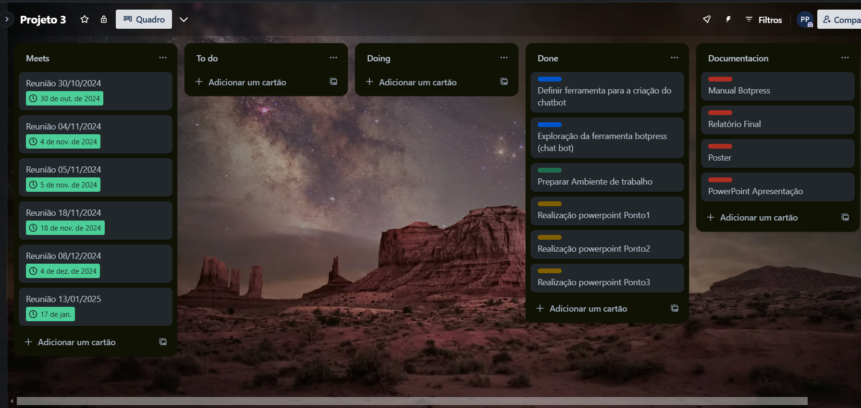

# Figure 1 – Illustrtion of the project management trello dashboard

**2.2 Technologies**

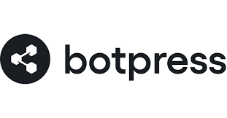

**2.2.1 BotPress**

Botpress is a comprehensive, open-source conversational AI platform that empowers developers to build, deploy, and manage intelligent chatbots efficiently. Botpress is designed to simplify the development process while offering robust capabilities for creating complex conversational experiences. It’s geared towards developers with varying levels of programming expertise and is used by businesses to enhance customer interaction, automate support, and streamline communication processes across various channels.

Some important web links:

Official Website: <https://botpress.com/>

BotPress Documentation: <https://botpress.com/docs/home>



**2.2.2 WordPress**

WordPress is an open-source content management system (CMS) that allows users to create and publish websites easily and flexibly. Initially launched in 2003 by Matt Mullenweg and Mike Little, WordPress was originally designed to enhance the possibilities of personal blogging. It has since evolved into a robust platform capable of managing complex websites, including e-commerce, media, and business sites.

Some importante web links:

Official Website: <https://wordpress.com/>

Wordpress Plugins: <https://wordpress.com/plugins>

Support Wordpress: <https://wordpress.com/support/>



**2.2.3 Visual Studio Code**

Visual Studio Code (VS Code) is a powerful, free, and open-source code editor developed by Microsoft. It's available on Windows, macOS, and Linux. VS Code is highly regarded for its performance, user-friendly interface, and flexibility that allows developers to use it for web development, application development, and even cloud applications.

Some importante web links:

Official Website: <https://code.visualstudio.com/>

Documentation: <https://code.visualstudio.com/docs>



**2.2.4 Android Studio**

Android Studio is an extensive integrated development environment (IDE) specifically tailored for Android app development. It is built on the IntelliJ IDEA platform by JetBrains and offers a comprehensive set of tools and features designed to improve productivity and efficiency in Android application development.

Some importante web links:

Official Website: <https://developer.android.com/>



**2.2.5 PHP**

PHP (Hypertext Preprocessor) is a widely used open-source general-purpose scripting language that is particularly suited to web development. PHP was created by Rasmus Lerdorf in 1994 and now is managed by The PHP Group. PHP is best known as a server-side scripting language, but it is also used in standalone graphical applications and in a command line interface.

Some importante web links:

Official Website: <https://www.php.net/>

Documentation: <https://www.php.net/docs.php>



**2.2.6 React Native**

React Native is a popular open-source framework that enables developers to build mobile applications using JavaScript and React. Developed by Facebook (now Meta), React Native was released in 2015 with the aim of allowing developers to create native apps for both iOS and Android platforms using a single codebase. This approach helps streamline the development process, reduce costs, and maintain consistency across both platforms.

Some importante web links:

Official Website: <https://reactnative.dev/>

Documentation: <https://reactnative.dev/docs/getting-started>



**2.2.7 GithHub**

GitHub is a cloud hosting service that manages Git repositories. It is built to leverage the developers to store, manage, track, and control changes in their code projects. Version control where contributions from multiple developers can be managed easily for software projects, GitHub was originally released in 2008 and it has become one of the largest and most well-known code repositories in the world, with millions of developers and organizations using it.

Some importante web links:

Official Website: <https://github.com/>

**3. BotPress Workflow**

The Botpress workflow is where the chatbot is constructed. This chatbot initially greets the user with a welcome message, after which the user can begin asking questions. The chatbot waits for the user to pose a question, and upon identifying one, it searches for an answer in the knowledge base, where information is stored in documents. After finding the answer, it is saved in a variable which serves as input for the artificial intelligence. This AI then summarizes the input, and the summary is stored in another variable. Finally, the information from this last variable is sent to the user. If desired, the user can continue to ask further questions.

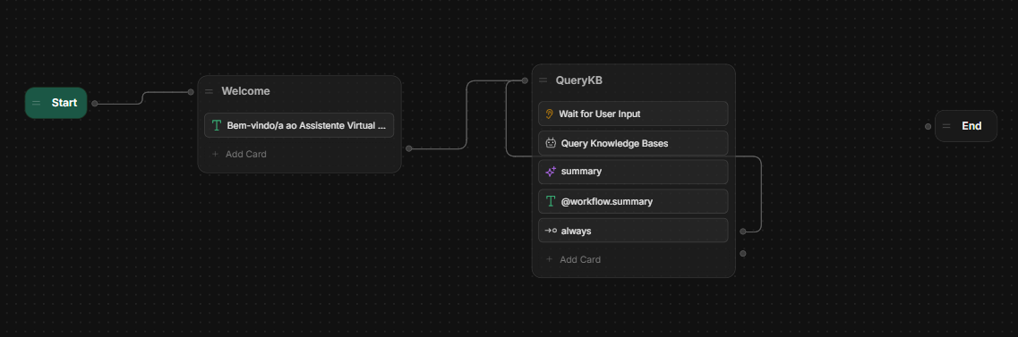

# Figure 2 – Illustration of the workflow botpress

# Figure 3 – Illustration of the knowledge base chatbot

**4. Developed features**

**4.1- MyIpvc**

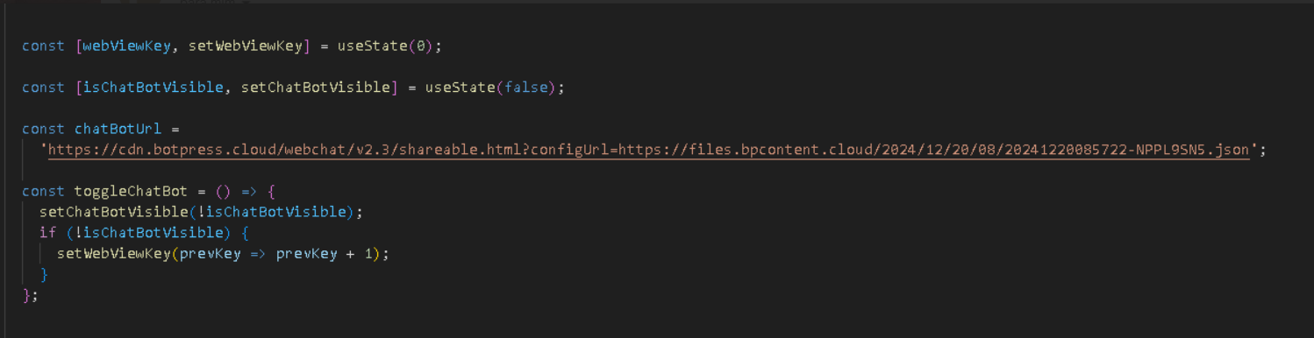

# Figure 4 – Illustration of the integration chatbot in myipvc

# Figure 5 – Illustration of the integration chatbot in myipvc

The state isChatBotVisible is a boolean used to control the visibility of the chatbot modal, and chatBotUrl holds the URL that the WebView will load.

The TouchableOpacity acts as a button that, when pressed, toggles the visibility of the chatbot modal through the toggleChatBot function. The Modal component displays its content on top of the main application content, using a slide animation and making it transparent so that the background content is partially visible. Inside the modal, there's a View container that holds the WebView and a close button. The close button also uses the toggleChatBot function to change the modal's visibility. The WebView itself loads the chatbot from the provided URL, and any change to the webviewKey triggers a reload of this WebView, ensuring the chatbot content is up-to-date.

**4.2 – ON**

# Figure 6 – Illustration of the integration chatbot in ON

Within a php page, add the scripts provided by botpress within the body to integrate the chatbot.

**5. Project Developed**

**5.1 – Myipvc**

# Figure 7,8 – Illustration of the result the integration in myipvc

The implementation carried out in the myipvc app on the home page has a button that, after being clicked, opens a modal in the app and loads the chatbot within the modal.

**5.2 – Plaform ON**

# Figure 9 – Illustration of the result the integration in ON

This was the final result of integrating the chatbot into a test dashboard on the platform.

**6. Difficulties & future features**

**6.1 Difficulties**

The main challenge was the use of Botpress. As it is a new platform, it required exploration to understand how it functions for chatbot creation.

**6.2 Future Features**

Due to limited experience with Botpress, a future feature to implement would be for the chatbot to display a default message to the user when it does not know the answer, indicating that it is unable to provide a response at this time.

**6.3 Final thoughts**

Despite the challenges faced while learning Botpress, the experience has been enriching. Mastering this tool opens up numerous possibilities for enhancing user interaction and automating responses effectively. Going forward, the goal is to refine the chatbot's capabilities, enabling it to handle a broader range of queries with greater precision. This endeavor will not only improve user satisfaction but also deepen our understanding of AI-driven communication platforms.

**7. Conlusions and Future Work**

**7.1 Conclusions**

The completion of this project was an incredibly enriching experience, marking my first venture into chatbot development. This opportunity allowed me to explore a platform that integrates artificial intelligence and enables deployment across various environments, such as mobile applications and websites.

Although the implementation was limited to a mobile application and tested on a demonstration page in PHP, it provided valuable insights into how these different environments function. Furthermore, the project offered the chance to work with various tools and technologies, laying a solid foundation for future endeavors.

**7.2 Future Work**

As future work, it would be important to implement a default answer in the chatbot for situations where it cannot provide an answer, presenting this response clearly to the user and ensuring a smoother and more optimized interaction. Additionally, integrating the chatbot into the portal website developed in WordPress would also be a valuable enhancement.

**9.** **Appendix**

**9.1 – BotPress Manual User**



