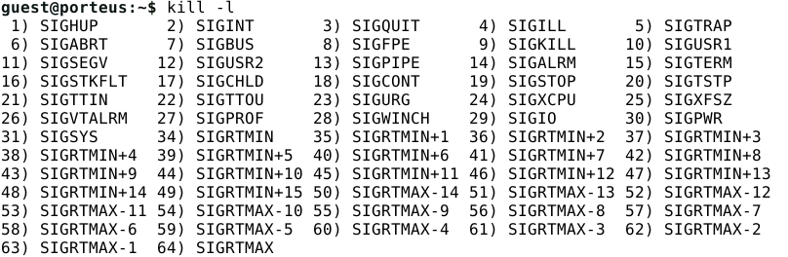**Ex1)** On a terminal of your Linux machine obtain the names and integer values of the signals.

Figure 1- all the values of the signals in the Linux

Here are some definitions of the signals:

1. SIGINT – Signal that interrupts the execution of the process.
2. SIGILL – Signal is sent when the programs contain machine code that the CPU is unable to understand.
3. SIGTRAP
4. SIGABRT – Signal is sent when the process calls the *abort function*.
5. SIGBUS – Sent when an attempt was made to access memory incorrectly.
6. SIGFPE – Sent when a *floating-point exception* occurs during the execution of the process.
7. SIGKILL – Signal that terminates the process. Cannot be interrupted.
8. SIGUSR1 – Signal that the programmer can define its behavior.
9. SIGSEGV – Sent when an attempt was made to access memory not allocated to the process.
10. SIGUSR2 – Signal that the programmer can define its behavior.
11. SIGPIPE – Signal sent to the process that is emitting output to a second process via *pipe*, and the execution of the second process has concluded.
12. SIGTERM – Signal that terminates the process.
13. SIGSTOP – Signal that pauses the execution of a process.