CSS Quiz 2

1. _____ If you have 5 paragraphs and you want two of them to be different from the others, you should consider using
   1. a class
   2. an id
   3. inline CSS
   4. none of the above
2. 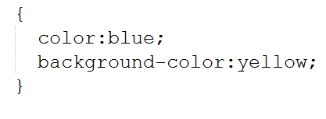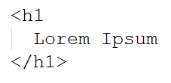(2 points) Complete the following code (HTML and CSS) to demonstrate than you know how to use an id attribute:

1. Short Answer (2 points): Why don’t most professional Web designers specify colors using color names (e.g., color:green)?
2. Code Writing (2 points): After searching online for colors to use on your site, you find the following code: 35FAB7. Write a CSS rule to turn all elements with class name “kowabunga” this color.
3. (1 point) All colors on computer screens are composed of varying levels of which three colors?
4. The cascade says that more “specific” CSS should take precedence over less specific CSS. Give one example of what this might mean. Demonstrate your example by writing actual HTML and CSS code snippets.