Web Exam Part 1

CS Intro, HTML Basics, and CSS Basics

1. _____ Which of the following is the largest file?
   1. 2.3 megabyte MP3 file
   2. 55 kilobyte Word document
   3. 0.3 gigabyte video file
   4. 513 kilobyte PNG file
2. _____ Which of the following is the binary representation of seven?
   1. 101
   2. 110
   3. 11
   4. 111
   5. 100
3. _____ Which of the following is NOT one of the three main parts of computer hardware?
   1. Hard drive
   2. Operating System
   3. Processor
   4. Memory
4. _____ Computers were originally used for
   1. doing mathematical calculations
   2. games
   3. communication
   4. missile guidance systems
5. _____ HTML is primarily used for
   1. the style of webpages
   2. the content of webpages
   3. making webpages interactive
   4. giving kids headaches in Web design class
6. _____ Which of the following is a valid HTML element?
   1. <!DOGTYPE greyhound>
   2. <spam>eat it</spam>
   3. <br id=”ezilla”>
   4. none of the above
7. _____ Which of the following is true of code indentation?
   1. Each sibling element should be indented one place further than the previous sibling.
   2. Indentation affects how the browser displays the webpage.
   3. Each child element should be indented one place further than its parent element.
   4. none of the above
8. _____ To create a paragraph in HTML, you should use the ______ tag
   1. paragraph
   2. para
   3. p
   4. p1
9. _____ To create a numbered list in HTML, you should use the _____ tag
   1. list
   2. ol
   3. li
   4. ul
10. _____ To create an image in HTML, you should use the _____ tag
    1. img
    2. picture
    3. image
    4. pic
11. _____ To tell the browser what name to put in the tab above the webpage, you should use the _____ tag
    1. h1
    2. title
    3. head
    4. meta
12. _____ Which of the following is a correct line of code?
    1. <a src=”index.html”>Link to Homepage</a>
    2. <img href=”dog.jpg”>
    3. <a href=index.html>Link to Homepage</a>
    4. none of the above
13. _____ Which of the following is true of absolute an relative paths.
    1. Relative paths are often URLs.
    2. Absolute paths are often shorter than relative paths.
    3. Absolute paths are always better to use if you can.
    4. A relative path to another file in the same folder as the one you’re working in now is just the name of that other file.
14. _____ Which type of CSS is written in individual HTML elements using the style attribute?
    1. Internal CSS
    2. Inline CSS
    3. External CSS
    4. Embedded CSS
15. _____ Which of the following in a correct way to specify a color in CSS?
    1. color: #43f45a
    2. color: rgb(44, 22, 123)
    3. color:pink
    4. all of the above are correct ways to specify a color in CSS
16. _____ Assuming an element has an id of “kowabunga”, which of the following is a proper CSS selector for that element?
    1. .kowabunga
    2. kowabunga
    3. #kowabunga
    4. none of the above

# Matching

|  |  |
| --- | --- |
| 1. _____ Use this if you want to center text 2. _____ Use this if you want to make text bold 3. _____ Use this if you want to make text italic 4. _____ Use this to change the color of text | * 1. color   2. background-color   3. background-image   4. text-align   5. font-weight   6. font-family   7. font-size   8. font-style |

# Computer Problem 1

From scratch, make a webpage that looks like this:

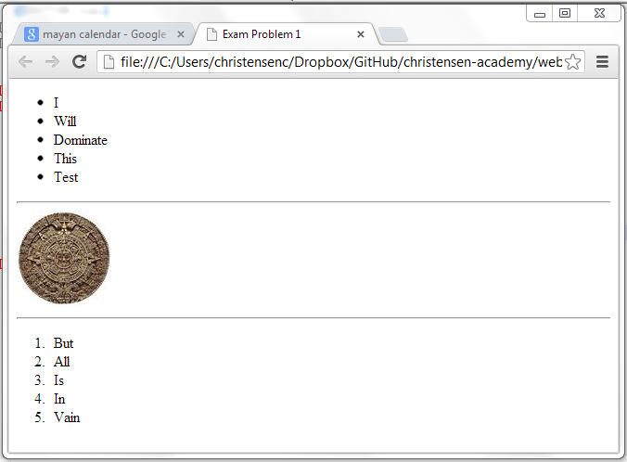

**Note**: The image has been provided.

# Computer Problem 2

Using the starter file for problem 2, make a webpage that looks like this:

