Part 1 Computer Part Study Guide Web Exam

Practice writing each of these webpages from scratch. On the exam, you can expect a similar problem. Make sure your indentation is good and there are no other errors in your code.

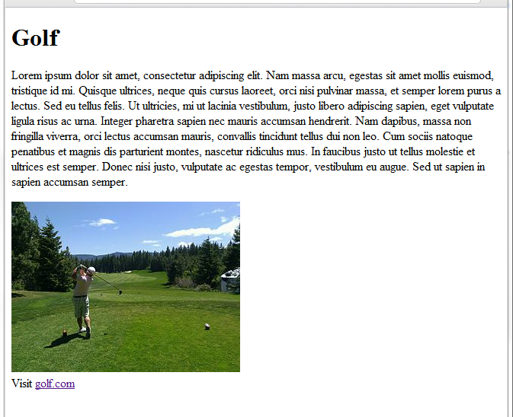

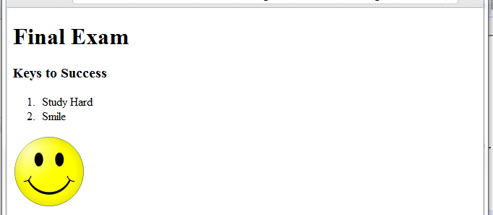

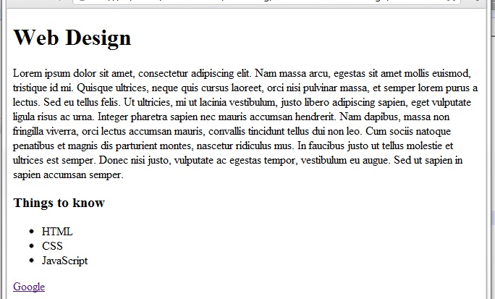

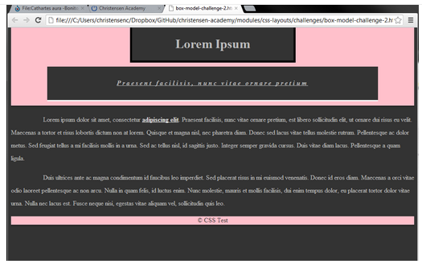This last one requires CSS. The others do not.