Final Exam Part 2 Review Computer Part

# CSS Layouts

Practice 1: Modify the css-layout-computer-problem-1.html file to make it look like this:

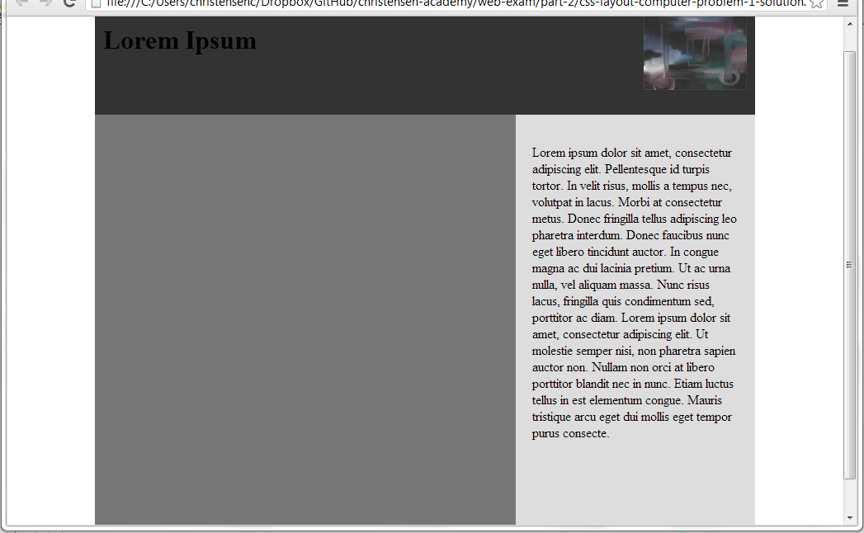

Practice 2: Modify the css-layout-computer-problem-1.html file to make it look like this:

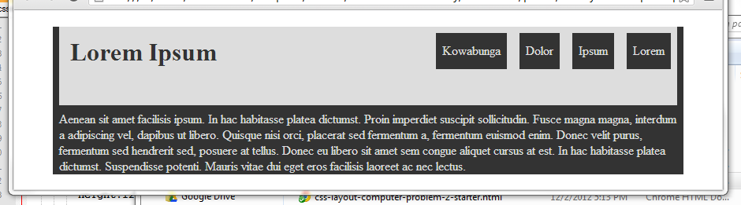

# Khan Academy

Practice 1: Make a drawing animate and bounce off of a wall.

# JavaScript

## Practice 1

Open the javascript-problem-1-starter.html file. It should look like this:

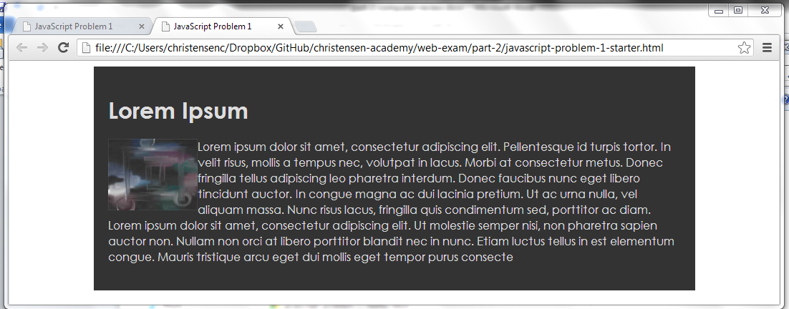

After clicking on the image, the popup should appear looking like this:

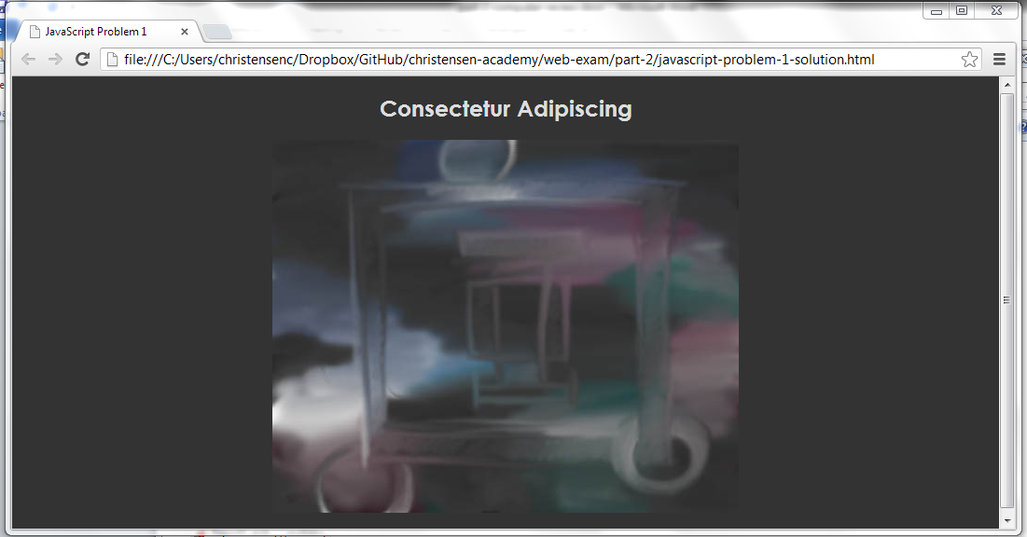

Clicking on the popup should hide the popup revealing the original page.

## Practice 2

Open the javascript-problem-2-starter.html file. It should look like this:

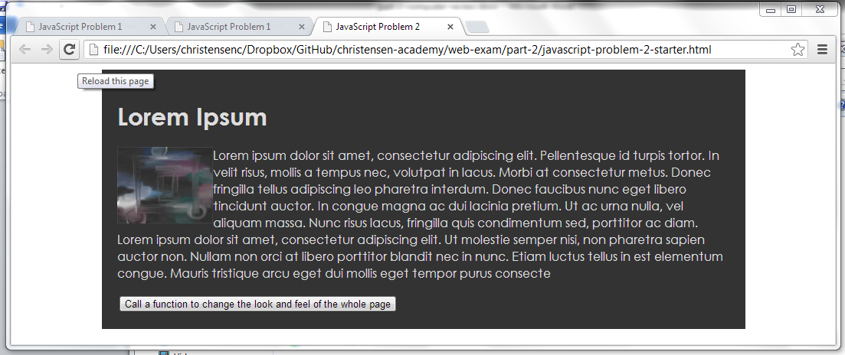

Write code so that after clicking the button it looks like this:

