# Definitions

Made by: Filip, Ignacio, Diego, Alex.

**Git checkout**, this command switches you to a different branch within your local repository. It doesn't directly access remote repositories.

**Git merge** is often used in conjunction with git checkout to select the current branch and then merge them together.

**Git push** allows you to push your commits from your local branch of your local git repository to the remote repository.

**Git pull** is better than fetch and merge, its more used the git pull, because git pull it’s a mix of the other two.

**Git stash** takes uncommitted changes, both those that are ready and those that are not, saves them aside for later use and then undoes them in the code you are working on. You can use stash pop and stash apply.

**Git rebase** The main reason for using it is to maintain a linear Project history, that is, to see how the main branch has progressed since it was started.

**Git fetch** allows you to update your local repository with the latest changes from a remote repository, but without merging those changes into your local working branches.

# Steps

* We have a main master branch, with the files, folders, etc...

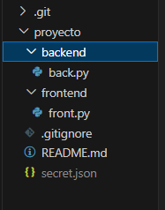

* We push to send all the files to the main branch from the repository.

>**git push** test3 (Repository) master (Main branch)

* We create a new branch, we modify files or create new ones.

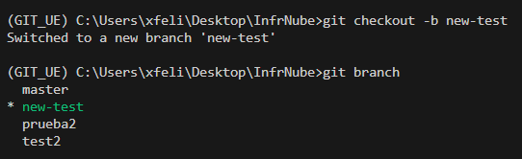

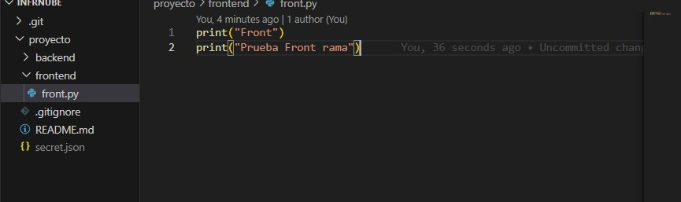

* First, we add the changes and then push to upload them in the new branch created from the repository.

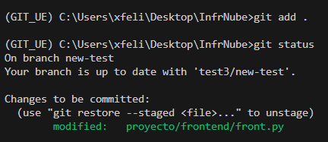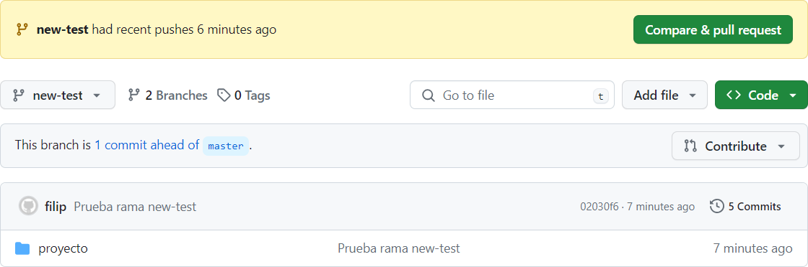

* We switch to the main branch and pull to have the original files and avoid conflicts.

>**git checkout** master

* While we are in the main branch, we merge the second branch to main one.

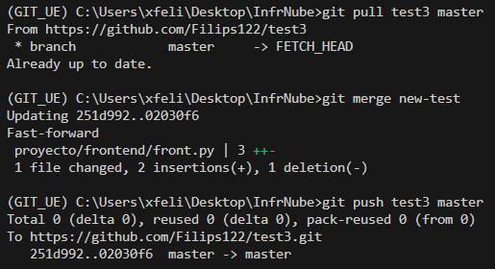

* After we merge both branches we make a push to send it to repository.
* If we use fetch it would be like merge but instead of branches, between repositories and it is a good practice if you don't want to "mess it up" in the main repository.

>**git fetch** test3

* This is to see the difference between actual branch and the repository you want to merge at.

>**git diff** master (Actual branch) test3/master (Repository that you want to merge)

* We do rebase if we want to have a cleaner history and not with all the changes as in merge.

>**git checkout** new-test

>**git rebase** main

>**git rebase** --abort