EH2745 Assignment II 2018

# Identifying and labeling the power system state

In assignment 2 for Computer application in power system a dataset of different busbar voltages magnitude and angles were given for 9 busbars at different time instants. Two different datasets were given, first the training set (the main data set) “measurement” set with 200-time instances. Second set is test set “analog_values” set with 20-time intendances that is used and test set.

In this assignment, 2 main tasks were required:

1. Develop a k-Means clustering algorithm and use it to identify the operational states in the database. Choose a suitable label for the states and link each cluster to one of the scenarios mentioned above with logical reason.
2. Develop a Java application to identify a previously unknown state of the system based on voltage measurements using a k-NN algorithm.

Through Java code, K-Means clustering algorithm was developed, resulted in clustering of 3600 different measured values in 4 different clusters. Each cluster has 9 points with 18 values, 9 voltage magnitude and their corresponding angles. Using these clusters, we managed to visualize the grid measurement as in figure 1. From these 2 graphs, the state of each cluster can be identified.

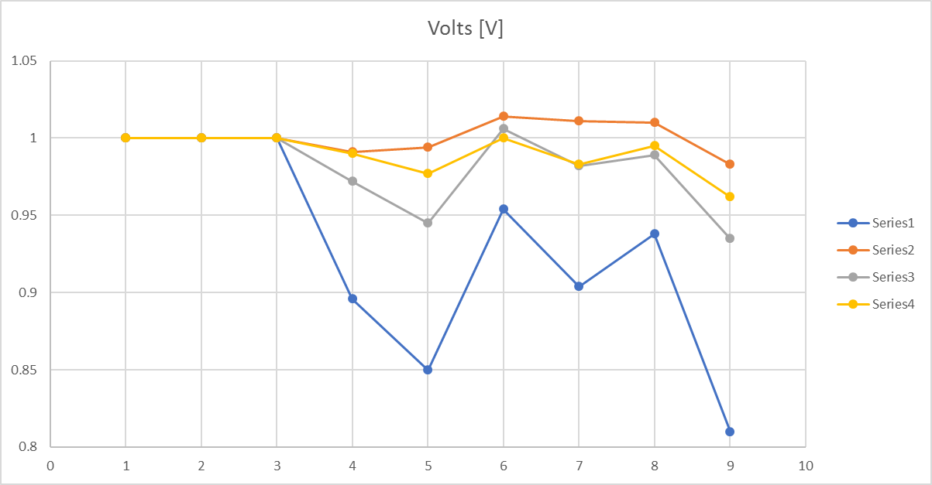

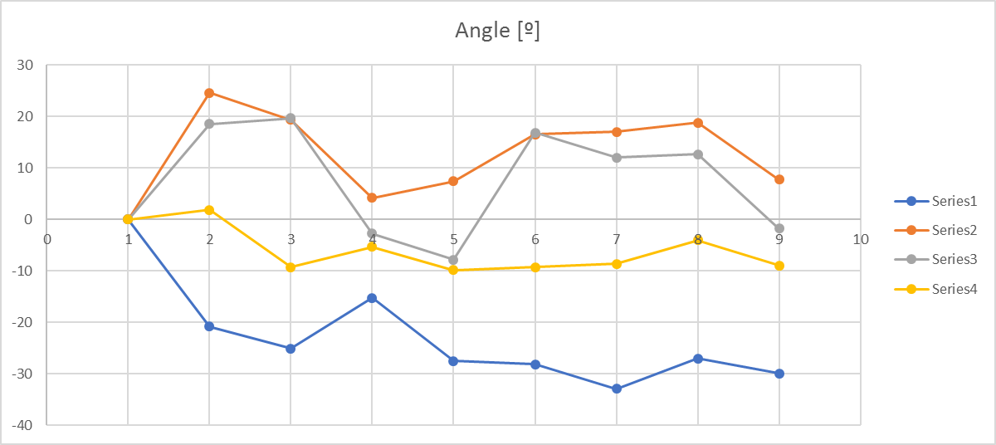

First, starting with the red line, it is obvious from the angles of this cluster centroid that all angles are of positive magnitude, this gives a strong indication of the state which is capacitive leading network and this case only occurs during low loading of the network that result in appearance of the capacitance of the lines result also in increase of voltage magnitude for some buses above 1 pu.

For the blue lines, it is noticed that for some buses connected there is huge difference in both voltage magnitude and angle, which gives an indication that these two buses are not connected anymore.

On the other hand, for the yellow line, it is obvious that the angle difference between the generator bus and the bus connected to it is quite small close to zero value which means that the amount of active power transfer is quite small if compared to other cases. Observing this we can conclude that there is most probably a generation disconnection from the network result in low active power transfer.

Finally, grey line, from the voltage magnitude point of view, it is obvious that a load bus is lower than one and from the angle point of view, it has a low negative value means that busbar is in lagging phase. This gives an indication of high loading of the system.

Therefore, we can conclude that, for our measurement dataset, the clusters can be labelled using this algorithm described previously through comparing different cluster centroids of each bus and building this comparison between bus voltages and magnitudes.

Labelling each cluster, now we can classify new added test points using KNN. Comparing the new added point with the closest k point and check the nearest k points label then the max appeared label will be given to the new point. Some point might give a misleading indication after being label which is solved through an algorithm that check each time instant 9 buses voltages and angles, if there is a specific case happening for only two buses and the others are basically normal the system will be classified according to this different label. For an example, if there is a line disconnection, the generator buses will basically act normally in terms of voltage, so the algorithm will search for the abnormal label which is the line disconnection and classify this time instant to this case.