|  |  |  |  |
| --- | --- | --- | --- |
| Articulo | ensamble | Acabado | Utilidad |
| X | 5 | 2 | 200 |
| y | 3 | 4 | 100 |
| disponibilidad | 105 | 70 |  |

P= MAX 200x+100y

S.A

R1) 5x+3y≤105

R2) 2x+4y≤70

R3) x,y≥0

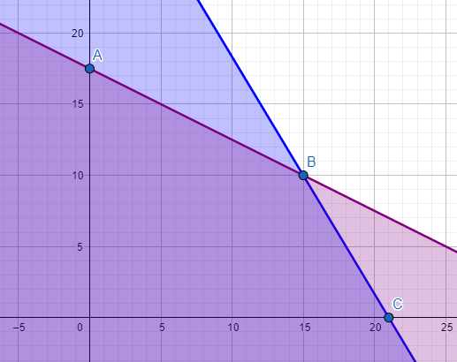

Solución

|  |  |  |
| --- | --- | --- |
| max | 200x | 100y |
| a | 1750 |  |
| b | 3000 |  |
| c | 4200 |  |