**“Objectives, scopes, limitations and the significance of this research are also topics covered in this article.”**

**COPIAR UMA CENA QUALQUER DE RELATED WORK**

COEXISTANCE

“WiFi and Bluetooth are two most commonly used short range wireless communication technologies. Recent years, with increasing number of WiFi and Bluetooth mobile terminals, tags, and other devices, a demand for integration and coexistence of these two technologies including their positioning function is booming.”

“This proposed hybrid localization system works based on the advantages of both the Bluetooth and Wi-Fi-based methods”

FINGERPRINT

“Fingerprint is one of the most widely used methods for locating devices in indoor wireless environments and we have witnessed the emergence of several positioning systems aimed for indoor environments based on this approach. However, additional efforts are required in order to improve the performance of these systems so that applications that are highly dependent on user location can provide better services to its users.”

“WiFi fingerprinting is one of the mainstream technologies for indoor localization. However, it requires an initial calibration phase during which the fingerprint database is built manually by site surveyors. This process is labour intensive, tedious, and needs to be repeated with any change in the environment. While a number of recent systems have been introduced to reduce the calibration effort through RF propagation models and/or crowdsourcing, these still have some limitations.”

“Positioning systems based on Wi-Fi fingerprinting has become very popular in recent years. These systems have been attracting the attention of many researchers and companies because they provide a low cost solution for real time positioning of both people and objects.”

RADIO MAPS

“Maintaining consistent radio maps for WiFi fingerprinting-based indoor positioning systems is an essential step to improve the performance of the positioning engines. The radio maps consist of WiFi fingerprints collected at a predefined set of positions/places within a positioning area. Each fingerprint consists of the identification and radio signal level of the surrounding Access Points (APs).”

“The results show that there is possibility to simplify the radio maps of the positioning engines without significant degradation on the positioning precision and accuracy, and therefore to reduce the processing time for estimating the position of a tracked WiFi tag. This result has an important impact on increasing the number of tags a single instance of a WiFi positioning engine can handle at a time.”

“While the global positioning system (GPS) enables devices to sense their location in most outdoor environments, bad weather and “urban canyons” can restrict its operation. In addition, there are many indoor positioning applications where GPS can provide only limited assistance, as it typically provides a position fix only near windows and doors.”

“To enable room-grain indoor and outdoor positioning in GPS-less environments, researchers have used physically-fixed wireless beacons to associate a unique “fingerprint” with each place or grid point. While the types of wireless beacons have varied over time, most techniques now use 802.11 WiFi beacons because of their near ubiquity, particularly in urban and suburban environments. Because of the difficulty in translating between distance and received signal strength, more compact alternatives to fingerprinting – e.g., triangulating among the beacons – are generally eschewed.”

“Wi-Fi localization has relatively high accuracy but requires high infrastructure costs. Sometimes, Wi-Fi access points (APs) do not work temporarily or change, requiring re-calibration of the whole system.”

“Preliminary experiments showed that Wi-Fi-based localization has a relatively small error, but is less accurate for positioning.”

“Indoor positioning systems using the IEEE 802.11 (WiFi) technology has a distinct advantage over other indoor positioning technologies in offering low cost, easily deployable, and highly available positioning systems. This is due to the fact that WiFi networks nowadays become quite common in many places and as a result, services/applications based on WiFi technology are getting popular.”

“Most of the WiFi Indoor positioning systems make use of the Fingerprinting technique. The Fingerprinting technique uses the method of matching WiFi signals measured at unknown positions with pre-measured signals collected at known positions. Hence, two main phases can be distinguished for the Fingerprinting technique: Calibration phase (offline) and positioning phase (online). In the calibration phase, a fingerprinting radio map for the positioning area is constructed by collecting WiFi signals from nearby Access Points (APs) and associating those WiFi measurements with physical coordinates/places creating what we called calibration points. The constructed radio map will be used later on during the positioning phase to approximate the position of the tracked person/object.”

“Location-based services (LBS) are one of the most popular classes of mobile services. Finding the position of a person or an object in the real world is a feature that has emerged in many mobile computing applications. Location-based services have a tremendous impact on our daily lives. Such services are especially available in outdoor spaces, typically using the Global Positioning System (GPS) for positioning. Despite an acceptable level of accuracy and precision, GPS systems require line of sight access to the orbiting GPS satellites. Furthermore, much of our lives are spent in indoor spaces, where the GPS signal is seriously compromised. Thus positioning techniques for indoor environments are becoming a market segment that provides new business opportunities.”

“The trust, the simplicity and the accuracy are some of the key factors in LBS. In particular, a positioning system for indoor environments opens the door to a range of services targeted to spaces such as offices, shopping malls and transport infrastructures like airports and subway stations.”

*

“As mentioned before, GPS is weak for indoor positioning, it is inapplicable in the domain of indoor navigation that needs penetration of signals inside buildings, so many problems can be recorded that will lead to adoption of new method for indoor localization:

• Need of high accuracy and scalability of positioning indoor which is hard to be applied using the available apps of outdoor positioning or methods of indoor that depend on Bluetooth beacons where developers have concerns in implementing it concerning scalability and expense, as well as the geomagnetic that is still not well known technology and can’t be risked to be used in applications that need high precision.

• Holding the truth that technologies other than Wi-Fi used in indoor positioning are of expensive and more complicated manners like the ultrasound or Laser, and need extra hardware to be tested and implemented.

• Obstructed human experience while being inside touristic places, where localization and navigation has turned into a necessity compelled by the penetration of smartphones in our life as obligation in order to ease his discovery of nearby places as shops or transportation stations faster and more feasibly.

• Indoor positioning systems are still in relative infancy, however our research of this domain has revealed a huge demand, utilization, and growth of indoor positioning system services.

• Significant demand of Wi-Fi localization in many fields of healthcare, proximity marketing, retail, travel and big estate offices that are difficult to navigate where people get lost when heading to a meeting which spends a lot of their work time, so deployments of indoor positioning services is increasing accordingly in the coming few years.”

*

“Wi-Fi localization involves many methods that depend on wireless access points to locate signals from a device like smartphone using the strength of the signals received. One of these methods is Wi-Fi trilateration which is as the name mentions a “tri” based technique that uses three access points to locate, it estimates the distance between the receiver and three transmitters by generating circles of radius around each access point as the distance from it, and their intersection points will define the area where the receiver is.”

“Another method for localization is fingerprinting, in this technique there is matching between previously calculated RSSI values with the real-time measured data.”

“Localization and tracking of objects have become a very important entity for the society for a long time. Nowadays, much outdoor localization and tracking solutions exist, based on Global Positioning System (GPS), which can take us within meters of certainty when locating the position of a building. In indoor environments, the received GPS signals are too weak to provide an accurate object location. At present, buildings are equipped with Wireless Local Area Network (WLAN) access points, such as airports, supermarkets, hospitals, museums, etc. It can be effectively implemented to use these access points as a source and to receive WiFi signals to locate user location in these internal environments.”

“WiFi-based indoor localization techniques leverage the Received Signal Strength (RSS) overheard from WiFi access points as the metric for the location determinations, building a WiFi fingerprint to combat the noisy wireless channel. Typical fingerprint-based WiFi localization techniques work in two phases: The first phase is initial training (i.e., calibration) during which RSS measurements (i.e., fingerprints) received from the multiple access points (APs) installed in the area of interest are recorded at known locations. Then, in the tracking phase, RSS measurements from the overheard APs at an unknown location are matched against the fingerprint database to determine the best location match either deterministically or probabilistically. Nonetheless, the deployment cost is prohibitive as the WiFi calibration process is time consuming, labour intensive and vulnerable to environmental dynamics.”

“During the last decade, numerous research projects explored the usage of Wi-Fi networks to build indoor positioning systems. Several different techniques were explored but, currently, the implementation of systems based on Wi-Fi fingerprints is the most common solution. Positioning techniques based on Wi-Fi fingerprinting are implemented based on the received signal strength indication (RSSI) of the Access Points (APs) that can be detected on site.”

“A Wi-Fi radio map is a database containing Wi-Fi fingerprints collected (often manually) in the different locations. The positioning systems (often also called positioning engines) compare the Wi-Fi fingerprint collected by the mobile device with the set of fingerprints contained in a previously build radio map. The location of the mobile device is then estimated by a similarity or best matching function, and because each record contained in the radio map is linked to a location name or coordinates the positioning system can provide the user's location.”

“Building a radio map is not a complex or demanding task for private and small sized places since it is fairly easy to manually collect fingerprints in the entire building and thus it is possible to build a complete radio map, linking places/locations to the collected fingerprints. When it comes to public spaces or larger buildings, the process of building radio maps manually is much more time consuming and in some cases difficult to be done. Usually these public or large areas highlight another problem: Wi-Fi networks often change, by setting up new APs or by moving and removing the existing ones. Changes on the layout of the spaces or simple changes on the position of furniture also contribute to alterations on the behaviour of Wi-Fi networks. Thus, the radio maps may become outdated and, therefore, they must be updated so that the positioning engine can continue to correctly identify the users' positions.”

“From the current application scenes of ILBSs (Indoor Localizations Based Services), WiFi technology has the following three advantages: (i) Widely distributed hot spots: WiFi hotspots can be distributed in various large or small buildings such as homes, hotels and shopping malls, which makes WiFi positioning suitable for many indoor environments. (ii) Low access conditions: due to the widespread distribution of existing WiFi infrastructure, most of the WiFi-based positioning systems do not need to rebuild or expand the network, which reduces application costs. (iii) High flexibility: WiFi signals are not severely affected by not line of sight (NLOS) in the complex indoor environment.”

**MOBILE INDOOR POSITIONING USING WI-FI LOCALIZATION (**[**https://www.afahc.ro/ro/revista/2015_1/119.pdf**](https://www.afahc.ro/ro/revista/2015_1/119.pdf) **) IMAGEM**

*Abstract*

“Objectives, scopes, limitations and the significance of this research are also topics covered in this article.”

“Indoor positioning technique opens possibilities for development of various intelligent systems that provide the user with location-based information inside buildings.”

*Keywords*

Wi-Fi, indoor positioning, trilateration

*Introduction*

“The problem requires creating map-based floor plans of interiors, choosing the effective positioning technology and algorithms and deploying the appropriate positioning devices inside buildings.”

“The distance was used to generate a circle around each transmitter. Then, by getting the intersection of the three circles, the location of the user was pinpointed. If given the correct information, it will produce a unique answer.”

**Mole: a Scalable, User-Generated ´ WiFi Positioning Engine [7]**

*Index Terms*

crowd-sourcing, WiFi positioning

*INTRODUCTION*

“The ability for a mobile device to perceive a user’s location has many applications, from social networking “check-ins” to location-appropriate content, such as automatically presenting people with a relevant train schedule.”

“While the global positioning system (GPS) enables devices to sense their location in most outdoor environments, bad weather and “urban canyons” can restrict its operation. In addition, there are many indoor positioning applications where GPS can provide only limited assistance, as it typically provides a position fix only near windows and doors.”

“To enable room-grain indoor and outdoor positioning in GPS-less environments, researchers have used physically-fixed wireless beacons to associate a unique “fingerprint” with each place or grid point. While the types of wireless beacons have varied over time, most techniques now use 802.11 WiFi beacons because of their near ubiquity, particularly in urban and suburban environments. Because of the difficulty in translating between distance and received signal strength, more compact alternatives to fingerprinting – e.g., triangulating among the beacons – are generally eschewed.”

“One of the key problems with fingerprinting, however, is learning the fingerprint for each place – however “places” are designated. We call the process where a person links a fingerprint to a place “binding.” Several commercial vendors offer positioning services, which include the fingerprint-generation survey.”

**Mapeamento Automático de Redes WiFi com base em Assinaturas Rádio [8]**

*Resumo*

*Keywords*

Wireless LAN, self-mapping location systems, graph drawing, WiFi Acess Points (APs) georeferencing

*Introdução*

“Dado o elevado número de redes existentes actualmente, especialmente em ambientes urbanos, nos últimos anos tem-se assistido ao surgimento de diversas tecnologias que exploram estas infra-estruturas para oferecer novas funcionalidades. De entre estas, destacam-se os sistemas de posicionamento, os quais exploram as assinaturas rádio criadas em cada local pelos Access Points (APs) para determinar a posição de dispositivos localizados nesses locais. Estes sistemas, designados por sistemas de localização em tempo real (RTLS – Real Time Location Systems), dependem do conhecimento da posição de cada AP para poderem calcular a posição dos dispositivos.”

“Acresce o facto de que as redes WiFi sofrem frequentemente alterações na sua configuração, física e lógica, através da instalação de novos APs e remoção e/ou reconfiguração dos existentes, pelo que estes mapas rapidamente se podem tornar obsoletos.”

II. ESTADO DA ARTE B. RADAR

“Este sistema de localização (fingerprinting) para estimar a localização do utilizador/terminal móvel necessita de duas fases:

* Off-line (ou calibração): na qual se coleccionam dados relativos às potências de sinal, nos diversos pontos assinalados na planta e em cada ponto é registada informação relativa a 4 direcções. Assim, durante esta fase são preservados dados na forma (t,x,y,d), onde t representa o instante de tempo da leitura, (x,y) são as coordenadas cartesianas do terminal móvel e d representa a direcção (sendo utilizada uma das seguintes referências: norte, sul, este, oeste). É ainda necessário que cada AP guarde a informação sobre a medição realizada da potência de sinal (SS), conjuntamente com uma marca temporal sincronizada, sendo preservados dados na forma (t,BS,SS).
* Real-time: são também coleccionados dados relativos às potências de sinal em tempo real, na forma (t,BS,SS). Os dados são comparados com os dados obtidos durante a fase off-line e é aplicado um algoritmo de triangulação, para estimar as coordenadas do utilizador.”

*III. MAPEAMENTO DA REDE COM BASE EM DADOS DE UTILIZAÇÃO DE REDES WIFI A. Arquitectura do sistema*

*B. Módulo de cálculo de estimativas de distâncias entre pares de APs*

*IMAGEM*

**Comparison of Hybrid Localization Methods Using Images and Wi-Fi Signals**

*Abstract*

“Indoor localization is important for many applications, such as navigation, movement tracking, geotagging, and augmented reality.”

“However, each localization method has advantages and disadvantages.”

*Keywords*

indoor localization; hybrid methods; images; Wi-Fi signals

*1. Introduction*

“Indoor localization is important for many applications, such as navigation, geotagging, movement tracking, and augmented reality. Recently, many methods have been proposed for indoor localization, including infrared light, ultrasonic waves, radio-frequency identification (RFID), Wi-Fi signals, and image processing.”

“Wi-Fi localization has relatively high accuracy but requires high infrastructure costs. Sometimes, Wi-Fi access points (APs) do not work temporarily or change, requiring re-calibration of the whole system.”

“Preliminary experiments showed that Wi-Fi-based localization has a relatively small error, but is less accurate for positioning.”

**Removing Useless APs and Fingerprints from WiFi Indoor Positioning Radio Maps**

*Abstract*

“Maintaining consistent radio maps for WiFi fingerprinting-based indoor positioning systems is an essential step to improve the performance of the positioning engines. The radio maps consist of WiFi fingerprints collected at a predefined set of positions/places within a positioning area. Each fingerprint consists of the identification and radio signal level of the surrounding Access Points (APs).”

“The results show that there is possibility to simplify the radio maps of the positioning engines without significant degradation on the positioning precision and accuracy, and therefore to reduce the processing time for estimating the position of a tracked WiFi tag. This result has an important impact on increasing the number of tags a single instance of a WiFi positioning engine can handle at a time.”

*Keywords*

WiFi indoor location; positioning engine performance; filtering positioning radio maps.

*INTRODUCTION*

“Indoor positioning systems using the IEEE 802.11 (WiFi) technology has a distinct advantage over other indoor positioning technologies in offering low cost, easily deployable, and highly available positioning systems. This is due to the fact that WiFi networks nowadays become quite common in many places and as a result, services/applications based on WiFi technology are getting popular.”

“Most of the WiFi Indoor positioning systems make use of the Fingerprinting technique. The Fingerprinting technique uses the method of matching WiFi signals measured at unknown positions with pre-measured signals collected at known positions. Hence, two main phases can be distinguished for the Fingerprinting technique: Calibration phase (offline) and positioning phase (online). In the calibration phase, a fingerprinting radio map for the positioning area is constructed by collecting WiFi signals from nearby Access Points (APs) and associating those WiFi measurements with physical coordinates/places creating what we called calibration points. The constructed radio map will be used later on during the positioning phase to approximate the position of the tracked person/object.”

*II. POSITIONING RADIO MAPS*

“The first step in performing indoor positioning using the Fingerprinting technique is the construction of a radio map for the positioning area. The radio map contains a large number of entries that represent the WiFi coverage within the positioning area. Each entry is associated with physical coordinates/place within the positioning area creating what we called calibration points. To approximate the current position of a tracked WiFi tag/terminal, a matching process has to be made to compare the radio signals measured by the WiFi tag (test sample) against the stored entries of the radio map”

**Combining similarity functions and majority rules for multi-building, multi-floor, WiFi Positioning [9]**

*Abstract*

“Fingerprint is one of the most widely used methods for locating devices in indoor wireless environments and we have witnessed the emergence of several positioning systems aimed for indoor environments based on this approach. However, additional efforts are required in order to improve the performance of these systems so that applications that are highly dependent on user location can provide better services to its users.”

*Keywords*

fingerprinting; indoor positioning; rssi; wlan; mobile computing)

*Introduction*

“Location-based services (LBS) are one of the most popular classes of mobile services. Finding the position of a person or an object in the real world is a feature that has emerged in many mobile computing applications. Location-based services have a tremendous impact on our daily lives. Such services are especially available in outdoor spaces, typically using the Global Positioning System (GPS) for positioning. Despite an acceptable level of accuracy and precision, GPS systems require line of sight access to the orbiting GPS satellites. Furthermore, much of our lives are spent in indoor spaces, where the GPS signal is seriously compromised. Thus positioning techniques for indoor environments are becoming a market segment that provides new business opportunities.”

“The trust, the simplicity and the accuracy are some of the key factors in LBS. In particular, a positioning system for indoor environments opens the door to a range of services targeted to spaces such as offices, shopping malls and transport infrastructures like airports and subway stations. One good example of indoor LBS is the location of doctors in a hospital environment where, in critical cases, doctors should be located and notified quickly.”

*WLAN Fingerprinting*

“Different wireless technologies can be used for supporting wireless indoor positioning systems. However, the constant development and the increasing popularity of IEEE 802.11 wireless local area networks (WLAN) lead to the development of many positioning systems that exploit these infrastructures. Such networks have their main benefit in the fact that they are standardized and they carry a high level of acceptance. Moreover, nowadays, the WiFi interface is the most common network interface found in mobile devices for data transfer and Internet access. The large coverage and the high-speed transmission rate are other features, which make WiFi to be recognized as a good infrastructure network to support a positioning system for the indoor environment.”

“Most of WLAN-based positioning systems in indoor environments are based on the Received Signal Strength Indicator (RSSI) value. In these positioning methods there are two phases: calibration and operation. In the calibration phase, which occurs before the operational phase, a radio map of the area where the mobile devices are to be detected is constructed. Later, during the operational phase, a user (or a device) obtains the signal strength of all visible WLAN access points and creates a sample that is sent to the server to be compared with the samples on the radio map. Consequently, the user’s position corresponds to the position associated with the most similar sample in the radio map.”

“The accuracy and the cost of computing are influential factors when choosing the technique for a positioning system. One of the major advantages of the fingerprinting-based methods is that they do not require the installation of any additional hardware. If a WLAN infrastructure exists, the position of the user can be obtained without additional hardware installation, thus the costs are smaller and the service can be offered in a shorter time.”

“However, WLANs were not natively designed to support a positioning function. Taking into account the existing obstacles introduced by the indoor environment, including reflections and multipath interference, the spread of radio signal in indoor environments is very hard to predict. Typically, in WLAN based positioning systems, the user carries the mobile device with him. The effect of the user’s presence close to the antenna is also an influential factor in the measured RSSI values. For these reasons, the basic fingerprinting technique is often combined with other techniques, such as Inertial Measurement Units or RFID, in order to overcome the outliers typical of WiFi fingerprinting and to improve accuracy. However, hybrid solutions demand the use of specific tags and the installation of additional hardware. In the work described in this paper, we base our solution on fingerprinting only in order to enable the positioning of off-the-shelf devices (tags, laptops, tablets and smartphones).”

*B. Issues in Fingerprinting*

“The signal spread in indoor spaces is extremely complex and signal strength changes very often and fast. The performance of the positioning system is often degraded because of the variability of the RSSI. In general, the received signal is composed of a Line Of Sight (LOS) component and several reflected signals with different levels of attenuation. Moreover, at a fixed location, the RSSI value from an AP varies throughout the time. This effect is caused by changes in the environment such as close/open doors, variations on the weather conditions like humidity and temperature, or by people moving around. In addition, an indoor space includes walls, floorboards and doors, which tend to block or reflect radio signals in complex ways. This variation is mainly due to the effect of multipath. Inevitably, the problem of multipath has a significant effect when the positioning system is implemented in a real environment. Traditionally, the variation of the RSSI is generalized as an additional noise signal. In order to minimize that noise, filters are normally applied.”

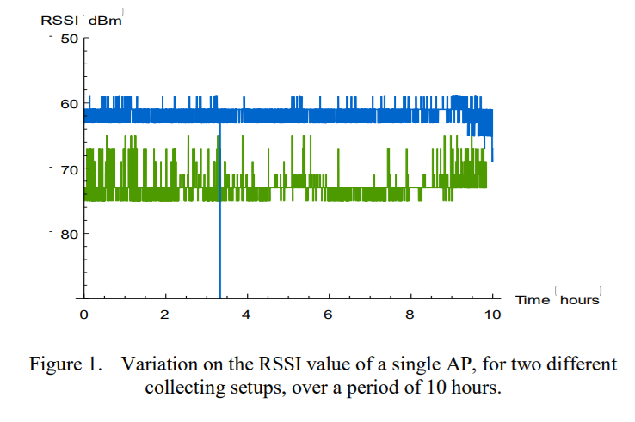“Fig. 1 shows an example of the RSSI variations along the time. The samples were taken over a period of 10 hours, with a five seconds interval, starting at midnight and ending at 10 am. Two collecting setups have been used, using similar USB WiFi network adapters (same brand and model), but connected to two different computers with different operating systems (Windows XP Server and Windows Seven). The USB adapters were placed within a few centimeters from each other. Each one of the lines in Fig. 1 shows how the signal level from one specific AP oscillated along the time.”

“In fingerprinting-based positioning systems, the size of the radio map is an influential factor to the computational load in the operational phase. A positioning system for a relatively large area incurs in a high computational complexity. On the other hand, the accuracy of the positioning system strongly depends on the number of calibration points and on the quality of the samples in the radio map. A more refined radio map, with more calibration points, can considerably increase the accuracy of the positioning system. However, a radio map with more calibration points makes the operational phase computationally more complex and more time-consuming. Nevertheless, especially in places with significant size, a part of the samples obtained during the calibration phase is not relevant to the operational phase.”

“For all these reasons, the optimization of the radio map has become a challenge in the fingerprinting-based positioning systems in order to fulfill the requirements of real-time applications.”

*II. RADIO MAP C. Final radio map*

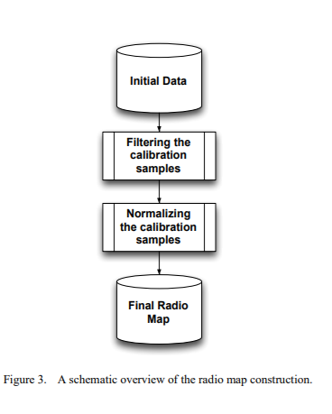

**Augmented Reality Indoor Navigation Based on Wi-Fi Trilateration**

*Abstract*

“Location based systems have become a vital part of our daily life. While outdoor localization has been around for years, indoor localization is still under heavy research due to the limitations of GPS satellite.”

*Keywords*

Indoor Localization, Wifi Trilateration, Fingerprinting, Augmented Reality

*Introduction*

“Outdoor localization using GPS is typically feasible, however indoor cannot be achieved due to the difficulty of satellite signal to go through buildings and ceilings. Other methods are used to solve this, such as indoor Wi-Fi signals for positioning. Holding the fact that WiFi works anywhere an access point is available, many applications depend on it in localization like mobile robotics that assign its own location in an indoor environment, using no extra hardware. Also, a person’s location indoors can be found using a device connected to Wi-Fi access point which furthermore can be used in various applications for touristic aims such as museums, university campuses, restaurants, malls, shops, transportations, and nonetheless tracking malicious users of some Wi-Fi network.”

“With the growth of location services, indoor positioning systems is in increased global evolution where companies and organizations are going toward developing new user experiences, profits, and advantageous brands of mobile applications applying location-based services, and those who haven’t yet improved these services are on their way to in the coming two years in purpose of attracting more customers by enhancing their experience and utility of their services beside compensating sales via proximity marketing, making use of locations, and taking much care of their brands served to users.”

“Nowadays 38% of organizations and companies surveyed have already applied indoor positioning systems with the lead for US with 43%, UK (33%), and Asia (33%). With the evolution of mobiles as a necessity in everyone’s life, and the truth that most of the peoples’ time is spent indoors, internal localization becomes more dependent on the use of smartphones to engage clients indoors and is branched into many types: Wi-Fi, Bluetooth Low Energy beacons(BLE), and geomagnetic indoor positioning systems.”

“As mentioned before, GPS is weak for indoor positioning, it is inapplicable in the domain of indoor navigation that needs penetration of signals inside buildings, so many problems can be recorded that will lead to adoption of new method for indoor localization:

• Need of high accuracy and scalability of positioning indoor which is hard to be applied using the available apps of outdoor positioning or methods of indoor that depend on Bluetooth beacons where developers have concerns in implementing it concerning scalability and expense, as well as the geomagnetic that is still not well known technology and can’t be risked to be used in applications that need high precision.

• Holding the truth that technologies other than Wi-Fi used in indoor positioning are of expensive and more complicated manners like the ultrasound or Laser, and need extra hardware to be tested and implemented.

• Obstructed human experience while being inside touristic places, where localization and navigation has turned into a necessity compelled by the penetration of smartphones in our life as obligation in order to ease his discovery of nearby places as shops or transportation stations faster and more feasibly.

• Indoor positioning systems are still in relative infancy, however our research of this domain has revealed a huge demand, utilization, and growth of indoor positioning system services.

• Significant demand of Wi-Fi localization in many fields of healthcare, proximity marketing, retail, travel and big estate offices that are difficult to navigate where people get lost when heading to a meeting which spends a lot of their work time, so deployments of indoor positioning services is increasing accordingly in the coming few years.”

“Wi-Fi localization involves many methods that depend on wireless access points to locate signals from a device like smartphone using the strength of the signals received. One of these methods is Wi-Fi trilateration which is as the name mentions a “tri” based technique that uses three access points to locate, it estimates the distance between the receiver and three transmitters by generating circles of radius around each access point as the distance from it, and their intersection points will define the area where the receiver is.”

“Another method for localization is fingerprinting, in this technique there is matching between previously calculated RSSI values with the real-time measured data.”

*II. RELATED WORK*

“As mentioned before, the creation of systems and solution for indoor positioning and navigation topic has been widely studied lately due to its significance in future industry among various aspects. During the research of this high momentous topic, it was found that large companies are employing systems of indoor localization in most of its planned technologies, architectural designs, and trends, beside those that have already updated their platforms, mobile applications and APIs to engage this approach as part of their services. These companies include also large and important ones such as Apple, Google, Cisco, and Alibaba.”

“Wi-Fi triangulation is the most popular method used among most of the systems of indoor positioning due to its high accuracy compared with other techniques, this precision reached as a maximum of 1 meter.”

“Several systems have been implemented in the field of indoor navigation, some of them provide APIs for developers in this domain, and others are by themselves applications for indoor positioning where they may include navigation features or only providing on map locations, they could provide information of places and statistical properties of studied areas, and some are still in the infancy stage to be applied in the near future. Most of the surveyed applications are considering Wi-Fi trilateration as their main method to achieve indoor positioning and navigation consequently, but they were always lacking some feature in solving this significant problem of localization inside which lead them to be of low efficiency and made this field still in the stage of experimentations.”

*III. SYSTEM DESIGN*

“In this section, we will discuss two approaches: trilateration and fingerprinting. Both approaches depend on RSSI measurements which consist of received signal strength indication that is the power level sent from an RF device (WiFi Access point). In order to calculate the location of a user, the distance from three access points computed using RSSI is evaluated.”

1. *Wi-Fi Trilateration*

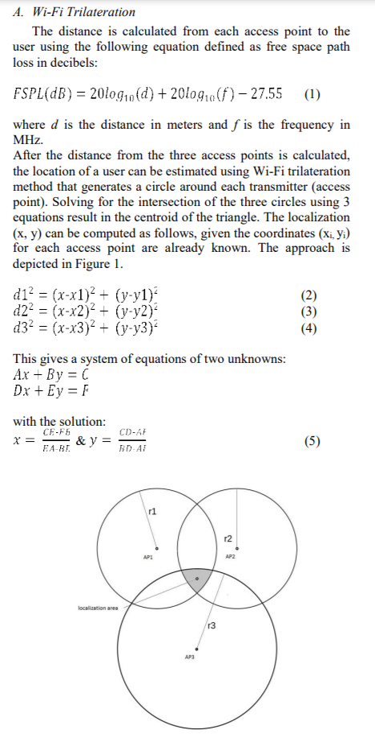

1. *Fingerprinting*

“Fingerprinting is a two-stage approach. The process starts by an offline acquisition followed by a localization approach based on interpolation.

1) Offline acquisition: In this stage, the indoor map is divided into sub grids and fixed points are places all over the map as the “fingerprints” separated by x meters (2 meters were used in this work). The RSSI values received on each point from three APs along with the MAC address and SSID are recorded, where RSSI is measured by dB. These values are then stored in a database for later use at the next stage.

2) Localization: This is the phase of determining the position and is done in real-time simulation. The current RSSI is measured from the three access points. Only two values are chosen which have the closest values to those pre-measured in in phase 1, and consequently are the nearest to the AP. The next step consists of measuring the midpoint between these two points, which will result in three points that form a triangle including the area of the location. Calculating the centroid of this triangle gives the required location.”

*C. System Architecture*

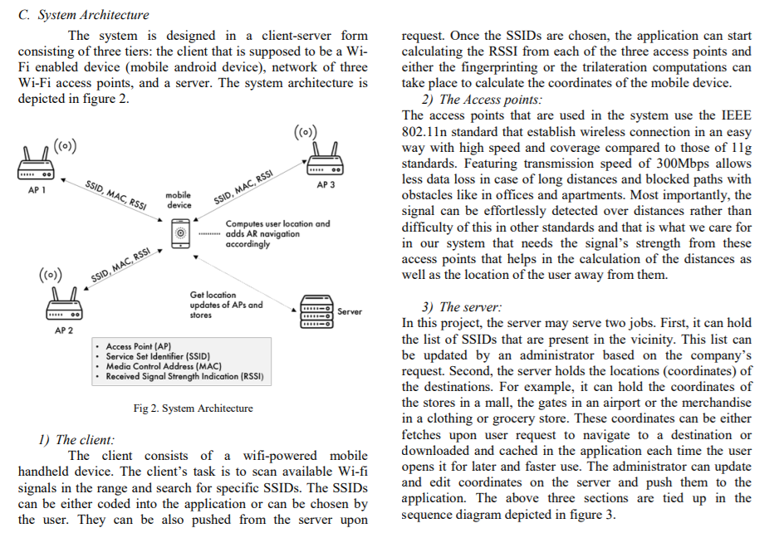

**Indoor Localization System Using Wi-Fi Technology Bom**

*Abstract*

“Recently, indoor localization has witnessed an increase in interest, due to the potential wide range of using in different applications, such as Internet of Things (IoT). It is also providing a solution for the absence of Global Positioning System (GPS) signals inside buildings. Different techniques have been used for performing the indoor localization, such as sensors and wireless technologies.”

*Index Terms*

Indoor Localization, Wi-Fi, tracking object, Distance measurement.

*I. INTRODUCTION*

“Localization and tracking of objects have become a very important entity for the society for a long time. Nowadays, much outdoor localization and tracking solutions exist, based on Global Positioning System (GPS), which can take us within meters of certainty when locating the position of a building. In indoor environments, the received GPS signals are too weak to provide an accurate object location. At present, buildings are equipped with Wireless Local Area Network (WLAN) access points, such as airports, supermarkets, hospitals, museums, etc. It can be effectively implemented to use these access points as a source and to receive WiFi signals to locate user location in these internal environments.”

“Indoor localization is the process of obtaining a device or user location in an indoor setting or surrounding. The localization of the indoor devices has been extensively studied, especially in the industrial environment and for wireless sensor networks and robots.”

“Most of the existing systems that offer indoor localization services used different wireless technologies, such as Bluetooth, WiFi, signals of cellular towers and ZigBee. The methods using Wi-Fi are more popular because WiFi networks dominate most public buildings, with no need for additional infrastructure and without limitations on the number of items to be monitored or tracked.”

“There are various indoor localization algorithms based on wireless signals. The main challenges in using these algorithms are to provide acceptable accuracy and deployment cost. For these reasons, a lot of interest has been gained in many research communities using WiFi for indoor localization techniques.”

*II. RELATED WORKS*

“Indoor localization can be defined as any system that provides the exact location of objects (a personal item) in a closed structure, such as supermarkets, hospitals, universities, airports and subways. Indoor location system has become very popular in recent years. Therefore, many systems and technologies have been proposed to get the user and device localization based into Object. The object can be a mobile phone, keys with attached microcontrollers a keychain, a wallet with embedded microcontroller or microcontroller in a child pocket, among others.”

**The Tale of Two Localization Technologies: Enabling Accurate Low-Overhead WiFi-based Localization for Low-end Phones**

*ABSTRACT*

“WiFi fingerprinting is one of the mainstream technologies for indoor localization. However, it requires an initial calibration phase during which the fingerprint database is built manually by site surveyors. This process is labour intensive, tedious, and needs to be repeated with any change in the environment. While a number of recent systems have been introduced to reduce the calibration effort through RF propagation models and/or crowdsourcing, these still have some limitations.”

*KEYWORDS*

Indoor Localization; WiFi Fingerprinting; BLE-based Localization

*Introduction*

“WiFi-based indoor localization techniques leverage the Received Signal Strength (RSS) overheard from WiFi access points as the metric for the location determinations, building a WiFi fingerprint to combat the noisy wireless channel. Typical fingerprint-based WiFi localization techniques work in two phases: The first phase is initial training (i.e., calibration) during which RSS measurements (i.e., fingerprints) received from the multiple access points (APs) installed in the area of interest are recorded at known locations. Then, in the tracking phase, RSS measurements from the overheard APs at an unknown location are matched against the fingerprint database to determine the best location match either deterministically or probabilistically. Nonetheless, the deployment cost is prohibitive as the WiFi calibration process is time consuming, labour intensive and vulnerable to environmental dynamics.”

“To further address the issues of WiFi-based localization, the iBeacon technology has been introduced. Beacons are cheap, portable, and energy-efficient devices based on the BlueTooth Low Energy (BLE) standard that can be installed at known locations in the area of interest. iBeacons periodically broadcast their identifier along with other location information which can be overheard by nearby compatible smartphones. A number of commercial solutions leverage iBeacons to provide proximity-based localization and, more recently, researchers have started to use them to provide more accurate continuous user tracking. Nonetheless, the BLE technology is currently limited to high-end smart phones, limiting their ubiquitous deployment on typical commodity devices with the majority of the users. In addition, the opportunity of using the existing WiFi-infrastructure for localization is missed in this case.”

*5.1 Fingerprinting-based Techniques*

“In these techniques, the radio map is built by maintaining the RSS signature of heard APs at different locations in a database during the offline phase. During the tracking phase, the set of overheard APs is matched against fingerprints in the database for the closest location in the RSS space to the unknown location. This matching is done using either deterministic methods or probabilistic methods. In the deterministic case, the fingerprint is represented by a scalar quantity, e.g. the average RSS of the heard APs in a certain location. During the online phase, the RSS vector collected while scanning the unknown location is matched (based on some distance metric such as Euclidean, Manhattan, or Mahalanobis distance) against the fingerprints of all locations maintained in the radio map to find the nearest match. On the other hand, probabilistic techniques construct signal strength histograms for the RSS received from each AP at each location in the area of interest. During tracking, the fingerprint is used to calculate the probability of the RSS vector at the unknown location at each location stored in the radio map. The most probable location is used as the estimated location. Many variants of probabilistic WiFi fingerprinting based indoor localization have been proposed to improve the performance. For instance, talking the high correlation between consecutive signal strength samples from same APs into account can help to achieve better accuracy. Another approach aims to detect small scale signal variations and perturbs the signal strength vector entries to overcome it, thus improving accuracy. Clustering locations that share a common set of access points will significantly reduce the computational overhead. Finally, probabilistic techniques have been proven to be superior to deterministic techniques. Although fingerprinting-based methods are relatively accurate, their deployment is impeded by the high cost of calibration phase and the user inconvenience. In addition, they need to handle the fingerprint differences between heterogeneous devices.”

**Wi-Fi fingerprint similarity in collaborative radio maps for indoor positioning [3]**

*Abstract*

“Positioning systems based on Wi-Fi fingerprinting has become very popular in recent years. These systems have been attracting the attention of many researchers and companies because they provide a low cost solution for real time positioning of both people and objects.”

*Keywords*

Wi-Fi fingerprinting, location, indoor positioning

*Introduction*

“During the last decade, numerous research projects explored the usage of Wi-Fi networks to build indoor positioning systems. Several different techniques were explored but, currently, the implementation of systems based on Wi-Fi fingerprints is the most common solution. Positioning techniques based on Wi-Fi fingerprinting are implemented based on the received signal strength indication (RSSI) of the Access Points (APs) that can be detected on site.”

“Combining these positioning systems with mobile applications makes possible to track and locate users, since frequently the location of a mobile device corresponds to the location of its owner. These systems, called Real-Time Location Systems (RTLS), depend on prior knowledge of existing Access Points in a given area.”

“A Wi-Fi radio map is a database containing Wi-Fi fingerprints collected (often manually) in the different locations. The positioning systems (often also called positioning engines) compare the Wi-Fi fingerprint collected by the mobile device with the set of fingerprints contained in a previously build radio map. The location of the mobile device is then estimated by a similarity or best matching function, and because each record contained in the radio map is linked to a location name or coordinates the positioning system can provide the user's location.”

“Building a radio map is not a complex or demanding task for private and small sized places since it is fairly easy to manually collect fingerprints in the entire building and thus it is possible to build a complete radio map, linking places/locations to the collected fingerprints. When it comes to public spaces or larger buildings, the process of building radio maps manually is much more time consuming and in some cases difficult to be done. Usually these public or large areas highlight another problem: Wi-Fi networks often change, by setting up new APs or by moving and removing the existing ones. Changes on the layout of the spaces or simple changes on the position of furniture also contribute to alterations on the behaviour of Wi-Fi networks. Thus, the radio maps may become outdated and, therefore, they must be updated so that the positioning engine can continue to correctly identify the users' positions.”

**Evaluation of fingerprinting-based WiFi indoor localization coexisted with Bluetooth**

*Abstract*

“WiFi and Bluetooth are two most commonly used short range wireless communication technologies. Recent years, with increasing number of WiFi and Bluetooth mobile terminals, tags, and other devices, a demand for integration and coexistence of these two technologies including their positioning function is booming.”

*Keywords:*

WiFi, Bluetooth, Coexistence, Positioning, Fingerprinting

**Survey on WiFi-based indoor positioning techniques**

*Introduction*

“From the current application scenes of ILBSs (Indoor Localizations Based Services), WiFi technology has the following three advantages: (i) Widely distributed hot spots: WiFi hotspots can be distributed in various large or small buildings such as homes, hotels and shopping malls, which makes WiFi positioning suitable for many indoor environments. (ii) Low access conditions: due to the widespread distribution of existing WiFi infrastructure, most of the WiFi-based positioning systems do not need to rebuild or expand the network, which reduces application costs. (iii) High flexibility: WiFi signals are not severely affected by not line of sight (NLOS) in the complex indoor environment.”

*2.1.1 Accuracy:*

“The primary purpose of ILBSs is to obtain the user's location, so the accuracy of positioning is one of the important indicators to measure the performance of different indoor positioning techniques. Of course, the requirements for positioning accuracy are different in different ILBSs. In many cases, other indicators such as cost, real-time and reliability need to be taken into account. For example, achieving ILBSs similar to locationbased store recommendation services do not require high-precision location information. Excessive precision will only increase its cost and reduce its real-time performance, which in turn leads to a decrease in the overall system evaluation. Unlike the store recommendation services, indoor navigation similar to the route to the store requires more accurate location information so that other indicators can only be considered on the basis of meeting accuracy. Most of the current research focuses on how to improve the accuracy of indoor positioning.”

*2.1.2 Real-time:*

“Real-time is as important as accuracy in some specific indoor applications. For example, when the criminals hold the hostages, police need to know in real time the location of hostages in order to have more opportunities for rescue. When a disaster occurs indoors, panicked trapped people may move at any time, and it is necessary to locate the trapped person in real time during an emergency rescue by the rescue team. Most indoor positioning algorithms use methods that modify algorithm complexity, signal acquisition, AP deployment and hardware to improve the real-time performance of the indoor positioning technology.”

*2.1.3 Scalability:*

“The scalability of indoor positioning technology is the ability of a system to adapt to changes in the environment after taking into account the required performance, cost, maintainability and other factors. When the system is expanded, the higher the system's scalability, the lower the additional cost required by the system and the lower the impact on other performance. Especially for commercial purposes, due to the increase of indoor users and the channel occupied by other wireless devices, the system processing capacity is overloaded. This factor degrades system performance, thus we have to improve the system. In addition, when expanded space is beyond the scope of the system, the system needs to make changes to software and additional equipments. High scalability ensures the system has a long life cycle. The linear increase in processing capacity and coverage of the entire system can be achieved by making some changes to the system or even adding only hardware devices.”

*2.1.4 Reliability:*

“The reliability of positioning system includes three elements: specified time, operating environment and accuracy. Therefore, reliability can be described as the probability that the feedback results by indoor positioning techniques have no obvious error in a given time and environment. In some special indoor scenarios, such as mine and firefighting, reliability is one of the primary conditions for evaluating positioning techniques. Especially in the face of some unexpected situations, if the reliability cannot be guaranteed, ILBSs may report incorrect positioning results in the event of an emergency, which may make the situation even more out of control.”

*2.1.5 Cost:*

“The cost will directly affect the application and popularity of ILBSs, hence its cost needs to be comprehensively considered in the design process of indoor positioning technology. Performance requirements, operating environment and hardware equipment affect its cost. Simultaneously, system maintenance and expansion costs are also major sources of the cost after the system design is completed. In recent years, due to the popularity of smart terminal devices and the development of wireless local area networks, the cost of ILBSs has been dropped significantly in many indoor scenarios.”

**Fusing Bluetooth Beacon Data with Wi-Fi Radiomaps for Improved Indoor Localization**

*Abstract*

“. Due to the widespread availability of IEEE 802.11, many localization platforms have been proposed, based on the Wi-Fi Received Signal Strength (RSS) indicator, using algorithms such as K-Nearest Neighbour (KNN), Maximum A Posteriori (MAP) and Minimum Mean Square Error (MMSE). In this paper, we introduce a hybrid method that combines the simplicity (and low cost) of Bluetooth Low Energy (BLE) and the popular 802.11 infrastructure, to improve the accuracy of indoor localization platforms.”

*1. Introduction*

“In all these applications, numerous programmable wireless sensors, with enhanced capabilities, are combined and configured in order to directly monitor several parameters in a non-invasive way [3].”

“Nowadays, where user profiling is very important, user localization and tracking are instrumental to a broad range of such services and applications [5–8]. User localization, in areas where the Global Positioning System (GPS) is not available, is typically achieved by utilizing several wireless communication technologies (Wi-Fi, Bluetooth, Long Term Evolution (LTE), Zigbee, Visual Light Communication (VLC), etc.).”

“Among all of these, fingerprint-based positioning is one of the most popular indoor localization techniques implemented by Real-Time Localization Systems (RTLS).”

“The main advantage of fingerprinting techniques is that they can utilize the existing wireless communication infrastructures, without the need to deploy any additional, specialized equipment. The dataset of fingerprints, called a “radiomap”, is the basis behind the positioning algorithms. Radiomaps can be generated rapidly and at a relatively low cost, particularly when a deterministic radio propagation simulator is used, instead of performing costly and lengthy measurement campaigns [15]. Fingerprinting requires both an offline and an online phase. During the offline phase, the radiomap is generated by recording the Access Points (AP) RSS values (that can be either measured or obtained through a simulator) for each location in the area of interest. Calibration and training techniques are usually used during this phase, in order to improve the quality of the radiomap [16]. During the online phase, the Mobile Station (MS) performs network discovery as well as real-time RSS measurements. Different positioning algorithms are then applied in order to identify the best match between the observed RSS fingerprint and the respective mean value of the fingerprints recorded during the offline phase.”

“On the other hand, by combining existing well-established Wi-Fi positioning systems with Bluetooth Low Energy (BLE) i-beacons, an excellent opportunity is created to enhance the user’s localization accuracy. This approach can make fingerprinting even more favourable, particularly in smart homes, since localization accuracy can be pursued by deploying only a small number of low-cost BLEs on top of the existing Wi-Fi infrastructure. This is, in fact, the methodology pursued in this paper, whereby we introduce a new method to combine BLE with Wi-Fi fingerprint positioning, in order to significantly improve the achieved localization accuracy.”

*2.2. BLE and the iBeacon Technology*

“BLE was introduced as part of Bluetooth 4.0 specifications, allowing the devices to support both BLE and classic Bluetooth protocols simultaneously [32]. The power efficiency of Bluetooth with low energy functionality was especially created for IoT applications. It allows devices to run for long periods on extremely low power sources, such as coin-cell batteries or energy-harvesting devices.”

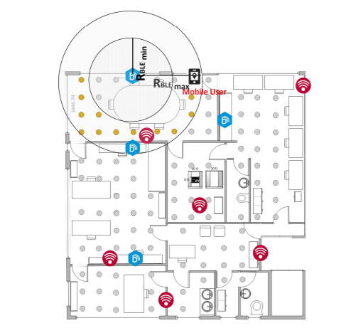

**Improving RF Fingerprinting Methods by Means of D2D Communication Protocol [6]**

*Abstract*

“Therefore, with the signals received from multiple APs, a unique fingerprint can be created. However, the Wi-Fi signal is affected by many factors which degrade the positioning error range to around a few meters.”

*1. Introduction and Motivation*

“The widespread application of Global Navigation Satellite System (GNSS) technology (such as GPS, Galileo, GLONASS) has solved most of the outdoor positioning problems. However, the localization accuracy sharply declines once the receiver enters a non-line of sight (NLOS) environment. Therefore, indoor positioning systems have been extensively investigated, and intense efforts have been devoted to enhancing the localization performance [1,2].”

“Among the current indoor positioning schemes, for instance, Radio Frequency Identification (RFID), Ultra-WideBand (UWB), Dead reckoning, image-based technology, and ultrasonic which strongly depend on extra devices, the Radio Frequency (RF) fingerprint positioning system has become a very promising and competitive technical solution for its high precision positioning by low-cost [3].”

“The strategy relies on the idea that every indoor location can be identified by a unique signal feature known as a fingerprint. Typical RF fingerprint (from now on, fingerprint) consists of radio measurements from multiple Access Points (AP), i.e., Received Signal Strengths (RSS) or path-loss measurements to provide a fingerprint of radio conditions at a specific location. The location of a fingerprint can be estimated using the known location of similar fingerprints previously recorded. One of the critical challenges to support such fingerprinting localization is to create and maintain accurate fingerprint databases [4]. A site survey is often used to collect fingerprints from a targeted area. However, site surveying is a time-consuming and labor-intensive process. It requires several measurements of each fingerprint to obtain the statistical value of signal strength. Often professional work is needed for efficient site surveying. Moreover, a well-built fingerprint database become outdated as soon as the environment changes. For instance, the redistribution of APs after maintenance might degrade the accuracy of the fingerprint-based positioning system. To solve the problems mentioned above, some new kind of radio map construction techniques have been proposed, including data collection with the help of volunteers, simultaneous localization and mapping, propagation model prediction, RSS prediction based on exist fingerprints, fingerprint construction using passive crowdsourcing data [5], or by means of unsupervised techniques.”

*3. Material and Methods*

“. Clock synchronization is crucial in TOA-based distance calculation, but it is impractical to have all the devices’ synchronized clock in a wireless network.”

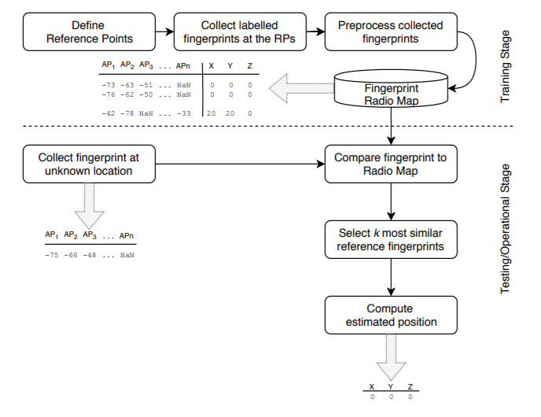

**Recent Advances in Indoor Localization: A Survey on Theoretical Approaches and Applications [1]**

*Abstract*

“In this paper, we survey different technologies and methodologies for indoor and outdoor localization with an emphasis on indoor methodologies and concepts.”

“Additionally, we discuss in this review different localization-based applications, where the location information is critical to estimate. Finally, a comprehensive discussion of the challenges in terms of accuracy, cost, complexity, security, scalability, etc. is given. The aim of this survey is to provide a comprehensive overview of existing efforts as well as auspicious and anticipated dimensions for future work in indoor localization techniques and applications.”

*I. INTRODUCTION*

“In this paper, we provide a review on recent techniques and concepts used to improve localization with their fundamental limits, challenges and applications with a particular focus on indoor environments.”

“Additionally, they do not explore advanced methodologies used to enhance localization, such as cooperative localization and data fusion techniques.”

*II. FUNDAMENTAL LIMITS OF LOCALIZATION IN INDOOR ENVIRONMENTS*

“However, basic localization techniques have their limitations. ToA/TDoA is limited by the requirement of at least 3 base stations (or ANs) to generate 2-D fix. AoA requires at least two base stations. The performance of AoA techniques is highly dependent on the range giving significant position estimation errors from relatively small error in the AoA measurements. They are restricted by the carrier frequency, and the size of the array. Thus, they are used only for localization in applications with requirement of low accuracy or in combination with other measurements. Also, AoA systems are sensitive to angular multipath, a major effect in indoor environment. Consequently, ToA techniques are preferred in urban areas due to multipath effect whereas AoA are preferred in open areas. Looking at the different access technologies for localization purposes, we can also note various limitations. For instance, empirical analysis of the appropriateness of WLAN localization showed that significant errors always occur, even though reasonable accuracy may be achieved [18]. Errors are mainly due to the presence of different locations with similar radio signatures, such as fingerprints or received signal strength, caused by the dynamic propagation of radio signals [15]. Thus, this is considered as a fundamental limit of pure WLAN-based techniques where large errors in range of 6 to 8m occur.”

“To give more insights about these aspects and limits, we will describe with the necessary details the stand-alone localization techniques used for indoor scenarios.”

**Wi‑Fi indoor positioning and navigation: a cloudlet‑based cloud computing approach**

*Abstract*

“Wi-Fi-based indoor positioning for determining accurate wireless indoor location information has become crucial in meeting increasing demands for location-based services by leveraging the Internet of Things (IoT) and ubiquitous connectivity. Most Wi-Fi-based indoor positioning techniques using wireless received signal strength (RSS)-based methods are afected by the indoor environment and depend on the respective signals from at least three reference access points.”

*Introduction*

“Increasing demands for location-based services require accurate wireless indoor location information. Location-based services include indoor navigation for people or robots, personnel, asset tracking, guiding blind people, factory automation, workplace safety, locating patients in a hospital, and location-based advertising [1]. Additionally, such services are becoming essential in various other felds such as mobile commerce, parcel or vehicle tracking, discovering the nearest shops or restaurants, and social networking [2]. Moreover, analyses of personnel and asset tracking and collecting movement data have been limited.”

“Wi-Fi based indoor localization systems have become a prominent tool for indoor positioning for various reasons. First, nearly all smartphones have a built-in Wi-Fi module. Second, Wi-Fi access points are installed ubiquitously, and a Wi-Fi based indoor localization system has suitable cost and accessibility [2, 21]. Tird, Wi-Fi does not require additional special-purpose hardware. Location estimation can be easily estimated by measuring the received signal strength (RSS) values from a Wi-Fi access point. Finally, the bandwidth of Wi-Fi systems has increased signifcantly to meet the requirements of high data rates [1].”

“Alternatively, Wi-Fi indoor positioning techniques are classifed into two categories, signal propagation models [17, 32] and location fngerprinting [29]. A comparison of signal propagation models and the location fngerprinting method is presented in Table 1. In a signal propagation model, an indoor positioning system using the time-of arrival (ToA) and time diference of arrival (TDoA) sufers from multipath fading on several paths [5] while measuring the distance to the station from mobile devices. Alternatively, the location can be estimated using the angles of the signals received from the mobile user and the Wi-Fi access point; this includes the angle of arrival (AoA) and angle of departure (AoD) techniques. Most systems based on AoA measure the relative angles between signals coming from multiple anchor nodes to estimate the position requiring the antenna directions of both the mobile user and Wi-Fi access point to be known. By measuring the time-of-fight of the signal traveling from the sender to the user and back, the round-trip time-of-fight (RToF) of the signal is used to measure a location.”

*Related works*

“Wi-Fi survey-based indoor positioning techniques are generally divided into two types, trilateration and triangulation algorithms [17, 43, 44], as shown in Figs. 3 and 4. A trilateration algorithm incorporates ToA, TDoA, RSS, and RToF techniques, while a triangulation algorithm incorporates AoA and AoD techniques. Trilateration algorithms measure the distance from multiple known access points, while triangulation algorithms compute the angles relative to multiple known access points.”

“The trilateration algorithm calculates the exact location of a user, given the exact location of access points and distances from each access point to the user.”

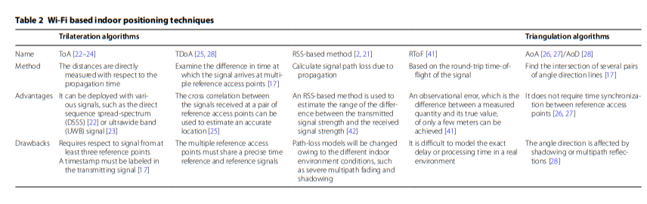

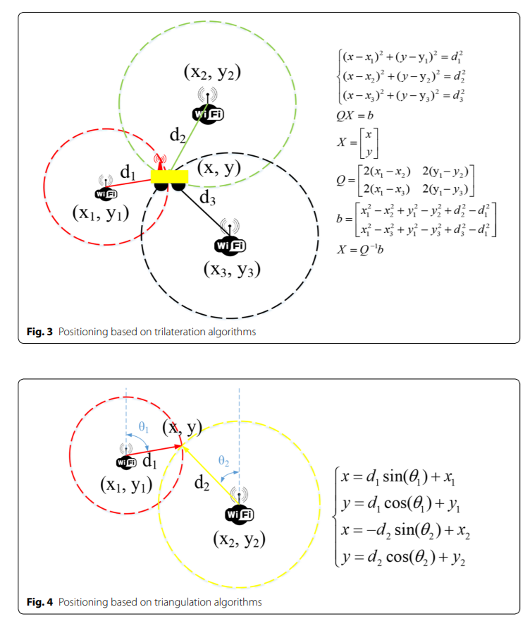

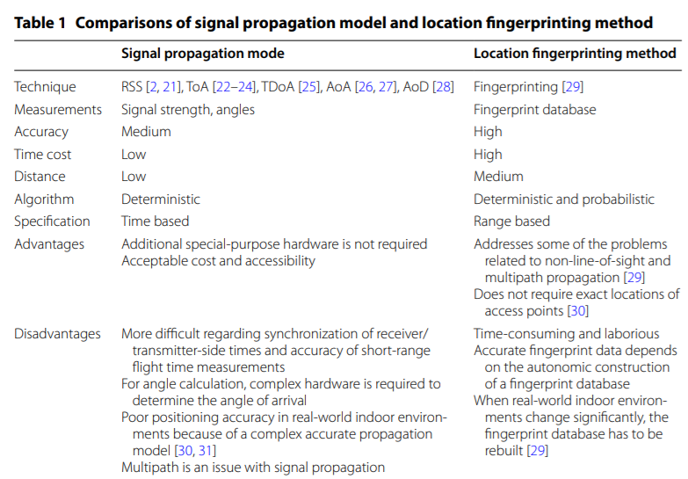

**A Survey of Indoor Localization Systems and Technologies TABELAS**

*Abstract*

“Indoor localization has recently witnessed an increase in interest, due to the potential wide range of services it can provide by leveraging Internet of Things (IoT), and ubiquitous connectivity. Different techniques, wireless technologies and mechanisms have been proposed in the literature to provide indoor localization services in order to improve the services provided to the users. However, there is a lack of an upto-date survey paper that incorporates some of the recently proposed accurate and reliable localization systems.”

“In contrast with the existing surveys, we also evaluate different systems from the perspective of energy efficiency, availability, cost, reception range, latency, scalability and tracking accuracy. Rather than comparing the technologies or techniques, we compare the localization systems and summarize their working principle. We also discuss remaining challenges to accurate indoor localization.”

1. *INTRODUCTION*

“The paper provides detailed discussion on the technologies and techniques for indoor localization as well as present some localization systems.”

“We aim to provide the reader with some of the latest localization systems and also evaluate them from cost, energy efficiency, reception range, availability, latency, scalability, and localization accuracy perspective.”

“This work provides a detailed discussion on different technologies that can be used for indoor localization services. We provide the pros and cons of different technologies and highlight their suitability and challenges for indoor localization. “

“We provide an exhaustive discussion on different techniques that can be used with a number of technologies for indoor localization. The discussed techniques rely on the signals emitted by the access technology to obtain an estimate of the user location.”

“Section IV: We present some of the metrics that can be used to evaluate the performance of any localization system. Our evaluation framework consists of metrics such as availability, cost, energy efficiency, reception range, tracking accuracy, latency and scalability.”

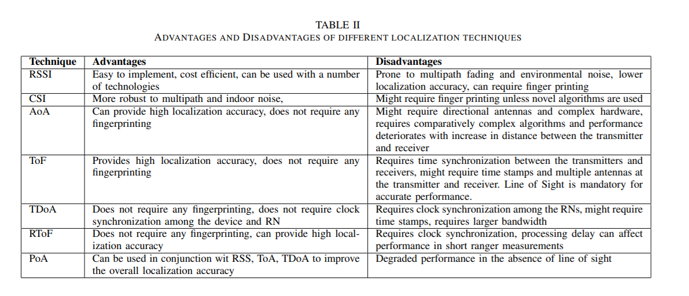

**A Survey of Smartphone-Based Indoor Positioning System Using RF-Based Wireless Technologies**

*Abstract*

“As fingerprinting localization is mostly accepted for IPS development owing to its good localization accuracy, we discuss fingerprinting localization in detail. In particular, our analysis is more focused on practical IPS that are realized using a smartphone and Wi-Fi/Bluetooth Low Energy (BLE) as a signal source. Furthermore, we elaborate on the challenges of practical IPS, the available solutions and comprehensive performance comparison, and present some future trends in IPS development.”

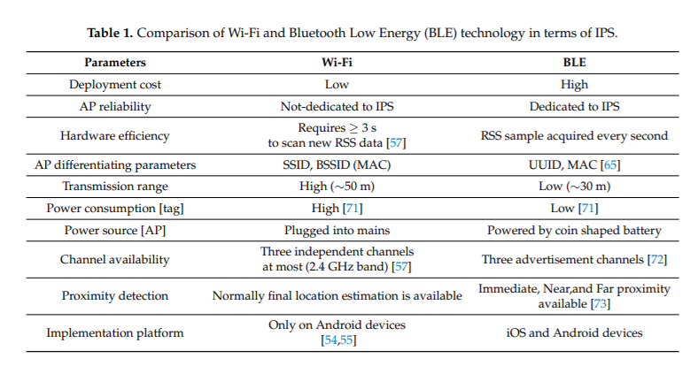

*5. The Performance Metrics*

**A state-of-the-art survey of indoor positioning and navigation systems and technologies**

*Abstract*

“The research and use of positioning and navigation technologies outdoors has seen a steady and exponential growth. Based on this success, there have been attempts to implement these technologies indoors, leading to numerous studies.”

“. In addition, positioning techniques applied in indoor positioning systems include the signal properties and positioning algorithms. The prevalent signal properties are Angle of Arrival (AOA), Time of Arrival (TOA), Time Difference of Arrival (TDOA) and Received Signal Strength Indication (RSSI), while the positioning algorithms are Triangulation, Trilateration, Proximity and Scene Analysis/ Fingerprinting.”

*Introduction*

“Likewise, using a mobile phone to navigate in an outdoor environment is dependent on uninterrupted access to satellite signals and network or Wi-Fi availability. In buildings where network or Wi-Fi availability is almost non-existent, users will find it difficult to do much on the mobile device (Aijaz et al., 2013). Such difficulties are mainly encountered in indoor environments, basements and underground environments of large buildings. These difficulties make internet access and the use of certain applications challenging. Hence, the mobility and ubiquity of the mobile device has made it a popular personal device, which has many uses including navigation (also known as Wayfinding). Navigation in indoor environments, which is the focus of this study, has become as popular as outdoor navigation.”

“As a result, attempts to implement these technologies indoors have led to numerous studies in this field, spurring researchers into discovering ways to make life easier for people while navigating indoor spaces. These works employed techniques and technologies which have varied levels of strengths, as well as weaknesses. The outcomes of this research have resulted in observed inhibitions in the various technologies which have affected performance.”

“In addition, the positioning techniques applied in indoor positioning systems and technologies include the signal properties and positioning algorithms. The prevalent signal properties are Angle of Arrival (AOA), Time of Arrival (TOA), Time Difference of Arrival (TDOA) and Received Signal Strength Indication (RSSI), while the positioning algorithms are Triangulation, Trilateration, Proximity and Scene Analysis/ Fingerprinting.”

“The focus, therefore, is on the application of techniques, algorithms and methods in indoor positioning and navigation scenarios by researchers in this field. This is meant to provide an understanding of present research stages, and propose possible research directions for further improvement. Hence, this survey made use of over 180 articles in journals, conference proceedings, books, book chapters, dissertations, and online articles or white papers to get an academic and industry view of the current state of the research. The literature search was done using flagship digital libraries. Only articles within the scope of this survey based on the study carried out in the articles were considered to be relevant. The survey follows a historical and systematic approach in its presentation. The indoor positioning techniques and technologies were discussed based on their classification or types, features, application scenarios, strengths and limitations.”

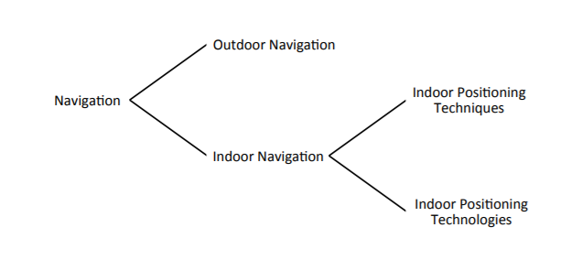

Figure 1: Flow diagram of survey discussion

*2.2 Indoor navigation*

“Mautz (2012, p. 7) points out that, “the ability to locate objects and people indoors remains a substantial challenge, forming the major bottleneck preventing seamless positioning in all environments.” Thus, navigating indoors with mobile devices became an interesting subject in recent years.”

“Indoor navigation is a subject that has been studied over the years using variety of techniques and technologies (Storms, Shockley, & Raquet, 2010; Hammadi, Hebsi, Zemerly, & Ng, 2012)Gu, Lo, and Niemegeers (2009) posit that an indoor navigation system consists of a network of devices used in locating objects or people inside a building. Upon knowing where something or someone is, activities such as tracking and position determination can be done with the information (Gu et al., 2009; H. Liu, Darabi, Banerjee, & Liu, 2007). The early indoor navigation systems involved using sensors, which consist of transmitters and receivers, for tracking and positioning (Want, Hopper, Falcão, & Gibbons, 1992; Fukuju, Minami, Morikawa, & Aoyama, 2003; Minami et al., 2004). Either of the transmitters or receivers could be fixed while the other is on the user who is in motion. Similarly, recent indoor navigation systems use mobile phones for positioning and navigation (K. Liu, Liu, & Li, 2013; Barberis, Bottino, Malnati, & Montuschi, 2014).”

“It involves the use of a mobile device, an installed navigation application in the mobile device, map of the indoor space of the building and a database to store map data. Navigating in large buildings, such as museums, airports, malls, hospitals and campuses, with an indoor navigation system guides a user to a preferred destination without hassles and without wasting time. However, the different technologies that have been used so far in indoor navigation implementation have limitations and are discussed subsequently.”

*3 INDOOR POSITIONING TECHNIQUES*

“In indoor positioning systems, ‘positioning techniques’ are used to determine and estimate the position of sensor nodes to improve positioning accuracy (Gu et al., 2009; Nuaimi & Kamel, 2011). A number of algorithms and techniques exist for obtaining bearing, range or proximity information based on signal measurement or properties (Amundson & Koutsoukos, 2009). The algorithms used in positioning systems translate recorded signal properties into distances and angles, and then computes the actual position or location of a target object. Thus, a user is able to use the position information in a navigation system during a navigation activity (Nuaimi & Kamel, 2011), and the position information can be used to track objects.”

“Although, most of the techniques, algorithms and constituents of the positioning technologies are not new, as they are implemented outdoors. However, how they fare indoors is different from outdoors altogether. This has spurred researchers into discovering ways of optimally applying the positioning techniques in position determination. To determine the position of a user, the two positioning techniques used are signal properties and positioning algorithms, shown in Figure 2.”

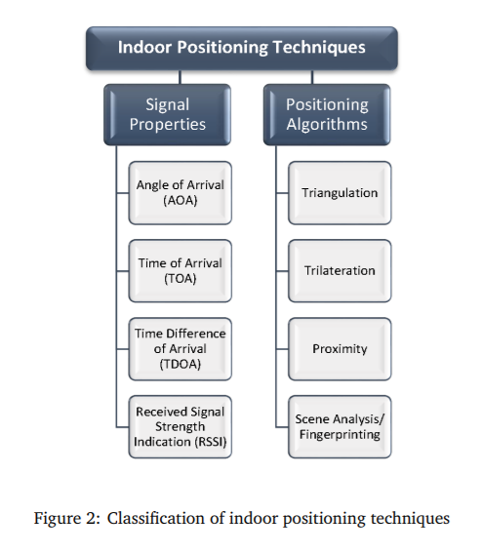

*3.1 Signal properties*

“Signal properties are geometrical parameters consisting of metrics such as angle, distance and signal to measure an object’s position using calculations (Ibid.).”

