BEETLE ESP32 DFR0575

1. **Setup**

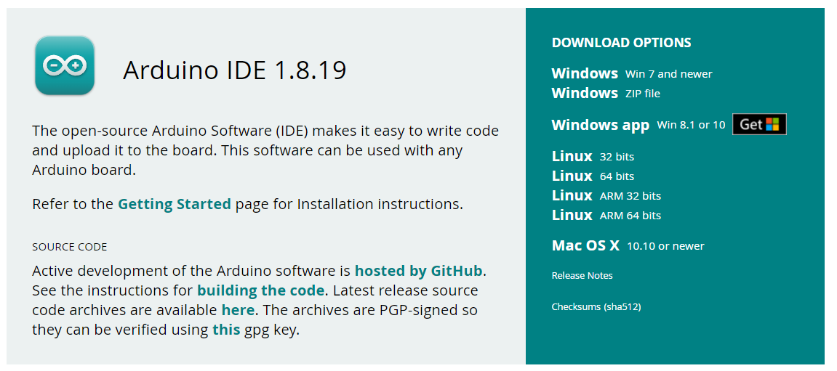

Using Arduino IDE is a more user-friendly approach.

1. **Adding the Board URL to Arduino IDE**

Open Arduino IDE (version 1.8.19).  
Navigate to File > Preferences and click the checked button as shown below:

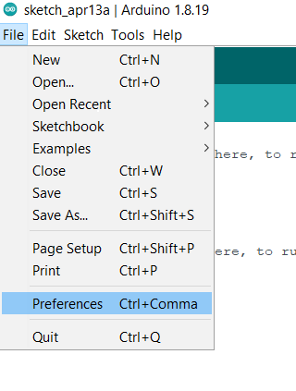

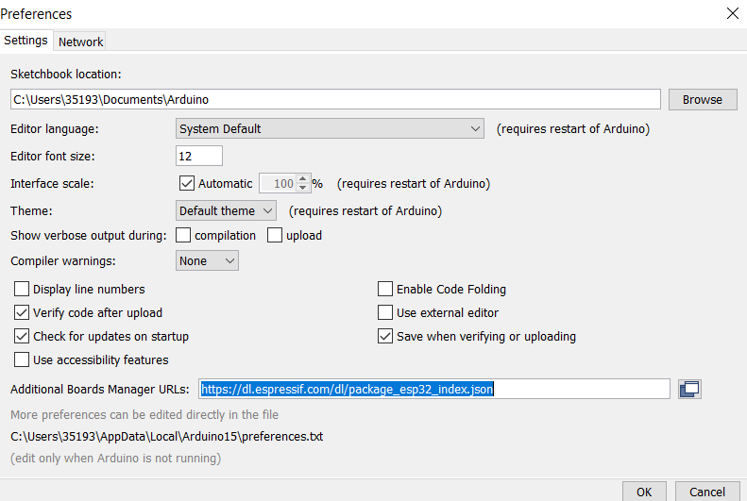

Enter the following URL in Additional Boards Manager URLs.

<https://dl.espressif.com/dl/package_esp32_index.json>

After the input is completed, click OK.

1. **Installing ESP32**

After adding the mainboard URL of [ESP32](https://www.dfrobot.com/product-1559.html) (ESP-WROOM-32) to Arduino IDE, it is needed to update the board list, and use [Arduino](https://www.dfrobot.com/category-35.html) IDE to download ESP32 (ESP-WROOM-32) libraries.

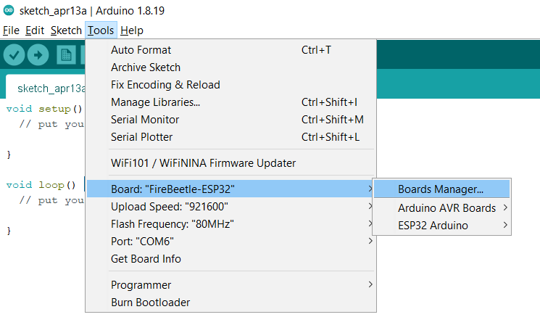

After opening the development board manager, the board list will automatically be updated.

When the update is finished type esp32, select it and click “Install”. The manager will automatically download the relevant libraries.

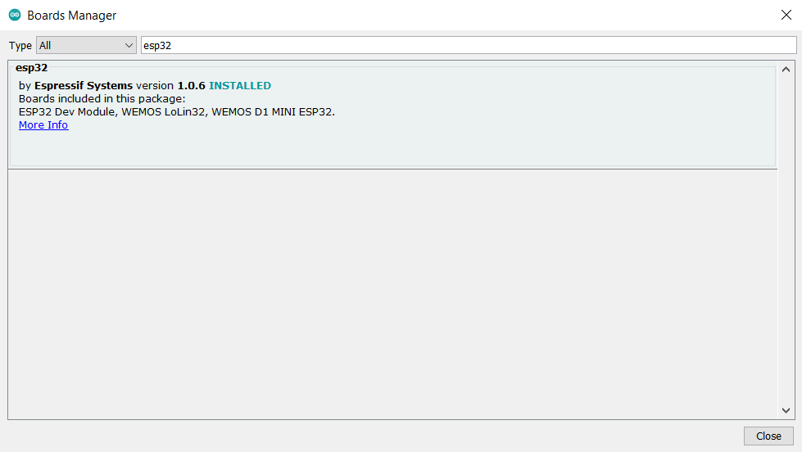

1. **Selecting the mainboard**

Open **tools->** board, select **FireBeetle-ESP32** mainboard, as shown in the following:

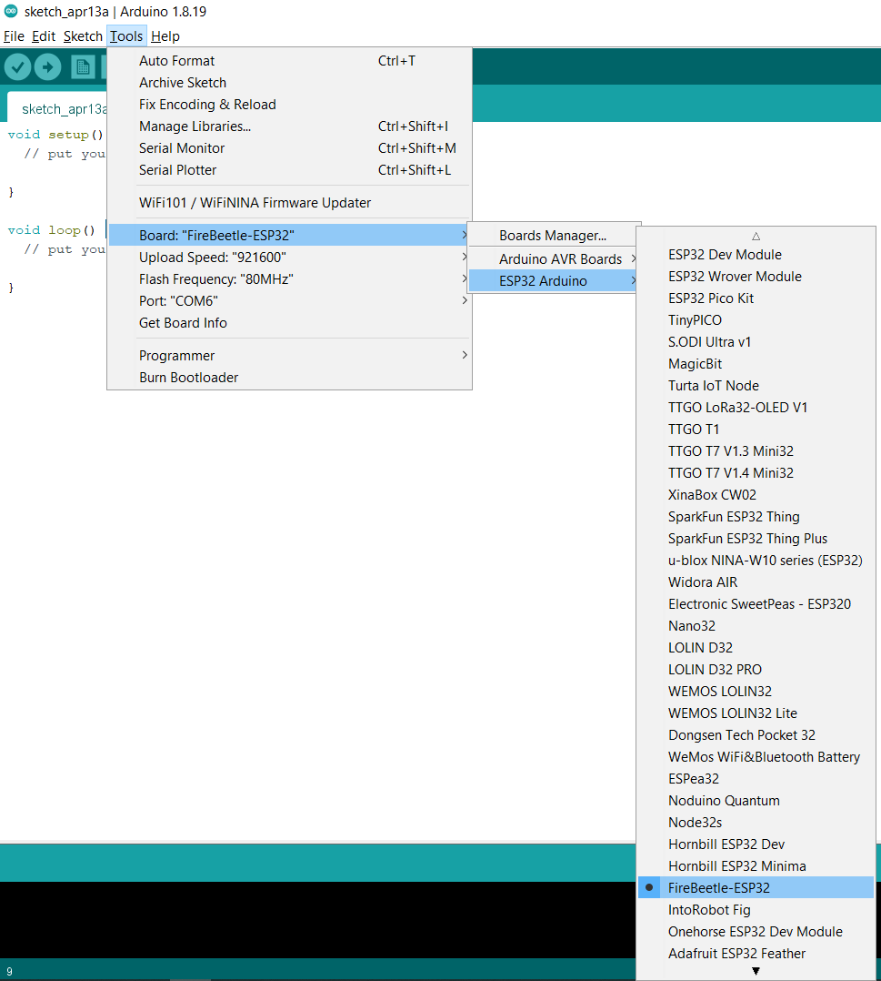

**Blink Program**

Now that the compilation environment is set up, it is possible to upload a test program.

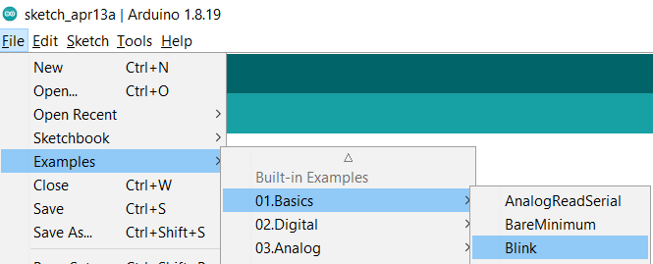

Click the   button to start compiling.

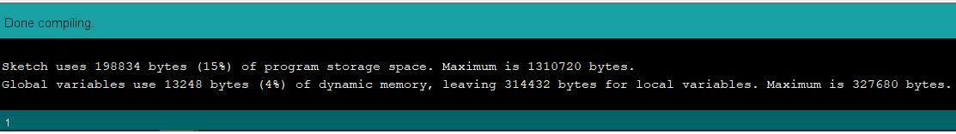

Click the  button to upload.

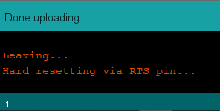

The device should start turning the led on for a second and off for another second.

**Scanning for WiFi networks while connected**

1. Connecting to a Wi-Fi Network

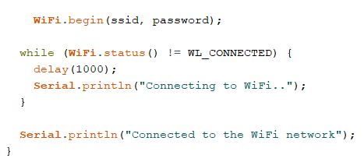

1. Scanning for Wi-Fi networks