|  |  |  |
| --- | --- | --- |
| Checkpoint IV | Checkpoint IV: First Prototype | |
| Group: | G16 |
| Date: | 2023/10/16 |
|  |  |

# Layout

The visual space is thoughtfully organized into three distinct sections, each dedicated to a specific idiom.

At the top of the layout, we present the Bar Chart. This component of the visualization is designed to provide a summarized view of the data, making it simpler to grasp key insights and trends. The bottom section features the Parallel Coordinates plot. This graph is designed to offer insights into the relationships and trends in the data, allowing for easy comparison and analysis. In the middle section, you will find the Parallel Set plot. Although it hasn't been included in this release, it remains a crucial element of our visualization strategy, as it effectively represents the categorical attributes within the dataset.

The position of this chart on layout is due to height is not too important as lines slopes so it is better to visualize inside an area of visualization where the focus on details is not so needed, giving more highlight on data flows.

# To enhance user experience and readability, we've ensured that the height of the Parallel Coordinates plot is triple that of the Bar Chart. This deliberate design choice aims to make it easier to navigate and understand the information, allowing users to dive into the data with greater ease.

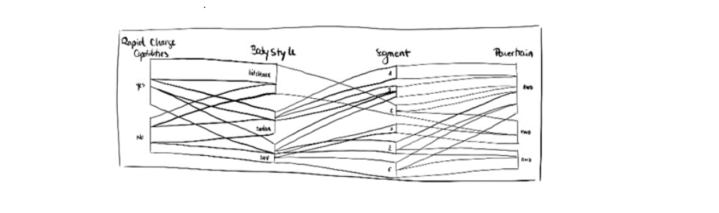

# Visual Encoding and Interactivity

# In the Parallel Coordinates graph, lines representing data instances with opacity that changes dynamically based on whether they fall within the specified range of values for each filter. The user can seamlessly adjust the filters by moving the sliders up and down, instantly narrowing or broadening the scope of the data. Additionally, for a deeper understanding of data relationships, the user has the freedom to drag and drop axes, altering their order to reveal intricate connections between attributes. These features put the user in control, allowing each one to interactively explore and analyze the dataset with ease.

The Bar Chart presents a straightforward visual encoding of data. Each bar in this chart is as a representation of a unique brand, and their colors are thoughtfully scaled to correspond to the average number of seats offered by each brand. This color encoding provides immediate insights into the dataset. This chart also interacts with the Parallel Coordinates plot. Whenever the user applies filters in the Parallel Coordinates section, the values in the Bar Chart update accordingly. This interactivity enables to observe how brand attributes change when filters are in place, making it an indispensable tool for comparative analysis and data-driven decision-making.

In the Bar Chart, by selecting one column and after a mouseover event being called it’s possible to observe the color spectrum on the Parallel Coordinates plot, with each color representing a specific brand. This additional feature adds an extra dimension to our analysis, facilitating a more in-depth exploration of the data. At the near end of the bar chart's x-axis, where a percentage value of models is displayed, you'll find a concise explanation that clarifies the purpose of this SVG text element. Essentially, it indicates the proportion of models we're filtering and analyzing in the chart.

# Implementation of Linking Mechanism

# The implementation of a linking mechanism allows different visual components, such as Parallel Coordinates plots and Bar Charts, to work in harmony. By sharing a common data source, interactions in one component can trigger changes in others.

# For instance, in a Parallel Coordinates plot, users can adjust filter settings, and this leads to dynamic updates in the Bar Chart. This synchronization of data and visuals is achieved through event listeners (drag and click) and call update functions. Smooth transitions and data filtering enhance the user experience.

# Additionally, if the user reorders the axes in the Parallel Coordinates plot, the event drags, and drop is started, and the mechanism ensures that this change is reflected in other components.

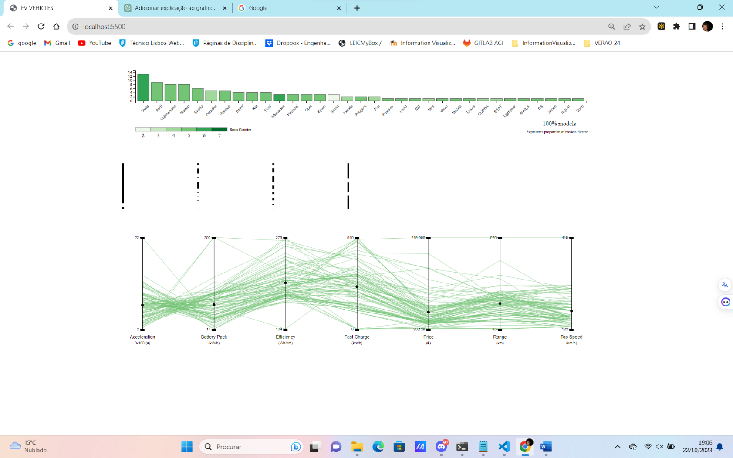

# When a user clicks on the markers to adjust the filters, we also call an update to all lines to verify if each one is inside the range or not. The user can also click to select the maximum of 2 bars of the Bar Chart. By testing and refining this linking mechanism, data visualizations become more intuitive and engaging, offering users a deeper understanding of the data.

