**DATABASE SYSTEM ASSIGNMENT 4**

BY VINAYAK RAGHUPATHY

netid-vr840

1. Map the UNIVERSITY database schema shown in Figure 3.20 into a relational database schema.

Solution:

1. Ignore Derived attributes

If ER diagram has any derived attribute then remove all derived attributes to make schema simpler. Derived attributes are the attributes, which can be derived from other attributes like age, full name. Age can be calculated as the difference of current date and the date of birth.

1. Mapping of all strong entities into tables.

Map all strong entities into tables. Create a relation R that includes all single attributes in the ER diagram and choose key attribute of ER diagram as primary key of relation R.

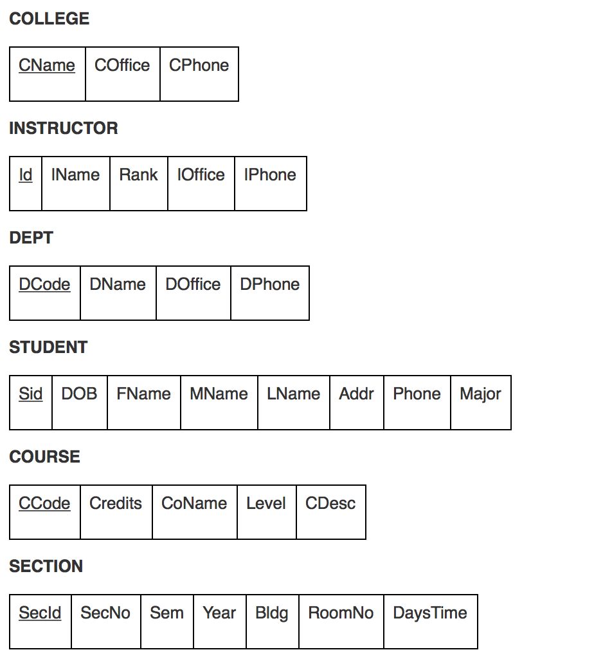

1. Mapping of weak entities.

For each weak entity create a separate relation R. Add all the simple attributes of weak entity into relation R. Include all primary keys of the relations to which weak entity is related as foreign key, to establish connection among the relations. Since the provided ER diagram has no weak entity, so there is no need to map weak entities.

1. 1:1 Mapping

For every binary 1:1 relationship in the relation R constructed by the ER schema, identify relation between two entities. This relationship might occur in the form of foreign key or by merging two attributes into one. (Both must have exact same number of attributes). Also add the attributes, which come under relationship.

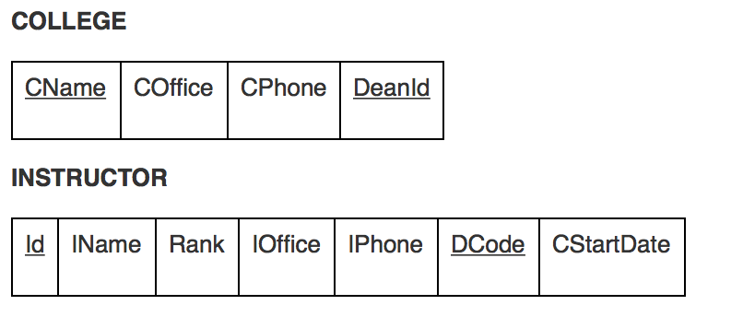

1. 1:N mapping

Identify all 1:N relationships in the ER diagram. For each regular binary 1:N relationship in relation R, add primary key of the participating relation of 1-side as foreign keys to the N-side relation.

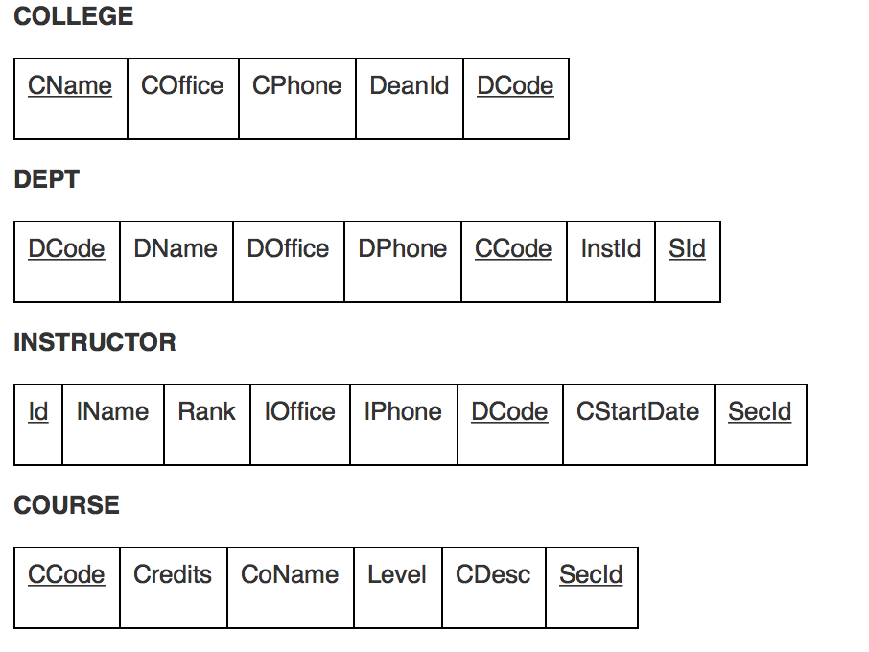

1. M: N mapping

Identify all M: N relationship in ER diagram. For each M: N relationship, create new relation S to represent relationship. Include all primary key attributes of participating relation as foreign key in the relation S.

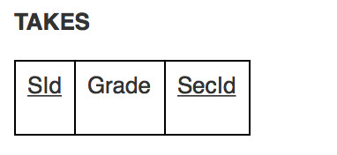

1. Mapping of multivalued attributes

For every n-ary relationship, where n>2, create a new relation R to represent the relationship. Include primary keys attributes of all participating relations as foreign keys attributes and also include the simple attributes of n-ary relationship.

Since the maximum value of n is 2 in the ER diagram provided, so there is no n-ary relationship.

Final relational schema, for ER diagram provided in Figure 3-20 can be generated as follows:

Final schema has seven relations, six from the strong entities and one from binary M: N relationship. Each relational table has primary and foreign keys. TAKES table represents relationship between STUDENT and SECTION table.

Also Grade can be calculated with the help of SID and Sec ID for corresponding semester, year or in particular section.

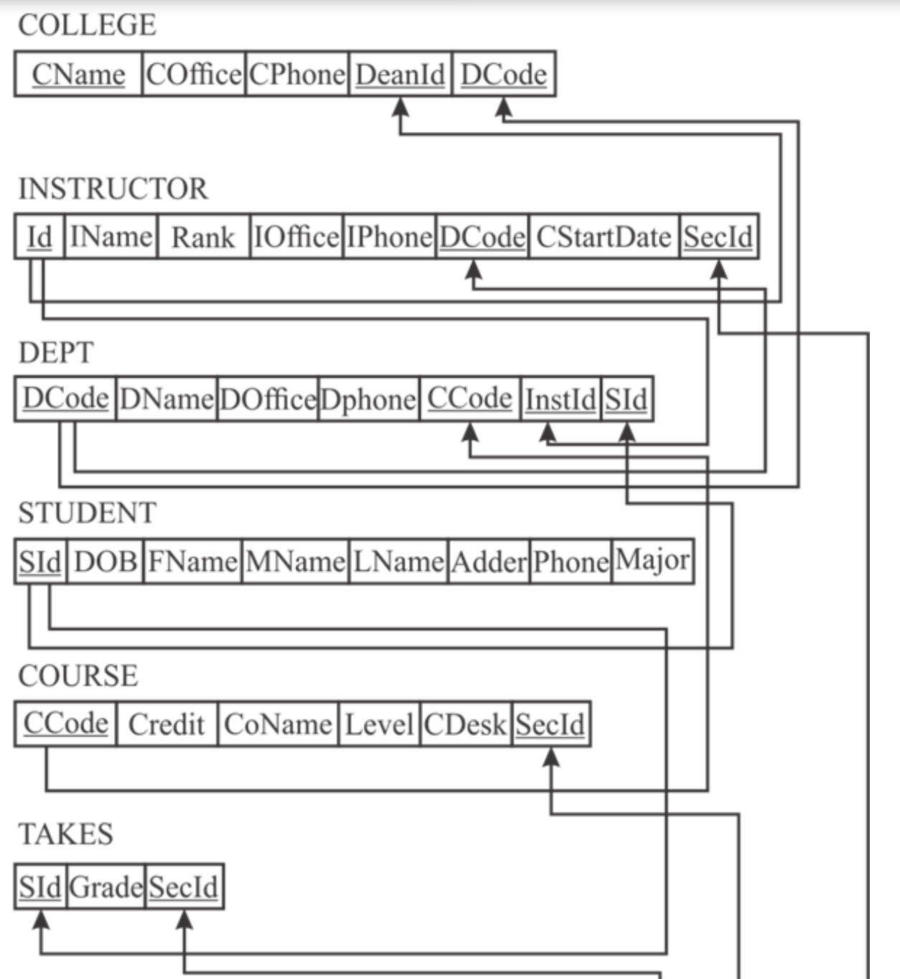

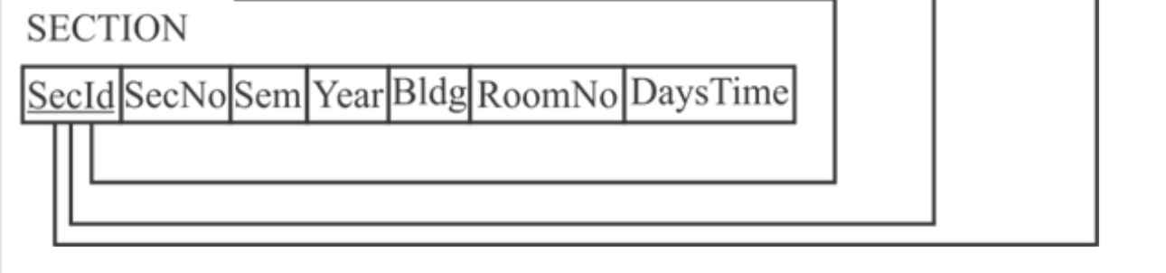

* In COLLEGE table CName is the primary key and Deanld and Dcode are foreign keys for INSTRUCTOR and DEPT table respectively. Deanld is the projection of id attribute in INSTRUCTOR table.
* In instructor table, id is working as primary key. DCODE and SECID are working as foreign key for DEPT and SECTION table respectively.
* In DEPT table DCode is unique for each department and it is working as primary key. To establish connection with COURSE, INSTRUCTOR and STUDENT, their primary keys can be used as foreign keys. Instld is primary key attribute in INSTRUCTOR table and it is working as foreign key here.
* STUDENT table has primary key only. To get the personal information of student Sid will be used. But to retrieve academic information connection is required with DEPT and TAKES table.
* Each course has its unique CCOde in Course table. COURSE table is logically connected with SECTION table and DEPT table to particulate the course in department and section.
* TAKES table is created using binary M: N relationship between STUDENT and SECTION. This is normalized form of both tables.
* In section table Secid is primary key.

1. Try to map the relational schema in Figure 6.14 into an ER schema. This is part of a process known as reverse engineering, where a conceptual schema is created for an existing implemented database. State any assumptions you make.

Solution:

Take the relational schema from the figure 6.14 it shows the relations of mapping the EER categories. Based on this we may construct the ER schema.

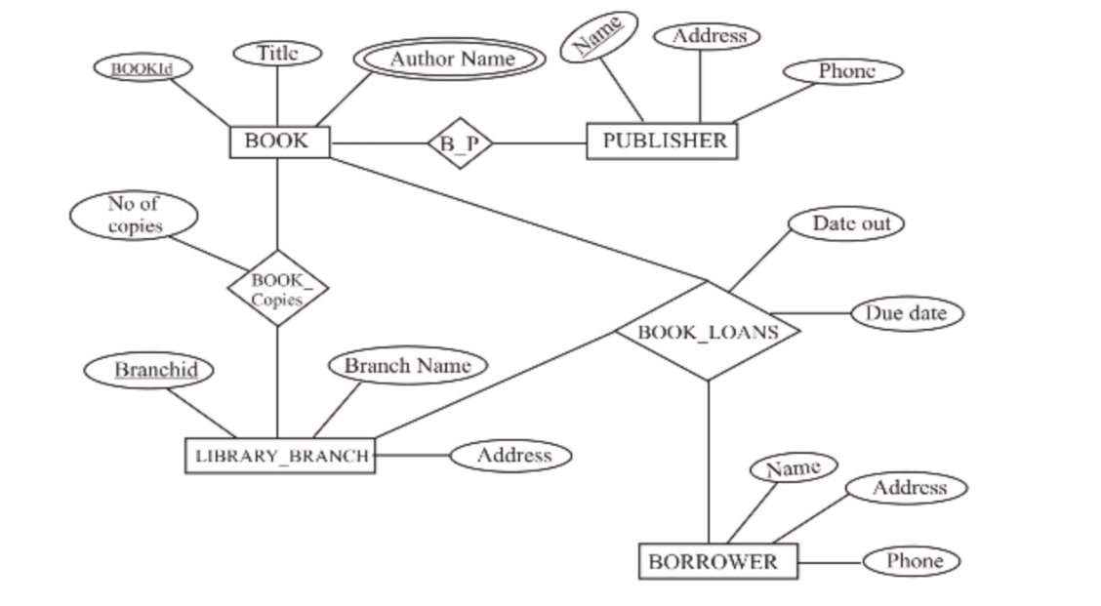

Here, BOOK_AUTHORS is the multivalued attribute. So it can be represented as weak entity type.

1. Map the EER diagrams in Figures 4.9 and 4.12 into relational schemas. Justify your choice of mapping options.

Solution:

From the figure 4.9 in the book, the relational schema is like this

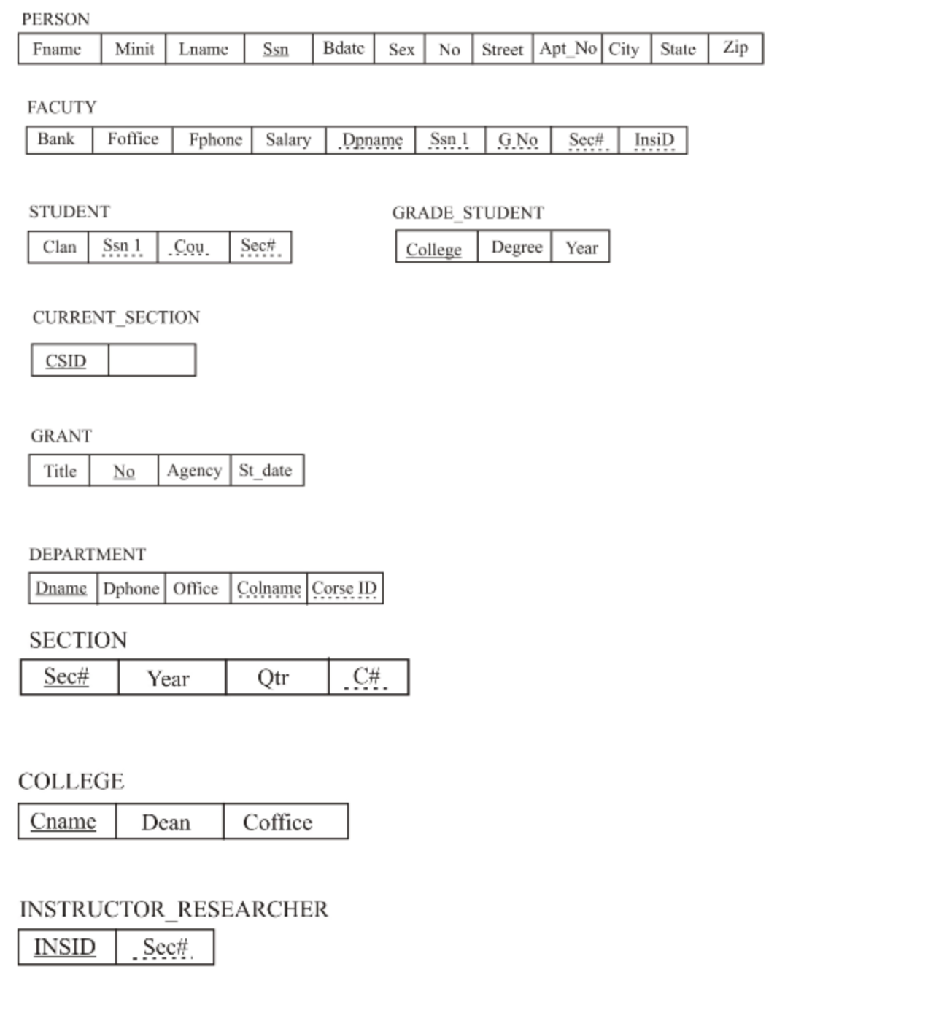

From the figure 4.12 in the book, the relational schema is like this

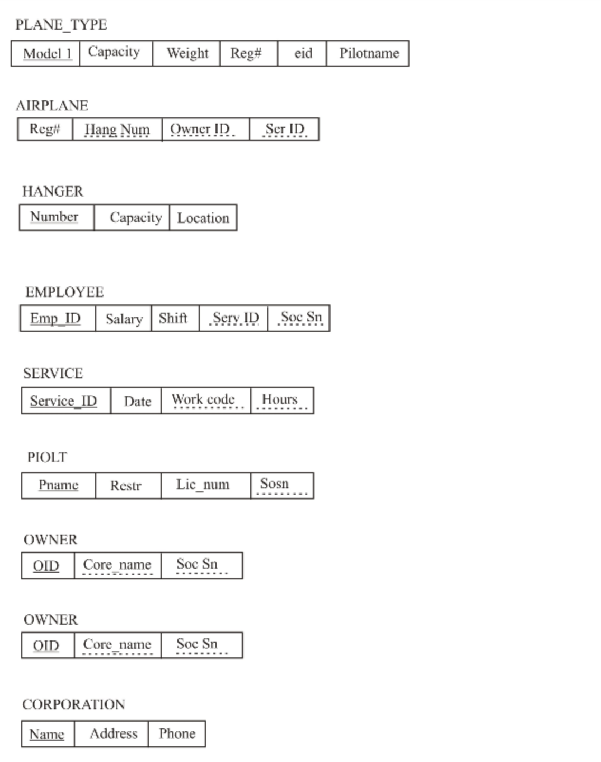

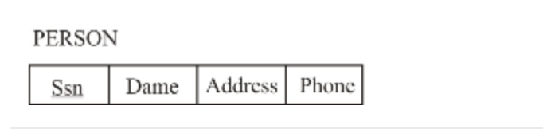

1. Is it possible to successfully map a binary M: N relationship type without requiring a new relation? Why or why not?

Solution:

It is not possible to successfully map a binary M: N relationship type without requiring a new relation. We can’t represent an M: N relationship type by a single foreign key attribute in one of the participating relations, because of M: N cardinality ratio, we must create a separate relationship relation S.

1. Consider the EER diagram in Figure 9.9 for a car dealer. Map the EER schema into a set of relations. For the VEHICLE to CAR/TRUCK/SUV generalization, consider the four options presented in Section 9.2.1 and show the relational schema design under each of those options.

Solution:

The relation schema for the diagram is given below:

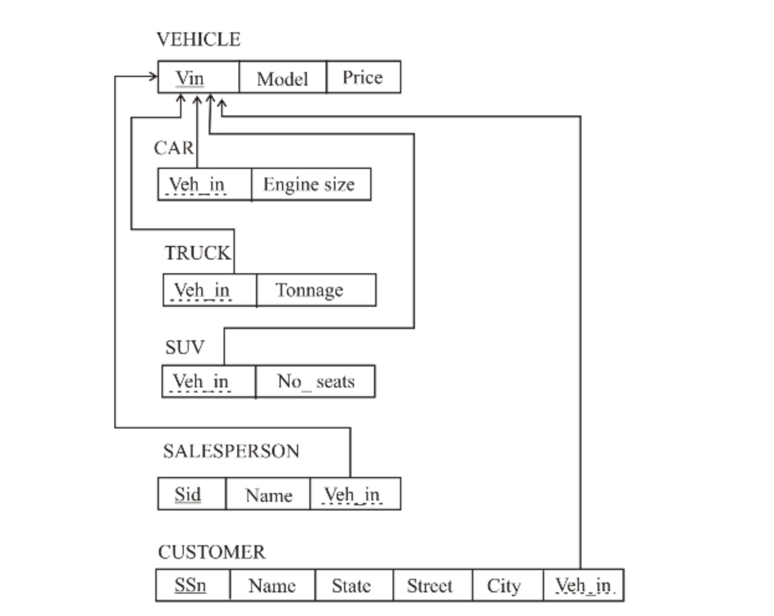

Generalization / Specialization:

For VEHICLE to CAR/TRUCK/ SUV

Convert each specialization with sub clans (CAR, TRUCK, SUV) and generalized super clan VEHICLE. Whether the attribute of VEHICLE are (Vin, model, price) and VIN is the primary key into relation schemas using the following options.

Option A:

Multiple relations – Super class and subclasses create a relation vehicle 1 for VEHICLE with attributes attrs (Vehicle 1) = (Vin, model, price) and primary key (Vehicle 1) = Vin

Create a relation vehicle I for each subclass with attr (vehicle I) = (Vin) U (attributes of CAR, TRUCK, SUV) and primary key (Vehicle I) = Vin

This option works for any specialization.

Option B:

Multiple relations subclass relations only.

Create a relation VEHICLE; for each sub class with attributes atts (VEHICLE I) = ( attributes of CAR, TRUCK, SUV) and PK ( VEHICLE I) = Vin.

This option only works for a specialization is overlapping an entity may be duplicated in several relations.

Option C:

Single relation with one type attribute:

Create a single relation VEHICLE 1 with attributes, atts (VEHICLE) = (Vin, model, price) U

(Attributes of CAR) U (attributes of TRUCK) U (attributes of SUV)

1. Using the attributes you provided for the EER diagram in Exercise 4.27, map the complete schema into a set of relations. Choose an appropriate option out of 8A thru 8D from Section 9.2.1 in doing the mapping of generalizations and defend your choice.

Solution:

