PEDRO MIGUEL ELGUERA MORA 19110148

ceti colomos  VISION ARTIFICIAL 7E1

Manual de usuario practica 10

MANUAL DE USUARIO

# EVIDENCIA

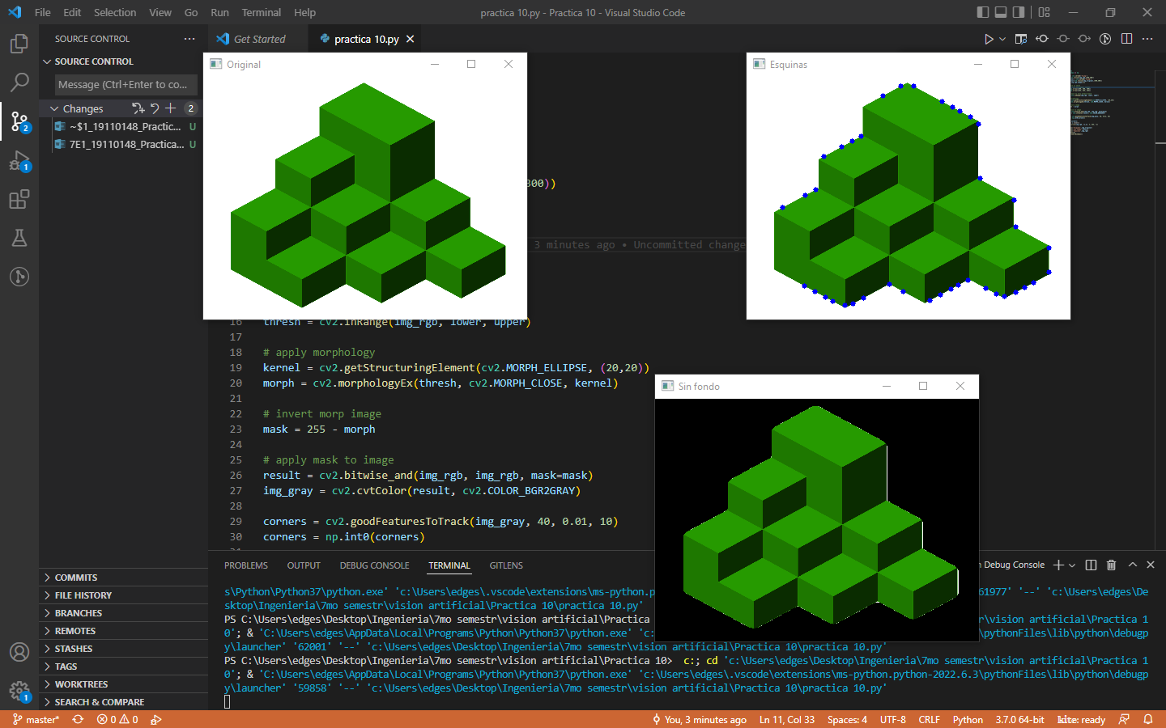

# APP

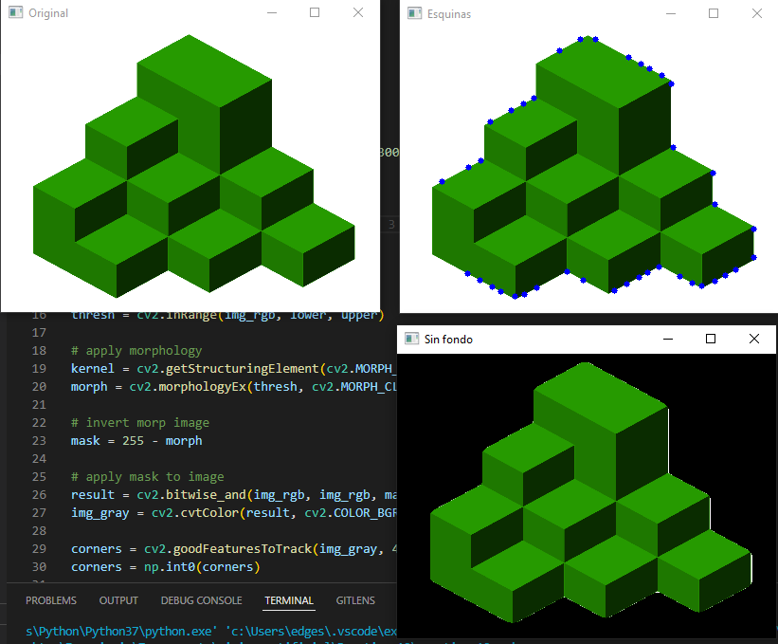

Esta es la vista principal de la aplicación.

# Git:

# <https://github.com/PedroElgueraCeti/Practica-10-VisionArtificial.git>

# Code:

#Pedro Miguel Elguera Mora 19110148

import cv2

import numpy as np

img_rgb = cv2.imread('R.png')

img_rgb=cv2.resize(img_rgb,(400,300))

img_original = cv2.imread('R.png')

img_original=cv2.resize(img_original,(400,300))

hh, ww = img_rgb.shape[:2]

# threshold on white

# Define lower and uppper limits

lower = np.array([200, 200, 200])

upper = np.array([255, 255, 255])

# Create mask to only select black

thresh = cv2.inRange(img_rgb, lower, upper)

# apply morphology

kernel = cv2.getStructuringElement(cv2.MORPH_ELLIPSE, (20,20))

morph = cv2.morphologyEx(thresh, cv2.MORPH_CLOSE, kernel)

# invert morp image

mask = 255 - morph

# apply mask to image

result = cv2.bitwise_and(img_rgb, img_rgb, mask=mask)

img_gray = cv2.cvtColor(result, cv2.COLOR_BGR2GRAY)

corners = cv2.goodFeaturesToTrack(img_gray, 40, 0.01, 10)

corners = np.int0(corners)

for i in corners:

    x,y = i.ravel()

    cv2.circle(img_rgb, (x,y), 3, 255, -1)

cv2.imshow('Original',img_original)

cv2.imshow('Sin fondo',result)

cv2.imshow('Esquinas',img_rgb)

cv2.waitKey(0)

cv2.destroyAllWindows()