PEDRO MIGUEL ELGUERA MORA 19110148

ceti colomos  VISION ARTIFICIAL 7E1

Manual de usuario practica 6

MANUAL DE USUARIO

# EVIDENCIA

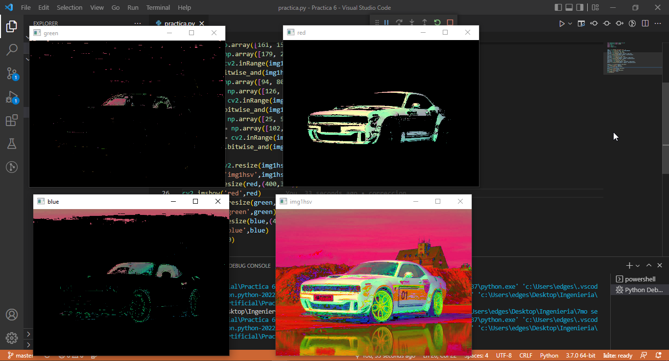

# APP

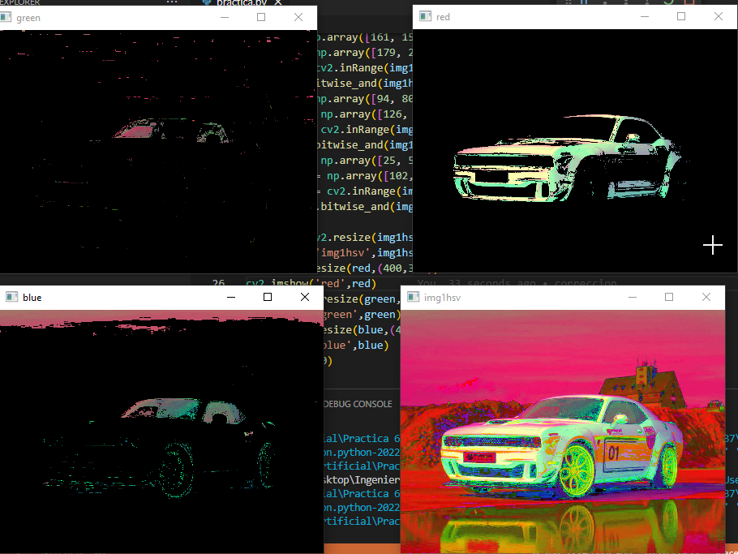

Esta es la vista principal de la aplicación.

# Git:

<https://github.com/PedroElgueraCeti/Practica-6_VisionArtificial.git>

# Code:

#Pedro Miguel Elguera Mora 19110148

from matplotlib import pyplot as plt

from matplotlib import pylab

import cv2

import imutils

import numpy as np

img1 = cv2.imread('challenger.jpg', 1)

img1hsv = cv2.cvtColor(img1, cv2.COLOR_BGR2HSV)

low_red = np.array([161, 155, 84])

high_red = np.array([179, 255, 255])

red_mask = cv2.inRange(img1hsv, low_red, high_red)

red = cv2.bitwise_and(img1hsv,img1hsv, mask=red_mask)

low_blue = np.array([94, 80, 2])

high_blue = np.array([126, 255, 255])

blue_mask = cv2.inRange(img1hsv, low_blue, high_blue)

blue = cv2.bitwise_and(img1hsv, img1hsv, mask=blue_mask)

low_green = np.array([25, 52, 72])

high_green = np.array([102, 255, 255])

green_mask = cv2.inRange(img1hsv, low_green, high_green)

green = cv2.bitwise_and(img1hsv, img1hsv, mask=green_mask)

img1hsv = cv2.resize(img1hsv,(400,300))

cv2.imshow('img1hsv',img1hsv)

red = cv2.resize(red,(400,300))

cv2.imshow('red',red)

green = cv2.resize(green,(400,300))

cv2.imshow('green',green)

blue = cv2.resize(blue,(400,300))

cv2.imshow('blue',blue)

cv2.waitKey(0)