PEDRO MIGUEL ELGUERA MORA 19110148

ceti colomos  VISION ARTIFICIAL 7E1

Manual de usuario practica 4

MANUAL DE USUARIO

# EVIDENCIA

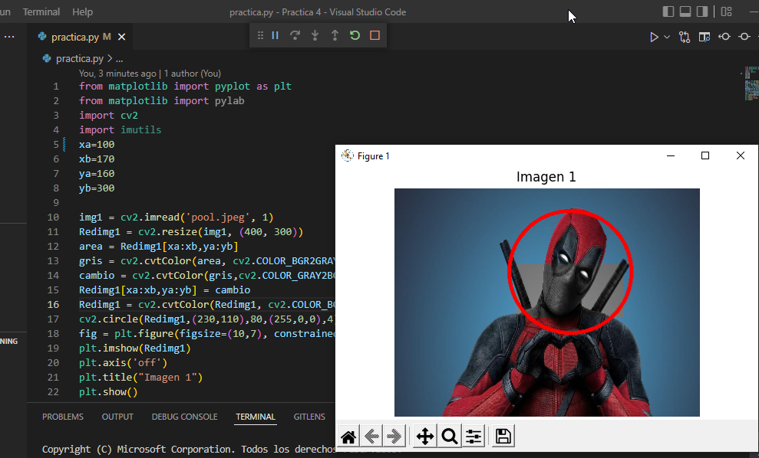

# APP

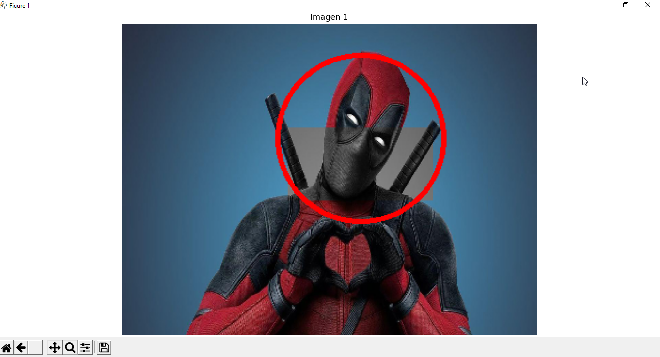

Esta es la vista principal de la aplicación.

# Git:

<https://github.com/PedroElgueraCeti/Practica4_VisionArtificial.git>

# Code:

#Pedro Miguel Elguera Mora 19110148

from matplotlib import pyplot as plt

from matplotlib import pylab

import cv2

import imutils

xa=100

xb=170

ya=160

yb=300

img1 = cv2.imread('pool.jpeg', 1)

Redimg1 = cv2.resize(img1, (400, 300))

area = Redimg1[xa:xb,ya:yb]

gris = cv2.cvtColor(area, cv2.COLOR_BGR2GRAY) #

cambio = cv2.cvtColor(gris,cv2.COLOR_GRAY2BGR)

Redimg1[xa:xb,ya:yb] = cambio

Redimg1 = cv2.cvtColor(Redimg1, cv2.COLOR_BGR2RGB)

cv2.circle(Redimg1,(230,110),80,(255,0,0),4)

fig = plt.figure(figsize=(10,7), constrained_layout=True)

plt.imshow(Redimg1)

plt.axis('off')

plt.title("Imagen 1")

plt.show()