PEDRO MIGUEL ELGUERA MORA 19110148

ceti colomos  VISION ARTIFICIAL 7E1

Manual de usuario practica 5

MANUAL DE USUARIO

# EVIDENCIA

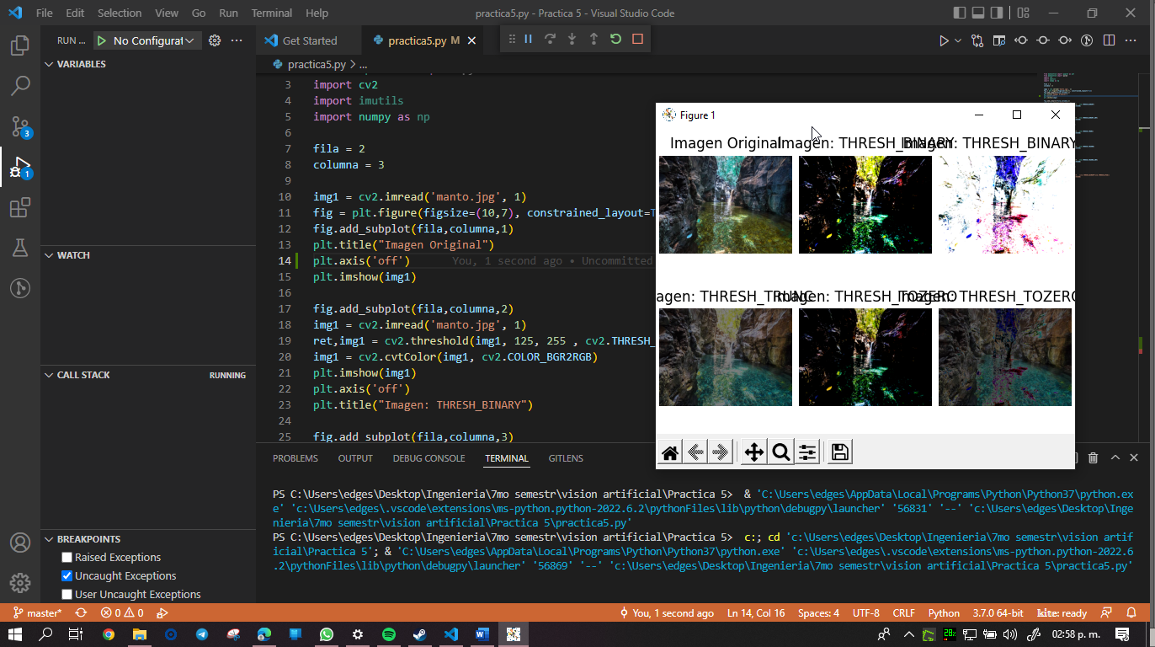

# APP

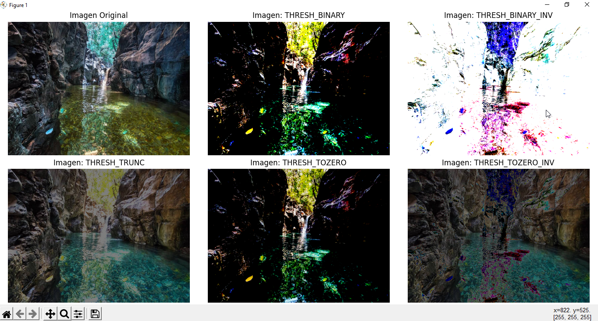

Esta es la vista principal de la aplicación.

# Git:

<https://github.com/PedroElgueraCeti/Practica5_VisionArtificial.git>

# Code:

#Pedro Miguel Elguera Mora 19110148

from matplotlib import pyplot as plt

from matplotlib import pylab

import cv2

import imutils

import numpy as np

fila = 2

columna = 3

img1 = cv2.imread('manto.jpg', 1)

fig = plt.figure(figsize=(10,7), constrained_layout=True)

fig.add_subplot(fila,columna,1)

plt.title("Imagen Original")

plt.axis('off')

plt.imshow(img1)

fig.add_subplot(fila,columna,2)

img1 = cv2.imread('manto.jpg', 1)

ret,img1 = cv2.threshold(img1, 125, 255 , cv2.THRESH_BINARY)

img1 = cv2.cvtColor(img1, cv2.COLOR_BGR2RGB)

plt.imshow(img1)

plt.axis('off')

plt.title("Imagen: THRESH_BINARY")

fig.add_subplot(fila,columna,3)

img1 = cv2.imread('manto.jpg', 1)

ret,img1 = cv2.threshold(img1, 125, 255 , cv2.THRESH_BINARY_INV)

img1 = cv2.cvtColor(img1, cv2.COLOR_BGR2RGB)

plt.imshow(img1)

plt.axis('off')

plt.title("Imagen: THRESH_BINARY_INV")

fig.add_subplot(fila,columna,4)

img1 = cv2.imread('manto.jpg', 1)

ret,img1 = cv2.threshold(img1, 125, 255 , cv2.THRESH_TRUNC)

img1 = cv2.cvtColor(img1, cv2.COLOR_BGR2RGB)

plt.imshow(img1)

plt.axis('off')

plt.title("Imagen: THRESH_TRUNC")

fig.add_subplot(fila,columna,5)

img1 = cv2.imread('manto.jpg', 1)

ret,img1 = cv2.threshold(img1, 125, 255 , cv2.THRESH_TOZERO)

img1 = cv2.cvtColor(img1, cv2.COLOR_BGR2RGB)

plt.imshow(img1)

plt.axis('off')

plt.title("Imagen: THRESH_TOZERO")

fig.add_subplot(fila,columna,6)

img1 = cv2.imread('manto.jpg', 1)

ret,img1 = cv2.threshold(img1, 125, 255 , cv2.THRESH_TOZERO_INV)

img1 = cv2.cvtColor(img1, cv2.COLOR_BGR2RGB)

plt.imshow(img1)

plt.axis('off')

plt.title("Imagen: THRESH_TOZERO_INV")

"""

fig.add_subplot(fila,columna,7)

img1 = cv2.imread('manto.jpg', 1)

ret,img1 = cv2.threshold(img1, 125, 255 , (cv2.THRESH_BINARY+cv2.THRESH_OTSU))

img1 = cv2.cvtColor(img1, cv2.COLOR_BGR2RGB)

plt.imshow(img1)

plt.axis('off')

plt.title("Imagen: THRESH_OTSU")

"""

plt.show()