MINERAÇÃO DE DADOS

Project 1 Classification of Abnormal Electric Vehicle Charging Sessions
Tasks 1 to 4 Data Preparation Model Optimisation and Final Evaluation

Academic year: 2026/2027 — 1st semester
Group: ______________________________
Students: Francisco Primavera (1230840)
Pedro Fonseca (1220987)
Date: 26 October 2026

1 Introduction and prediction objective
This report investigates abnormal termination of electric vehicle charging sessions using information available at session start. Tasks 1 and 2 establish the data audit and temporal evaluation protocol; Task 3 compares five feature groups, three individual classifiers and three ensembles. Task 4 optimises two promising ensembles, examines the alert threshold and interprets the selected model. The frozen histogram gradient boosting model achieves final-test F1 0.5407, precision 0.5456 and recall 0.5359 at threshold 0.29. History provides the largest gains in the fixed-tree feature-group comparison, but performance varies over time and is lower without user history. The workload and earlier descriptive exposure of the eventual test period limit deployment and independence claims.
The target is_Abnormal is created from end_cause. Charging ends normally and User stops charging are labelled normal (0), while the other observed causes describe failures and are labelled abnormal (1). Treating a deliberate user stop as normal is an adopted definition: it does not necessarily indicate a technical failure. end_cause is used only to construct the target because it is known after the session ends.

2 Dataset overview
The dataset contains 441,077 sessions and 47 original columns: 21 integer, 18 floating-point and 8 text columns. Integer user and post identifiers are labels rather than quantities. Start times range from 31 December 2019 to 31 December 2021, representing 25 calendar months. Four timestamps were initially stored as text and were successfully parsed into a separate datetime table. No fully duplicated rows were found after text cleaning.
Table 1 Dataset overview
Characteristic | Result
Charging sessions | 441,077
Original variables | 47
Temporal coverage | 31 Dec 2019 – 31 Dec 2021
Represented months | 25
Fully duplicated rows | 0
Invalid/missing parsed timestamps | 0

2 1 Target distribution
There are 359,143 normal sessions (81.42%) and 81,934 abnormal sessions (18.58%). The imbalance means that accuracy alone can hide poor detection of abnormal sessions. Evaluation therefore includes positive-class F1, precision and recall rather than accuracy alone.
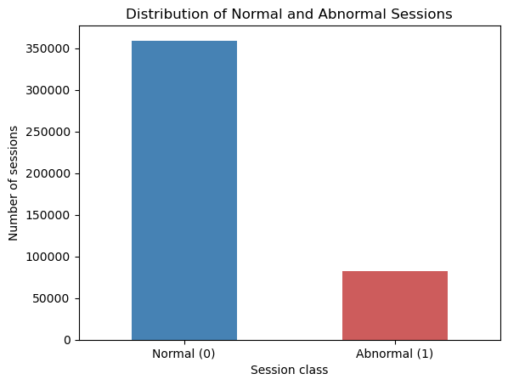
Figure 1 Distribution of normal and abnormal sessions

3 Data quality audit

3 1 Missing values and historical no history states
Missing values occur only in four time-since-history variables. In every case, the missing value agrees with the matching no-history indicator, and no inconsistent rows were found.
Table 2 Missing elapsed times and matching history indicators
Time-since variable | Missing | Matching no-history indicator | Inconsistent
Post: previous completed session | 92 | 92 | 0
Post: previous completed abnormal | 367 | 367 | 0
User: previous completed session | 56,647 | 56,647 | 0
User: previous completed abnormal | 136,279 | 136,279 | 0

These absences represent a lack of relevant completed-session history rather than accidental data loss. All rows and no-history indicators are retained. Constant-zero imputation is implemented within the modelling pipelines while the matching indicators preserve the meaning of missing history. Missing values remain unchanged in the exploratory candidate table.

3 2 Temporal consistency
No session ends before it starts. All five zero-duration sessions have zero energy and DC Output Fault as their end cause. This is consistent with attempts that failed immediately, so they are retained. The evidence does not independently confirm whether their timestamps are correct.
Table 3 Timestamp consistency checks
Check | Rows | Percentage
Order creation after session start | 248,588 | 56.359%
Session ending before start | 0 | 0.000%
Zero-duration session | 5 | 0.001%
Payment recorded before session end | 87,202 | 19.770%

Order creation follows session start in 248,588 records (56.36%), and payment precedes session end in 87,202 records (19.77%). Median order-minus-start and payment-minus-end differences are 6 and 20 seconds, respectively. Maximum gaps reach approximately 3.2 and 431 days; minimum gaps are −361 and −1,314 seconds. These relationships warrant caution, but the available evidence does not establish which timestamps to correct. All records remain unchanged.

3 3 Logical numerical checks and suspicious values
Descriptive minima and maxima show non-negative energy, monetary values and precipitation, positive electricity prices, humidity within 32–99%, and historical rates within 0–1. Row-by-row checks found no case where previous abnormal counts exceed the corresponding total within the same window. All six tested binary variables contain only 0 and 1.
There are 54,621 zero-energy sessions (12.38%), of which 45,563 are abnormal under the adopted definition (83.42%). Failure-related causes are frequent, but zero energy also occurs with user stops and normal completion. Zero energy alone is insufficient evidence for deletion. Final energy is excluded from predictors because it is unavailable at session start.

3 4 Categorical consistency and rare categories
Whitespace checks identified 18,370 affected location values and leading or trailing whitespace in all 441,077 values of both Order creation time and Payment time. All text columns were trimmed, and a repeated check found no remaining whitespace at their boundaries. This corrects formatting differences without altering the meaning of the values.
There are 13 location categories, 3 districts and 7 tariff periods. The least frequent location has 12,401 observations and the least frequent tariff period has 22,843, so no grouping is justified solely by low frequency. Rare end causes remain part of the target definition and are not predictor categories.

4 Predictor availability and leakage audit
Selection follows the session-start decision. Final energy, monetary outcomes, End Time and Payment time are excluded because they describe the transaction during or after charging. end_cause supplies the label and is excluded from inputs. Order creation time is excluded because its availability is not consistently prior to session start. Raw UserID and Charging Post ID are excluded to reduce identity memorisation and related generalisation risks, while aggregated histories remain candidates.
Table 4 Predictor availability and preparation decisions
Group | Decision | Rationale
Target | Keep as response only | is_Abnormal is the prediction target.
Post-session outcomes | Exclude | Energy, monetary outcomes, End Time, Payment time and end_cause are unavailable at prediction time.
UserID / Charging Post ID | Exclude raw identifiers | Avoid direct identity memorisation and reduce privacy/generalisation/cold-start risk.
Order creation time | Exclude | Its timing is not consistently prior to Start Time.
Start Time | Transform then exclude raw value | Derive hour, weekday, month and weekend indicator.
Historical summaries | Retain provisionally | Chronologically constructed and potentially available, but require ablation, privacy and cold-start analysis.
Weather / tariff / location | Retain | Available or assumed available at session start.

There are 35 direct candidate predictors. Four calendar features derived from Start Time are added, giving 39 columns and 441,077 rows in X_candidates. Weather is treated as estimates or forecasts available at session start, as permitted by the brief. The supplied historical summaries are described as chronologically constructed; their histories were not independently reconstructed in this audit.

5 Exploratory analysis of candidate predictors

5 1 Numerical distributions and potential outliers
Temperature ranges from −3.2°C to 33.6°C, with the histogram showing its highest concentration around 25–30°C. Negative temperature is plausible. Precipitation is strongly right-skewed: its median is zero, its third quartile is 1.2 mm, and its maximum is 152.1 mm. The first histogram bin includes zero and small positive values, so it is not a count of dry sessions.
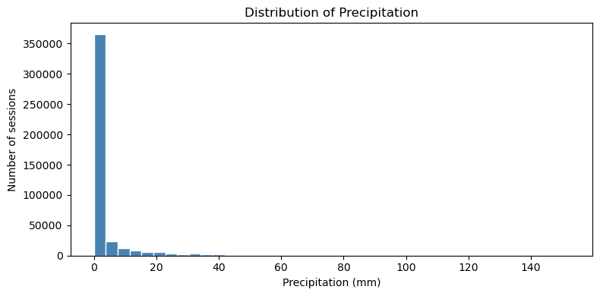
Figure 2 Distribution of precipitation
User activity is also strongly skewed. The 30-day completed-session count has a median of 7, a mean of 55.72 and a maximum of 2,605. The 730-day count has a median of 21 and a maximum of 14,566. Account sharing or fleet activity could explain high counts, but these explanations were not verified. No outlier threshold, capping or transformation was applied: extreme values alone do not establish data errors.

5 2 Contextual categorical relationships
Abnormal-session percentages differ considerably across locations, from approximately 8% in Industrial Park to 32% in Expressway Service District A. District rates range from approximately 14.7% in Tongxiang to 24.7% in Xiuzhou. Tariff-period differences are smaller, approximately 16.7–20.5%. These associations do not establish causality or independent predictive value.
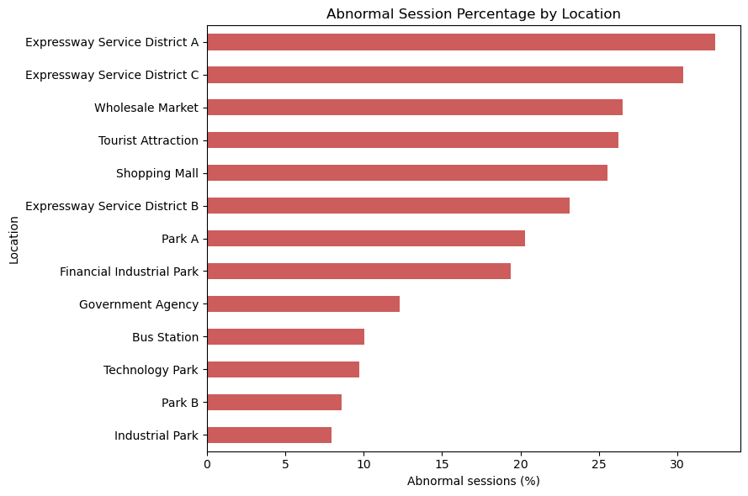
Figure 3 Abnormal session percentage by location
Location, district and tariff period remain candidates after the descriptive analysis. Their additional predictive contribution is tested through the Task 3 ablation rather than inferred from marginal associations.

5 3 Cold start and historical risk information
Sessions associated with new users have an abnormal rate of 20.56%, compared with 18.29% for other sessions, a difference of 2.27 percentage points. This modest association motivates separate attention to limited-history cases, but it does not establish model performance for new users.
Selected historical rates are higher in sessions that end abnormally. For charging-post history over 30 days, the median is 25.22% in abnormal sessions and 12.18% in normal sessions. For user history over 730 days, the corresponding medians are 20.00% and 16.67%.
The difference is larger for the selected charging-post rate. This suggests potentially useful information, but median comparisons do not measure classifier performance or establish that one historical group is superior. The feature-group comparison in Section 11 evaluates their predictive contribution.

5 4 Correlation and potentially redundant predictors
Spearman correlation identified six numerical candidate pairs above 0.90. This exploratory method is appropriate for the strongly skewed historical variables. The pairs involve post session counts over 7 and 30 days (0.906), user counts over 30 and 180 days (0.912) and over 180 and 730 days (0.980), user abnormal counts over 180 and 730 days (0.962), and user abnormal rates over 180 and 730 days (0.959). Overlapping windows naturally share information; high correlation alone does not justify exclusion.
The sixth pair is is_new_user and user_no_previous_completed_session (0.995). They differ in 531 observations: the user is not new but has no previous completed-session history. Earlier sessions still in progress could explain this, but the mechanism is unconfirmed. Both indicators are retained in the current G4 comparison. Their separate predictive contributions have not been isolated, and their near redundancy remains a limitation.

5 5 Calendar relationships
Hour, weekday, month and weekend status are available at prediction time. Hourly abnormal rates range from 15.72% at 07:00 to 20.67% at 12:00 and may overlap with tariff information. Weekday rates range from 18.18% to 19.17%; weekend and weekday rates are 18.39% and 18.65%. These marginal differences provide limited evidence of individual usefulness but do not rule out interactions. Weekend status is derived from weekday and may be redundant.

6 Temporal analysis and implications for evaluation
December 2019 contains only 17 sessions and is excluded from monthly comparisons without removing those records from the dataset. Across 2020–2021, monthly volume ranges from 1,391 to 27,794 sessions and abnormal prevalence ranges from 13.70% to 26.31%. Monthly unique-user counts range from 516 to 7,519; active-post counts are more stable, ranging from 83 to 92. Active means at least one recorded session in the month, not confirmed equipment availability.
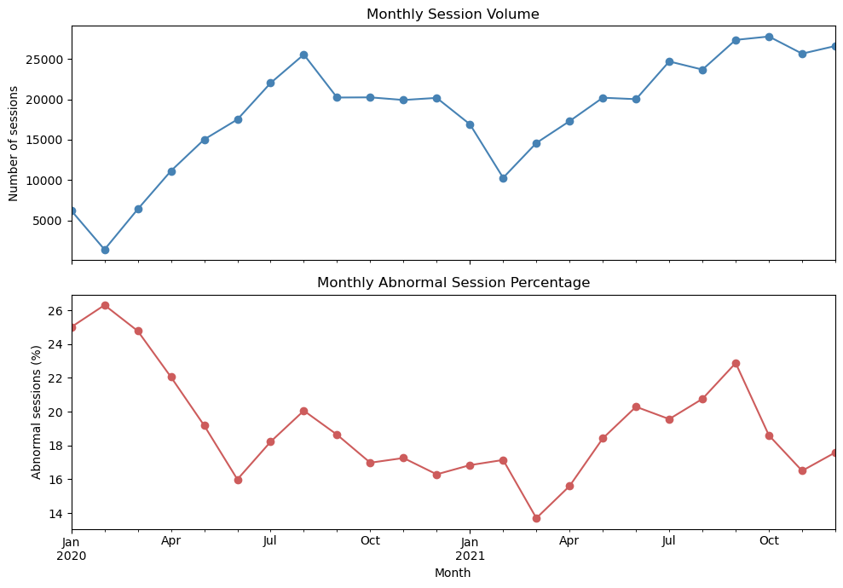
Figure 4 Monthly volume and abnormal session percentage
Volume and abnormal prevalence fluctuate rather than following the same trend. Low volume in February 2020 coincides with fewer users and active posts; the cause is not established. Monthly median temperature shows seasonality, ranging from 5.2°C to 31.2°C. The median 30-day post abnormal rate ranges from 10.71% to 21.56%. New-user sessions account for 31.38% in January 2020 and a lower, fluctuating share afterwards.
These findings show that selected session conditions and user composition change over time. Evaluation uses chronological folds and reports performance by period. Monthly medians and proportions summarise selected properties rather than complete distributions. The validation boundaries and metrics are defined in Task 2 below.

7 Data preparation strategy
The audit leads to the following preparation plan:
- All investigated rows are retained because the audited findings do not establish a sufficient basis for deletion.
- Text values are trimmed. Location, district and tariff categories are retained without grouping.
- The four historical time-since variables use constant-zero imputation with the corresponding no-history flags retained inside each modelling pipeline.
- Raw identifiers, the target and variables unavailable at session start are excluded from the predictor matrix.
- The four derived calendar variables are retained as candidates; the raw Start Time is excluded from X_candidates.
- Extremes are not capped and correlated predictors are not automatically removed. Preparation is fitted using training observations only.
- Categorical encoding learns categories from the training data and handles previously unseen categories during validation.
- Numerical scaling is fitted within the training folds for logistic regression and KNN. No resampling or dimensionality reduction is applied.
- Temporal validation compares historical feature groups and evaluates limited-history performance in Task 3.

Explicit Imputation of Time Since Variables
The four time-since variables use constant-zero imputation while retaining their matching no-history indicators: post_hours_since_previous_completed_session, post_hours_since_previous_completed_abnormal, user_days_since_previous_completed_session and user_days_since_previous_completed_abnormal. Missing values match the absence of relevant completed history. Median imputation would assign an artificial typical interval where none exists. Zero is a placeholder; the indicator distinguishes no history from an observed elapsed interval.
This constant rule estimates no population statistic and is implemented within the model pipelines. The same fitted preparation transforms validation observations, while missing values remain unchanged in the exploratory DataFrame. Scaling is fitted only on each training fold for logistic regression and KNN. Zero placeholders can still influence numerical distances, so the interpretation depends on both the value and its retained indicator.

Redundancy Between Related Predictors
Related predictors are discussed by meaning as well as correlation. The six Spearman correlations above 0.90 involve overlapping historical windows and the near-equivalent user flags. is_new_user and user_no_previous_completed_session differ in 531 observations; their similar names do not establish exact equivalence. Weekend status is completely derived from weekday. Tariff period and electricity price also encode related tariff context; their independent predictive contribution is not assumed.
The 39 candidates are retained for the present comparison. No individual removal experiment was performed for the two user flags, weekend status, historical windows or tariff representations. Their overlap is a documented limitation rather than a reason to delete variables without validation evidence.

Protection of the Final Test Set
The final test contains sessions starting on or after 12 July 2021 at 14:28:34. These records were included in the initial descriptive analysis, limiting claims of an entirely unseen evaluation. Subsequent preparation, feature, model and threshold selection used development data only.
The predictor set, preprocessing, model family, hyperparameters and threshold were fixed before the final evaluation. Test performance did not lead to changes in these choices. Prior descriptive inspection remains a limitation of the evaluation design.

8 Final Task 1 synthesis

8 1 Main characteristics and problems
The tested logical conditions are consistent. Missing values match no-history indicators; zero-duration records have zero energy and DC output faults. Key findings are structural missing history, whitespace, unusual timestamp gaps, zero-energy failures, class imbalance, skewed activity, predictor redundancy and temporal change. This evidence supports retaining observations while excluding unavailable outcomes; it does not independently confirm every record as correct.

8 2 Variables retained as candidates
The Task 1 candidate groups are location, weather, tariffs, charging-post history, user history, concurrent activity and calendar features. X_candidates contains 35 direct predictors and four calendar features. Task 3 studies their development contribution; Section 14 reports the subsequently frozen final-test evaluation.

8 3 Unresolved limitations and assumptions
- The true event order cannot be verified for unusual timestamp gaps; no correction is inferred from the available data.
- Extreme activity may reflect shared accounts or fleets, but this explanation is unverified. Retention does not amount to independent confirmation of validity.
- Weather is assumed available as estimates or forecasts at session start, as allowed by the brief. Treating user stops as normal is an adopted target definition.
- Historical summaries depend on previous completed-session records being operationally available. They may contain behavioural information, raise privacy concerns and generalise differently to new accounts, posts or other networks.
- Descriptive associations alone do not establish predictive usefulness. Task 3 evaluates feature groups and ensemble performance with and without completed user history. Individual redundancy-removal experiments were not performed, and new-post performance cannot be estimated because those validation cases are absent.

8 4 Implications for model development
Class imbalance and temporal changes motivate evaluation beyond overall accuracy. Missing history, categories and skewness affect preprocessing and model choice. Learned preparation is fitted within training folds. The evaluation examines temporal stability, historical information and limited-history cases under the protocol in Task 2.

9 Task 2 Prediction and evaluation setting
We adopt a monitoring application and a chronological evaluation design. Approximately two thirds of sessions support development and the final third supports later testing. Four expanding-window folds support configuration comparison and common-threshold selection by mean F1. Recall, missed abnormalities and false-alert workload accompany F1. This section defines the evaluation design; the completed development results are presented in Task 3.

9 1 Prediction and Operational Setting
Each observation represents one electric-vehicle charging session. The positive class is abnormal termination (is_Abnormal = 1); the negative class is normal termination (is_Abnormal = 0).
The target is derived from end_cause. Charging ends normally and User stops charging are treated as normal; all other observed causes describe failures and are treated as abnormal. A deliberate user stop is not necessarily a technical failure. This is an adopted outcome definition, not a claim that every user stop is operationally desirable. Missing or unrecognised termination labels in future data would require review rather than automatic classification.
Prediction takes place at session start. The proposed use is additional monitoring of sessions estimated to have increased risk of abnormal termination. An alert indicates estimated risk, not a confirmed fault or confirmation of transferred energy. It does not automatically interrupt charging or notify users that charging succeeded. Inspection or intervention would require further evidence.

9 2 Evaluation Objectives and Error Consequences
A false positive flags a session that actually ends normally. For additional monitoring, it generates unnecessary work and may contribute to alert fatigue. A false negative leaves an abnormal session unflagged, missing an opportunity for closer monitoring and timely investigation.
Missing an abnormal session is considered somewhat more concerning than an unnecessary monitoring alert. F1 nevertheless balances precision and recall symmetrically. This qualitative preference is expressed by higher mean recall when mean F1 is tied, and by explicit reporting of missed abnormalities. No measured error costs or monitoring-capacity limit have been supplied.
If alerts were instead used to block charging, trigger costly inspection or communicate a confirmed fault to users, false positives would have more serious consequences and the metric and threshold policy would need revision.

9 3 Variable Eligibility and Exclusions
Table 5 Variable eligibility at session start
Supplied variables | Category | Justification
Location Information and District Name | Eligible predictors | Known charging context at session start
Temperature, Relative Humidity and Precipitation | Eligible predictors under an assumption | Treated as estimates or forecasts available at session start, as allowed by the brief
electricity_price and tariff_period | Eligible predictors | Tariff applicable at session start
Charging-post and user historical summaries, no-history flags, is_new_user and user_active_sessions_at_start | Eligible predictors | Supplied as chronological summaries of previously completed activity or concurrent activity available at prediction time
end_cause | Target construction only | Defines the label and becomes known at termination
Transaction power/kwh, Electricity cost/Yuan, Service charge/Yuan, Transaction Amount/Yuan, Actual Payment/Yuan, End Time and Payment time | Excluded during or after the session | Final transaction information is unavailable at session start
UserID and Charging Post ID | Excluded for another methodological reason | Raw identity may encourage memorisation; exclusion reduces direct identity use and supports consideration of unseen accounts and posts
Order creation time | Excluded for an availability reason | Recorded after session start in many rows, so availability at the chosen prediction time is not established
Start Time | Used for feature derivation | Available at prediction time; derive hour, weekday, month and weekend status rather than use the raw timestamp
is_Abnormal | Target only | Response to predict, excluded from input features

The initial matrix contains 35 direct candidates and four calendar features, totalling 39 columns. Eligibility does not establish usefulness: redundant indicators and calendar features remain provisional. Feature-group selection uses temporal development results.
Historical feature eligibility excludes outcomes unavailable at prediction time. Earlier completed sessions within a validation or test period may contribute to a later session's history under sequential operational use; this does not mean fitting the model on validation or test labels. The supplied histories were not independently reconstructed. Section 11 discusses availability, privacy and generalisation, while Section 13 reports the limited-history diagnostic.

9 4 Evaluation Metrics and Their Limitations
F1 = 2 TP / (2 TP + FP + FN) is the primary metric for comparing configurations and selecting a common decision threshold. It is the harmonic mean of precision and recall, covered in the evaluation slides and practical notebook [2, 4]. It focuses on abnormal-session detection without allowing numerous true negatives to dominate. Both missed events and unnecessary alerts matter for the proposed monitoring application, making this a practical compromise when no measured costs or capacity limit are available. F1 ignores true negatives, depends on threshold and prevalence, and does not assess calibration. It does not encode a greater cost for false negatives; the qualitative detection preference is reflected only in the recall tie-break and explicit error reporting.
Table 6 Complementary evaluation metrics
Metric | Meaning and relevance | Limitation
Recall = TP / (TP + FN) | Fraction of abnormal sessions detected; reflects the priority of avoiding missed events | Does not penalise false alerts on its own
Precision = TP / (TP + FP) | Fraction of alerts that are correct; describes alert usefulness | Does not describe missed abnormal sessions and depends on prevalence
F1 = 2 TP / (2 TP + FP + FN) | Primary balance of precision and recall for the abnormal class | Symmetric; ignores TN and depends on threshold/prevalence. Recall and false negatives are reported separately.
Balanced accuracy = (recall + specificity) / 2 | Gives equal importance to detection in both classes | Does not encode unequal error costs
Confusion matrix with TP, FP, FN and TN | Shows the actual counts behind the rates | Counts depend on the number of evaluated sessions
Accuracy = (TP + TN) / N | Supplementary overall correctness | Can conceal failure to detect the minority class

Specificity is TN / (TN + FP). TP, FP, FN and TN refer to abnormal termination as the positive class. When there are no predicted alerts, precision and F1 are reported as zero by convention. Both classes are present in every full validation period; empty history subgroups have undefined metrics.

Operational Measures
Each evaluation period includes correct alerts (1,000 TP / N), false alerts (1,000 FP / N), missed abnormal sessions (1,000 FN / N), and total alerts (1,000 (TP + FP) / N). Normalising by N permits comparison across periods of different size. These rates describe workload and missed events, depend on prevalence and threshold, and do not estimate monetary loss.

Stability Measures
Each fold has its own metrics and prevalence. F1 is summarised by unweighted mean, sample standard deviation and minimum-to-maximum range, with complementary mean precision, recall, balanced accuracy and accuracy. Chronological comparisons describe temporal variation. Four related folds do not provide independent replications or a confidence interval.

9 5 Chronological Training and Final Test Split
Sessions are ordered by Start Time. The start timestamp at approximately two thirds of the observations determines the cut: 12 July 2021 at 14:28:34. All sessions before the cut form the training set; sessions at or after the cut form the final test set. Equal timestamps are kept together. Predictors and targets use the same row indices and are stored separately.
Training contains 294,051 sessions (66.67%), including 240,511 normal and 53,540 abnormal sessions (18.21%). It spans 31 December 2019 at 21:27:03 to 12 July 2021 at 14:27:42. Testing contains 147,026 sessions (33.33%), including 118,632 normal and 28,394 abnormal sessions (19.31%). It spans 12 July 2021 at 14:28:34 to 31 December 2021 at 23:52:14. Every training session precedes every test session.
The two-thirds/one-third proportion follows the familiar holdout allocation from the course, but chronological selection replaces random stratification to satisfy the project. The allocation provides many observations of both classes and a later test period covering approximately five and a half months. It is a practical design choice, not a statistically optimal proportion. Class proportions are not forced to match because changes over time are part of the intended evaluation.
The full dataset, including the eventual test period, was inspected descriptively in Task 1, and split class counts were checked. The test is therefore not completely unseen. From this point, test features, labels and scores will not guide feature choice, hyperparameters, calibration or threshold selection. This restriction reduces selection bias but cannot undo prior inspection. Strict evaluation on data never inspected would require an additional future dataset.

Outcome Availability at the Test Boundary
The initial training partition contains 45 sessions that started before the cut but ended at or after it. Their outcomes would not yet be available when the test period begins. They remain in the audited dataset but are excluded from final fitting. X_final_train and y_final_train contain the 294,006 sessions completed before the cut; X_test and y_test are unchanged. End Time is used solely to check training-label availability, never as a predictor. The assumption is that termination outcomes become available at the recorded end time; unrecorded reporting delays cannot be assessed.
Table 7 Initial chronological split
Set | Sessions | Normal | Abnormal | Abnormal percentage
Training | 294,051 | 240,511 | 53,540 | 18.21%
Final test | 147,026 | 118,632 | 28,394 | 19.31%

9 6 Expanding Window Validation Design
Four complete calendar quarters are used for validation within the initial training set. Each model is fitted using sessions earlier than its validation start, so the training window expands while validation windows remain consecutive and non-overlapping.
Table 8 Temporal validation boundaries
Fold | Training ends before | Validation interval with exclusive end
1 | 1 July 2020 | 1 July to 1 October 2020
2 | 1 October 2020 | 1 October 2020 to 1 January 2021
3 | 1 January 2021 | 1 January to 1 April 2021
4 | 1 April 2021 | 1 April to 1 July 2021

The initial training period covers approximately six months, including the 17 sessions from December 2019. Later training sets add the earlier validation periods, as their outcomes would then be historical. Sessions from 1 July to the cut on 12 July 2021 are not used as an incomplete fifth validation quarter; they remain available for the final refit on all training observations.
Quarterly validation supplies substantial samples, reduces sensitivity to very short fluctuations and permits comparisons across different operating periods. Four folds fit the available time coverage without reducing the initial training window below the chosen six months. More or fewer folds are possible; four is justified by this design rather than claimed to be optimal.
After excluding unfinished training sessions, training sizes grow from 57,661 to 227,658 sessions. Validation sizes range from 41,797 to 67,825 sessions, with abnormal proportions between 15.82% and 19.04%. Equal calendar duration does not imply equal record counts. Both classes are present in every fold; observed prevalence differences are preserved. The initial six-month window does not cover every season, which is a limitation of the first fold.
At each validation boundary, training sessions have both started and ended before that boundary. This excludes 38, 37, 39 and 27 still-active sessions from folds 1–4, respectively. They may enter a later training fold after completion. Validation membership remains based on session start; its outcomes are used only for subsequent retrospective scoring.
Table 9 Temporal fold sizes and class proportions
Fold | Training sessions | Validation sessions | Training abnormal percentage | Validation abnormal percentage
1 | 57,661 | 67,825 | 20.20% | 19.04%
2 | 125,487 | 60,364 | 19.57% | 16.84%
3 | 185,849 | 41,797 | 18.69% | 15.82%
4 | 227,658 | 57,542 | 18.16% | 18.22%

9 7 Fitting Preprocessing and Selecting the Model
Each configuration and fold uses a fresh preprocessing and model pipeline fitted only on completed, eligible training observations. Historical time-since variables are zero-imputed with their indicators retained. Categorical vocabularies and, for logistic regression and KNN, scaling parameters are learned within the fold. Validation inputs use the fitted preparation unchanged. Text trimming and calendar extraction are deterministic transformations applied before modelling.
No-history indicators distinguish absent history from observed elapsed intervals. The categorical encoder handles unseen values. Numerical standardisation is used for logistic regression and KNN, while tree models retain numerical scales. Historical summaries represent information available at session start, under the operational assumption described above.
Every configuration uses the same four temporal folds and the threshold grid 0.01 to 0.99 in steps of 0.01. One common threshold maximises unweighted mean validation F1. Numerical ties within 1e-12 are resolved by higher mean recall, lower sample F1 standard deviation and then higher threshold. Configurations are compared using unrounded selected mean F1, followed by recall and variability; additional configuration tie rules are specified for each search.
F1 depends on the decision threshold, so configuration and threshold are evaluated together. The course practical notebook demonstrates threshold selection from precision-recall values and pooled out-of-fold predictions [4]. Our project adapts this principle to chronological folds and mean quarterly F1. Each configuration uses one threshold across the four periods. All three retained classifiers produce abnormal-class probability estimates, and use the same grid from 0.01 to 0.99. The estimates are not assumed calibrated, and the selected threshold is optimal only within this grid. Feature, parameter and threshold selection reuse validation outcomes, so selected scores are potentially optimistic.

9 8 Aggregation Across Temporal Folds
The primary comparison is unweighted mean F1 at each configuration's common development-selected threshold, giving each quarter equal importance. Fold values, sample standard deviation, range and prevalence describe chronological changes. Threshold/configuration selection reuses validation labels, so these summaries are development estimates.
Different validation sizes mean an unweighted mean gives a small quarter the same importance as a busy quarter. This is deliberate: the comparison values stability across time periods. A validation-size-weighted mean can be supplied as an additional perspective, but is not interchangeable with recomputing F1 from pooled confusion counts.
Confusion counts are summed across non-overlapping validation quarters to obtain supplementary pooled precision, recall, F1 and alert rates per 1,000 sessions. Pooled F1 differs from mean fold F1 and does not replace the primary comparison. Section 13 reports per-fold F1, stability summaries and pooled errors for all three individual models and all three ensembles. Overlapping training windows make fold scores dependent.

9 9 Baseline Interpretation
The majority class learned from each training fold is normal (0). Its accuracy ranges from 80.96% to 84.18%, but abnormal recall and F1 are zero and balanced accuracy is 0.50. It generates no alerts and misses all abnormal sessions, approximately 158–190 per 1,000. Undefined precision is reported as zero by convention.
The always-abnormal baseline provides a second reference: recall = 1, precision = validation prevalence p, and F1 = 2p/(1+p). Its F1 is approximately 0.273–0.320 across the four folds, but every normal session generates a false alert. A nonzero F1 alone therefore does not establish useful monitoring. Neither reference is chosen using final-test labels.
The baseline table reports majority-class accuracy, majority F1, always-abnormal F1 and abnormalities missed by the majority baseline per 1,000. Candidate configurations are assessed against both references on the same temporal periods, with false alerts and false negatives reported.
Table 10 Baseline validation results
Fold | Majority accuracy | Majority F1 | Always-abnormal F1 | Majority missed per 1000
1 | 80.96% | 0.0000 | 0.3199 | 190.40
2 | 83.16% | 0.0000 | 0.2883 | 168.43
3 | 84.18% | 0.0000 | 0.2731 | 158.17
4 | 81.78% | 0.0000 | 0.3083 | 182.25

The always-abnormal baseline has unweighted mean F1 0.2974, with sample standard deviation 0.0208. It has perfect recall but a false alert for every normal session. The majority baseline has F1 zero in every period.

9 10 Threshold Selection and Final Evaluation Protocol
- The initial candidate matrix contains 39 columns and applies all documented predictor exclusions. G4 is retained after the feature-group comparison on development data.
- Candidate configurations are evaluated across the four expanding-window folds, with preparation fitted within each eligible training set. Selection uses unweighted mean validation F1; variability and operational workload accompany this comparison.
- A score at or above the selected threshold produces an abnormal prediction. Each configuration has one common threshold across the four periods. Different configurations may select different thresholds; numerical threshold values do not establish comparative calibration or operational quality.
- Selection uses maximum mean validation F1, followed by mean recall and F1 standard deviation within a numerical tolerance of 1e-12. Remaining threshold ties favour the higher threshold. Configuration-specific tie rules complete the selection. F1 does not encode unequal error costs. Recall, missed abnormalities, precision and alert workload are reported separately; operational acceptability remains unknown.
- Threshold, feature and configuration selection reuse development outcomes. Their selected validation scores are therefore potentially optimistic and are not independent estimates of final performance. The additional G5 comparison was motivated during development, so it is exploratory. Final-test outcomes were excluded from these selections.
- After predictor, preparation, model and threshold choices were fixed, a fresh pipeline was fitted on 294,006 sessions completed before the test cutoff. This includes eligible July sessions outside the complete validation quarters and excludes the 45 training-partition sessions still active at the cutoff.
- The final pipeline was evaluated on 147,026 later test sessions with the selected threshold unchanged. Results include F1, precision, recall, balanced accuracy, accuracy, confusion counts and operational rates. No modelling choice was revised using these outcomes.
- The same fixed policy was assessed overall, by calendar month and by history availability. July is identified as a partial month, with sample sizes and prevalence included. These diagnostics describe the selected solution rather than further optimisation.
This protocol governs F1-based development. Validation supports selection and is not treated as an untouched evaluation sample. Final-test performance is excluded from development decisions; Section 14 evaluates the frozen solution once. Earlier descriptive exposure of that period remains a limitation.

10 Completion of the evaluation design
The protocol specifies the target, prediction time, predictor eligibility, error consequences, metrics, temporal boundaries, fold sizes, preparation, baselines and aggregation. Task 3 implements the initial model comparisons and diagnostics. KNN receives a six-configuration search; the other Task 3 models use fixed initial settings. Section 14 reports the subsequent focused optimisation of two ensembles and the final evaluation under this protocol.
The main qualification is prior descriptive inspection of the eventual test period. We disclose this exposure rather than claim a fully untouched external test. A prospective independent dataset would be needed to remove that limitation. The monitoring priority, six-month initial training window, quarterly folds and threshold objective are also explicit assumptions. These choices remained fixed during final evaluation.

11 Task 3 Feature groups and individual model evaluation
The completed Task 3 experiments compare five feature groups, three individual modelling principles and three ensemble principles. A six-configuration KNN search is separate from the fixed initial settings of the other models. All use four expanding-window periods with preparation fitted only on completed training sessions. These Task 3 tables are development estimates; the later final-test evaluation is reported in Section 14 [1, 5].

11 1 Feature groups and experimental control
The reference learner is a decision tree with maximum depth 5, minimum leaf size 50, no class weighting and random seed 42. The depth limit restricts the number of successive conditions, while the leaf-size requirement discourages rules supported by very few observations. These are fixed initial settings, not optimised values. Trees can capture thresholds and interactions and do not require numerical scaling [3]. Keeping the learner and temporal folds unchanged isolates the contribution of feature sets within this modelling approach.
Table 11 Feature groups evaluated with the reference decision tree
Group | Information supplied
G1 | Location and district, weather, hour, weekday, month and weekend indicator
G2 | G1 plus electricity price and tariff period
G3 | G2 plus charging-post history and post no-history indicators
G4 | G3 plus user history, user no-history indicators, new-user flag and concurrent account activity
G5 | G1 plus user history and concurrent account activity, without tariff or charging-post history
G1-G4 implement the required cumulative comparison [1]. G5 asks whether user history contributes when charging-post history is absent. It was added during development after inspecting the initial groups and is an exploratory extension. Calendar variables occur in every group, so G2 tests tariff information beyond this particular representation of time. It does not test tariffs beyond every possible calendar encoding.
For each group and fold, categorical vocabularies are learned from training data with unseen categories ignored at validation time. Numerical missing values are replaced with zero, with no-history indicators retained. The comparison uses one group-specific threshold across all four folds, selected from 0.01-0.99 by mean F1. Consequently, a feature-group effect includes adaptation of the decision threshold, rather than comparing every group at an arbitrary threshold of 0.5.

11 2 Mean validation performance
Table 12 Feature group results at their selected common thresholds
Group | Threshold | Mean F1 | SD F1 | Mean precision | Mean recall
G1 | 0.23 | 0.3469 | 0.0352 | 0.2408 | 0.7175
G2 | 0.23 | 0.3452 | 0.0375 | 0.2394 | 0.7216
G3 | 0.29 | 0.5297 | 0.0477 | 0.5995 | 0.4762
G4 | 0.27 | 0.5414 | 0.0406 | 0.5073 | 0.5811
G5 | 0.22 | 0.4252 | 0.0153 | 0.4271 | 0.4247
Adding tariffs changes mean F1 by -0.0017 (G2 minus G1). There is no observed gain for this tree and calendar representation. Tariff information may overlap with start-hour features or have effects the chosen tree does not capture; the experiment does not identify the cause or establish that tariffs are uninformative in every model.
Charging-post history produces the largest improvement: +0.1845 mean F1 from G2 to G3. These summaries can describe recurrent local reliability and recent abnormal activity before the current session starts, which gives a plausible predictive role. This interpretation is associational, not evidence that a particular post characteristic causes termination.
Adding user history raises mean F1 by +0.0117 from G3 to G4. Mean recall increases from 0.4762 to 0.5811 while mean precision falls from 0.5995 to 0.5073. The improvement therefore reflects a different detection-versus-alert trade-off, not uniformly better precision and recall. G5 exceeds G1 by +0.0783 mean F1, supporting the usefulness of user information even without post history. G3 also exceeds G5, but this contrast differs in tariff information as well as history type and is not a clean isolation of post versus user history.
G4 has the highest mean F1 and is provisionally retained for the individual-model comparison. G5 has the smallest fold standard deviation, 0.0153, but its lower mean F1 does not make it preferable under the predefined primary criterion. No statistical significance or operational acceptance is inferred from these descriptive summaries.

11 3 Consistency across temporal periods
Table 13 Fold F1 at each group common threshold
Fold | G1 | G2 | G3 | G4 | G5
1 | 0.3435 | 0.3435 | 0.5840 | 0.5889 | 0.4356
2 | 0.3601 | 0.3590 | 0.5187 | 0.5281 | 0.4370
3 | 0.3003 | 0.2948 | 0.4705 | 0.4933 | 0.4038
4 | 0.3837 | 0.3837 | 0.5455 | 0.5553 | 0.4242
G4 achieves the highest F1 in every fold. Relative to G3, gains are 0.0049, 0.0094, 0.0228 and 0.0098, respectively, using displayed rounded values. Charging-post history improves all four folds, and G5 exceeds G1 in every period. Tariff additions produce two ties at displayed precision and two small declines. This consistency supports the provisional G4 choice within this tree-based experiment.
Across the four folds, F1 ranges are G1 0.3003 to 0.3837; G2 0.2948 to 0.3837; G3 0.4705 to 0.5840; G4 0.4933 to 0.5889; G5 0.4038 to 0.4370. These ranges describe temporal variation for the reference tree at each group's selected common threshold.
Fold 3 has the lowest F1 for all five groups. Its abnormal prevalence is also the lowest, but that does not establish why performance falls: both the population and the learned models differ over time. Shared changes in prevalence, user composition, seasonality or the predictor-outcome relationship could contribute. Only four quarters are observed and their training windows overlap; no independent-replication or causal claim is made.

11 4 Threshold interpretation
The retained G1 comparison uses threshold 0.23, selected by mean F1 over the four temporal validation periods. All four quarters use this common threshold. The resulting mean F1 is 0.3469. The feature-group comparison therefore reflects each group at its development-selected operating point, rather than a threshold chosen separately for each quarter.
The evaluation practical notebook illustrates how thresholds change precision, recall and F1 [4]. The project uses F1, rather than precision-recall curve area, as the selection objective. Thresholds are model-specific; their numerical values alone do not establish which classifier has better performance or a lower alert workload.

11 5 Operational availability privacy and cold start
Historical predictors are only admissible if previous outcomes have become available before the current session starts. Counts, rates and elapsed times may require an operational data store that updates completed sessions reliably. Concurrent account activity is a separate session-start signal; its eligibility excludes outcomes of sessions that remain active. The project supplies chronological summaries; we rely on that construction rather than independently reconstructing them [1].
User histories encode behaviour and require appropriate access controls, retention policies and purpose limitations. Removing raw identifiers from model inputs does not anonymise the histories. Post history can reflect location, usage and infrastructure conditions; it may generalise differently to new posts or another charging network. The feature gains do not establish causal effects or fairness.
No-history indicators retain new users and posts rather than deleting them, but do not guarantee adequate cold-start predictions. Section 13 compares ensemble performance for sessions with and without completed user history. No session in these validation folds lacks completed post history, so predictive performance for new posts cannot be estimated. G4 remains a development choice rather than evidence of equal performance across users or infrastructure conditions.

12 Individual classifier selection and initial results
We retain logistic regression, a decision tree and KNN to compare three distinct hypotheses: a linear relationship on the log-odds scale, conditional threshold rules and interactions, and similarity between sessions in the supplied feature space. This selection is justified by learning principles and data representation, not by retaining only the highest observed scores [1, 3]. The choice was refined during development after preliminary experiments; it is not presented as a selection made without prior results. Naive Bayes and RBF SVM experiments are preserved separately as exploratory evidence. All retained models use G4, identical temporal folds and eligible training records; the tree results are reused from G4 ablation.

12 1 Logistic regression
Logistic regression supplies a regularised linear reference with low observed computational requirements. It models a linear predictor transformed into an abnormal-class probability; equivalently, the log-odds are linear in the supplied features. Calendar variables and historical summaries may have nonlinear effects or interactions that this initial representation does not express. Coefficients can support interpretation conditional on the fitted model, but correlated histories complicate individual effects and coefficients are not causal explanations [3].
Categorical predictors are one-hot encoded. Numerical predictors are zero-imputed and standardised inside each fold, making their scales more comparable under regularisation. The initial configuration uses C = 1.0, no class weights, maximum 2,000 iterations and seed 42. These are initial settings, not tuned choices. The selected common threshold is 0.25. Lowering the decision threshold can alter minority-class recall without resampling; it does not establish that class imbalance is fully resolved.

12 2 Decision tree
The tree provides interpretable conditional rules and can capture nonlinear thresholds and interactions between context and histories without imposing a linear log-odds relationship or Gaussian distributions. One-hot encoding avoids giving unordered categories an artificial numerical order. Numerical scaling is unnecessary because tree splits depend on feature order and thresholds [3]. Its depth 5 and minimum leaf size 50 restrict complexity; sensitivity to training samples and omitted interactions remain possible. No class weighting is used in this reference configuration. Its selected common threshold is 0.27.

12 3 K nearest neighbours
KNN provides an instance-based alternative: it predicts from outcomes among nearby historical sessions rather than fitting a linear boundary or a sequence of tree rules. The hypothesis is that sessions with similar context and prior activity can have similar termination outcomes. It does not require Gaussian within-class distributions or conditional independence, but relies on the chosen representation and distance being informative [3]. Correlated histories can repeatedly weight similar information, and Euclidean distance between encoded categories, counts and rates is an approximation rather than an established optimal geometry.
KNN uses a fresh copy of the logistic preprocessing specification in each fold: categorical variables are one-hot encoded, numerical missing values are replaced with zero while no-history flags are retained, and numerical features are standardised using training statistics only. Standardisation prevents numerical units from dominating but does not remove correlation or make all feature contributions equivalent. Euclidean distance is used through Minkowski p = 2, brute-force neighbour search and two workers. No records are subsampled. The model stores prepared training observations, so measured prediction cost is more informative than fit time alone.

12 4 Limited KNN parameter search
We compare k = 5, 15 and 31 with uniform and inverse-distance weights, giving six configurations and 24 temporal-fold fits. Increasing k tests whether a broader neighbourhood reduces sensitivity to individual sessions. Inverse-distance weights test whether closer neighbours should contribute more. G4, preprocessing, Euclidean distance and fold boundaries remain fixed. Each configuration selects its own common threshold from the same 0.01-0.99 grid by mean fold F1. This is tuning one algorithm, not adding six independent modelling principles.
Selection uses unrounded mean F1, then higher mean recall and lower sample F1 standard deviation within tolerance 1e-12. Remaining within-configuration ties prefer a higher threshold. Otherwise tied configurations prefer uniform weights and then larger k by a deterministic convention, not a universal complexity claim. The selected configuration is k = 31 with uniform weights and threshold 0.29. Equal rounded F1 values for the two k = 31 settings do not prove exact equality of their full-precision selection scores. The same validation outcomes select and describe the configuration, so the selected scores remain development estimates.
Table 14 Six KNN configurations on the four temporal folds
k | Weights | Threshold | Mean F1 | SD F1 | Precision | Recall
5 | Uniform | 0.40 | 0.4627 | 0.0510 | 0.4364 | 0.4935
5 | Distance | 0.34 | 0.4628 | 0.0510 | 0.4366 | 0.4933
15 | Uniform | 0.33 | 0.5001 | 0.0472 | 0.5191 | 0.4826
15 | Distance | 0.31 | 0.5001 | 0.0472 | 0.5197 | 0.4820
31 | Uniform | 0.29 | 0.5153 | 0.0462 | 0.5293 | 0.5024
31 | Distance | 0.28 | 0.5153 | 0.0463 | 0.5310 | 0.5008

12 5 Initial comparison of individual models
Table 15 Retained models at common selected thresholds
Model | Threshold | Mean F1 | SD F1 | Mean precision | Mean recall
Decision tree | 0.27 | 0.5414 | 0.0406 | 0.5073 | 0.5811
Logistic regression | 0.25 | 0.5357 | 0.0409 | 0.5267 | 0.5462
KNN k 31 uniform | 0.29 | 0.5153 | 0.0462 | 0.5293 | 0.5024
The decision tree has the highest mean F1, 0.5414, followed by logistic regression at 0.5357 and selected KNN at 0.5153. Tree recall is highest at 0.5811. KNN has the highest mean precision of the three, 0.5293, just above logistic regression at 0.5267, but lower recall at 0.5024. This is a precision-recall trade-off rather than uniform improvement. The tree exceeds KNN by 0.0261 mean F1 and logistic regression by 0.0057; neither difference is claimed statistically significant.
KNN tuning raises mean F1 by 0.0526 from the initial five-neighbour uniform configuration. Mean precision rises from 0.4364 to 0.5293, recall from 0.4935 to 0.5024, and sample F1 standard deviation falls from 0.0510 to 0.0462. Most improvement accompanies a larger neighbourhood: mean F1 is approximately 0.4627 at k = 5, 0.5001 at k = 15 and 0.5153 at k = 31. Changing the weighting scheme has little effect at displayed precision. This supports the tested broader neighbourhood, but does not identify a globally optimal k or distance.
Tuning effort differs: KNN was selected from six configurations, while the tree and logistic regression use initial settings. All have selected thresholds, but this does not equalise their hyperparameter searches. The ranking is therefore a development comparison rather than evidence of each family's best achievable performance. G4 was selected with a tree and is not established as optimal for every learner. Section 13 presents per-fold F1, descriptive stability and operational errors for all six models. Section 14 reports the subsequent optimisation of two promising ensembles.

12 6 Computational evidence
The six KNN configurations required approximately 34.1-38.0 seconds for the four fits and predictions combined in the complete execution. The selected k = 31 uniform configuration required 1.3934 seconds of fitting and 35.3194 seconds of prediction, approximately 36.7 seconds in total. Its very short fit time mainly reflects preparing and storing observations, not evidence that prediction is computationally free. These are interactive measurements on the available hardware and implementation, not a controlled benchmark or a guaranteed scaling law.
Earlier exploratory runs evaluated Gaussian Naive Bayes (mean F1 0.5013) and RBF SVM (0.5129). The SVM required 14,053.0 seconds, approximately 3 hours 54 minutes, without exceeding the initial tree or logistic-regression F1. These earlier exploratory experiments are distinct from the final three-classifier comparison, and their timings belong to an earlier execution. KNN is retained for its instance-based principle, not because it dominates Naive Bayes in every setting; its initial configuration was worse. The measured full-fold KNN runtime was manageable in this setting; this does not guarantee the same runtime on different hardware or datasets. No further individual algorithms are added.

12 7 Class imbalance limitations and individual model conclusion
The retained models use no resampling or explicit class weighting. KNN distance weights influence neighbours rather than class balance or error costs. F1 and threshold selection adjust evaluation and alert policy but do not alter training imbalance. KNN tuning does not remove correlated information or establish an optimal distance. The notebook and Section 13 provide individual-model confusion summaries and temporal comparisons; Section 13 also assesses ensemble performance by user-history availability. Subsequent model selection in Task 4 uses development data only.
The completed individual-model experiments support G4 and a focused comparison of logistic regression, the decision tree and KNN. The selected KNN uses 31 neighbours and uniform weights. The tree and logistic regression currently have higher mean F1, but tuning effort differs, so the ranking remains provisional. The ensemble investigation below tests three different combination principles under the same temporal protocol. No ensemble performance or final-test result is inferred from the individual scores.

13 Initial ensemble model evaluation
Three ensemble approaches are implemented to compare distinct principles: random forest, histogram gradient boosting and equal-weight soft voting. The purpose is to test whether combining learners provides a useful improvement over the retained individual classifiers, not to assume that a larger collection of models must perform better. The choice follows the course treatment of voting, bagging, random forests and boosting [8]. Each approach uses G4 and the same four expanding-window validation periods as the individual models.
All three ensembles are evaluated on the same four temporal folds. The following sections report their selected common-threshold metrics, period-specific changes, confusion counts, operational workload, runtime and limited-history diagnostics. The probabilities calculated in Task 3 remain in memory for aggregation. No additional models are fitted for the pooled or subgroup analyses.

13 1 Random forest
An individual tree can change substantially when its training sample changes. A random forest averages predictions from many trees fitted to bootstrap samples and considers a random subset of features at each split. These two sources of variation can diversify the trees and reduce variance relative to an unstable single learner, as discussed in the course [8]. Correlated historical variables may still generate correlated trees or substitute for one another; aggregation does not remove redundancy or guarantee generalisation.
The initial forest uses 200 trees, maximum depth 12, minimum leaf size 50, square-root feature sampling and bootstrap samples containing 80% of the available training observations. Random seed 42 and two workers make execution reproducible in configuration and computationally bounded. Two hundred trees provide a moderate aggregation size; the depth and leaf-size restrictions limit very small local rules. These are fixed starting choices, not parameters shown to be optimal. No class weights or resampling are introduced beyond the forest bootstrap itself.
Categorical features are one-hot encoded using training categories; numerical values are zero-imputed with their history indicators retained. Scaling is unnecessary for threshold-based tree splits. All preparation is fitted anew within each eligible temporal training set. A forest may outperform the reference tree partly because its constituent trees can grow deeper than depth 5. Therefore a measured gain cannot be attributed solely to averaging without an additional controlled comparison at matched tree complexity.

13 2 Histogram gradient boosting
Boosting builds an additive model sequentially, allowing later learners to improve the current predictions. In gradient boosting, updates follow the loss gradient rather than necessarily applying the explicit misclassification reweighting used by AdaBoost. The histogram implementation groups numerical values into bins to make split search practical for larger datasets. This approach is relevant if termination risk depends on nonlinear combinations of weather, calendar and historical activity that the linear reference misses. The course introduces boosting principles and its variants, and the practical ensemble notebook uses HistGradientBoostingClassifier [8].
The initial configuration uses 150 iterations, learning rate 0.08, at most 15 leaf nodes per tree and minimum leaf size 50. A modest learning rate limits each update while multiple small trees can represent increasingly detailed interactions. These settings define a manageable initial experiment and do not establish an optimum. Repeated fitting on the same training sample can still overfit, and more iterations are not automatically beneficial. The algorithm fits a classification loss; it does not directly optimise F1 during training.
The pipeline one-hot encodes categories into a dense matrix, zero-imputes numerical inputs and retains no-history indicators. No numerical standardisation or class weighting is applied. Automatic early stopping is disabled so the estimator does not create a random internal validation subset that conflicts with the chronological design. The iteration count is fixed for this experiment. Task 4 retains 150 iterations and disabled automatic early stopping while comparing other hyperparameters on the temporal development folds.

13 3 Equal weight soft voting
Soft voting combines the abnormal-class probability estimates from logistic regression, the depth-5 G4 tree and the selected KNN with 31 uniform-weight neighbours. Each component receives weight one third. The linear, rule-based and instance-based approaches can capture different relationships; averaging may help if their errors are sufficiently complementary. It can also reduce performance if errors are highly correlated or a weaker component pulls useful scores in an unhelpful direction. Diversity of algorithm names alone does not demonstrate complementary errors.
For each validation session the ensemble probability estimate is the arithmetic mean of the three component estimates. The components are not first converted into class labels. This preserves information for selecting a common decision threshold by validation F1, unlike ordinary hard majority voting. Different component thresholds are not averaged or applied before combination. Equal weights avoid an additional learned weighting search; they do not establish that the components are equally accurate or equally calibrated.
The implementation reuses predictions already generated by each component on the corresponding G4 fold. It checks that fold identifiers, session indices, target values and probability-array lengths match before averaging. These predictions were produced by models and preprocessing fitted only on sessions completed before the validation boundary. Reusing them avoids redundant training and produces the same voting scores as refitting the same deterministic component configurations in those folds. Selecting KNN and G4 on the same development outcomes still adds selection optimism; the reuse does not turn validation into an independent test.
No meta-model is fitted, so this is voting rather than stacking. The absence of stacking avoids a further requirement to generate chronological out-of-fold inputs for a learned combiner. Component probability calibration has not been established. An equal-weight average remains a score suitable for threshold comparison but is not assumed to be a calibrated estimate of real-world failure frequency.

13 4 Shared validation and computational accounting
For the forest and boosting, each fold creates a fresh preparation and classifier pipeline. Training observations have started and ended before validation begins. Validation membership follows session start within the next quarter. End Time is used only to verify training-outcome availability and is never a predictor. Numerical libraries are limited to two threads during these ensemble fits and predictions. This respects the same causal time order as the individual-model experiments.
For each ensemble, the existing selection helper evaluates thresholds 0.01-0.99. It maximises unweighted mean F1 across the four folds, resolves ties within 1e-12 by mean recall and sample F1 standard deviation, and then prefers the higher threshold. One common threshold is used across all quarters for that ensemble. The threshold is selected from ensemble probabilities; it is not inherited from any constituent. Selection uses full precision; tables display rounded results.
The comparison includes mean F1, precision and recall, per-fold F1, sample F1 standard deviation and range, balanced accuracy, accuracy and confusion counts. Operational measures include correct alerts, false alerts, missed abnormalities and total alerts per 1,000 sessions, plus alert rate as a percentage. Pooled rates are recomputed from summed counts over non-overlapping quarters, preserving differences in quarter sizes.
The reported forest and boosting times include fresh fold fitting and validation prediction. Soft voting reuses component scores, so its averaging time alone is not a fair end-to-end comparison with newly fitted ensembles. Its total computational requirement includes preparation, fitting and prediction for all required components, even when those costs were incurred in earlier cells. Since complete component timings were not recorded uniformly, a complete voting-runtime benchmark is not claimed. The prediction arrays remain in memory, allowing threshold analysis without repeating the fitting stage.
These three ensemble configurations have fixed initial settings, while KNN has received a limited parameter search. Search effort is unequal, the same folds support multiple choices, and no confidence interval or significance claim is warranted from four related validation periods. Calibration, class weighting and resampling have not been added. An apparent F1 gain would not prove that the resulting alert load is operationally acceptable or that cold-start cases are handled adequately.

13 5 Ensemble and individual model results
Table 16 Mean validation metrics at each selected common threshold
Model | Threshold | Mean F1 | SD F1 | Precision | Recall
Decision Tree | 0.27 | 0.5414 | 0.0406 | 0.5073 | 0.5811
Logistic Regression | 0.25 | 0.5357 | 0.0409 | 0.5267 | 0.5462
KNN | 0.29 | 0.5153 | 0.0462 | 0.5293 | 0.5024
Random forest | 0.26 | 0.5575 | 0.0353 | 0.5437 | 0.5734
Histogram boosting | 0.29 | 0.5601 | 0.0400 | 0.5876 | 0.5363
Soft voting | 0.26 | 0.5474 | 0.0416 | 0.5545 | 0.5411
Histogram boosting has the highest mean F1, 0.5601, followed by random forest at 0.5575 and soft voting at 0.5474. All three exceed the reference tree, 0.5414. The gains are +0.0187, +0.0161 and +0.0060, respectively, approximately 3.45%, 2.97% and 1.10% relative to the tree F1. These relative changes are changes in a metric, not percentages of correctly classified sessions or proven reductions in operational losses.
Boosting has the highest mean precision, 0.5876, but mean recall 0.5363 is lower than the tree (0.5811) and random forest (0.5734). Its better F1 therefore does not mean that it detects more abnormal sessions. Random forest offers a different compromise: more detection and the lowest observed ensemble F1 standard deviation, 0.0353. The boosting-versus-forest mean-F1 difference is only 0.0026 and does not establish a statistically or operationally decisive advantage.
Soft voting exceeds every constituent in mean F1, including the strongest individual tree by 0.0060. This supports the tested equal-weight combination at its own selected operating point; it does not prove independent component errors, calibrated probabilities or that including KNN is essential. No two-component ablation or learned voting-weight search was performed. The result is below both forest and boosting, showing that combining diverse classifier families does not automatically give the best ensemble.

13 6 Consistency across the four validation folds
Table 17 F1 by temporal fold at fixed model specific thresholds
Fold | Decision tree | Logistic regression | KNN | Random forest | Histogram boosting | Soft voting
1 | 0.5889 | 0.5791 | 0.5626 | 0.5962 | 0.6056 | 0.5929
2 | 0.5281 | 0.5185 | 0.5066 | 0.5502 | 0.5491 | 0.5357
3 | 0.4933 | 0.4873 | 0.4552 | 0.5127 | 0.5110 | 0.4957
4 | 0.5553 | 0.5577 | 0.5367 | 0.5708 | 0.5747 | 0.5652
All three ensembles exceed the tree in every fold. Forest gains range from 0.0073 to 0.0221 F1, boosting from 0.0167 to 0.0210 and voting from 0.0024 to 0.0099. These comparisons use the same sessions at each model's selected common threshold, so operating-point selection contributes to the gain. The table also includes logistic regression and KNN. The following summary separates F1 variability from complementary mean accuracy measures.
Table 18 Temporal stability and supplementary mean metrics
Model | Mean F1 | SD F1 | Minimum F1 | Maximum F1 | Mean balanced accuracy | Mean accuracy
Decision tree | 0.5414 | 0.0406 | 0.4933 | 0.5889 | 0.7309 | 0.8286
Logistic regression | 0.5357 | 0.0409 | 0.4873 | 0.5791 | 0.7211 | 0.8354
KNN | 0.5153 | 0.0462 | 0.4552 | 0.5626 | 0.7041 | 0.8360
Random forest | 0.5575 | 0.0353 | 0.5127 | 0.5962 | 0.7356 | 0.8419
Histogram boosting | 0.5601 | 0.0400 | 0.5110 | 0.6056 | 0.7283 | 0.8539
Soft voting | 0.5474 | 0.0416 | 0.4957 | 0.5929 | 0.7246 | 0.8447
Boosting has the highest F1 in folds 1 and 4; forest is highest in folds 2 and 3. Thus boosting does not dominate forest in every period. Fold 3 is the lowest-scoring period for all three ensembles, as for the feature-group comparison. Its lower class prevalence and changes in session conditions may contribute, but their causal effects were not isolated. The boosting F1 is 0.6056 in fold 1, while its primary four-fold mean is 0.5601.
Four quarters and overlapping training windows provide descriptive temporal evidence, not independent replications. The observed consistency of gains supports further consideration of the ensembles but does not establish statistical significance or stability in a new charging network.

13 7 Confusion counts and operational consequences
The validation quarters contain 227,528 non-overlapping sessions, including 40,179 abnormal sessions. The following tables sum confusion counts and operational rates for all six retained models. These pooled metrics weight observations equally and differ from the primary unweighted mean of quarterly F1. Correct alerts are TP per 1,000 sessions, and alert rate is total alerts per 1,000 divided by 10 to express a percentage.
Table 19 Pooled confusion counts for individual and ensemble models
Model | TP | FP | FN | TN
Decision tree | 23,593 | 22,275 | 16,586 | 165,074
Logistic regression | 22,230 | 19,405 | 17,949 | 167,944
KNN | 20,599 | 17,747 | 19,580 | 169,602
Random forest | 23,471 | 19,410 | 16,708 | 167,939
Histogram boosting | 21,978 | 15,132 | 18,201 | 172,217
Soft voting | 22,136 | 17,322 | 18,043 | 170,027
Table 20 Pooled metrics and rates per 1000 validation sessions
Model | F1 | Precision | Recall | Correct alerts | False alerts | Missed abnormal | Total alerts
Decision tree | 0.5484 | 0.5144 | 0.5872 | 103.69 | 97.90 | 72.90 | 201.59
Logistic regression | 0.5434 | 0.5339 | 0.5533 | 97.70 | 85.29 | 78.89 | 182.99
KNN | 0.5246 | 0.5372 | 0.5127 | 90.53 | 78.00 | 86.06 | 168.53
Random forest | 0.5652 | 0.5474 | 0.5842 | 103.16 | 85.31 | 73.43 | 188.46
Histogram boosting | 0.5687 | 0.5922 | 0.5470 | 96.59 | 66.51 | 79.99 | 163.10
Soft voting | 0.5559 | 0.5610 | 0.5509 | 97.29 | 76.13 | 79.30 | 173.42
Among the individual models, the tree detects more abnormalities but generates more false alerts: 103.69 correct and 97.90 false alerts per 1,000 sessions. Logistic regression gives 97.70 correct and 85.29 false alerts; KNN gives 90.53 correct and 78.00 false alerts. Their total alert rates are 20.16%, 18.30% and 16.85%, respectively. Lower alert volume therefore does not by itself imply better detection. These rates are recomputed from pooled counts and differ from mean quarterly metrics.
Compared with forest, boosting generates 18.80 fewer false alerts per 1,000 sessions but misses 6.56 more abnormal sessions per 1,000. It flags about 163.10 sessions per 1,000, versus 188.46 for forest. This is the operational trade-off behind the small F1 difference. Because missed abnormalities are qualitatively more concerning in the proposed monitoring application, forest remains a relevant alternative even though the primary F1 rule ranks boosting first.
Voting generates 76.13 false alerts and misses 79.30 abnormal sessions per 1,000. Its pooled F1, 0.5559, is higher than its mean fold F1, 0.5474; these are different aggregations, not inconsistent calculations. None of the three workloads can be called acceptable without monitoring capacity, action costs and service requirements. No monetary benefit or asymmetric error-cost ratio has been measured.

13 8 Performance with limited user history
A diagnostic analysis uses the ensemble probabilities computed during the same execution and supplied no-history flags on validation sessions only. Each ensemble retains its previously selected common threshold, with no subgroup threshold tuning. There are 27,474 sessions without completed user history and 200,054 with such history. Their abnormal prevalences differ: 20.75% versus 17.23%. This is a development diagnostic rather than a separate evaluation set or a causal fairness study.
Table 21 Pooled ensemble performance by completed user history
Model | User history | Sessions | F1 | Recall
Random forest | None | 27,474 | 0.4409 | 0.3612
Random forest | Available | 200,054 | 0.5809 | 0.6210
Histogram boosting | None | 27,474 | 0.4292 | 0.3181
Histogram boosting | Available | 200,054 | 0.5859 | 0.5848
Soft voting | None | 27,474 | 0.4383 | 0.3621
Soft voting | Available | 200,054 | 0.5717 | 0.5822
All three ensembles have substantially lower recall without completed user history. Boosting detects 31.81% of abnormalities in that subgroup, versus 58.48% when user history is available. Forest detects 36.12% versus 62.10%; voting detects 36.21% versus 58.22%. These findings qualify the aggregate results and the operational usefulness of G4. The populations, prevalence and available predictors differ, so the gaps do not establish that history alone causes the change or that any group is discriminated against.
No validation session has the no-completed-post-history flag. The experiment therefore cannot estimate cold-start performance for new posts. User-history diagnostics do not resolve post cold start, generalisation to another network or privacy obligations. Excluding raw user and post identifiers does not anonymise behavioural summaries.

13 9 Computational evidence and voting reuse
Table 22 Total fit and prediction time across four folds in seconds
Model | Fit | Prediction | Total
Random forest | 134.41 | 3.06 | 137.46
Histogram boosting | 24.01 | 3.37 | 27.37
Boosting required approximately 27.37 seconds in total and forest 137.46 seconds, a ratio of about 5.0 in this execution. Boosting therefore combines the highest mean F1 with the smaller measured cost of these two ensembles. This is an implementation- and hardware-specific observation, not a universal claim that boosting is faster than random forests. The models use different tree counts and complexity controls and were not matched in parameter-search budget.
Voting averages predictions already generated for the three constituents. The reuse is valid because their G4 validation session indices and targets match and each component was trained on earlier completed sessions. Averaging alone is not its end-to-end runtime: preparing, fitting and predicting with every component still has a cost. Complete component timings are not available on a common measurement basis, so no numeric total-runtime claim is made for voting. No model was retrained to create these pooled metrics or subgroup diagnostics.

13 10 Provisional ensemble conclusion
Histogram boosting is the leading candidate under the predefined mean-validation-F1 criterion: F1 0.5601 at threshold 0.29, with gains over the tree in all four folds and a short measured runtime. Random forest at threshold 0.26 remains operationally relevant because it has higher recall and smaller fold variability, at the cost of more alerts. Voting improves the retained individual models but gives a smaller gain than the other ensembles. The results do not support expecting a mean F1 of 0.60; that value was approached only in the first quarter.
At this initial comparison stage, only KNN has received a parameter search. The ensemble ranking supports a provisional development choice rather than final acceptance. Section 14 reports the subsequent optimisation, threshold comparison, model interpretation and frozen final evaluation. Reuse of development outcomes, small differences between candidates, limited-history recall gaps and unknown monitoring capacity remain qualifications.

14 Task 4 Optimisation interpretation and final evaluation
We optimise Histogram Gradient Boosting and Random Forest because they have the strongest initial mean validation F1 and offer different detection-versus-alert compromises. Both represent nonlinear interactions in G4. We retain the four temporal folds, outcome-availability exclusions, training-only preparation and mean-F1 selection rule. The final period is used only after the model and threshold are frozen. The searches do not imply that other families or larger spaces could not perform better.

14 1 Search spaces and experimental procedure
The course covers grid search and influential ensemble parameters [8]. We implement the same exhaustive-combination principle with temporal folds, rather than copying the GridSearchCV example. The numerical candidates are project choices around the initial models: boosting varies update size, leaf count and minimum leaf size; forest varies depth, minimum leaf size and feature sampling. The restricted grids control computational cost and do not establish a global optimum.
Table 23 Explicit hyperparameter search spaces
Model | Parameter | Candidate values
Histogram boosting | learning_rate | 0.05 and 0.10
Histogram boosting | max_leaf_nodes | 15 and 31
Histogram boosting | min_samples_leaf | 50 and 100
Random forest | max_depth | 8 and 12
Random forest | min_samples_leaf | 20 and 50
Random forest | max_features | sqrt and log2
Boosting keeps 150 iterations fixed; this count is not selected by the search. Forest keeps 200 trees and 80% bootstrap samples. Both retain seed 42 and no class weights; execution uses two computational threads. Boosting automatic early stopping stays disabled to avoid random internal validation. Each grid has eight combinations. The original forest is included; the original boosting rate 0.08 adds a ninth candidate. Reusing original predictions leaves 60 new fold fits: eight boosting and seven forest configurations over four folds.
Each candidate selects one common threshold from 0.01 to 0.99 by maximum unweighted mean fold F1. Ties within 1e-12 prefer higher mean recall, lower F1 sample standard deviation, then the original configuration and fixed grid order; threshold ties prefer the higher threshold. This deterministic rule is not a universal complexity ranking. Search spaces and initial settings are fixed before fitting. Each new grid candidate is fitted on the four temporal folds, while the initial candidate reuses the Task 3 predictions computed during the same execution. The same development outcomes support selection and description, so the selected estimates can be optimistic.

14 2 Initial and selected model comparison
Table 24 Mean validation metrics before and after search
Model | Stage | Threshold | Mean F1 | SD F1 | Precision | Recall
Histogram boosting | Initial | 0.29 | 0.5601 | 0.0400 | 0.5876 | 0.5363
Histogram boosting | Selected | 0.29 | 0.5614 | 0.0379 | 0.5872 | 0.5391
Random forest | Initial | 0.26 | 0.5575 | 0.0353 | 0.5437 | 0.5734
Random forest | Selected | 0.30 | 0.5582 | 0.0391 | 0.5914 | 0.5304
The selected boosting configuration uses learning rate 0.05, maximum 31 leaves, minimum leaf size 50 and threshold 0.29. Mean F1 increases by 0.0013, from 0.5601 to 0.5614; its standard deviation decreases from 0.0400 to 0.0379. It improves three quarters but slightly worsens the first. Precision is almost unchanged and recall rises slightly. This is a small descriptive improvement, not proof of a meaningful operational or statistically significant gain.
The selected forest uses depth 12, minimum leaf size 20, sqrt feature sampling and threshold 0.30. Its mean F1 rises only 0.0007, from 0.5575 to 0.5582, while standard deviation increases from 0.0353 to 0.0391. It improves two folds and worsens two. Mean precision rises from 0.5437 to 0.5914 but recall falls from 0.5734 to 0.5304. The higher selected F1 therefore does not establish a stable or uniformly preferable monitoring policy.
Table 25 Paired temporal validation F1 before and after search
Fold | Boosting initial | Boosting selected | Forest initial | Forest selected
1 | 0.6056 | 0.6046 | 0.5962 | 0.6018
2 | 0.5491 | 0.5505 | 0.5502 | 0.5492
3 | 0.5110 | 0.5152 | 0.5127 | 0.5092
4 | 0.5747 | 0.5753 | 0.5708 | 0.5725
Optimised boosting remains the strongest candidate under the predefined primary rule, with mean F1 0.5614 versus 0.5582 for optimised forest and at most 0.5601 for the initial models. It also has lower variability and slightly higher recall than the selected forest, although the original forest remains a higher-recall operating alternative. We retain boosting without expanding the grid after final testing. Initial and optimised ensemble timings come from the same complete execution. These hardware-dependent measurements are descriptive rather than a controlled benchmark.

14 3 Threshold selection and operational consequences
We use one criterion, maximum mean quarterly F1, rather than introducing a cost function or recall constraint after seeing the results. There are no measured error costs or capacity limits. The selected threshold 0.29 is obtained from predictions made on development sessions not used to fit the corresponding fold model. Threshold 0.50 is a prespecified reference. Neither policy is selected using final-test outcomes.
Table 26 Default and selected threshold on temporal validation
Policy | Threshold | Mean fold F1 | SD fold F1 | Pooled F1 | Pooled precision | Pooled recall
Default | 0.50 | 0.5156 | 0.0477 | 0.5263 | 0.7337 | 0.4103
Selected | 0.29 | 0.5614 | 0.0379 | 0.5696 | 0.5910 | 0.5497
Table 27 Pooled validation consequences per 1000 sessions
Policy | Alert rate percent | Correct per 1000 | False per 1000 | Missed per 1000
Default | 9.87 | 72.45 | 26.29 | 104.14
Selected | 16.42 | 97.07 | 67.17 | 79.52
Across 227,528 validation sessions, lowering the threshold increases pooled recall from 0.4103 to 0.5497 while precision falls from 0.7337 to 0.5910. It produces 24.63 additional correct alerts and 40.88 additional false alerts per 1,000 sessions. Alert rate rises from 9.87% to 16.42%. These describe monitoring workload, not monetary benefit. Pooled F1 differs from the unweighted quarterly mean used for selection.

14 4 Threshold behaviour and probability interpretation
The model output is used as an alert score rather than as a calibrated estimate of an individual session's failure probability. Under the project brief, calibration analysis is optional for this operational use [1]. We do not fit a calibrator or claim that a score of 0.30 means an exact 30% abnormal-termination frequency. The decision policy is evaluated with precision, recall, F1 and confusion matrices, following the evaluation methods covered in the course [2, 4].
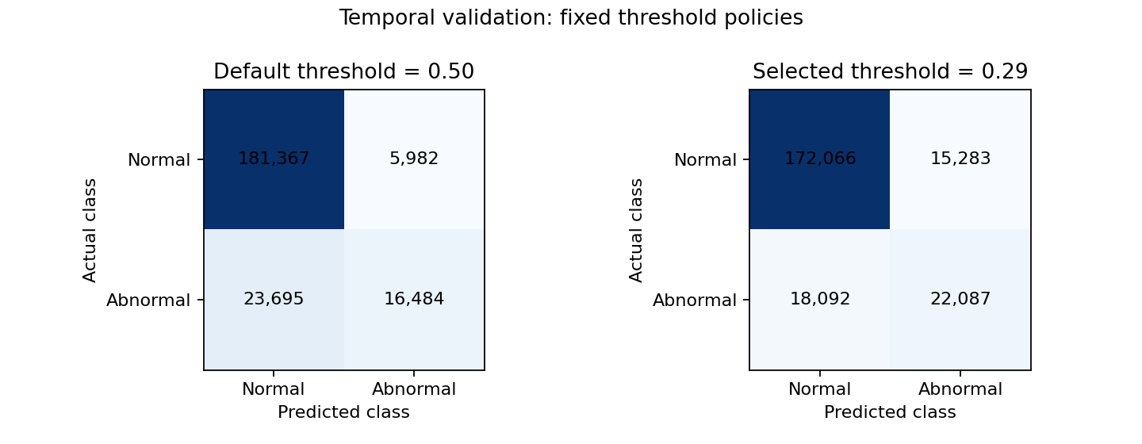
Figure 5 Validation confusion matrices at the default and selected thresholds
The matrices show the trade-off already quantified in Tables 26 and 27: lowering the threshold detects more abnormalities but generates more false alerts. Threshold selection changes classifications, not the underlying scores or their calibration. The threshold remains fixed at 0.29 before final testing. Communicating scores as absolute risks would require a separate, temporally valid calibration assessment before independent evaluation.

14 5 Interpretation of the selected model
We describe the selected boosting model using grouping, statistics and plots from the exploratory-analysis materials [6]. Applying these tools to model predictions is our project adaptation. All 39 original G4 predictors are profiled. Numerical variables with more than ten distinct values use at most five quantile intervals; other variables keep their categories, with missing values separate. Mean score and alert rate use temporal-validation predictions retained in memory, also summarised by fold. The four plots illustrate calendar, tariff, post and user history. These display choices do not alter model selection.
Table 28 Validation score profiles for historical abnormal rates
Historical predictor | Observed interval | Sessions | Mean score | Alert rate percent
Post history 30 days | (0.00285, 0.0523] | 45,532 | 0.0471 | 1.77
Post history 30 days | (0.255, 0.985] | 45,506 | 0.4246 | 50.49
User history 730 days | (0.00367, 0.0952] | 46,049 | 0.0746 | 4.01
User history 730 days | (0.241, 0.942] | 45,487 | 0.3503 | 48.37
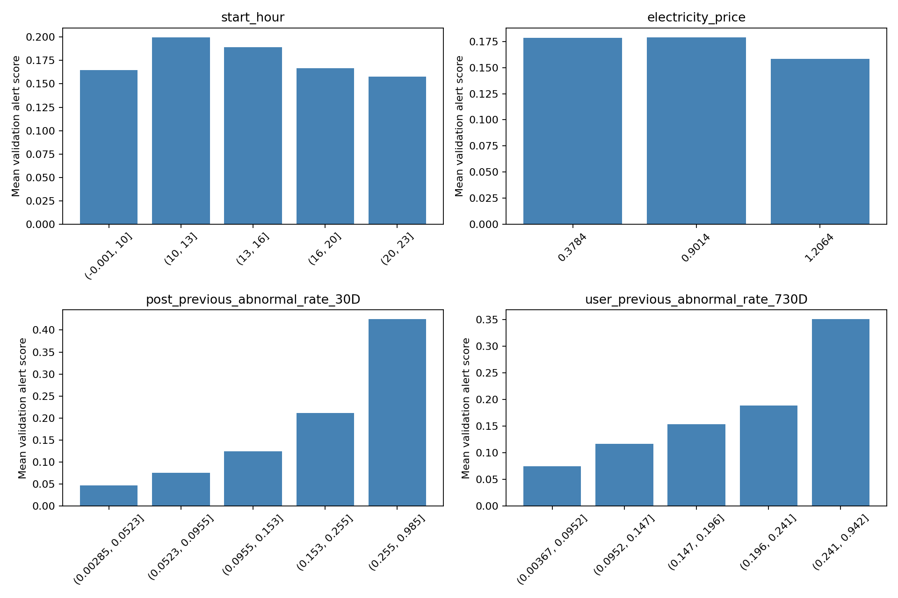
Figure 6 Mean validation alert scores across observed predictor values
Validation scores are higher in sessions with worse historical outcomes. For post history, mean score rises from 0.0471 in the lowest observed interval to 0.4246 in the highest, while alert rate rises from 1.77% to 50.49%. For user history, the corresponding mean scores are 0.0746 and 0.3503, with alert rates 4.01% and 48.37%. Mean scores across the three electricity-price levels range from 0.1582 to 0.1791. These are marginal descriptions of the model's own predictions; they do not isolate individual effects, establish causality or rank independent feature importance. Correlated inputs and interactions can create or conceal patterns. The Task 3 fixed-tree ablation provides separate evidence about information groups, not a boosting-specific ablation.
The same profiles describe predictions from the final fitted pipeline on all 294,006 eligible development sessions, without refitting or using test outcomes. These development descriptions can be optimistic and are not new generalisation estimates. Tables cover every predictor and no-history flag. The profiles give qualitative evidence about where the model assigns higher scores, but cannot identify independent variable influence or decompose individual predictions. The method has this limitation when addressing the interpretation requirement; neither analysis changes the model or threshold.

14 6 Frozen model and final test
Before final prediction, the notebook displays the selected model, classifier parameters and threshold. The G4 predictors, preprocessing pipeline and model specification are held in variables. The fixed model uses one-hot categories, zero imputation with history flags, 150 boosting iterations, learning rate 0.05, 31 leaf nodes and minimum leaf size 50, with seed 42 and early stopping disabled. The primary threshold is 0.29; 0.50 is fixed as a comparison only. No calibrator or class weighting is added.
After selection is complete, a fresh pipeline is fitted on 294,006 sessions completed before 12 July 2021 at 14:28:34, excluding the 45 still active. It scores 147,026 later sessions once within the execution. The fitted pipeline and test predictions remain in memory for the subsequent analyses. Fitting required 15.38 seconds and prediction 2.63 seconds in this execution. Test prevalence is 19.31%. Earlier descriptive EDA included this period, so it is not claimed to be fully unseen; subsequent model and threshold choices did not use its performance.
Table 29 Final test at the prespecified default and frozen selected thresholds
Policy | Threshold | Precision | Recall | F1 | Balanced accuracy | Accuracy
Default | 0.50 | 0.7146 | 0.3575 | 0.4766 | 0.6617 | 0.8483
Selected | 0.29 | 0.5456 | 0.5359 | 0.5407 | 0.7146 | 0.8242
The primary selected policy has TP=15,217, FP=12,672, FN=13,177 and TN=105,960. It detects 53.59% of abnormalities and 54.56% of alerts are correct. Test pooled F1 is 0.5407, below pooled validation F1 0.5696; development mean-fold F1 0.5614 is a different aggregation. This later-period result is reported without changing the threshold or model.
Table 30 Final monitoring consequences per 1000 sessions
Policy | Alert rate percent | Correct per 1000 | False per 1000 | Missed per 1000
Default | 9.66 | 69.04 | 27.57 | 124.08
Selected | 18.97 | 103.50 | 86.19 | 89.62
Relative to threshold 0.50, the selected policy detects 34.46 additional abnormalities but generates 58.62 additional false alerts per 1,000 sessions. Its 18.97% alert rate is a substantial workload, not evidence of acceptability. The majority baseline has F1 zero and accuracy 0.8069; always predicting abnormal has F1 0.3237 and flags every session. The chosen model exceeds both baselines in positive-class F1, but misses 46.41% of abnormalities.

14 7 Temporal and limited history performance
Table 31 Final monthly performance at the frozen threshold
Month | Sessions | Abnormal percent | F1 | Precision | Recall | False per 1000 | Missed per 1000
2021-07 partial | 15,879 | 19.67 | 0.5913 | 0.5915 | 0.5911 | 80.29 | 80.42
2021-08 | 23,692 | 20.76 | 0.5813 | 0.5862 | 0.5765 | 84.50 | 87.92
2021-09 | 27,374 | 22.88 | 0.5991 | 0.5671 | 0.6349 | 110.91 | 83.55
2021-10 | 27,794 | 18.60 | 0.4974 | 0.5086 | 0.4867 | 87.46 | 95.49
2021-11 | 25,669 | 16.50 | 0.4497 | 0.4852 | 0.4190 | 73.36 | 95.87
2021-12 | 26,618 | 17.59 | 0.5041 | 0.5257 | 0.4842 | 76.83 | 90.73
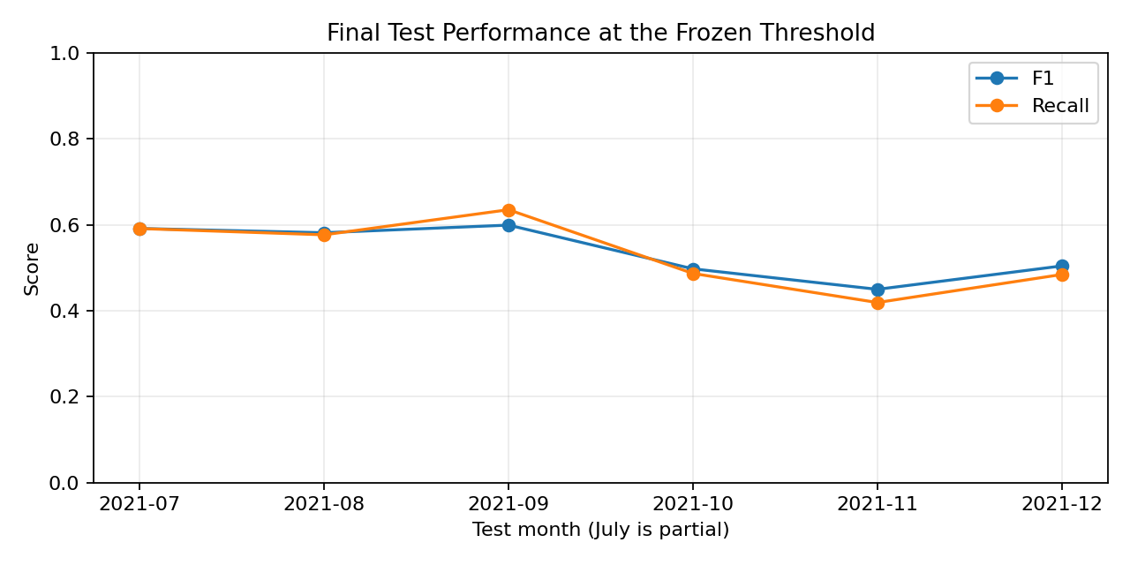
Figure 7 Monthly final test performance at the frozen threshold
Monthly F1 ranges from 0.4497 in November to 0.5991 in September. Recall also falls in the later months, reaching 0.4190 in November. July contains only sessions after the cutoff and is a partial month. Prevalence and predictor conditions vary, but the analysis does not isolate a cause for the deterioration. The model and threshold remained fixed throughout this diagnostic analysis.
Table 32 Final performance by availability of completed history
History subgroup | Sessions | F1 | Recall
No completed user history | 18,893 | 0.4495 | 0.4169
Has completed user history | 128,133 | 0.5545 | 0.5552
No completed post history | 0 | Not estimable | Not estimable
Sessions without completed user history have recall 0.4169, versus 0.5552 when history is available. They differ in composition and prevalence, so the gap does not establish a causal effect or discrimination. No test session lacks completed post history, leaving new-post performance unassessed. Excluding identifiers does not anonymise behavioural histories, and the single-network evaluation does not establish transfer to other infrastructure.

15 Overall conclusions and limitations
The audit supports retaining investigated records while excluding post-session predictors. Temporal validation preserves training-outcome availability, and the ablation identifies charging-post history as the largest gain, with an additional benefit from user history. Three individual principles and three ensemble principles were compared before two focused searches. Boosting is selected under the predefined F1 rule, but tuning yields only a small development improvement. The final frozen policy achieves F1 0.5407, precision 0.5456 and recall 0.5359, with material false-alert workload and temporal variability.
The model and threshold were fixed before final prediction and were not revised afterward. Limitations include initial descriptive exposure of the eventual test period, reuse of development outcomes, restricted search spaces and unequal earlier tuning effort, correlated histories, the descriptive nature of prediction profiles, unverified absolute-risk calibration, unknown error costs and monitoring capacity, absence of new-post cases and lack of external-network evaluation. The results support a reproducible monitoring study rather than deployment readiness.

16 Reproducibility and execution
The submitted notebook is projeto_final.ipynb, accompanied by Charging_Data_educational.csv and the environment dependencies specified in requirements.txt. A complete execution calculates the temporal model comparisons, hyperparameter searches, final fit and test predictions directly from the original dataset. Models and prediction arrays remain in memory; no previously generated result files or serialised models are loaded.
Within the same execution, threshold summaries, pooled metrics, monthly comparisons and history diagnostics reuse the predictions already calculated. A new kernel requires fitting and prediction again. The saved notebook contains the outputs of the complete execution, including the selected configurations and final evaluation. The numerical results agree with the preceding implementation, while execution times reflect the current run.

References
[1] Project brief. Project 1 Classification of Abnormal Electric Vehicle Charging Sessions. Mineracao de Dados, 2026/2027, first semester. Version containing Tasks 1 to 4. Task 2, PDF pp. 4-6; Task 3, pp. 6-7; Task 4, pp. 7-8.
[2] Rodrigues, F. MINDD 04 Model Evaluation. Course slides, 2026/2027. F1, PDF p. 26; classification thresholds and precision-recall curves, PDF pp. 34-35. The PDF page numbering differs from the slide labels.
[3] Rodrigues, F. MINDD 05 Predictive Models. Course slides, 2026/2027. K nearest neighbours, PDF pp. 5-13; decision trees, pp. 14-20; logistic regression, pp. 41-44; preprocessing guidance, p. 52. Earlier Naive Bayes and SVM experiments are documented separately.
[4] Course practical notebook sampling_evaluation.ipynb. Precision-recall threshold illustration and out-of-fold F1 threshold selection. Our expanding temporal windows and mean-fold aggregation are project-specific adaptations.
[5] Experimental notebook projeto_final.ipynb, submission version dated 26 October 2026, with complete Tasks 1 to 4 execution outputs. Results include feature-group comparisons, individual and ensemble evaluation, temporal hyperparameter searches, threshold comparisons, descriptive prediction profiles and final-test diagnostics.
[6] Course materials. Introduction to Data Science, Python Exploratory Data Analysis, Data Preparation, Lab Sheet 1, Lab Sheet 2 and TP Evaluation Models. Mineracao de Dados, 2026/2027.
[7] Zhang, Y., Xu, T., Chen, T., et al. (2025). A high-resolution electric vehicle charging transaction dataset with multidimensional features in China. Scientific Data, 12, 643. https://doi.org/10.1038/s41597-025-04982-1
[8] Rodrigues, F. MINDD 06 Ensemble Learning. Course slides, 2026/2027. Voting, PDF pp. 6-8; bagging and random forests, pp. 11-20; boosting, pp. 21-24; parameter optimisation and search strategies, pp. 26-42. Practical notebook ensemble_leraning.ipynb includes voting, random forest and histogram gradient boosting.

