0.- crear una nueva llamada mongo_movies

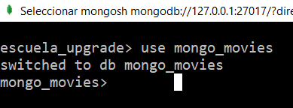

**Documentos a Insertar**

## Insertar los siguientes documentos en una colección llamada movies

**db.movies.insertMany([{title : "Fight Club" ,writer : "Chuck Palahniuk" ,year : 1999, actors : [ "Brad Pitt","Edward Norton"]},**

**{title : "Pulp Fiction", writer : "Quentin Tarantino", year : 1994, actors : [ "John Travolta", "Uma Thurman" ]},**

**{title : "Inglorious Basterds", writer:"Quentin Tarantino", year : 2009, actors : [ "Brad Pitt", "Diane Kruger", "Eli Roth"]},**

**{title : 'The Hobbit: An Unexpected Journey', writer:"J.R.R. Tolkein", year : 2012, franchise : "The Hobbit"},**

**{title : "The Hobbit: The Desolation of Smaug", writer : "J.R.R. Tolkein", year : 2013, franchise : "The Hobbit"},**

**{title : "The Hobbit: The Battle of the Five Armies", writer : "J.R.R. Tolkein", year : 2012, franchise : "The Hobbit", synopsis : "Bilbo and Company are forced to engage in a war against an array of combatants and keep the Lonely Mountain from falling into the hands of a rising darkness."},**

**{title : "Pee Wee Herman's Big Adventure"},**

**{title : "Avatar"}])**

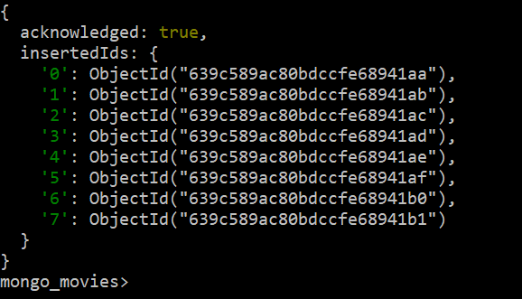

**Consultas / Buscar documentos**

## 1.- Obtener todos los documentos

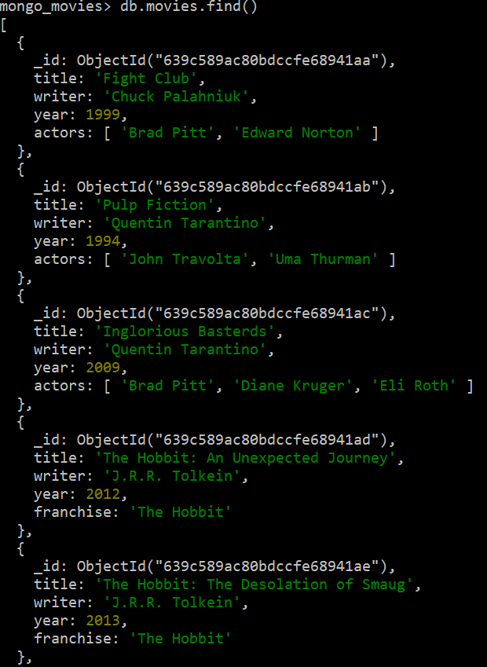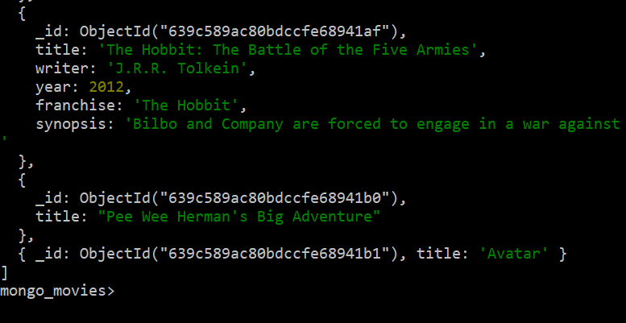

## 2 Obtener documentos con writer igual a "Quentin Tarantino"

**db.movies.find({writer:"Quentin Tarantino"})**

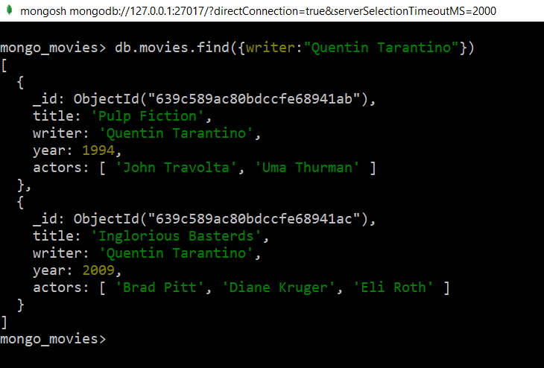

## 3 Obtener documentos con actors que incluyan a "Brad Pitt"

db.movies.find({actors:{$in:['Brad Pitt']}})

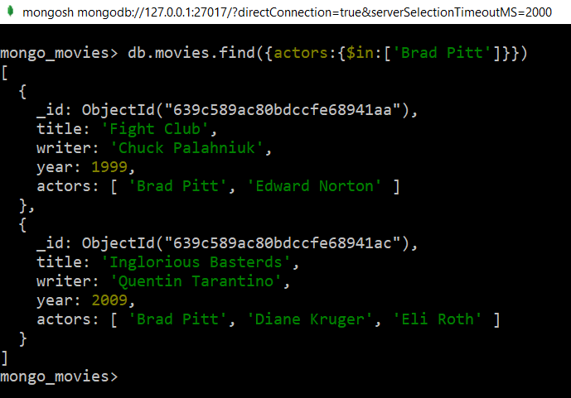

## 4 Obtener documentos con franchise igual a "The Hobbit"

db.movies.find({franchise:"The Hobbit"})

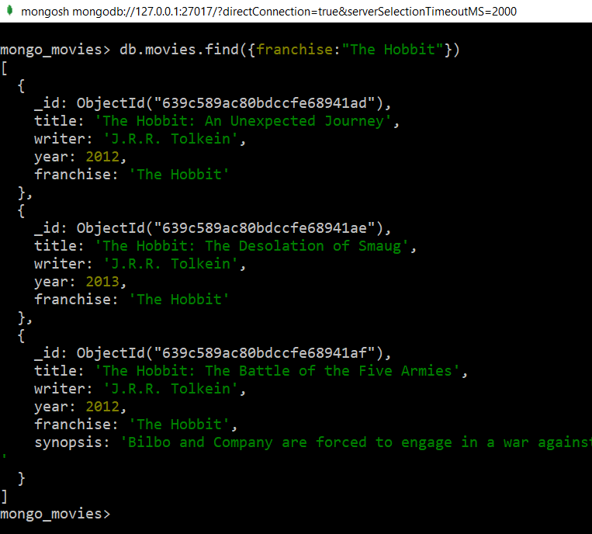

5. Obtener todas las películas de los 90s.

db.movies.find({"year":{$gte:1990,$lt:2000}})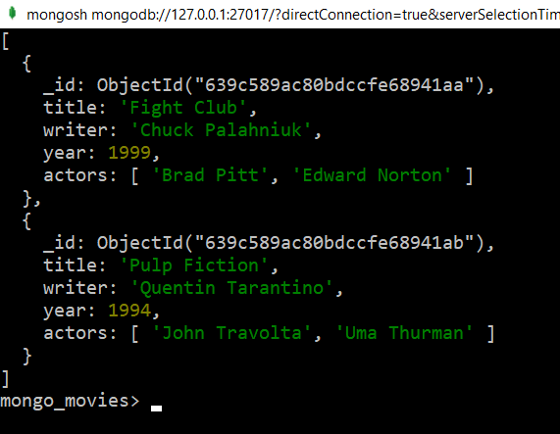

6 Obtener las películas estrenadas entre el año 2000 y 2010.

db.movies.find({"year":{$gte:2000,$lt:2011}})

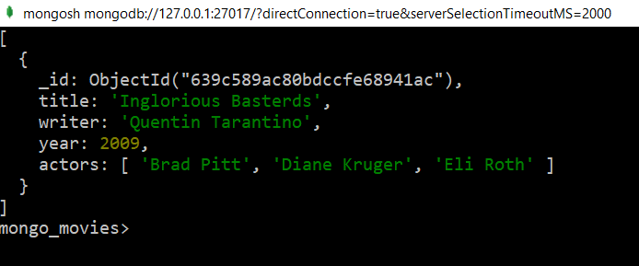

**Actualizar Documentos**