**Interação Pessoa-Máquina**

**2023/2024**

**CartGuru**

Stage 6: Evaluation results and presentation of the final project

**Authors: Lab class Nº P1**

58592, Vasco Malta **Group Nº 3**

60127, João Ribeiro

60590, Pedro Gasparinho **Professor:**

60811, Tiago Meirim Teresa Romão

Month 11, 2023

**Heuristic Evaluation**

This is the heuristic evaluation made by group nº8 about our app.

|  |  |  |  |  |  |
| --- | --- | --- | --- | --- | --- |
| Nº | Problem | Heuristic | Description | Severity | Solution |
| 1 | Unrestricted Post Addition | Visibility of system status, User control and freedom | Users can add an unlimited number of posts by repeatedly clicking the Confirm button, leading to potential spam and clutter. | Moderate | Implement a mechanism to disable the "Add post" window after the Confirm button is clicked once.  Display a loading  indicator to show that the system is processing the request. |
| 2 | Overlapping Text | Visibility of system status,  Consistency and standards | The "Welcome to CartGuru" text is overlapped, affecting the visual appeal and readability of the  interface. | Low | Adjust the layout to ensure proper spacing and positioning of the text.  Test the layout on different screen sizes to ensure responsiveness. |
| 3 | Chaotic Pantry Section | Flexibility and efficiency of use,  Aesthetic and minimalist design | The Pantry section is chaotic, with an overly complex calendar and a  lack of predefined product options. | High | Simplify the expiration process by replacing the calendar with a field to input the number of days until the product expires.  Provide a dropdown list of predefined product options for users to choose from.  Ensure the interface maintains a clean and organised appearance. |
| 5 | Case sensitivity | Match between system and the real  world, Error prevention, Recognition rather than recall | When adding a item anywhere  there is a specific way in terms of  lower and upper case of the letters that the word should be written. | High | Accepting different ways to write the same word, let the user write in all lowercase or all uppercase for example.  And if there is a limited number of items a selection field would be more adequate. |

|  |  |  |  |  |  |
| --- | --- | --- | --- | --- | --- |
| 6 | No item completion | User control & freedom, Recognition rather than recall | When adding  items, there is no auto-completion or suggestions, or partial word matching, so the user must memorize the exact name of every item (or one word of the item, in the case of “add to list”). | High | Add partial word matching for “add to list”, add  auto-complete suggestions  with partial matching on other item inputs. |
| 7 | Bugged “Notify me” on pantry edit | Visibility of system status | When editing an  item in the pantry, the “Notify me” option shows “Option 0” instead of what the previously selected option was. | Minor | Show the previously selected option. |
| 8 | Inconvenient unit selection | Flexibility & efficiency of use | When adding an  item to the list, the user must input the number of items manually. | Minor | Add + and - buttons to  increment and decrement the number of units. Alternatively, make it a scrolling dial, while preserving the option of manual input. |
| 9 | Trapped in floating dialogue | Flexibility & efficiency of use | When a floating dialogue appears, the user may only exit it through the “x” button. | Minor | Allow the android back button or a touch in the background to exit the dialogue as well. |

**Evaluation results**

1. Unrestricted Post Addition

Problem description: Users can add an unlimited number of posts by repeatedly clicking the Confirm button, leading to potential spam and clutter.

Our view on the problem: We agree with the problem, even though our initial idea was to stay in the page so that the user can do many posts in quick succession of different items, without the need to go to the community tab.

Proposed solution: Implement a mechanism to disable the "Add post" window after the Confirm button is clicked once. Display a loading indicator to show that the system is processing the request.

Comments and implementation: We agree with the first part of the solution. We decided to implement it in a way that the fields are cleared when the post is submitted, making that the user can’t spam press the “Add post” button because the fields are empty.  
About the second part of the solution, we also agree but since the application does not contact a server, the load times are almost instantaneous, which is why we don’t have a loading indicator and the feedback messages suffice.

1. Overlapping Text

Problem description: The "Welcome to CartGuru" text is overlapped, affecting the visual a peal and readability of the interface.

Our view on the problem: We noticed this problem close to the deadline. Since we couldn’t test with many different sized displays, this problem went unsolved.

Proposed solution: Adjust the layout to ensure proper spacing and positioning of the text. Test the layout on different screen sizes to ensure responsiveness.

Comments and implementation: We reduced the font size to comply with the solution they gave. We also tested in new displays, but we can’t assure that all the displays will work with this new font size, since this task is very time-consuming.

1. Chaotic Pantry Section

Problem description: The Pantry section is chaotic, with an overly complex calendar and a lack of predefined product options.

Our view on the problem: We don’t agree that the section is chaotic or that the calendar is overly complex, however we find this section to be somewhat cluttered due to the size of the calendar. The lack of predefined product options is related to problem 6, where we explain more in depth that topic.

Proposed solution: Simplify the expiration process by replacing the calendar with a field to input the number of days until the product expires. Provide a dropdown list of predefined product options for users to choose from. Ensure the interface maintains a clean and organized appearance.

Comments and implementation: Inputting the number of days until expiration requires the user to calculate it, which isn’t very user friendly, instead we decided to hide the calendar under a pop-up to make the screen feel cleaner, as the calendar was taking up a lot of space. Once again, the solution regarding the dropdown list is related to problem 6, where we explain more in depth that topic.

1. Case sensitivity

Problem description: When adding an item anywhere there is a specific way in terms of lower and upper case of the letters that the word should be written.

Our view on the problem: We agree with the problem. The way that this was implemented it restricted the user and led him to errors.

Proposed solution: Accepting different ways to write the same word, let the user write in all lowercase or all uppercase for example. And if there is a limited number of items a selection field would be more adequate.

Comments and implementation: We implemented the first suggestion. About the second one, we found that the number of items is big enough to not be adequate to use a selection field.

1. No item completion

Problem description: When adding items, there is no auto-completion or suggestions, or partial word matching, so the user must memorize the exact name of every item (or one word of the item, in the case of “add to list”).

Our view on the problem: We agree with the problem, since it helps the user a lot. Ideally, we wanted to implement a similar search algorithm, but it’s out of the scope of this project to do such implementation.

Proposed solution: Add partial word matching for “add to list”, add auto-complete suggestions with partial matching on other item inputs.

Comments and implementation: We agree with the solution but decided to not implement it due to time constraints and it being very functionality heavy, which is out of the scope of this project.

1. Bugged “Notify me” on pantry edit

Problem description: When editing an item in the pantry, the “Notify me” option shows “Option 0” instead of what the previously selected option was.

Our view on the problem: This is a minor bug that we identified during late stages of phase 4, but we couldn’t locate the source of this problem.

Proposed solution: Show the previously selected option.

Comments and implementation: Taking a better look at the code, we quickly identified the source and it’s fixed.

1. Inconvenient unit selection

Problem description: When adding an item to the list, the user must input the number of items manually.

Our view on the problem: We agree with this problem, we considered a few different input options but ended up choosing only the text input for simplicity and better control.

Proposed solution: Add + and - buttons to increment and decrement the number of units. Alternatively, make it a scrolling dial, while preserving the option of manual input.

Comments and implementation: We agree with this solution. In fact, initially we had thought of having both the text input and the “+” and “-“ buttons, but for simplicity we decided to only keep the text input and the text input offers the possibility of quickly inserting any number, while with only the buttons we would to click many times to insert big numbers. It seems that some users are more likely to prefer having both options so we will sacrifice a bit of simplicity to achieve flexibility in the controls.

1. Trapped in floating dialogue

Problem description: When a floating dialogue appears, the user may only exit it through the “x” button.

Our view on the problem: We comprehend their view, but we think that our approach is more secure. In pop-ups that originate from less critical actions we offer the possibility to close the pop-up on any other part of the screen. For pop-ups associated with critical actions, such as deleting items, we decided to restrain the user to compel them to make a conscious decision that would deeply affect the state of the data.

Proposed solution: Allow the android back button or a touch in the background to exit the dialogue as well.

Comments and implementation: Once again we do not agree with these solutions, although we recognize that our solution is a trade-off between security/confirmation and flexibility.

Photo with the solution of problem 3

Photo with the solution of problem 8

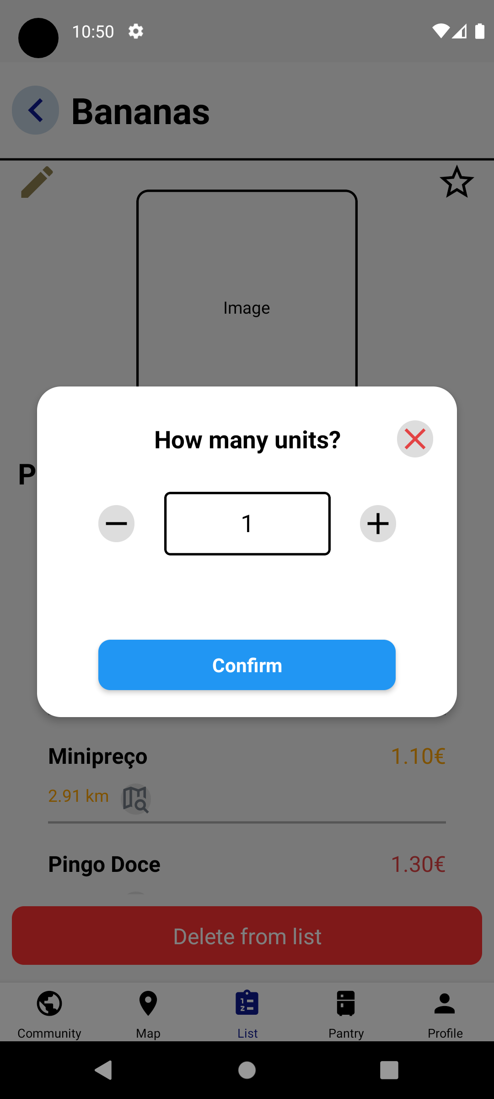

**Heuristic Self-evaluation**

|  |  |  |  |  |  |
| --- | --- | --- | --- | --- | --- |
| Nº | Problem | Heuristic | Description | Severity | Solution |
| 1 | List items elevation | “Aesthetic and Minimalist Design” and “Consistency & Standards” | The items in lists generally have a shadow to evidence them from other elements of the interface, it also can represent possible interaction with the item itself, which is the case in some of the pages in our app | Low | Add a shadow effect to all list in our application. |
| 2 | Critical actions pop-up | “Consistency and standards” | The button that confirms the critical action was attributed the blue color, which isn’t associated with critical actions in this app. The cancel button is also a bit small. | Hight | Make the cancel button bigger and change the color of the confirm button to red. |
| 3 | Missing edit buttons | “Flexibility and efficiency of use” | Some pages/components related to the list were lacking the edit button | High | Add the missing buttons in the needed places, in particular the “Item” page and the “Shopping List in Supermarket” page |

Photo with solution for problem 1

Photo with the solution of problem 2

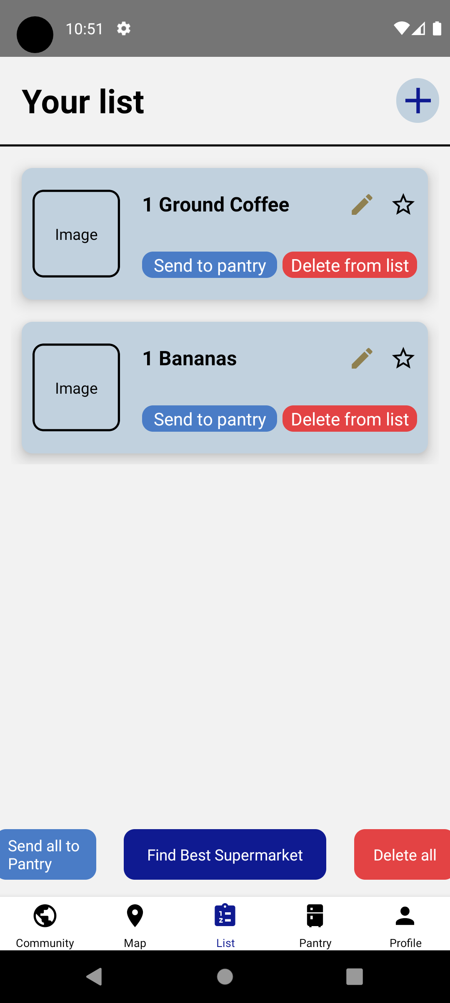

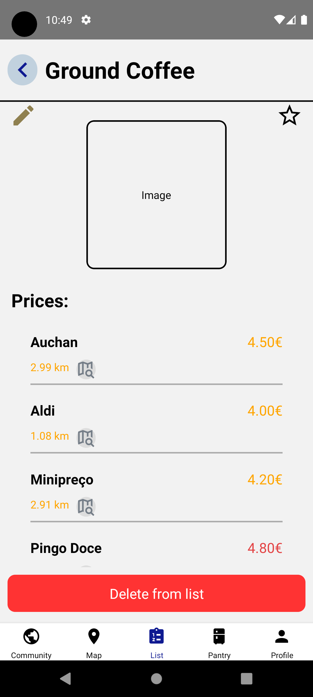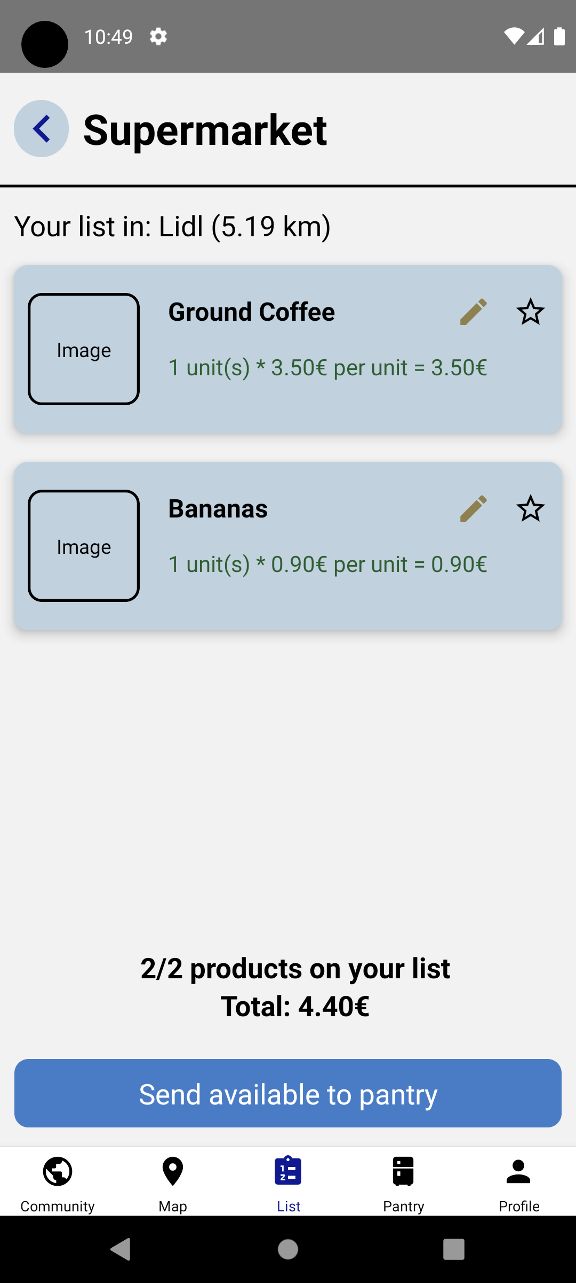Photos with solution for problem 3