|  |  |
| --- | --- |
| **Pedro Gonçalves Valle** | **98300** |
| **Vinicius Toffoli Pereira** | **551170** |

**A1)**



**A2)** 

**A3)**

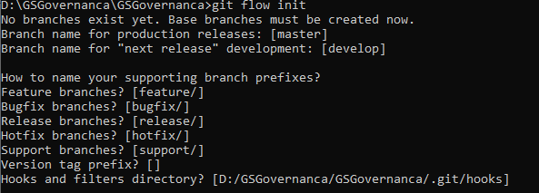

**B)**

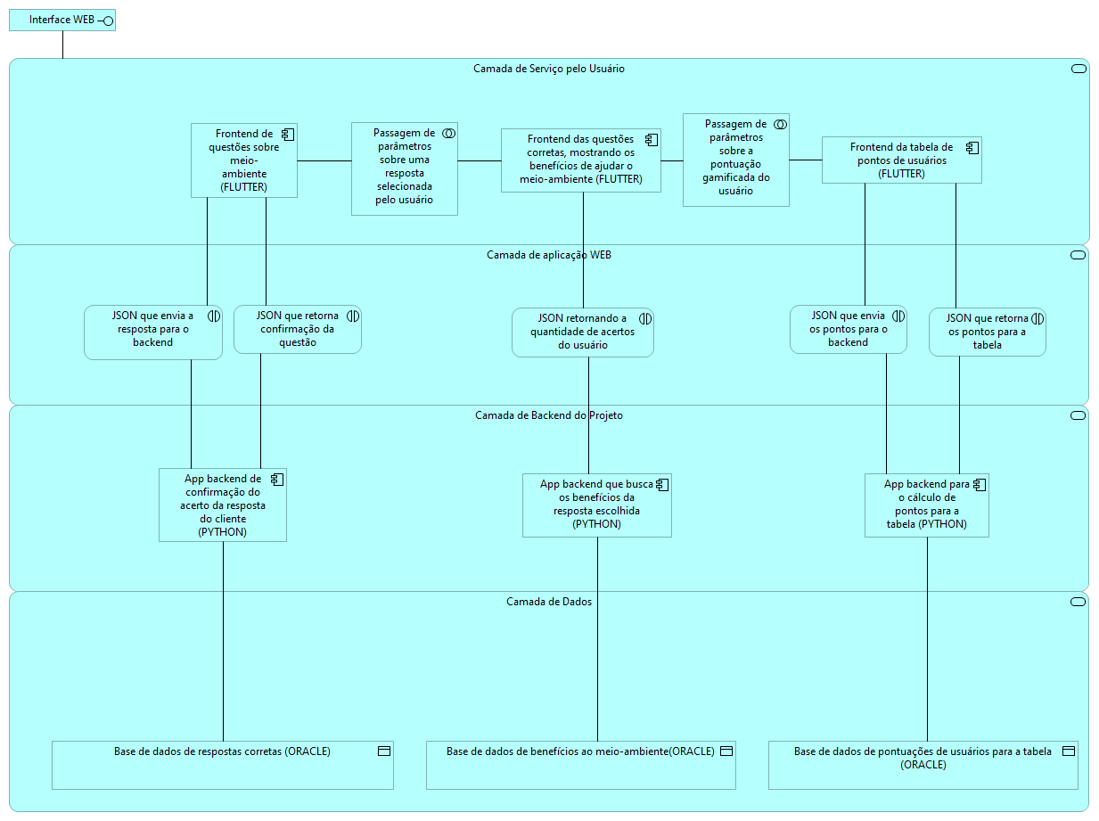

**C1)** 