Desarrollo de interfaces

Pedro Gutiérrez Vico

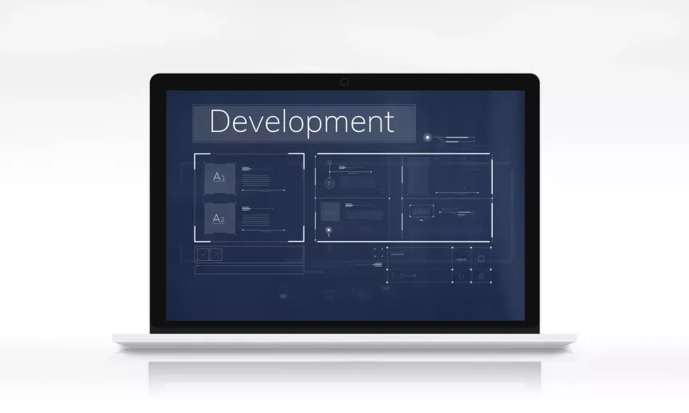
Ejercicio Guiado

4.5.1 Paso 1: Instalar Postman
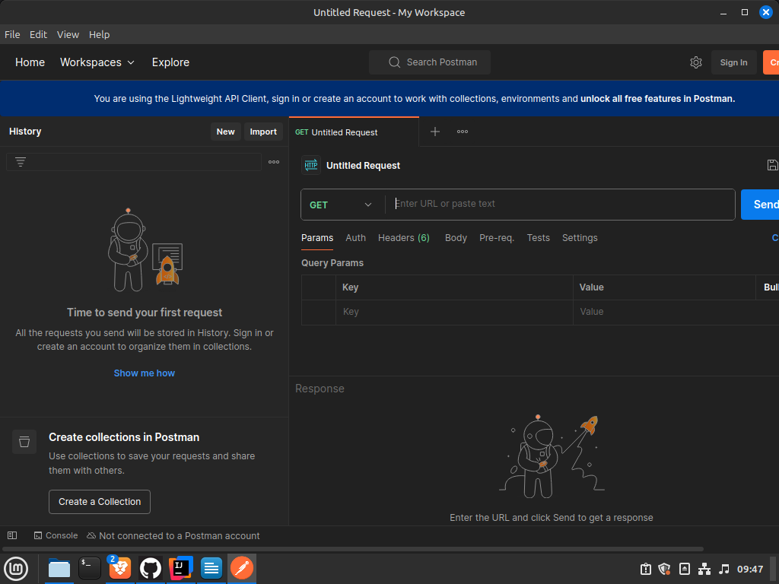

4.5.2 Paso 2: Elegir una API Pública

https://jsonplaceholder.typicode.com/

4.5.3 Paso 3: Realizar una Solicitud GET

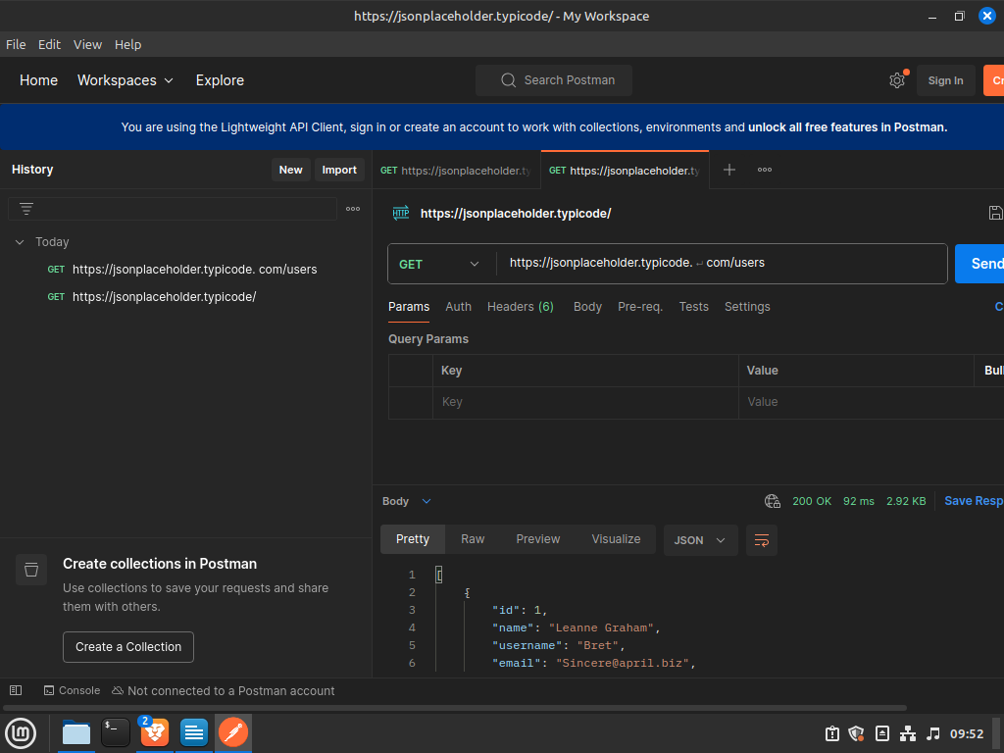

4.5.4 Paso 4: Analizar la Respuesta
{
"id": 1,
"name": "Leanne Graham",
"username": "Bret",
"email": "Sincere@april.biz",
"address": {
"street": "Kulas Light",
"suite": "Apt. 556",
"city": "Gwenborough",
"zipcode": "92998-3874",
"geo": {
"lat": "-37.3159",
"lng": "81.1496"
}
},
"phone": "1-770-736-8031 x56442",
"website": "hildegard.org",
"company": {
"name": "Romaguera-Crona",
"catchPhrase": "Multi-layered client-server neural-net",
"bs": "harness real-time e-markets"
}
},
{
"id": 2,
"name": "Ervin Howell",
"username": "Antonette",
"email": "Shanna@melissa.tv",
"address": {
"street": "Victor Plains",
"suite": "Suite 879",
"city": "Wisokyburgh",
"zipcode": "90566-7771",
"geo": {
"lat": "-43.9509",
"lng": "-34.4618"
}
},
"phone": "010-692-6593 x09125",
"website": "anastasia.net",
"company": {
"name": "Deckow-Crist",
"catchPhrase": "Proactive didactic contingency",
"bs": "synergize scalable supply-chains"
}
},
{
"id": 3,
"name": "Clementine Bauch",
"username": "Samantha",
"email": "Nathan@yesenia.net",
"address": {
"street": "Douglas Extension",
"suite": "Suite 847",
"city": "McKenziehaven",
"zipcode": "59590-4157",
"geo": {
"lat": "-68.6102",
"lng": "-47.0653"
}
},
"phone": "1-463-123-4447",
"website": "ramiro.info",
"company": {
"name": "Romaguera-Jacobson",
"catchPhrase": "Face to face bifurcated interface",
"bs": "e-enable strategic applications"
}
}
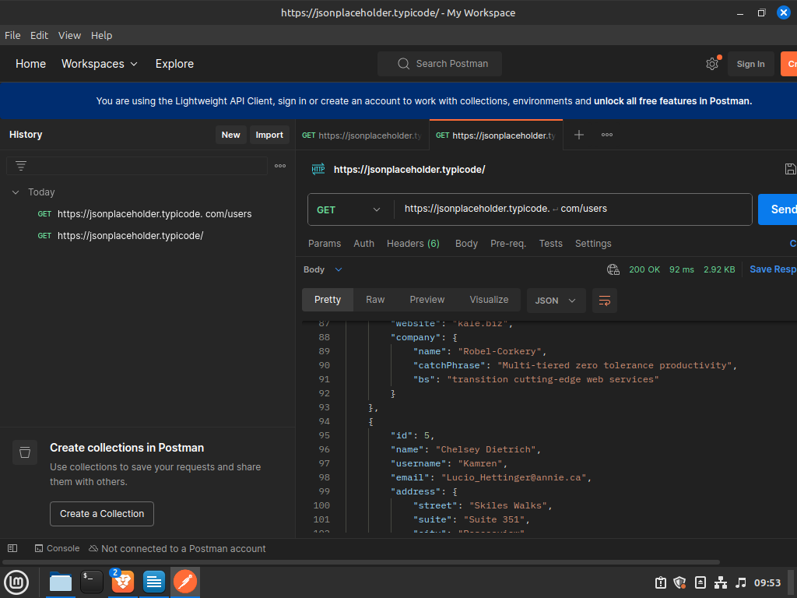

4.5.5 Paso 5: Realizar una Solicitud GET para obtener un solo usuario

{
"id": 1,
"name": "Leanne Graham",
"username": "Bret",
"email": "Sincere@april.biz",
"address": {
"street": "Kulas Light",
"suite": "Apt. 556",
"city": "Gwenborough",
"zipcode": "92998-3874",
"geo": {
"lat": "-37.3159",
"lng": "81.1496"
}
},
"phone": "1-770-736-8031 x56442",
"website": "hildegard.org",
"company": {
"name": "Romaguera-Crona",
"catchPhrase": "Multi-layered client-server neural-net",
"bs": "harness real-time e-markets"
}
}
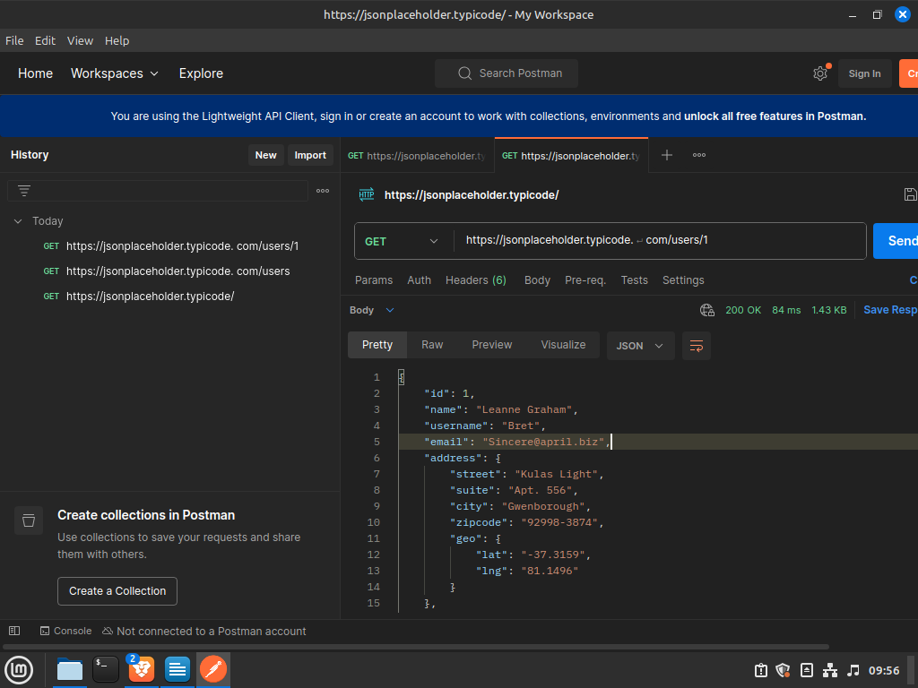

4.5.6 Paso 6: Realizar una Solicitud POST

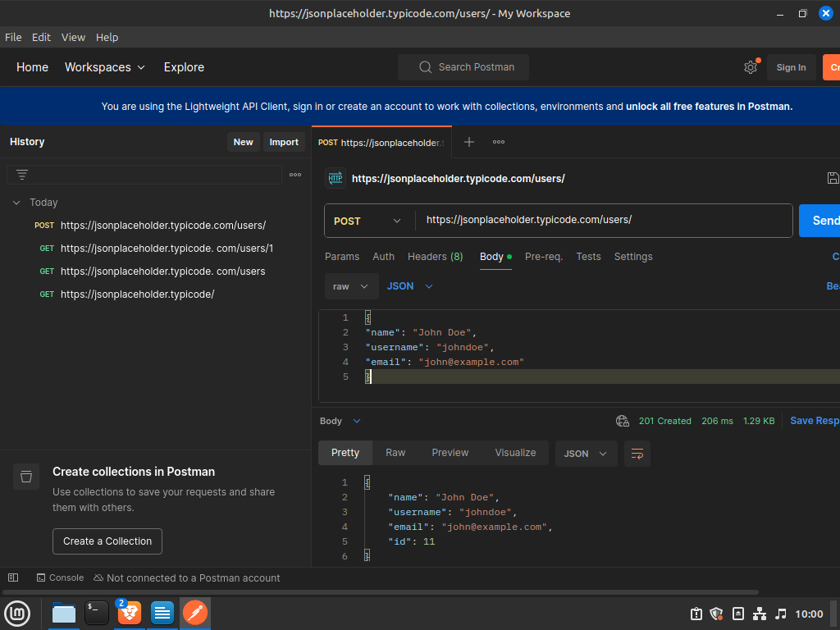

4.5.7 Paso 7: Realizar una Solicitud PATCH

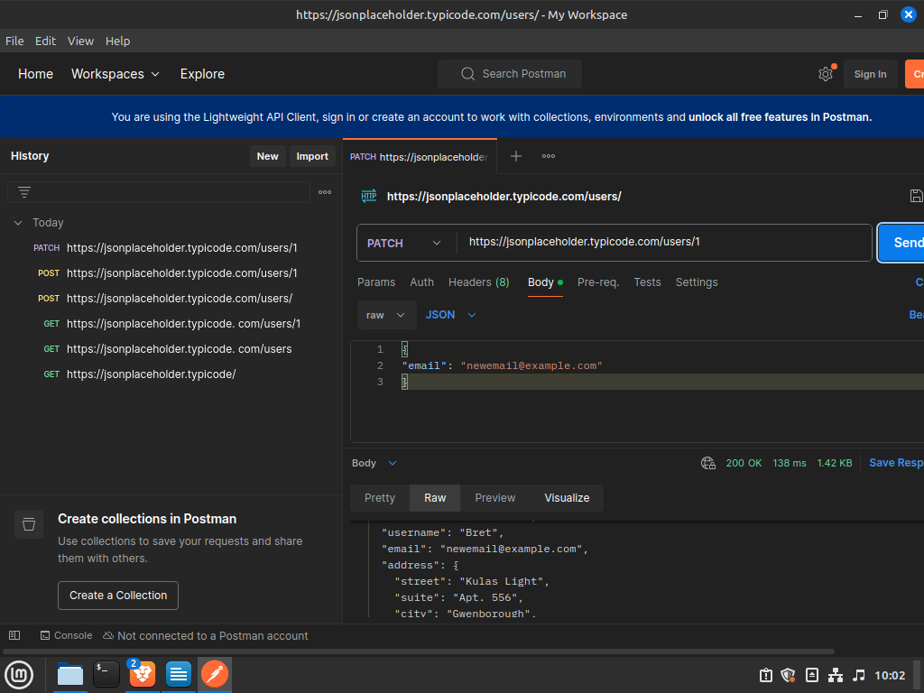

4.5.8 Paso 8: Explorar Otros Endpoints

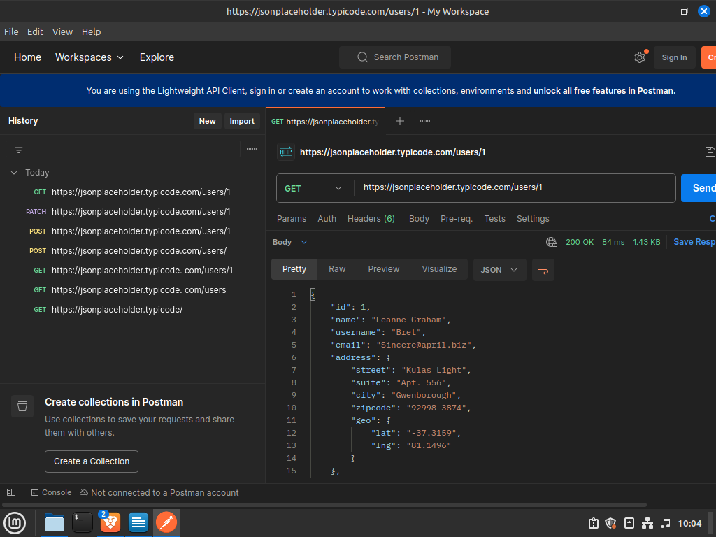
Obtener un solo usuario:

Actualizar un usuario completamente (con PUT):
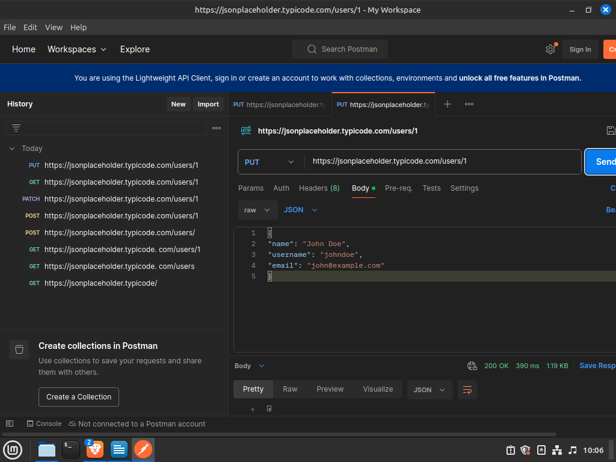

Eliminar un usuario (con DELETE):
