**Creating Room:**

To create a new room for sharing files, navigate to the main page, click on create room

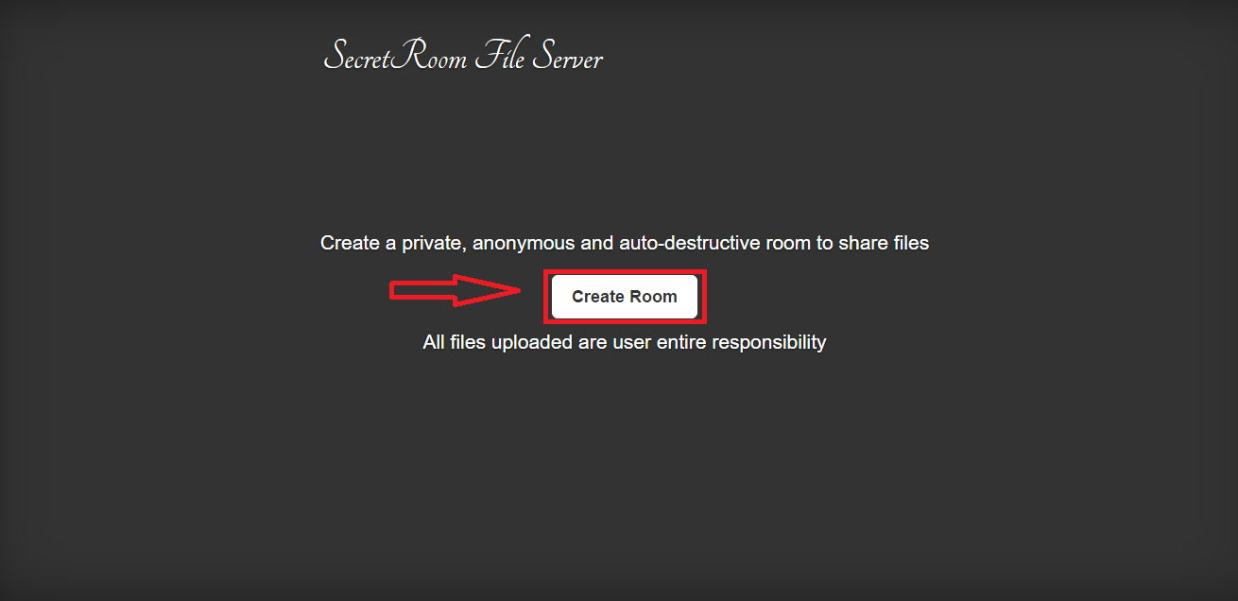You will be redirected to your room automatically.

Keep in mind that the only way to access your room is with its URL.

**Uploading Files:**

To upload a file, click on the button upload

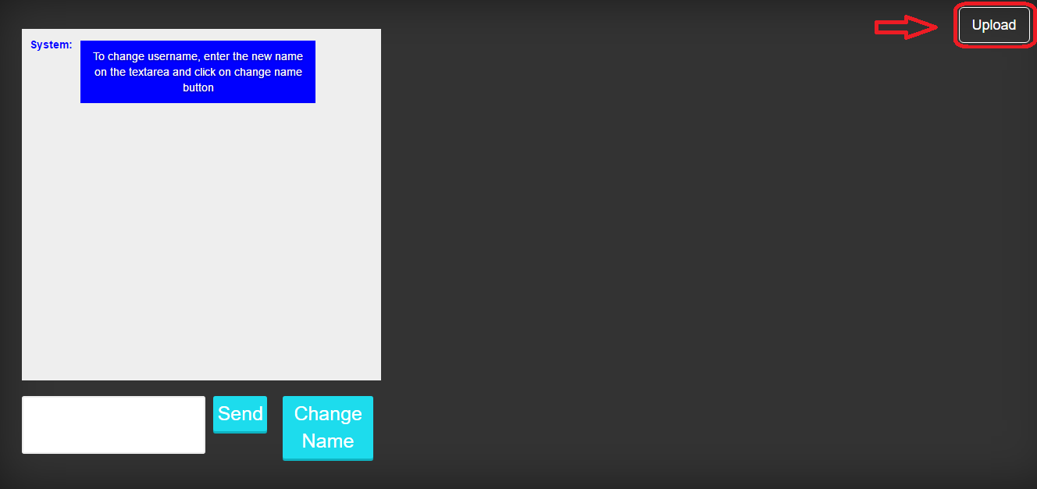

Now, click on the button to choose the file

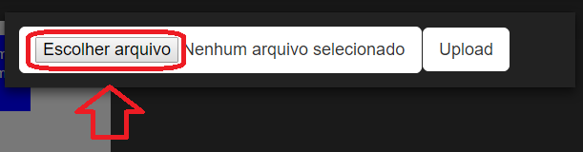

*The button’s text will change according to your language.

The last step now is to click on the button upload

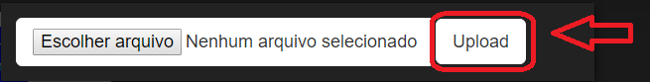The windows will close automatically after the file is upload.

**Changing name on chat:**

To change your username name, first enter the new name on the textarea.

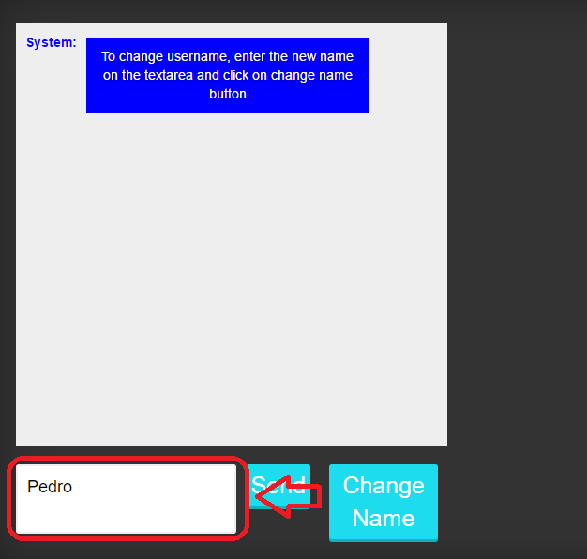

Then click on the change name button

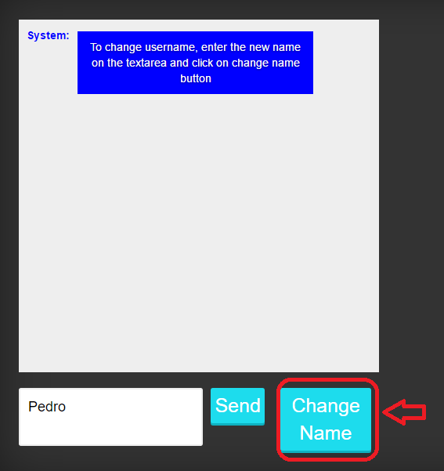

A message will be shown informing the new username

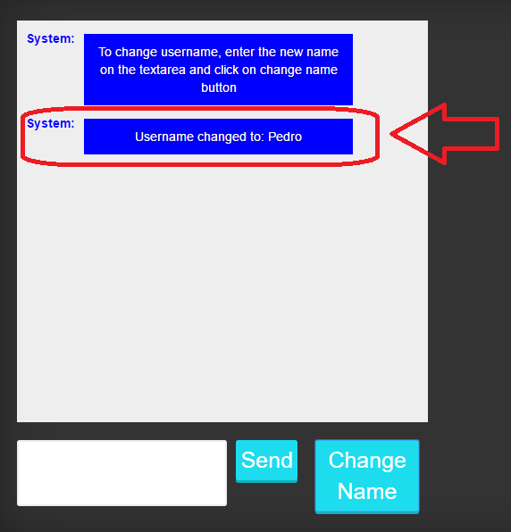

**Changing name on chat:**

To send message on the chat, first type the message on the textarea

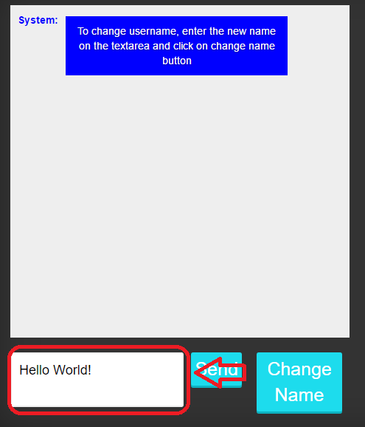

Then click on the send button

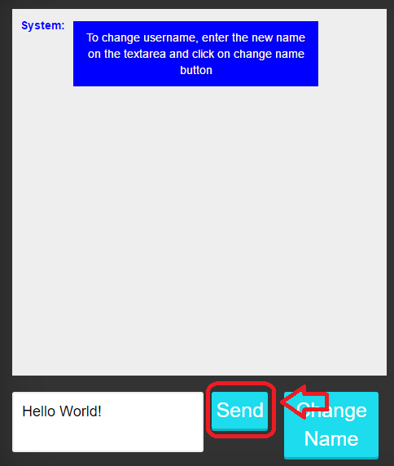

Message will be sent

