Section A36.4 Calculation of Effective Perceived Noise Level From Measured Data

A36.4.1 *General.*

A36.4.1.1 The basic element for noise certification criteria is the noise evaluation measure known as effective perceived noise level, EPNL, in units of EPNdB, which is a single number evaluator of the subjective effects of airplane noise on human beings. EPNL consists of instantaneous perceived noise level, PNL, corrected for spectral irregularities, and for duration. The spectral irregularity correction, called “tone correction factor”, is made at each time increment for only the maximum tone.

A36.4.1.2 Three basic physical properties of sound pressure must be measured: level, frequency distribution, and time variation. To determine EPNL, the instantaneous sound pressure level in each of the 24 one-third octave bands is required for each 0.5 second increment of time during the airplane noise measurement.

A36.4.1.3 The calculation procedure that uses physical measurements of noise to derive the EPNL evaluation measure of subjective response consists of the following five steps:

(a) The 24 one-third octave bands of sound pressure level are converted to perceived noisiness (noy) using the method described in section A36.4.2.1 (a). The noy values are combined and then converted to instantaneous perceived noise levels, PNL(k).

(b) A tone correction factor C(k) is calculated for each spectrum to account for the subjective response to the presence of spectral irregularities.

(c) The tone correction factor is added to the perceived noise level to obtain tone-corrected perceived noise levels PNLT(k), at each one-half second increment:

PNLT(k) = PNL(k) + C(k)

The instantaneous values of tone-corrected perceived noise level are derived and the maximum value, PNLTM, is determined.

(d) A duration correction factor, D, is computed by integration under the curve of tone-corrected perceived noise level versus time.

(e) Effective perceived noise level, EPNL, is determined by the algebraic sum of the maximum tone-corrected perceived noise level and the duration correction factor:

EPNL = PNLTM + D

A36.4.2 *Perceived noise level.*

A36.4.2.1 Instantaneous perceived noise levels, PNL(k), must be calculated from instantaneous one-third octave band sound pressure levels, SPL(i, k) as follows:

(a) Step 1: For each one-third octave band from 50 through 10,000 Hz, convert SPL(i, k) to perceived noisiness n(i, k), by using the mathematical formulation of the noy table given in section A36.4.7.

(b) Step 2: Combine the perceived noisiness values, n(i, k), determined in step 1 by using the following formula:

[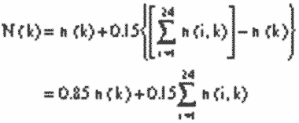](https://img.federalregister.gov/ER08JY02.001/ER08JY02.001_original_size.png)

where n(k) is the largest of the 24 values of n(i, k) and N(k) is the total perceived noisiness.

(c) Step 3: Convert the total perceived noisiness, N(k), determined in Step 2 into perceived noise level, PNL(k), using the following formula:

[](https://img.federalregister.gov/ER08JY02.002/ER08JY02.002_original_size.png)

Note:

PNL(k) is plotted in the current advisory circular for this part.

A36.4.3 *Correction for spectral irregularities.*

A36.4.3.1 Noise having pronounced spectral irregularities (for example, the maximum discrete frequency components or tones) must be adjusted by the correction factor C(k) calculated as follows:

(a) Step 1: After applying the corrections specified under section A36.3.9, start with the sound pressure level in the 80 Hz one-third octave band (band number 3), calculate the changes in sound pressure level (or “slopes”) in the remainder of the one-third octave bands as follows:

*s*(3,*k*) = no value

s(4,*k*) = SPL(4,*k*)−SPL(3,*k*)

•

•

s(*i,k*) = SPL(*i,k*)−SPL(*i*−1,*k*)

•

•

s(24,*k*) = SPL(24,*k*)−SPL(23,*k*)

(b) Step 2: Encircle the value of the slope, s(i, k), where the absolute value of the change in slope is greater than five; that is where:

|Δ*s*(*i,k*)| = |*s*(*i,k*)−*s*(*i*−1,*k*)|>5

(c) Step 3:

(1) If the encircled value of the slope s(i, k) is positive and algebraically greater than the slope s(i−1, k) encircle SPL(i, k).

(2) If the encircled value of the slope s(i, k) is zero or negative and the slope s(i−1, k) is positive, encircle SPL(i−1, k).

(3) For all other cases, no sound pressure level value is to be encircled.

(d) Step 4: Compute new adjusted sound pressure levels SPL′(i, k) as follows:

(1) For non-encircled sound pressure levels, set the new sound pressure levels equal to the original sound pressure levels, SPL′(i, k) = SPL(i, k).

(2) For encircled sound pressure levels in bands 1 through 23 inclusive, set the new sound pressure level equal to the arithmetic average of the preceding and following sound pressure levels as shown below:

SPL′(*i,k*) = 1⁄2[SPL(*i*−1,*k*) + SPL(*i* + 1,*k*)]

(3) If the sound pressure level in the highest frequency band (i = 24) is encircled, set the new sound pressure level in that band equal to:

SPL′(24,*k*) = SPL(23,*k*) + *s*(23,*k*)

(e) Step 5: Recompute new slope s′(i, k), including one for an imaginary 25th band, as follows:

*s*′(3,*k*) = *s*′(4,*k*)

*s*′(4,*k*) = SPL′(4,*k*)−SPL′(3,*k*)

•

•

*s*′(*i,k*) = SPL′(*i,k*)−SPL′(*i*−1,*k*)

•

•

*s*′(24,*k*) = SPL′(24,*k*)−SPL′(23,*k*)

*s*′(25,*k*) = *s*′(24,*k*)

(f) Step 6: For i, from 3 through 23, compute the arithmetic average of the three adjacent slopes as follows:

*s̄*(*i,k*) = 1⁄3[*s*′(*i,k*) + *s*′(*i* + 1,*k*) + *s*′(*i* + 2,*k*)]

(g) Step 7: Compute final one-third octave-band sound pressure levels, SPL′ (i,k), by beginning with band number 3 and proceeding to band number 24 as follows:

SPL′(3,*k*) = SPL(3,k)

SPL′(4,*k*) = SPL′(3,k) + *s̄*(3,*k*)

•

•

SPL′(*i,k*) = SPL′(i−1,k) + *s̄*(i−1,k)

•

•

SPL′(24,*k*) = SPL′(23,k) + *s̄*(23,k)

(h) Setp 8: Calculate the differences, F (i,k), between the original sound pressure level and the final background sound pressure level as follows:

*F*(*i,k*) = SPL(*i,k*)-SPL′(*i,k*)

and note only values equal to or greater than 1.5.

(i) Step 9: For each of the relevant one-third octave bands (3 through 24), determine tone correction factors from the sound pressure level differences F (i, k) and Table A36-2.

[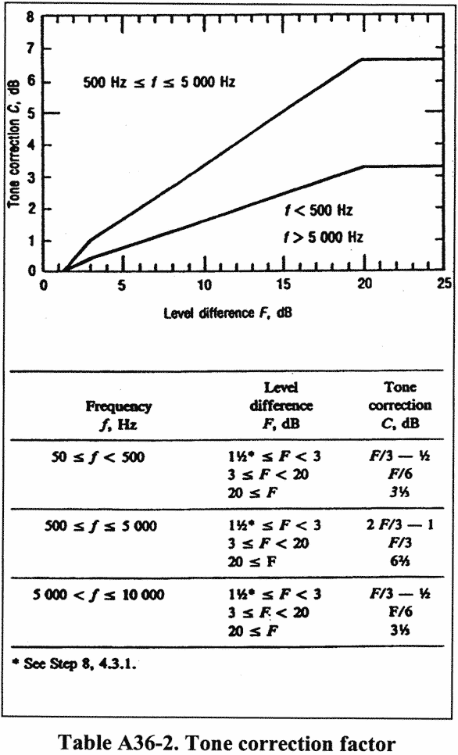](https://img.federalregister.gov/ER08JY02.003/ER08JY02.003_original_size.png)

(j) Step 10: Designate the largest of the tone correction factors, determined in Step 9, as C(k). (An example of the tone correction procedure is given in the current advisory circular for this part). Tone-corrected perceived noise levels PNLT(k) must be determined by adding the C(k) values to corresponding PNL(k) values, that is:

PNLT(*k*) = PNL(*k*) + *C*(*k*)

For any i-th one-third octave band, at any k-th increment of time, for which the tone correction factor is suspected to result from something other than (or in addition to) an actual tone (or any spectral irregularity other than airplane noise), an additional analysis may be made using a filter with a bandwidth narrower than one-third of an octave. If the narrow band analysis corroborates these suspicions, then a revised value for the background sound pressure level SPL′(i,k), may be determined from the narrow band analysis and used to compute a revised tone correction factor for that particular one-third octave band. Other methods of rejecting spurious tone corrections may be approved.

A36.4.3.2 The tone correction procedure will underestimate EPNL if an important tone is of a frequency such that it is recorded in two adjacent one-third octave bands. An applicant must demonstrate that either:

(a) No important tones are recorded in two adjacent one-third octave bands; or

(b) That if an important tone has occurred, the tone correction has been adjusted to the value it would have had if the tone had been recorded fully in a single one-third octave band.

A36.4.4 Maximum tone-corrected perceived noise level

A36.4.4.1 The maximum tone-corrected perceived noise level, PNLTM, must be the maximum calculated value of the tone-corrected perceived noise level PNLT(k). It must be calculated using the procedure of section A36.4.3. To obtain a satisfactory noise time history, measurements must be made at 0.5 second time intervals.

Note 1:

Figure A36-2 is an example of a flyover noise time history where the maximum value is clearly indicated.

Note 2:

In the absence of a tone correction factor, PNLTM would equal PNLM.

[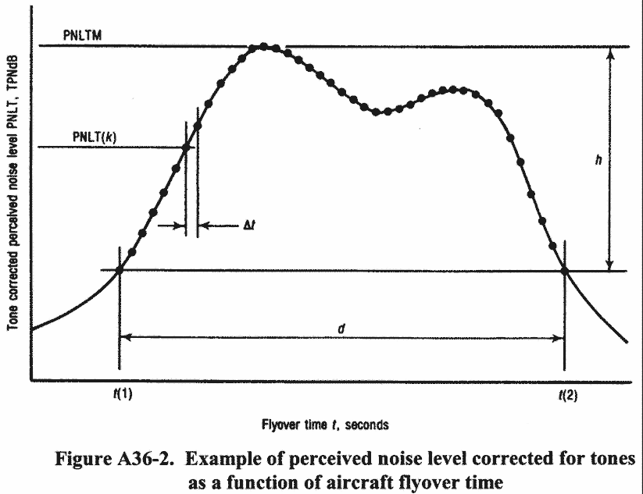](https://img.federalregister.gov/ER08JY02.004/ER08JY02.004_original_size.png)

A36.4.4.2 After the value of PNLTM is obtained, the frequency band for the largest tone correction factor is identified for the two preceding and two succeeding 500 ms data samples. This is performed in order to identity the possibility of tone suppression at PNLTM by one-third octave band sharing of that tone. If the value of the tone correction factor C(k) for PNLTM is less than the average value of C(k) for the five consecutive time intervals, the average value of C(k) must be used to compute a new value for PNLTM.

A36.4.5 *Duration correction.*

A36.4.5.1 The duration correction factor D determined by the integration technique is defined by the expression:

[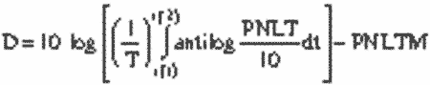](https://img.federalregister.gov/ER08JY02.005/ER08JY02.005_original_size.png)

where T is a normalizing time constant, PNLTM is the maximum value of PNLT, t(1) is the first point of time after which PNLT becomes greater than PNLTM-10, and t(2) is the point of time after which PNLT remains constantly less than PNLTM-10.

A36.4.5.2 Since PNLT is calculated from measured values of sound pressure level (SPL), there is no obvious equation for PNLT as a function of time. Consequently, the equation is to be rewritten with a summation sign instead of an integral sign as follows:

[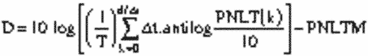](https://img.federalregister.gov/ER08JY02.006/ER08JY02.006_original_size.png)

where Δt is the length of the equal increments of time for which PNLT(k) is calculated and d is the time interval to the nearest 0.5s during which PNLT(k) remains greater or equal to PNLTM-10.

A36.4.5.3 To obtain a satisfactory history of the perceived noise level use one of the following:

(a) Half-Second time intervals for Δt; or

(b) A shorter time interval with approved limits and constants.

A36.4.5.4 The following values for T and Δt must be used in calculating D in the equation given in section A36.4.5.2:

T = 10 s, and

Δt = 0.5s (or the approved sampling time interval).

Using these values, the equation for D becomes:

[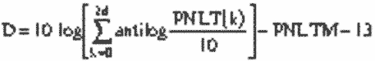](https://img.federalregister.gov/ER08JY02.007/ER08JY02.007_original_size.png)

where d is the duration time defined by the points corresponding to the values PNLTM-10.

A36.4.5.5 If in using the procedures given in section A36.4.5.2, the limits of PNLTM-10 fall between the calculated PNLT(k) values (the usual case), the PNLT(k) values defining the limits of the duration interval must be chosen from the PNLT(k) values closest to PNLTM-10. For those cases with more than one peak value of PNLT(k), the applicable limits must be chosen to yield the largest possible value for the duration time.

A36.4.6 *Effective perceived noise level.*

The total subjective effect of an airplane noise event, designated effective perceived noise level, EPNL, is equal to the algebraic sum of the maximum value of the tone-corrected perceived noise level, PNLTM, and the duration correction D. That is:

EPNL = PNLTM + D

where PNLTM and D are calculated using the procedures given in sections A36.4.2, A36.4.3, A36.4.4. and A36.4.5.

A36.4.7 *Mathematical formulation of noy tables.*

A36.4.7.1 The relationship between sound pressure level (SPL) and the logarithm of perceived noisiness is illustrated in Figure A36-3 and Table A36-3.

A36.4.7.2 The bases of the mathematical formulation are:

(a) The slopes (M(b), M(c), M(d) and M(e)) of the straight lines;

(b) The intercepts (SPL(b) and SPL(c)) of the lines on the SPL axis; and

(c) The coordinates of the discontinuities, SPL(a) and log n(a); SPL(d) and log n = −1.0; and SPL(e) and log n = log (0.3).

A36.4.7.3 Calculate noy values using the following equations:

(a)

SPL ≥SPL (a)

n = antilog {(c)[SPL−SPL(c)]}

(b)

SPL(b) ≤SPL <SPL(a)

n = antilog {M(b)[SPL−SPL(b)]}

(c)

SPL(e) ≤SPL <SPL(b)

n = 0.3 antilog {M(e)[SPL−SPL(e)]}

(d)

SPL(d) ≤SPL <SPL(e)

n = 0.1 antilog {M(d)[SPL−SPL(d)]}

A36.4.7.4 Table A36-3 lists the values of the constants necessary to calculate perceived noisiness as a function of sound pressure level.

[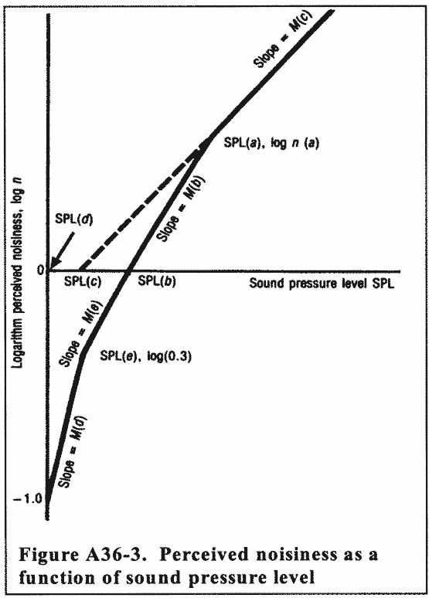](https://img.federalregister.gov/ER08JY02.008/ER08JY02.008_original_size.png)[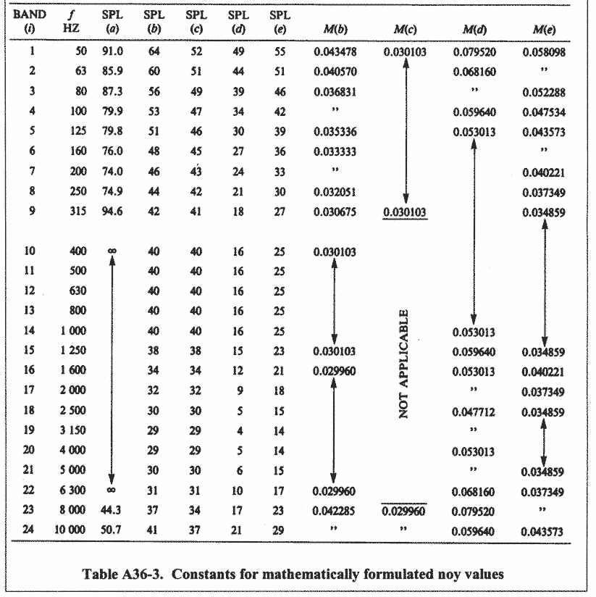](https://img.federalregister.gov/ER08JY02.009/ER08JY02.009_original_size.png)

part a - reference conditions

*Section H36.1 General.* This appendix prescribes noise requirements for helicopters specified under [§ 36.1](https://www.ecfr.gov/current/title-14/section-36.1), including:

(a) The conditions under which helicopter noise certification tests under Part H must be conducted and the measurement procedures that must be used under [§ 36.801](https://www.ecfr.gov/current/title-14/section-36.801) to measure helicopter noise during each test;

(b) The procedures which must be used under [§ 36.803](https://www.ecfr.gov/current/title-14/section-36.803) to correct the measured data to the reference conditions and to calculate the noise evaluation quantity designated as Effective Perceived Noise Level (EPNL); and

(c) The noise limits for which compliance must be shown under [§ 36.805](https://www.ecfr.gov/current/title-14/section-36.805).

Section H36.3 Reference Test Conditions.

(a) ***Meteorological conditions.*** Aircraft position, performance data and noise measurements must be corrected to the following noise certification reference atmospheric conditions which shall be assumed to exist from the surface to the aircraft altitude:

(1) Sea level pressure of 2,116 psf (1,013.25 hPa).

(2) Ambient temperature of 77 degrees F (25 degrees C).

(3) Relative humidity of 70 percent.

(4) Zero wind.

(b) ***Reference test site.*** The reference test site is flat and without line-of-sight obstructions across the flight path that encompasses the 10 dB down points.

(c) ***Takeoff reference profile.***

(1) Figure H1 illustrates a typical takeoff profile, including reference conditions.

(2) The reference flight path is defined as a straight line segment inclined from the starting point (1,640 feet (500 meters) from the center microphone location and 65 feet (20 meters) above ground level) at a constant climb angle β defined by the certificated best rate of climb and Vy for minimum engine performance. The constant climb angle β is derived from the manufacturer's data (approved by the FAA) to define the flight profile for the reference conditions. The constant climb angle β is drawn through Cr and continues, crossing over station A, to the position corresponding to the end of the type certification takeoff path represented by position Ir.

(d) ***Level flyover reference profile.*** The beginning of the level flyover reference profile is represented by helicopter position Dr (Figure H2). The helicopter approaches position Dr in level flight 492 feet above ground level as measured at Station A. Reference airspeed must be either 0.9VH; 0.9VNE; 0.45VH + 65 kts (0.45VH + 120km/h); or 0.45VNE + 65kts (0.45VNE + 120 km/h), whichever of the four speeds is least. The helicopter crosses directly overhead station A in level flight and proceeds to position Jr.

(e) For noise certification purposes, VH is defined as the airspeed in level flight obtained using the minimum specified engine torque corresponding to maximum continuous power available for sea level pressure of 2,116 psf (1,013.25 hPa) at 77 °F (25 °C) ambient conditions at the relevant maximum certificated weight. The value of VNE is the never-exceed airspeed. The values of VH and VNE that are used for noise certification must be listed in the approved Rotorcraft Flight Manual.

(f) ***Approach reference profile.***

(1) Figure H3 illustrates approach profile, including reference conditions.

(i) The beginning of the approach profile is represented by helicopter position E. The position of the helicopter is recorded for a sufficient distance (EK) to ensure recording of the entire interval during which the measured helicopter noise level is within 10 dB of Maximum Tone Corrected Perceived Noise Level (PNLTM). The reference flight path, ErKr represents a stable flight condition in terms of torque, rpm, indicated airspeed, and rate of descent resulting in a 6° approach angle.

(ii) The test approach profile is defined by the approach angle η passing directly over the station A at a height of AH, to position K, which terminates the approach noise certification profile. The test approach angle η must be between 5.5° and 6.5°.

(2) The helicopter approaches position H along a constant 6° approach slope throughout the 10 dB down time period. The helicopter crosses position E and proceeds along the approach slope crossing over station A until it reaches position K.

*Section H36.5 Symbols and units.* The following symbols and units as used in this appendix for helicopter noise certification have the following meanings.

Flight Profile Identification - Positions

| **Position** | **Description** |
| --- | --- |
| A | Location of the noise measuring point at the flight-track noise measuring station vertically below the reference (takeoff, flyover, or approach) flight path. |
| C | Start of noise certification takeoff flight path. |
| Cr | Start of noise certification reference takeoff flight path. |
| D | Start of noise certification flyover flight path. |
| Dr | Start of noise certification reference flyover path. |
| E | Start of noise certification approach flight path. |
| Er | Start of noise certification reference approach flight path. |
| F | Position on takeoff flight path directly above noise measuring station A. |
| Fr | Position on reference takeoff path directly above noise measuring Station A. |
| G | Position on flyover flight path directly above noise measuring station A. |
| Gr | Position on reference flyover path directly above noise measuring Station A. |
| H | Position on approach flight path directly above noise measuring station A. |
| Hr | Position on reference path directly above noise measuring Station A. |
| I | End of noise type certification takeoff flight path. |
| Ir | End of noise type certification reference takeoff flight path. |
| J | End of noise type certification flyover flight path. |
| Jr | End of noise type certification reference flyover flight path. |
| K | End of noise certification approach type flight path. |
| Kr | End of noise type certification reference approach flight path. |
| L | Position on measured takeoff flight path corresponding to PNLTM at station A. |
| Lr | Position on reference takeoff flight path corresponding to PNLTM of station A. |
| M | Position on measured flyover flight path corresponding to PNLTM of station A. |
| Mr | Position on reference flyover flight path corresponding to PNLTM of station A. |
| N | Position on measured approach flight path corresponding to PNLTM at station A. |
| Nr | Position on reference approach flight path corresponding to PNLTM at station A. |
| S | Sideline noise measuring station (note: a subscript denotes the aircraft orientation relative to the direction of flight). |

Flight Profile Distances

| **Distance** | **Unit** | **Meaning** |
| --- | --- | --- |
| AF | Feet | *Takeoff Height.* The vertical distance between helicopter and station A. |
| AG | Feet | *Flyover Height.* The vertical distance between the helicopter and station A. |
| AH | Feet | *Approach Height.* The vertical distance between the helicopter and station A. |
| AL | Feet | *Measured Takeoff Noise Path.* The distance from station A to the measured helicopter position L. |
| ALr | Feet | *Reference Takeoff Noise Path.* The distance from station A to the reference helicopter position Lr. |
| AM | Feet | *Measured Flyover Noise Path.* The distance from station A to the measured helicopter position M. |
| AMr | Feet | *Reference Flyover Noise Path.* The distance from station A to helicopter position Mr on the reference flyover flight path. |
| AN | Feet | *Measured Approach Noise Path.* The distance from station A to the measured helicopter noise position N. |
| ANr | Feet | *Reference Approach Noise Path.* The distance from station A to the reference helicopter position Nr. |
| CI | Feet | *Takeoff Flight Path Distance.* The distance from position C at which the helicopter establishes a constant climb angle on the takeoff flight path passing over station A and continuing to position I at which the position of the helicopter need no longer be recorded. |
| DJ | Feet | *Flyover Flight Path Distance.* The distance from position D at which the helicopter is established on the flyover flight path passing over station A and continuing to position J at which the position of the helicopter need no longer be recorded. |
| EK | Feet | *Approach Flight Path Distance.* The distance from position E at which the helicopter establishes a constant angle on the approach flight path passing over station A and continuing to position K at which the position of the helicopter need no longer be recorded. |

part b - noise measurement under [§ 36.801](https://www.ecfr.gov/current/title-14/section-36.801)

Section H36.101 Noise certification test and measurement conditions.

(a) ***General.*** This section prescribes the conditions under which aircraft noise certification tests must be conducted and the measurement procedures that must be used to measure helicopter noise during each test.

(b) ***Test site requirements.***

(1) Tests to show compliance with established helicopter noise certification levels must consist of a series of takeoffs, level flyovers, and approaches during which measurement must be taken at noise measuring stations located at the measuring points prescribed in this section.

(2) Each takeoff test, flyover test, and approach test includes simultaneous measurements at the flight-track noise measuring station vertically below the reference flight path and at two sideline noise measuring stations, one on each side of the reference flight track 492 feet (150m) from, and on a line perpendicular to, the flight track of the noise measuring station.

(3) The difference between the elevation of either sideline noise measuring station may not differ from the flight-track noise measuring station by more than 20 feet.

(4) Each noise measuring station must be surrounded by terrain having no excessive sound absorption characteristics, such as might be caused by thick, matted, or tall grass, shrubs, or wooded areas.

(5) During the period when the takeoff, flyover, or approach noise/time record indicates the noise measurement is within 10 dB of PNLTM, no obstruction that significantly influences the sound field from the aircraft may exist -

(i) For any flight-track or sideline noise measuring station, within a conical space above the measuring position (the point on the ground vertically below the microphone), the cone being defined by an axis normal to the ground and by half-angle 80° from this axis; and

(ii) For any sideline noise measuring station, above the line of sight between the microphone and the helicopter.

(6) If a takeoff or flyover test series is conducted at weights other than the maximum takeoff weight for which noise certification is requested, the following additional requirements apply:

(i) At least one takeoff test and one flyover test must be conducted at, or above, the maximum certification weight.

(ii) Each test weight must be within + 5 percent or −10 percent of the maximum certification weight.

(7) Each approach test must be conducted with the aircraft stabilized and following a 6.0 degree ±0.5 degree approach angle and must meet the requirements of section H36.107 of this part.

(8) If an approach test series is conducted at weights other than the maximum landing weight for which certification is requested, the following additional requirements apply:

(i) At least one approach test must be conducted at a weight at, or above, the maximum landing weight.

(ii) Each test weight must be between + 5 percent and −10 percent of the maximum certification weight.

(c) ***Weather restrictions.*** The tests must be conducted under the following atmospheric conditions:

(1) No rain or other precipitation.

(2) Ambient air temperature between 14 °F and 95 °F (−10 °C and 35 °C), inclusively, at a point 33 feet (10 meters) above the ground at the noise measuring station and at the aircraft. The temperature and relative humidity measured at a point 33 feet (10 meters) above the ground at the noise measuring station must be used to adjust for propagation path absorption.

(3) Relative humidity and ambient temperature at a point 33 feet (10 meters) above the ground at the noise measuring station and at the aircraft, is such that the sound attenuation in the one-third octave band centered at 8 kHz is not greater than 12 dB/100 meters and the relative humidity is between 20 percent and 95 percent, inclusively.

(4) Wind velocity as measured at 10 meters above ground does not exceed 10 knots (19 km/h) and the crosswind component does not exceed 5 knots (9 km/h). The wind shall be determined using a continuous thirty-second averaging period spanning the 10dB down time interval.

(5) No anomalous meteorological conditions (including turbulence) that will significantly affect the noise level of the aircraft when the noise is recorded at each noise measuring station.

(6) The wind velocity, temperature, and relative humidity measurements required under the appendix must be measured in the vicinity of noise measuring stations 10 meters above the ground. The location of the meteorological measurements must be approved by the FAA as representative of those atmospheric conditions existing near the surface over the geographical area which aircraft noise measurements are made. In some cases, a fixed meteorological station (such as those found at airports or other facilities) may meet this requirement.

(7) Temperature and relative humidity measurements must be obtained within 30 minutes of each noise test.

(d) ***Aircraft testing procedures.***

(1) The aircraft testing procedures and noise measurements must be conducted and processed in a manner that yields the noise evaluation measure designated as Effective Perceived Noise Level (EPNL) in units of EPNdB, as prescribed in [Appendix A of this part](https://www.ecfr.gov/current/title-14/part-36/appendix-Appendix%20A%20to%20Part%2036).

(2) The helicopter height and lateral position relative to the reference flight track (which passes through the flight track noise measuring station) must be determined using an FAA-approved method. The equipment used to make the determination must be independent of normal flight instrumentation. Applicable independent systems are radar tracking, theodolite triangulation, laser trajectography, photo scaling, or differential global positioning system.

(3) The helicopter position along the flight path must be related to the noise recorded at the noise measuring stations by means of synchronized signals recorded at an approved sampling rate. The helicopter position must be recorded relative to the reference flight track during the entire time interval in which the recorded signal is within 10 dB of PNLTM. Measuring and sampling equipment must be approved by the FAA before testing.

(4) Aircraft performance data sufficient to make the corrections required under section H36.205 of this appendix must be recorded at an FAA-approved sampling rate using FAA-approved equipment.

Section H36.103 Takeoff test conditions.

(a) This section, in addition to the applicable requirements of sections H36.101 and H36.205(b) of this appendix, applies to all takeoff noise tests conducted under this appendix to show compliance with Part 36.

(b) A test series must consist of at least six flights over the flight-track noise measuring station (with simultaneous measurements at all three noise measuring stations) as follows:

(1) An airspeed of either Vy ±5 knots or the lowest approved speed ±5 knots for the climb after takeoff, whichever speed is greater, must be established and maintained throughout the 10 dB-down time interval.

(2) The horizontal portion of each test flight must be conducted at an altitude of 65 feet (20 meters) above the ground level at the flight-track noise measuring station.

(3) Upon reaching a point 1,640 feet (500 meters) from the noise measuring station, the helicopter must be stabilized at the maximum takeoff power that corresponds to minimum installed engine(s) specification power available for the reference ambient conditions or gearbox torque limit, whichever is lower.

(4) The helicopter must be maintained throughout the 10 dB-down time interval at the best rate of climb speed Vy ±5 knots, or the lowest approved speed for climb after takeoff, whichever is greater, for an ambient temperature of 25 °C at sea level.

(5) The average rotor speed must not vary from the maximum normal operating rotor RPM by more than ±1.0 percent during the 10 dB-down time interval.

(6) The helicopter must stay within ±10° or ±65 feet (±20 meters), whichever is greater, from the vertical above the reference track throughout the 10dB-down time interval.

(7) A constant takeoff configuration selected by the applicant must be maintained throughout the takeoff reference procedure with the landing gear position consistent with the airworthiness certification tests for establishing best rate-of-climb speed, Vy.

Section H36.105 Flyover test conditions.

(a) This section, in addition to the applicable requirements of sections H36.101 and H36.205(c) of this appendix, applies to all flyover noise tests conducted under this appendix to show compliance with Part 36.

(b) A test series consists of at least six flights. The number of level flights made with a headwind component must be equal to the number of level flights made with a tailwind component with simultaneous measurements at all three noise measuring stations -

(1) In level flight cruise configuration;

(2) At a height of 492 feet ±30 feet (150 ±9 meters) above the ground level at the flight-track noise measuring station; and

(3) The helicopter must fly within ±10° or ±65 feet (±20 meters), whichever is greater, from the vertical above the reference track throughout the 10 dB-down time interval.

(c) Each flyover noise test must be conducted -

(1) At a speed of 0.9VH; 0.9VNE; 0.45VH + 65 kts (0.45VH + 120 km/h); or 0.45VNE + 65 kts (0.45VNE + 120 km/h), whichever speed is least, to be maintained throughout the measured portion of the flyover;

(2) At average rotor speed, which must not vary from the maximum normal operating rotor RPM by more than ±1.0 percent during the 10 dB-down time interval.

(3) With the power stabilized during the period when the measured helicopter noise level is within 10 dB of PNLTM.

(d) The airspeed shall not vary from the reference airspeed by more than ±5 knots (9 km/hr).

Section H36.107 Approach test conditions.

(a) This section, in addition to the requirements of sections H36.101 and H36.205(d) of this appendix, applies to all approach tests conducted under this appendix to show compliance with Part 36.

(b) A test series must consist of at least six flights over the flight-track noise measuring station (with simultaneous measurements at the three noise measuring stations) -

(1) On an approach slope of 6° ±0.5°;

(2) At a height of 394 ±33 feet (120 ±10 meters)

(3) The helicopter must fly within ±10° or ±65 feet (±20 meters) lateral deviation tolerance, whichever is greater, from the vertical above the reference track throughout the 10 dB-down time interval;

(4) At stabilized airspeed equal to the certificated best rate of climb Vy, or the lowest approved speed for approach, whichever is greater, with power stabilized during the approach and over the flight path reference point, and continued to a normal touchdown; and

(5) At average rotor speed, which may not vary from the maximum normal operating rotor RPM by more than ±1.0 percent during the 10 dB-down time interval; and

(6) The constant approach configuration used in airworthiness certification tests, with the landing gear extended, must be maintained throughout the approach reference procedure.

(c) The airspeed shall not vary from the reference airspeed by more than ±5 knots (±9 km/hr).

Section H36.109 Measurement of Helicopter Noise Received on the Ground.

The measurement system and the measurement, calibration and general analysis procedures to be used are provided in Appendix A, section A36.3 of this part.

Section H36.111 Reporting and correcting measured data.

(a) ***General.*** Data representing physical measurements, and corrections to measured data, including corrections to measurements for equipment response deviations, must be recorded in permanent form and appended to the record. Each correction must be reported and is subject to FAA approval. An estimate must be made of each individual error inherent in each of the operations employed in obtaining the final data.

(b) ***Data reporting.***

(1) Measured and corrected sound pressure levels must be presented in one-third octave band levels obtained with equipment conforming to the standards prescribed in section H36.109 of this appendix.

(2) The type of equipment used for measurement and analysis of all acoustic, aircraft performance, and meteorological data must be reported.

(3) The atmospheric environmental data required to demonstrate compliance with this appendix, measured throughout the test period, must be reported.

(4) Conditions of local topography, ground cover, or events which may interfere with sound recording must be reported.

(5) The following aircraft information must be reported:

(i) Type, model, and serial numbers, if any, of aircraft engines and rotors.

(ii) Gross dimensions of aircraft and location of engines.

(iii) Aircraft gross weight for each test run.

(iv) Aircraft configuration, including landing gear positions.

(v) Airspeed in knots.

(vi) Helicopter engine performance as determined from aircraft instruments and manufacturer's data.

(vii) Aircraft flight path, above ground level in feet, determined by an FAA approved method which is independent of normal flight instrumentation, such as radar tracking, theodolite triangulation, laser trajectography, or photographic scaling techniques.

(6) Aircraft speed, and position, and engine performance parameters must be recorded at an approved sampling rate sufficient to correct to the noise certification reference test conditions prescribed in section H36.3 of this appendix. Lateral position relative to the reference flight-track must be reported.

(c) ***Data corrections.***

(1) Aircraft position, performance data and noise measurement must be corrected to the noise certification reference conditions as prescribed in sections H36.3 and H36.205 of this appendix.

(2) The measured flight path must be corrected by an amount equal to the difference between the applicant's predicted flight path for the certification reference conditions and the measured flight path at the test conditions. Necessary corrections relating to helicopter flight path or performance may be derived from FAA-approved data for the difference between measured and reference conditions, together with appropriate allowances for sound attenuation with distance. The Effective Perceived Noise Level (EPNL) correction may not exceed 2.0 EPNdB except for takeoff flight condition, where the correction may not exceed 4.0 EPNdB, of which the arithmetic sum of Δ1 (described in section H36.205(f)(1)) and the term −7.5 log (AL/ALr) from Δ2 term (described in section H36.205(g)(1)(i)) may not exceed 2.0 EPNdB, for any combination of the following:

(i) The helicopter not passing vertically above the measuring station.

(ii) Any difference between the reference flight track and the actual test flight track; and

(iii) Detailed correction requirements prescribed in section H36.205 of this appendix.

(3) Helicopter sound pressure levels within the 10 dB-down time interval must exceed the mean background sound pressure levels determined under section B36.3.9.11 by at least 3 dB in each one-third octave band, or must be corrected under an FAA-approved method.

(d) ***Validity of results.***

(1) The test results must produce three average EPNL values within the 90 percent confidence limits, each value consisting of the arithmetic average of the corrected noise measurements for all valid test runs at the takeoff, level flyovers, and approach conditions. The 90 percent confidence limit applies separately to takeoff, flyover, and approach.

(2) The minimum sample size acceptable for each takeoff, approach, and flyover certification measurements is six. The number of samples must be large enough to establish statistically for each of the three average noise certification levels a 90 percent confidence limit which does not exceed ±1.5 EPNdB. No test result may be omitted from the averaging process, unless otherwise specified by the FAA.

(3) To comply with this appendix, a minimum of six takeoffs, six approaches, and six level flyovers is required. To be counted toward this requirement, each flight event must be validly recorded at all three noise measuring stations.

(4) The approved values of VH and Vy used in calculating test and reference conditions and flight profiles must be reported along with measured and corrected sound pressure levels.

Section H36.113 Atmospheric attenuation of sound.

(a) The values of the one-third octave band spectra measured during helicopter noise certification tests under this appendix must conform, or be corrected, to the reference conditions prescribed in section H36.3(a). Each correction must account for any differences in the atmospheric attenuation of sound between the test-day conditions and the reference-day conditions along the sound propagation path between the aircraft and the microphone. Unless the meteorological conditions are within the test window prescribed in this appendix, the test data are not acceptable.

(b) ***Attenuation rates.*** The procedure for determining the atmospheric attenuation rates of sound with distance for each one-third octave bands must be determined in accordance with SAE ARP 866A (Incorporated by reference, see § 36.6). The atmospheric attenuation equations are provided in both the International and English systems of units in section A36.7 of appendix A to this part.

(c) ***Correction for atmospheric attenuation.***

(1) EPNL values calculated for measured data must be corrected whenever -

(i) The ambient atmospheric conditions of temperature and relative humidity do not conform to the reference conditions, 77 °F and 70%, respectively, or

(ii) The measured flight paths do not conform to the reference flight paths.

(iii) The temperature and relative humidity measured at 33 feet (10 meters) above the ground must be used to adjust for propagation path absorption.

(2) The mean attenuation rate over the complete sound propagation path from the aircraft to the microphone must be computed for each one-third octave band from 50 Hz to 10,000 Hz. These rates must be used in computing the corrections required in section H36.111(d) of this appendix.

part c - noise evaluation and calculation under [§ 36.803](https://www.ecfr.gov/current/title-14/section-36.803)

Section H36.201 Noise Evaluation in EPNdB.

(a) Effective Perceived Noise Level (EPNL), in units of effective perceived noise decibels (EPNdB), shall be used for evaluating noise level values under [§ 36.803 of this part](https://www.ecfr.gov/current/title-14/part-36/section-36.803). Except as provided in [paragraph (b)](https://www.ecfr.gov/current/title-14/appendix-Appendix%20H%20to%20Part%2036#p-Appendix-H-to-Part-36(b)) of this section, the procedures in appendix A of Part 36 must be used for computing EPNL. appendix A includes requirements governing determination of noise values, including calculations of:

(1) Perceived noise levels;

(2) Corrections for spectral irregularities;

(3) Tone corrections;

(4) Duration corrections;

(5) Effective perceived noise levels; and

(6) Mathematical formulation of noy tables.

(b) Notwithstanding the provisions of section A36.4.3.1(a), for helicopter noise certification, corrections for spectral irregularities shall start with the corrected sound pressure level in the 50 Hz one-third octave band.

Section H36.203 Calculation of noise levels.

(a) To demonstrate compliance with the noise level limits of section H36.305, the noise values measured simultaneously at the three noise measuring points must be arithmetically averaged to obtain a single EPNdB value for each flight.

(b) The calculated noise level for each noise test series, *i.e.*, takeoff, flyover, or approach must be the numerical average of at least six separate flight EPNdB values. The 90 percent confidence limit for all valid test runs under section H36.111(d) of this appendix applies separately to the EPNdB values for each noise test series.

Section H36.205 Detailed data correction procedures.

(a) ***General.*** If the test conditions do not conform to those prescribed as noise certification reference conditions under section H36.305 of this appendix, the following correction procedure shall apply:

(1) If there is any difference between measured test and reference conditions, an appropriate correction must be made to the EPNL calculated from the measured noise data. Conditions that can result in a different value include:

(i) Atmospheric absorption of sound under measured test conditions that are different from the reference test conditions; or

(ii) Measured flight path that is different from the reference flight path.

(2) The following correction procedures may produce one or more possible correction values which must be added algebraically to the calculated EPNL to bring it to reference conditions:

(i) The flight profiles must be determined for both reference and test conditions. The procedures require noise and flight path recording with a synchronized time signal from which the test profile can be delineated, including the aircraft position for which PNLTM is observed at the noise measuring station. For takeoff, the flight profile corrected to reference conditions may be derived from FAA approved manufacturer's data.

(ii) The sound propagation paths to the microphone from the aircraft position corresponding to PNLTM must be determined for both the test and reference profiles. The SPL values in the spectrum of PNLTM must then be corrected for the effects of -

(A) Change in atmospheric sound absorption;

(B) Atmospheric sound absorption on the linear difference between the two sound path lengths; and

(C) Inverse square law on the difference in sound propagation path length. The corrected values of SPL must then be converted to a reference condition PNLTM value from which PNLTM must be subtracted. The resulting difference represents the correction which must be added algebraically to the EPNL calculated from the measured data.

(iii) As observed at the noise measuring station, the measured PNLTM distance is different from the reference PNLTM distance and therefore the ratio must be calculated and used to determine a noise duration correction factor. Effective perceived noise level, EPNL, is determined by the algebraic sum of the maximum tone corrected perceived noise level (PNLTM) and the duration correction factor.

(iv) For aircraft flyover, alternative source noise corrections require FAA approval and must be determined and adjusted to account for noise level changes caused by the differences between measured test conditions and reference conditions.

(b) ***Takeoff profiles.***

(1) Figure H1 illustrates a typical takeoff profile, including reference conditions.

(i) The reference takeoff flight path is described in section H36.3(c).

(ii) The test parameters are functions of the helicopter's performance and weight and the atmospheric conditions of temperature, pressure, wind velocity and direction.

(2) For the actual takeoff, the helicopter approaches position C in level flight at 65 feet (20 meters) above ground level at the flight track noise measuring station and at either Vy ±5 knots or the lowest approved speed for the climb after takeoff, whichever speed is greater.

[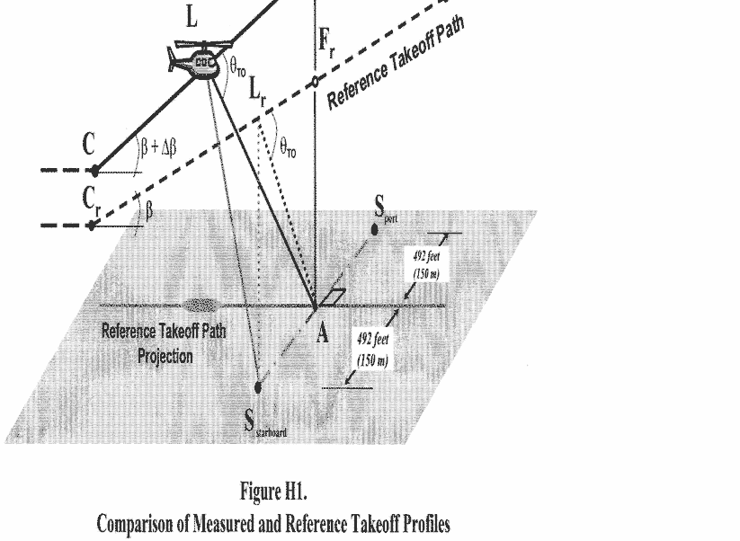](https://img.federalregister.gov/ER02JN04.000/ER02JN04.000_original_size.png)

(3) Figure H1 illustrates the significant geometrical relationships influencing sound propagation. Position L represents the helicopter location on the measured takeoff path from which PNLTM is observed at station A, and Lr is the corresponding position on the reference sound propagation path. Propagation paths AL and ALr both form the same angle θ (theta) relative to their respective flight paths.

(c) ***Level flyover profiles.***

(1) The noise type certification level flyover profile is shown in Figure H2. Airspeed must be stabilized within ±5 knots of the reference airspeed determined using the procedures in section H36.3(d). The number of level flights made with a headwind component must be equal to the number of level flights made with a tailwind component.

[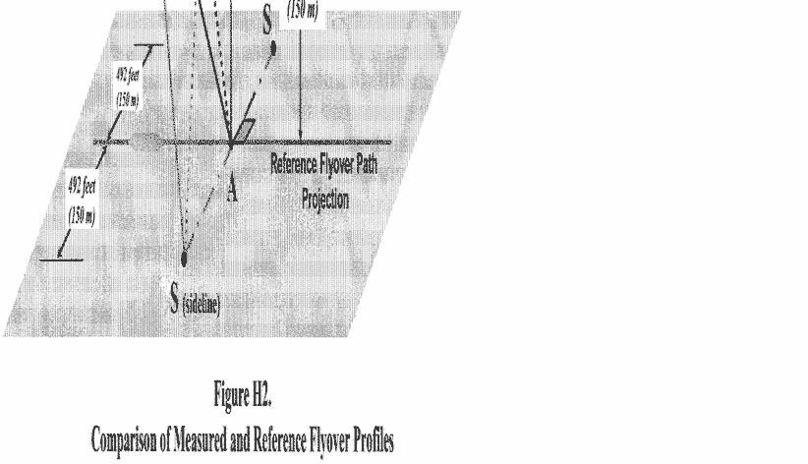](https://img.federalregister.gov/ER02JN04.001/ER02JN04.001_original_size.png)

(2) Figure H2 illustrates comparative flyover profiles when test conditions do not conform to prescribed reference conditions. The position of the helicopter shall be recorded for a distance (DJ) sufficient to ensure recording of the entire interval during which the measured helicopter noise level is within 10 dB of PNLTM, as required. The flyover profile is defined by the height AG which is a function of the operating conditions controlled by the pilot. Position M represents the helicopter location on the measured flyover flight path for which PNLTM is observed at station A, and Mr is the corresponding position on the reference flight path.

(d) ***Approach profiles.***

(1) Figure H3 illustrates a typical approach profile, including reference conditions.

(2) The helicopter approaches position H along a 6° (±0.5°) average approach slope throughout the 10dB-down time interval. Deviation from the 6° average approach slope must be approved by the FAA before testing.

[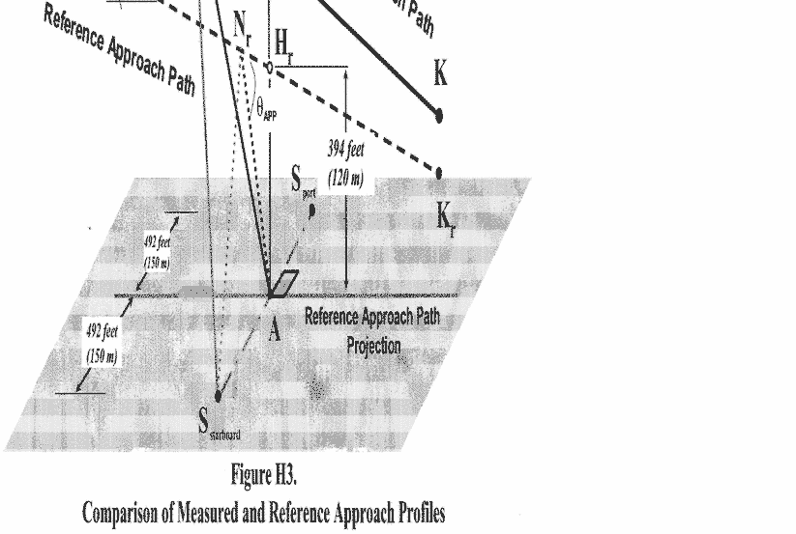](https://img.federalregister.gov/ER02JN04.002/ER02JN04.002_original_size.png)

(3) Figure H3 illustrates portions of the measured and reference approach flight paths including the significant geometrical relationships influencing sound propagation. The measured approach path is represented by segment EK with an approach allowable angle θ. Reference positions, Er and Kr, define an idealized reference approach angle of 6°. Position N represents the helicopter location on the measured approach flight path for which PNLTM is observed at measuring station A, and Nr is the corresponding position on the reference approach flight path. The measured and reference noise propagation paths are AN and ANr, respectively, both of which form the same angle, θAPP, corresponding to PNLTM relative to their approach flight paths.

(e) ***Correction of noise at source during level flyover.***

(1) For level overflight, if any combination of the following three factors, airspeed deviations from reference, rotor speed deviations from reference, and temperature deviations from reference, results in a noise correlating parameter whose value deviates from the reference value of this parameter, then source noise adjustments must be determined from the manufacturer's data that is approved by the FAA.

(2) Off-reference tip Mach number adjustments must be based upon a sensitivity curve of PNLTM versus advancing blade tip Mach number, deduced from overflights performed at different airspeeds surrounding the reference airspeed. If the test aircraft is unable to attain the reference value, then an extrapolation of the sensitivity curve is permitted if data cover at least a range of 0.03 Mach units. The advancing blade tip Mach number must be computed using true airspeed, onboard outside air temperature, and rotor speed. A separate PNLTM versus advancing blade tip Mach number function must be derived for each of the three certification microphone locations, *i.e.*, centerline, sideline left, and sideline right. Sideline left and right are defined relative to the direction of flight for each run. PNLTM adjustments are to be applied to each microphone datum using the appropriate PNLTM function.

(f) ***PNLT corrections.*** If the measured ambient atmospheric conditions of temperature and relative humidity differ from those prescribed as reference conditions under this appendix (77 degrees F and 70 percent, respectively), corrections to the EPNL values must be calculated from the measured data under [paragraph (a)](https://www.ecfr.gov/current/title-14/appendix-Appendix%20H%20to%20Part%2036#p-Appendix-H-to-Part-36(a)) of this section as follows:

(1) ***Takeoff flight path.*** For the takeoff flight path shown in Figure H1, the spectrum of PNLTM observed at station A for the aircraft at position L is decomposed into its individual SPL(*i*) values.

(i) Step 1. A set of corrected values are then computed as follows:

SPL(*i*)r = SPL(*i*) + *C*[α(*i*) −α(*i*)o]AL + *C*α(*i*)o (AL − ALr) + 20 log (AL/ALr)

where SPL(*i*) and SPL(*i*)r are the measured and corrected sound pressure levels, respectively, in the *i*-th one-third octave band. The first correction term adjusts for the effect of change in atmospheric sound absorption where α(*i*) and α(*i*)o are the sound attenuation coefficients for the test and reference atmospheric conditions, respectively, for the *i*-th one-third octave band, and AL is the measured takeoff sound propagation path. The conversion factor constant, *C*, is 0.001 for English System of Units and is 0.01 for International System of Units. The second correction term adjusts for the effects of atmospheric attenuation due to the difference in the sound propagation path length where ALr is the Reference takeoff sound propagation path. The third correction term, known as the “inverse square” law, adjusts for the effect of the difference in the sound propagation path lengths.

(ii) Step 2. The corrected values of the SPL(*i*)r are then converted to reference condition PNLT and a correction term calculated as follows:

Δ1 = PNLT − PNLTM

which represents the correction to be added algebraically to the EPNL calculated from the measured data.

(2) ***Level flyover flight path.***

(i) The procedure described in [paragraph (f)(1)](https://www.ecfr.gov/current/title-14/appendix-Appendix%20H%20to%20Part%2036#p-Appendix-H-to-Part-36(f)(1)) of this section for takeoff paths is also used for the level flyover paths, with the values of SPL(*i*)r relating to the flyover sound propagation paths shown in Figure H2 as follows:

SPL(*i*)r = SPL(*i*) + *C*[α(*i*) −α(*i*)o]AM + *C*α(*i*)o (AM − AMr) + 20 log (AM/AMr)

where the lines AM and AMr are the measured and reference level flyover sound propagation paths, respectively.

(ii) The remainder of the procedure is the same for the flyover condition as that prescribed in the [paragraph (f)(1)(ii)](https://www.ecfr.gov/current/title-14/appendix-Appendix%20H%20to%20Part%2036#p-Appendix-H-to-Part-36(f)(1)(ii)) of this section regarding takeoff flight path.

(3) ***Approach flight path.***

(i) The procedure described in [paragraph (f)(1)](https://www.ecfr.gov/current/title-14/appendix-Appendix%20H%20to%20Part%2036#p-Appendix-H-to-Part-36(f)(1)) of this section for takeoff paths is also used for the approach paths, with the values of SPL(*i*)r relating to the approach sound propagation paths shown in Figure H3 as follows:

SPL(*i*)r = SPL(*i*) + *C*[α(*i*) −α(*i*)o]AN + *C*α(*i*)o (AN − ANr) + 20 log (AN/ANr)

where the lines AN and ANr are the measured and reference approach sound propagation paths, respectively.

(ii) The remainder of the procedure is the same for the approach condition as that prescribed in the [paragraph (f)(1)(ii)](https://www.ecfr.gov/current/title-14/appendix-Appendix%20H%20to%20Part%2036#p-Appendix-H-to-Part-36(f)(1)(ii)) of this section regarding takeoff flight path.

(4) ***Sideline microphones.***

(i) The procedure prescribed in [paragraph (f)(1)](https://www.ecfr.gov/current/title-14/appendix-Appendix%20H%20to%20Part%2036#p-Appendix-H-to-Part-36(f)(1)) of this section for takeoff paths is also used for the propagation to the sideline locations, with the values of SPL(*i*)r relating as follows to the measured sideline sound propagation path shown in Figure H3 as follows:

SPL(*i*)r = SPL(*i*) + *C*[α(*i*) −α(*i*)o]SX + *C*α(*i*)o (SX − SXr) + 20 log (SX/SXr)

where S is the sideline measuring station and, based upon the flight condition, the helicopter positions, X and Xr, correspond to:

X = L, and Xr = Lr for takeoff

X = M, and Xr = Mr for flyover

X = N, and Xr = Nr for approach

(ii) The remainder of the procedure is the same for the sideline paths as that prescribed in the [paragraph (f)(1)(ii)](https://www.ecfr.gov/current/title-14/appendix-Appendix%20H%20to%20Part%2036#p-Appendix-H-to-Part-36(f)(1)(ii)) of this section regarding takeoff flight paths.

(g) ***Duration corrections.***

(1) If the measured takeoff and approach flight paths do not conform to those prescribed as the corrected and reference flight paths, respectively, under section A36.5(d)(2) it will be necessary to apply duration corrections to the EPNL values calculated from the measured data. Such corrections must be calculated as follows:

(i) ***Takeoff flight path.*** For the takeoff path shown in Figure H1, the correction term is calculated using the formula -

Δ2 = −7.5 log (AL/ALr) + 10 log (V/Vr)

which represents the correction that must be added algebraically to the EPNL calculated from the measured data. The lengths AL and ALr are the measured and reference takeoff distances from the noise measuring station A to the measured and the reference takeoff paths, respectively. A negative sign indicates that, for the particular case of a duration correction, the EPNL calculated from the measured data must be reduced if the measured takeoff path is at greater altitude than the reference takeoff path.

(ii) ***Level flyover flight paths.*** For the level flyover flight path, the correction term is calculated using the formula -

Δ2 = −7.5 log (AM/AMr) + 10 log (V/Vr)

where AM is the measured flyover distance from the noise measuring station A to the measured flyover path, and AMr is the reference distance from station A to the reference flyover path.

(iii) ***Approach flight path.*** For the approach path shown in Figure H3, the correction term is calculated using the formula -

Δ2 = −7.5 log (AN/ANr) + 10 log (V/Vr)

where AN is the measured approach distance from the noise measuring station A to the measured approach path, and ANr is the reference distance from station A to the reference approach path.

(iv) ***Sideline microphones.*** For the sideline flight path, the correction term is calculated using the formula -

Δ2 = −7.5 log (SX/SXr) + 10 log (V/Vr)

where S is the sideline measuring station and based upon the flight condition, the helicopter positions, X and Xr, correspond to:

X = L, and Xr = Lr for takeoff

X = M, and Xr = Mr for flyover

X = N, and Xr = Nr for approach

(2) The adjustment procedure described in this section shall apply to the sideline microphones in the take-off, overflight, and approach cases. Although the noise emission is strongly dependent on the directivity pattern, variable from one helicopter type to another, the propagation angle θ shall be the same for test and reference flight paths. The elevation angle ψ shall not be constrained but must be determined and reported. The certification authority shall specify the acceptable limitations on ψ. Corrections to data obtained when these limits are exceeded shall be applied using FAA approved procedures.

part d - noise limits under [§ 36.805](https://www.ecfr.gov/current/title-14/section-36.805)

Section H36.301 Noise measurement, evaluation, and calculation.

Compliance with this part of this appendix must be shown with noise levels measured, evaluated, and calculated as prescribed under Parts B and C of this appendix.

Section H36.303 [Reserved]

Section H36.305 Noise levels.

(a) ***Limits.*** For compliance with this appendix, the applicant must show by flight test that the calculated noise levels of the helicopter, at the measuring points described in section H36.305(a) of this appendix, do not exceed the following, (with appropriate interpolation between weights):

(1) ***Stage 1*** noise limits for acoustical changes for helicopters are as follows:

(i) For takeoff, flyover, and approach calculated noise levels, the noise levels of each Stage 1 helicopter that exceed the Stage 2 noise limits plus 2 EPNdB may not, after a change in type design, exceed the noise levels created prior to the change in type design.

(ii) For takeoff, flyover, and approach calculated noise levels, the noise levels of each Stage 1 helicopter that do not exceed the Stage 2 noise limits plus 2 EPNdB may not, after the change in type design, exceed the Stage 2 noise limits plus 2 EPNdB.

(2) ***Stage 2*** noise limits are as follows:

(i) ***For takeoff calculated noise levels*** - 109 EPNdB for maximum takeoff weights of 176,370 pounds (80,000 kg) or more, reduced by 3.01 EPNdB per halving of the weight down to 89 EPNdB, after which the limit is constant.

(ii) ***For flyover calculated noise levels*** - 108 EPNdB for maximum weights of 176,370 pounds (80,000 kg) or more, reduced by 3.01 EPNdB per halving of the weight down to 88 EPNdB, after which the limit is constant.

(iii) ***For approach calculated noise levels*** - 110 EPNdB for maximum weights of 176,370 pounds (80,000 kg) or more, reduced by 3.01 EPNdB per halving of the weight down to 90 EPNdB, after which the limit is constant.

(3) ***Stage 3*** noise limits are as follows:

(i) For takeoff - For a helicopter having a maximum certificated takeoff weight of 176,370 pounds (80,000 kg) or more, the noise limit is 106 EPNdB, which decreases linearly with the logarithm of the helicopter weight (mass) at a rate of 3.0 EPNdB per halving of the weight (mass) down to 86 EPNdB, after which the limit is constant.

(ii) For flyover - For a helicopter having a maximum certificated takeoff weight of 176,370 pounds (80,000 kg) or more, the noise limit is 104 EPNdB, which decreases linearly with the logarithm of the helicopter weight (mass) at a rate of 3.0 EPNdB per halving of the weight (mass) down to 84 EPNdB, after which the limit is constant.

(iii) For approach - For a helicopter having a maximum certificated takeoff weight of 176,370 pounds (80,000 kg) or more, the noise limit is 109 EPNdB, which decreases linearly with the logarithm of the helicopter weight (mass) at a rate of 3.0 EPNdB per halving of the weight (mass) down to 89 EPNdB, after which the limit is constant.

(b) ***Tradeoffs.*** Except to the extent limited under [§ 36.11(b) of this part](https://www.ecfr.gov/current/title-14/part-36/section-36.11#p-36.11(b)), the noise limits prescribed in [paragraph (a)](https://www.ecfr.gov/current/title-14/appendix-Appendix%20H%20to%20Part%2036#p-Appendix-H-to-Part-36(a)) of this section may be exceeded by one or two of the takeoff, flyover, or approach calculated noise levels determined under section H36.203 of this appendix if

(1) The sum of the exceedances is not greater than 4 EPNdB;

(2) No exceedance is greater than 3 EPNdB; and

(3) The exceedances are completely offset by reduction in the other required calculated noise levels.

[Amdt. 36-14, [53 FR 3541](https://www.federalregister.gov/citation/53-FR-3541), Feb. 5, 1988; [53 FR 4099](https://www.federalregister.gov/citation/53-FR-4099), Feb. 11, 1988; [53 FR 7728](https://www.federalregister.gov/citation/53-FR-7728), Mar. 10, 1988, as amended by Amdt. 36-54, [67 FR 45237](https://www.federalregister.gov/citation/67-FR-45237), July 8, 2002; Amdt. 36-25, [69 FR 31234](https://www.federalregister.gov/citation/69-FR-31234), June 2, 2004; Amdt. 36-25, [69 FR 41573](https://www.federalregister.gov/citation/69-FR-41573), July 9, 2004; Amdt. 36-30, [79 FR 12045](https://www.federalregister.gov/citation/79-FR-12045), Mar. 4, 2014; FAA Doc. No. FAA-2015-3782, Amdt. No. 36-31, [82 FR 46131](https://www.federalregister.gov/citation/82-FR-46131), Oct. 4, 2017]