Section A36.4 Calculation of Effective Perceived Noise Level From Measured Data

A36.4.1 *General.*

A36.4.1.1 The basic element for noise certification criteria is the noise evaluation measure known as effective perceived noise level, EPNL, in units of EPNdB, which is a single number evaluator of the subjective effects of airplane noise on human beings. EPNL consists of instantaneous perceived noise level, PNL, corrected for spectral irregularities, and for duration. The spectral irregularity correction, called “tone correction factor”, is made at each time increment for only the maximum tone.

A36.4.1.2 Three basic physical properties of sound pressure must be measured: level, frequency distribution, and time variation. To determine EPNL, the instantaneous sound pressure level in each of the 24 one-third octave bands is required for each 0.5 second increment of time during the airplane noise measurement.

A36.4.1.3 The calculation procedure that uses physical measurements of noise to derive the EPNL evaluation measure of subjective response consists of the following five steps:

(a) The 24 one-third octave bands of sound pressure level are converted to perceived noisiness (noy) using the method described in section A36.4.2.1 (a). The noy values are combined and then converted to instantaneous perceived noise levels, PNL(k).

(b) A tone correction factor C(k) is calculated for each spectrum to account for the subjective response to the presence of spectral irregularities.

(c) The tone correction factor is added to the perceived noise level to obtain tone-corrected perceived noise levels PNLT(k), at each one-half second increment:

PNLT(k) = PNL(k) + C(k)

The instantaneous values of tone-corrected perceived noise level are derived and the maximum value, PNLTM, is determined.

(d) A duration correction factor, D, is computed by integration under the curve of tone-corrected perceived noise level versus time.

(e) Effective perceived noise level, EPNL, is determined by the algebraic sum of the maximum tone-corrected perceived noise level and the duration correction factor:

EPNL = PNLTM + D

A36.4.2 *Perceived noise level.*

A36.4.2.1 Instantaneous perceived noise levels, PNL(k), must be calculated from instantaneous one-third octave band sound pressure levels, SPL(i, k) as follows:

(a) Step 1: For each one-third octave band from 50 through 10,000 Hz, convert SPL(i, k) to perceived noisiness n(i, k), by using the mathematical formulation of the noy table given in section A36.4.7.

(b) Step 2: Combine the perceived noisiness values, n(i, k), determined in step 1 by using the following formula:

[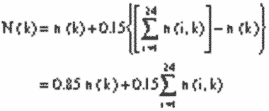](https://img.federalregister.gov/ER08JY02.001/ER08JY02.001_original_size.png)

where n(k) is the largest of the 24 values of n(i, k) and N(k) is the total perceived noisiness.

(c) Step 3: Convert the total perceived noisiness, N(k), determined in Step 2 into perceived noise level, PNL(k), using the following formula:

[](https://img.federalregister.gov/ER08JY02.002/ER08JY02.002_original_size.png)

Note:

PNL(k) is plotted in the current advisory circular for this part.

A36.4.3 *Correction for spectral irregularities.*

A36.4.3.1 Noise having pronounced spectral irregularities (for example, the maximum discrete frequency components or tones) must be adjusted by the correction factor C(k) calculated as follows:

(a) Step 1: After applying the corrections specified under section A36.3.9, start with the sound pressure level in the 80 Hz one-third octave band (band number 3), calculate the changes in sound pressure level (or “slopes”) in the remainder of the one-third octave bands as follows:

*s*(3,*k*) = no value

s(4,*k*) = SPL(4,*k*)−SPL(3,*k*)

•

•

s(*i,k*) = SPL(*i,k*)−SPL(*i*−1,*k*)

•

•

s(24,*k*) = SPL(24,*k*)−SPL(23,*k*)

(b) Step 2: Encircle the value of the slope, s(i, k), where the absolute value of the change in slope is greater than five; that is where:

|Δ*s*(*i,k*)| = |*s*(*i,k*)−*s*(*i*−1,*k*)|>5

(c) Step 3:

(1) If the encircled value of the slope s(i, k) is positive and algebraically greater than the slope s(i−1, k) encircle SPL(i, k).

(2) If the encircled value of the slope s(i, k) is zero or negative and the slope s(i−1, k) is positive, encircle SPL(i−1, k).

(3) For all other cases, no sound pressure level value is to be encircled.

(d) Step 4: Compute new adjusted sound pressure levels SPL′(i, k) as follows:

(1) For non-encircled sound pressure levels, set the new sound pressure levels equal to the original sound pressure levels, SPL′(i, k) = SPL(i, k).

(2) For encircled sound pressure levels in bands 1 through 23 inclusive, set the new sound pressure level equal to the arithmetic average of the preceding and following sound pressure levels as shown below:

SPL′(*i,k*) = 1⁄2[SPL(*i*−1,*k*) + SPL(*i* + 1,*k*)]

(3) If the sound pressure level in the highest frequency band (i = 24) is encircled, set the new sound pressure level in that band equal to:

SPL′(24,*k*) = SPL(23,*k*) + *s*(23,*k*)

(e) Step 5: Recompute new slope s′(i, k), including one for an imaginary 25th band, as follows:

*s*′(3,*k*) = *s*′(4,*k*)

*s*′(4,*k*) = SPL′(4,*k*)−SPL′(3,*k*)

•

•

*s*′(*i,k*) = SPL′(*i,k*)−SPL′(*i*−1,*k*)

•

•

*s*′(24,*k*) = SPL′(24,*k*)−SPL′(23,*k*)

*s*′(25,*k*) = *s*′(24,*k*)

(f) Step 6: For i, from 3 through 23, compute the arithmetic average of the three adjacent slopes as follows:

*s̄*(*i,k*) = 1⁄3[*s*′(*i,k*) + *s*′(*i* + 1,*k*) + *s*′(*i* + 2,*k*)]

(g) Step 7: Compute final one-third octave-band sound pressure levels, SPL′ (i,k), by beginning with band number 3 and proceeding to band number 24 as follows:

SPL′(3,*k*) = SPL(3,k)

SPL′(4,*k*) = SPL′(3,k) + *s̄*(3,*k*)

•

•

SPL′(*i,k*) = SPL′(i−1,k) + *s̄*(i−1,k)

•

•

SPL′(24,*k*) = SPL′(23,k) + *s̄*(23,k)

(h) Setp 8: Calculate the differences, F (i,k), between the original sound pressure level and the final background sound pressure level as follows:

*F*(*i,k*) = SPL(*i,k*)-SPL′(*i,k*)

and note only values equal to or greater than 1.5.

(i) Step 9: For each of the relevant one-third octave bands (3 through 24), determine tone correction factors from the sound pressure level differences F (i, k) and Table A36-2.

[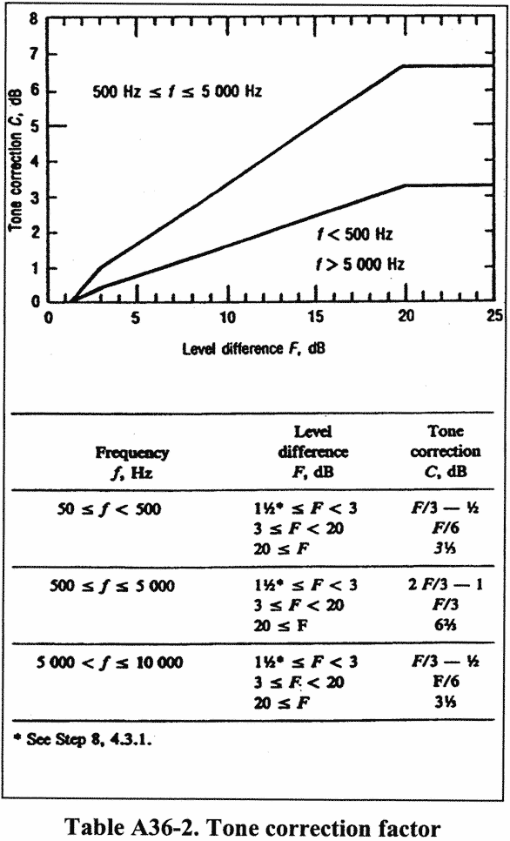](https://img.federalregister.gov/ER08JY02.003/ER08JY02.003_original_size.png)

(j) Step 10: Designate the largest of the tone correction factors, determined in Step 9, as C(k). (An example of the tone correction procedure is given in the current advisory circular for this part). Tone-corrected perceived noise levels PNLT(k) must be determined by adding the C(k) values to corresponding PNL(k) values, that is:

PNLT(*k*) = PNL(*k*) + *C*(*k*)

For any i-th one-third octave band, at any k-th increment of time, for which the tone correction factor is suspected to result from something other than (or in addition to) an actual tone (or any spectral irregularity other than airplane noise), an additional analysis may be made using a filter with a bandwidth narrower than one-third of an octave. If the narrow band analysis corroborates these suspicions, then a revised value for the background sound pressure level SPL′(i,k), may be determined from the narrow band analysis and used to compute a revised tone correction factor for that particular one-third octave band. Other methods of rejecting spurious tone corrections may be approved.

A36.4.3.2 The tone correction procedure will underestimate EPNL if an important tone is of a frequency such that it is recorded in two adjacent one-third octave bands. An applicant must demonstrate that either:

(a) No important tones are recorded in two adjacent one-third octave bands; or

(b) That if an important tone has occurred, the tone correction has been adjusted to the value it would have had if the tone had been recorded fully in a single one-third octave band.

A36.4.4 Maximum tone-corrected perceived noise level

A36.4.4.1 The maximum tone-corrected perceived noise level, PNLTM, must be the maximum calculated value of the tone-corrected perceived noise level PNLT(k). It must be calculated using the procedure of section A36.4.3. To obtain a satisfactory noise time history, measurements must be made at 0.5 second time intervals.

Note 1:

Figure A36-2 is an example of a flyover noise time history where the maximum value is clearly indicated.

Note 2:

In the absence of a tone correction factor, PNLTM would equal PNLM.

[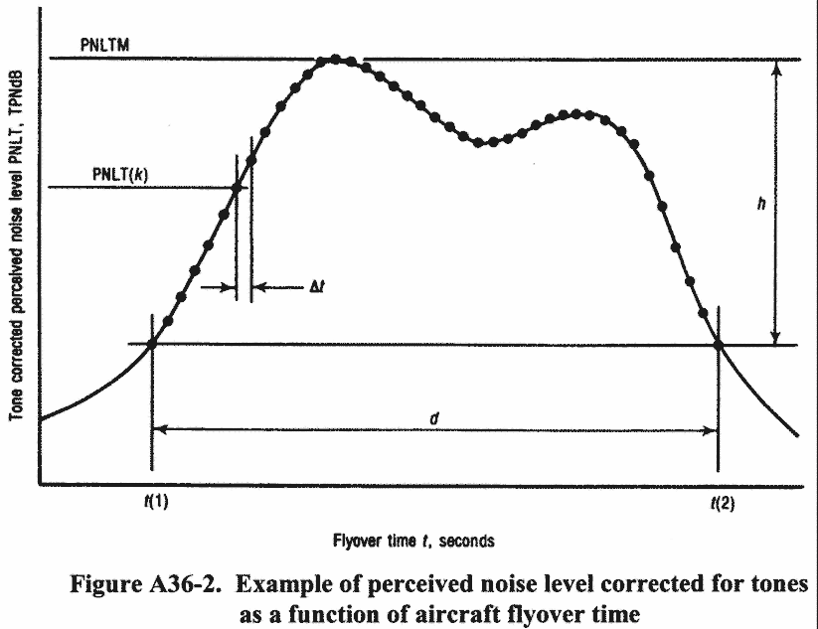](https://img.federalregister.gov/ER08JY02.004/ER08JY02.004_original_size.png)

A36.4.4.2 After the value of PNLTM is obtained, the frequency band for the largest tone correction factor is identified for the two preceding and two succeeding 500 ms data samples. This is performed in order to identity the possibility of tone suppression at PNLTM by one-third octave band sharing of that tone. If the value of the tone correction factor C(k) for PNLTM is less than the average value of C(k) for the five consecutive time intervals, the average value of C(k) must be used to compute a new value for PNLTM.

A36.4.5 *Duration correction.*

A36.4.5.1 The duration correction factor D determined by the integration technique is defined by the expression:

[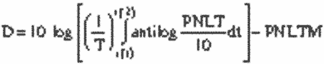](https://img.federalregister.gov/ER08JY02.005/ER08JY02.005_original_size.png)

where T is a normalizing time constant, PNLTM is the maximum value of PNLT, t(1) is the first point of time after which PNLT becomes greater than PNLTM-10, and t(2) is the point of time after which PNLT remains constantly less than PNLTM-10.

A36.4.5.2 Since PNLT is calculated from measured values of sound pressure level (SPL), there is no obvious equation for PNLT as a function of time. Consequently, the equation is to be rewritten with a summation sign instead of an integral sign as follows:

[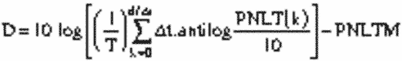](https://img.federalregister.gov/ER08JY02.006/ER08JY02.006_original_size.png)

where Δt is the length of the equal increments of time for which PNLT(k) is calculated and d is the time interval to the nearest 0.5s during which PNLT(k) remains greater or equal to PNLTM-10.

A36.4.5.3 To obtain a satisfactory history of the perceived noise level use one of the following:

(a) Half-Second time intervals for Δt; or

(b) A shorter time interval with approved limits and constants.

A36.4.5.4 The following values for T and Δt must be used in calculating D in the equation given in section A36.4.5.2:

T = 10 s, and

Δt = 0.5s (or the approved sampling time interval).

Using these values, the equation for D becomes:

[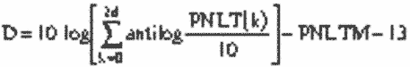](https://img.federalregister.gov/ER08JY02.007/ER08JY02.007_original_size.png)

where d is the duration time defined by the points corresponding to the values PNLTM-10.

A36.4.5.5 If in using the procedures given in section A36.4.5.2, the limits of PNLTM-10 fall between the calculated PNLT(k) values (the usual case), the PNLT(k) values defining the limits of the duration interval must be chosen from the PNLT(k) values closest to PNLTM-10. For those cases with more than one peak value of PNLT(k), the applicable limits must be chosen to yield the largest possible value for the duration time.

A36.4.6 *Effective perceived noise level.*

The total subjective effect of an airplane noise event, designated effective perceived noise level, EPNL, is equal to the algebraic sum of the maximum value of the tone-corrected perceived noise level, PNLTM, and the duration correction D. That is:

EPNL = PNLTM + D

where PNLTM and D are calculated using the procedures given in sections A36.4.2, A36.4.3, A36.4.4. and A36.4.5.

A36.4.7 *Mathematical formulation of noy tables.*

A36.4.7.1 The relationship between sound pressure level (SPL) and the logarithm of perceived noisiness is illustrated in Figure A36-3 and Table A36-3.

A36.4.7.2 The bases of the mathematical formulation are:

(a) The slopes (M(b), M(c), M(d) and M(e)) of the straight lines;

(b) The intercepts (SPL(b) and SPL(c)) of the lines on the SPL axis; and

(c) The coordinates of the discontinuities, SPL(a) and log n(a); SPL(d) and log n = −1.0; and SPL(e) and log n = log (0.3).

A36.4.7.3 Calculate noy values using the following equations:

(a)

SPL ≥SPL (a)

n = antilog {(c)[SPL−SPL(c)]}

(b)

SPL(b) ≤SPL <SPL(a)

n = antilog {M(b)[SPL−SPL(b)]}

(c)

SPL(e) ≤SPL <SPL(b)

n = 0.3 antilog {M(e)[SPL−SPL(e)]}

(d)

SPL(d) ≤SPL <SPL(e)

n = 0.1 antilog {M(d)[SPL−SPL(d)]}

A36.4.7.4 Table A36-3 lists the values of the constants necessary to calculate perceived noisiness as a function of sound pressure level.

[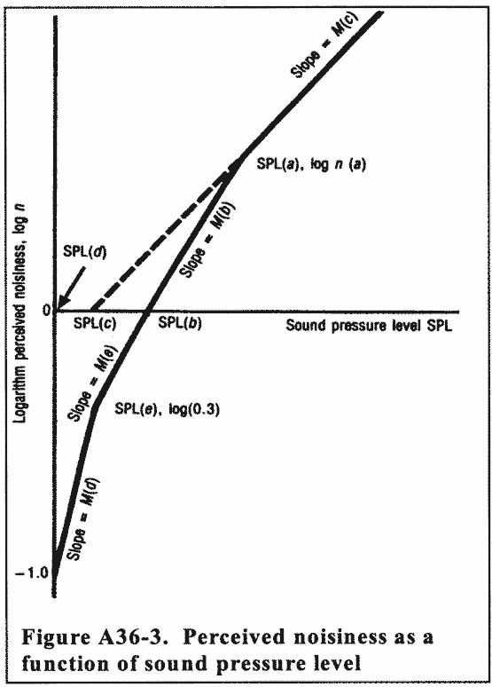](https://img.federalregister.gov/ER08JY02.008/ER08JY02.008_original_size.png)[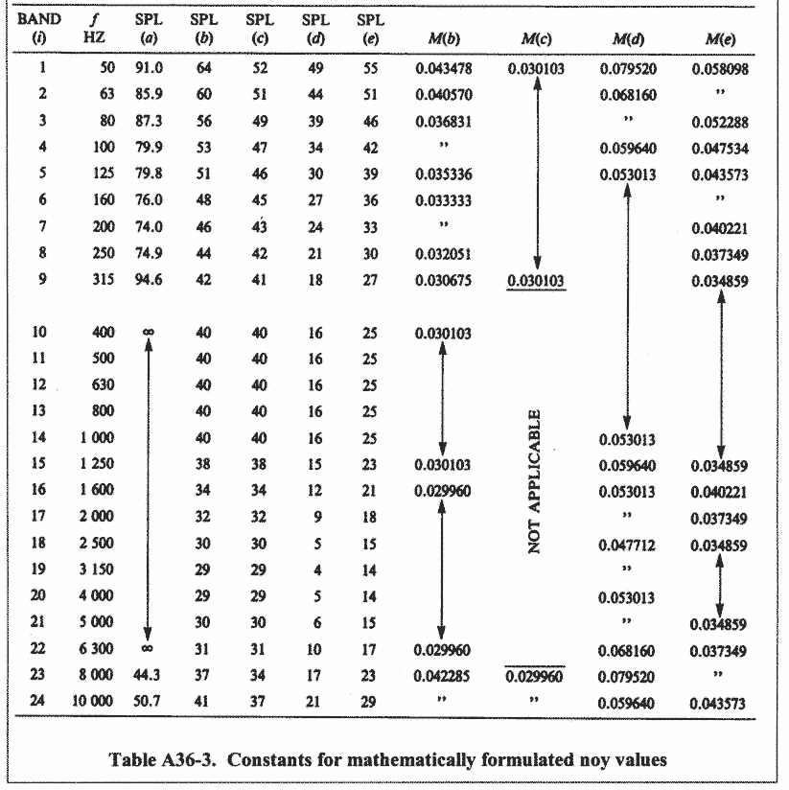](https://img.federalregister.gov/ER08JY02.009/ER08JY02.009_original_size.png)