part a - reference conditions

*Section H36.1 General.* This appendix prescribes noise requirements for helicopters specified under [§ 36.1](https://www.ecfr.gov/current/title-14/section-36.1), including:

(a) The conditions under which helicopter noise certification tests under Part H must be conducted and the measurement procedures that must be used under [§ 36.801](https://www.ecfr.gov/current/title-14/section-36.801) to measure helicopter noise during each test;

(b) The procedures which must be used under [§ 36.803](https://www.ecfr.gov/current/title-14/section-36.803) to correct the measured data to the reference conditions and to calculate the noise evaluation quantity designated as Effective Perceived Noise Level (EPNL); and

(c) The noise limits for which compliance must be shown under [§ 36.805](https://www.ecfr.gov/current/title-14/section-36.805).

Section H36.3 Reference Test Conditions.

(a) ***Meteorological conditions.*** Aircraft position, performance data and noise measurements must be corrected to the following noise certification reference atmospheric conditions which shall be assumed to exist from the surface to the aircraft altitude:

(1) Sea level pressure of 2,116 psf (1,013.25 hPa).

(2) Ambient temperature of 77 degrees F (25 degrees C).

(3) Relative humidity of 70 percent.

(4) Zero wind.

(c) ***Takeoff reference profile.***

(1) Figure H1 illustrates a typical takeoff profile, including reference conditions.

(2) The reference flight path is defined as a straight line segment inclined from the starting point (1,640 feet (500 meters) from the center microphone location and 65 feet (20 meters) above ground level) at a constant climb angle β defined by the certificated best rate of climb and Vy for minimum engine performance. The constant climb angle β is derived from the manufacturer's data (approved by the FAA) to define the flight profile for the reference conditions. The constant climb angle β is drawn through Cr and continues, crossing over station A, to the position corresponding to the end of the type certification takeoff path represented by position Ir.

(d) ***Level flyover reference profile.*** The beginning of the level flyover reference profile is represented by helicopter position Dr (Figure H2). The helicopter approaches position Dr in level flight 492 feet above ground level as measured at Station A. Reference airspeed must be either 0.9VH; 0.9VNE; 0.45VH + 65 kts (0.45VH + 120km/h); or 0.45VNE + 65kts (0.45VNE + 120 km/h), whichever of the four speeds is least. The helicopter crosses directly overhead station A in level flight and proceeds to position Jr.

(e) For noise certification purposes, VH is defined as the airspeed in level flight obtained using the minimum specified engine torque corresponding to maximum continuous power available for sea level pressure of 2,116 psf (1,013.25 hPa) at 77 °F (25 °C) ambient conditions at the relevant maximum certificated weight. The value of VNE is the never-exceed airspeed. The values of VH and VNE that are used for noise certification must be listed in the approved Rotorcraft Flight Manual.

(f) ***Approach reference profile.***

(1) Figure H3 illustrates approach profile, including reference conditions.

(i) The beginning of the approach profile is represented by helicopter position E. The position of the helicopter is recorded for a sufficient distance (EK) to ensure recording of the entire interval during which the measured helicopter noise level is within 10 dB of Maximum Tone Corrected Perceived Noise Level (PNLTM). The reference flight path, ErKr represents a stable flight condition in terms of torque, rpm, indicated airspeed, and rate of descent resulting in a 6° approach angle.

(ii) The test approach profile is defined by the approach angle η passing directly over the station A at a height of AH, to position K, which terminates the approach noise certification profile. The test approach angle η must be between 5.5° and 6.5°.

(2) The helicopter approaches position H along a constant 6° approach slope throughout the 10 dB down time period. The helicopter crosses position E and proceeds along the approach slope crossing over station A until it reaches position K.

Section H36.103 Takeoff test conditions.

(a) This section, in addition to the applicable requirements of sections H36.101 and H36.205(b) of this appendix, applies to all takeoff noise tests conducted under this appendix to show compliance with Part 36.

(b) A test series must consist of at least six flights over the flight-track noise measuring station (with simultaneous measurements at all three noise measuring stations) as follows:

(1) An airspeed of either Vy ±5 knots or the lowest approved speed ±5 knots for the climb after takeoff, whichever speed is greater, must be established and maintained throughout the 10 dB-down time interval.

(2) The horizontal portion of each test flight must be conducted at an altitude of 65 feet (20 meters) above the ground level at the flight-track noise measuring station.

(3) Upon reaching a point 1,640 feet (500 meters) from the noise measuring station, the helicopter must be stabilized at the maximum takeoff power that corresponds to minimum installed engine(s) specification power available for the reference ambient conditions or gearbox torque limit, whichever is lower.

(4) The helicopter must be maintained throughout the 10 dB-down time interval at the best rate of climb speed Vy ±5 knots, or the lowest approved speed for climb after takeoff, whichever is greater, for an ambient temperature of 25 °C at sea level.

(5) The average rotor speed must not vary from the maximum normal operating rotor RPM by more than ±1.0 percent during the 10 dB-down time interval.

(6) The helicopter must stay within ±10° or ±65 feet (±20 meters), whichever is greater, from the vertical above the reference track throughout the 10dB-down time interval.

(7) A constant takeoff configuration selected by the applicant must be maintained throughout the takeoff reference procedure with the landing gear position consistent with the airworthiness certification tests for establishing best rate-of-climb speed, Vy.

Section H36.105 Flyover test conditions.

(a) This section, in addition to the applicable requirements of sections H36.101 and H36.205(c) of this appendix, applies to all flyover noise tests conducted under this appendix to show compliance with Part 36.

(b) A test series consists of at least six flights. The number of level flights made with a headwind component must be equal to the number of level flights made with a tailwind component with simultaneous measurements at all three noise measuring stations -

(1) In level flight cruise configuration;

(2) At a height of 492 feet ±30 feet (150 ±9 meters) above the ground level at the flight-track noise measuring station; and

(3) The helicopter must fly within ±10° or ±65 feet (±20 meters), whichever is greater, from the vertical above the reference track throughout the 10 dB-down time interval.

(c) Each flyover noise test must be conducted -

(1) At a speed of 0.9VH; 0.9VNE; 0.45VH + 65 kts (0.45VH + 120 km/h); or 0.45VNE + 65 kts (0.45VNE + 120 km/h), whichever speed is least, to be maintained throughout the measured portion of the flyover;

(2) At average rotor speed, which must not vary from the maximum normal operating rotor RPM by more than ±1.0 percent during the 10 dB-down time interval.

(3) With the power stabilized during the period when the measured helicopter noise level is within 10 dB of PNLTM.

(d) The airspeed shall not vary from the reference airspeed by more than ±5 knots (9 km/hr).

Section H36.107 Approach test conditions.

(a) This section, in addition to the requirements of sections H36.101 and H36.205(d) of this appendix, applies to all approach tests conducted under this appendix to show compliance with Part 36.

(b) A test series must consist of at least six flights over the flight-track noise measuring station (with simultaneous measurements at the three noise measuring stations) -

(1) On an approach slope of 6° ±0.5°;

(2) At a height of 394 ±33 feet (120 ±10 meters)

(3) The helicopter must fly within ±10° or ±65 feet (±20 meters) lateral deviation tolerance, whichever is greater, from the vertical above the reference track throughout the 10 dB-down time interval;

(4) At stabilized airspeed equal to the certificated best rate of climb Vy, or the lowest approved speed for approach, whichever is greater, with power stabilized during the approach and over the flight path reference point, and continued to a normal touchdown; and

(5) At average rotor speed, which may not vary from the maximum normal operating rotor RPM by more than ±1.0 percent during the 10 dB-down time interval; and

(6) The constant approach configuration used in airworthiness certification tests, with the landing gear extended, must be maintained throughout the approach reference procedure.

(c) The airspeed shall not vary from the reference airspeed by more than ±5 knots (±9 km/hr).

(b) ***Takeoff profiles.***

(1) Figure H1 illustrates a typical takeoff profile, including reference conditions.

(i) The reference takeoff flight path is described in section H36.3(c).

(ii) The test parameters are functions of the helicopter's performance and weight and the atmospheric conditions of temperature, pressure, wind velocity and direction.

(2) For the actual takeoff, the helicopter approaches position C in level flight at 65 feet (20 meters) above ground level at the flight track noise measuring station and at either Vy ±5 knots or the lowest approved speed for the climb after takeoff, whichever speed is greater.

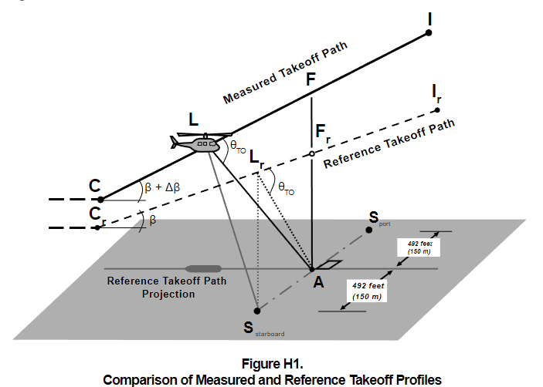

(3) Figure H1 illustrates the significant geometrical relationships influencing sound propagation. Position L represents the helicopter location on the measured takeoff path from which PNLTM is observed at station A, and Lr is the corresponding position on the reference sound propagation path. Propagation paths AL and ALr both form the same angle θ (theta) relative to their respective flight paths.

(c) ***Level flyover profiles.***

(1) The noise type certification level flyover profile is shown in Figure H2. Airspeed must be stabilized within ±5 knots of the reference airspeed determined using the procedures in section H36.3(d). The number of level flights made with a headwind component must be equal to the number of level flights made with a tailwind component.

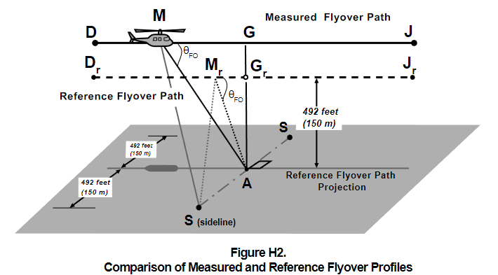

(2) Figure H2 illustrates comparative flyover profiles when test conditions do not conform to prescribed reference conditions. The position of the helicopter shall be recorded for a distance (DJ) sufficient to ensure recording of the entire interval during which the measured helicopter noise level is within 10 dB of PNLTM, as required. The flyover profile is defined by the height AG which is a function of the operating conditions controlled by the pilot. Position M represents the helicopter location on the measured flyover flight path for which PNLTM is observed at station A, and Mr is the corresponding position on the reference flight path.

(d) ***Approach profiles.***

(1) Figure H3 illustrates a typical approach profile, including reference conditions.

(2) The helicopter approaches position H along a 6° (±0.5°) average approach slope throughout the 10dB-down time interval. Deviation from the 6° average approach slope must be approved by the FAA before testing.

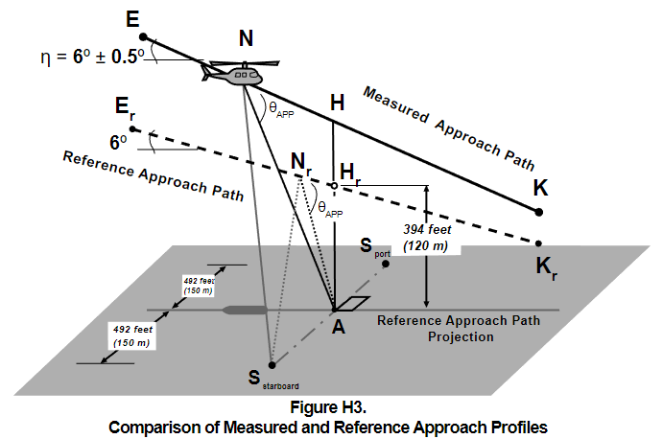

(3) Figure H3 illustrates portions of the measured and reference approach flight paths including the significant geometrical relationships influencing sound propagation. The measured approach path is represented by segment EK with an approach allowable angle θ. Reference positions, Er and Kr, define an idealized reference approach angle of 6°. Position N represents the helicopter location on the measured approach flight path for which PNLTM is observed at measuring station A, and Nr is the corresponding position on the reference approach flight path. The measured and reference noise propagation paths are AN and ANr, respectively, both of which form the same angle, θAPP, corresponding to PNLTM relative to their approach flight paths.

part d - noise limits under [§ 36.805](https://www.ecfr.gov/current/title-14/section-36.805)

Section H36.301 Noise measurement, evaluation, and calculation.

Compliance with this part of this appendix must be shown with noise levels measured, evaluated, and calculated as prescribed under Parts B and C of this appendix.

Section H36.305 Noise levels.

(a) ***Limits.*** For compliance with this appendix, the applicant must show by flight test that the calculated noise levels of the helicopter, at the measuring points described in section H36.305(a) of this appendix, do not exceed the following, (with appropriate interpolation between weights):

(1) ***Stage 1*** noise limits for acoustical changes for helicopters are as follows:

(i) For takeoff, flyover, and approach calculated noise levels, the noise levels of each Stage 1 helicopter that exceed the Stage 2 noise limits plus 2 EPNdB may not, after a change in type design, exceed the noise levels created prior to the change in type design.

(ii) For takeoff, flyover, and approach calculated noise levels, the noise levels of each Stage 1 helicopter that do not exceed the Stage 2 noise limits plus 2 EPNdB may not, after the change in type design, exceed the Stage 2 noise limits plus 2 EPNdB.

(2) ***Stage 2*** noise limits are as follows:

(i) ***For takeoff calculated noise levels*** - 109 EPNdB for maximum takeoff weights of 176,370 pounds (80,000 kg) or more, reduced by 3.01 EPNdB per halving of the weight down to 89 EPNdB, after which the limit is constant.

(ii) ***For flyover calculated noise levels*** - 108 EPNdB for maximum weights of 176,370 pounds (80,000 kg) or more, reduced by 3.01 EPNdB per halving of the weight down to 88 EPNdB, after which the limit is constant.

(iii) ***For approach calculated noise levels*** - 110 EPNdB for maximum weights of 176,370 pounds (80,000 kg) or more, reduced by 3.01 EPNdB per halving of the weight down to 90 EPNdB, after which the limit is constant.

(3) ***Stage 3*** noise limits are as follows:

(i) For takeoff - For a helicopter having a maximum certificated takeoff weight of 176,370 pounds (80,000 kg) or more, the noise limit is 106 EPNdB, which decreases linearly with the logarithm of the helicopter weight (mass) at a rate of 3.0 EPNdB per halving of the weight (mass) down to 86 EPNdB, after which the limit is constant.

(ii) For flyover - For a helicopter having a maximum certificated takeoff weight of 176,370 pounds (80,000 kg) or more, the noise limit is 104 EPNdB, which decreases linearly with the logarithm of the helicopter weight (mass) at a rate of 3.0 EPNdB per halving of the weight (mass) down to 84 EPNdB, after which the limit is constant.

(iii) For approach - For a helicopter having a maximum certificated takeoff weight of 176,370 pounds (80,000 kg) or more, the noise limit is 109 EPNdB, which decreases linearly with the logarithm of the helicopter weight (mass) at a rate of 3.0 EPNdB per halving of the weight (mass) down to 89 EPNdB, after which the limit is constant.

(b) ***Tradeoffs.*** Except to the extent limited under [§ 36.11(b) of this part](https://www.ecfr.gov/current/title-14/part-36/section-36.11#p-36.11(b)), the noise limits prescribed in [paragraph (a)](https://www.ecfr.gov/current/title-14/appendix-Appendix%20H%20to%20Part%2036#p-Appendix-H-to-Part-36(a)) of this section may be exceeded by one or two of the takeoff, flyover, or approach calculated noise levels determined under section H36.203 of this appendix if

(1) The sum of the exceedances is not greater than 4 EPNdB;

(2) No exceedance is greater than 3 EPNdB; and

(3) The exceedances are completely offset by reduction in the other required calculated noise levels.