Interface Design (Assignment 1)

Pedro Fernandes, Nr.60694

# Good Design

In this example, I selected the Delta Q Qool Evolution coffee machine. Its design is quite intuitive: simply pull the lever up, insert a designated capsule as intended, and then lower the lever. When the machine is ready to dispense coffee, the buttons will illuminate accordingly, with each option indicating different output levels.

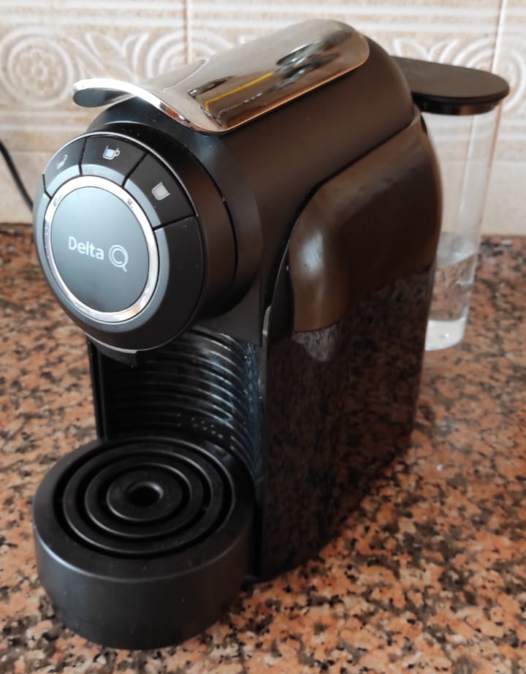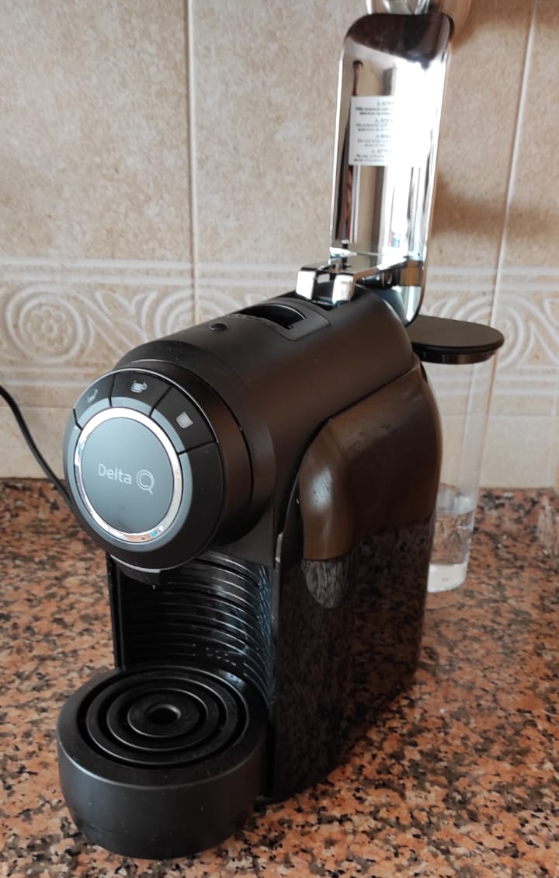

# Bad Design

In this instance, I opted for a microwave made by Fagor, although I'm uncertain about the specific model. This machine serves the purpose of heating up food, whether it's cold or not. At first glance, it appears quite intuitive, with a clear method for opening the door and a straightforward way to set the timer using the right-hand wheel. However, it's not immediately apparent which button initiates the microwave, and which one stops it, as the symbols are rather unconventional. Additionally, the microwave offers various options that may not be immediately intuitive in terms of their functions, necessitating reference to the instruction manual to understand their usage.

One way to enhance this design is by replacing the unconventional symbols on the buttons with more standard icons. Alternatively, the addition of a dedicated button for starting and stopping the machine's operation would also simplify its usability.

