Movies Information

Authors: Inês Leite (92928), Pedro Marques (92926)

Information Visualization, 2021/2022 (MSc Informatics Engineering, University of Aveiro)

Abstract

In this report, we present our visualization of a movie’s dataset available in *Kaggle*. As such, using our platform it’s possible to visualize statistics like which countries produced the most movies as well as the most popular movies.

# Motivation and objectives

Everyone watches movies but doesn’t know much about them. The goal of this project was to give more insights about the movies overall, this is, the countries that produce them, the genres that are more produced, and the more popular movies at the time the dataset was made.

# Users and the Questions

## **Characterization of the users and their context**

Everyone can use this platform, but it it’s for people that are interested in finding out more about movies overall.

The users’ age from the usability tests ranged from 18 to 55, and their level of computer skills ranged from low to high.

## **Questions to Answer**

This work wants to answer questions like the following:

**General**:

* What countries produce the most movies?
* What genres of movies are more produced?
* What are the popular movies right now?

**Specific**:

* What’s the revenue of the USA from 1950 to 2000?
* How many Adventure movies are Comedies as well?
* What are the most popular romance movies in Australia?

# Dataset

The dataset used is ‘The Movies Dataset” from *Kaggle*. It has several columns but only 8 are used: budget, genres, popularity, production_countries, release_date, revenue, title, and vote_average.

# Visualization Solution

For visualizing the solution, firstly, a fidelity prototype was made and tested on some users. After finalizing the first version of the functional prototype, it was also tested. Lastly, the feedback was applied, and a high-fidelity prototype was developed.

## **Low fidelity prototype and user feedback**

Our first development of the prototype was simple and ended up suffering a major rework. First, we visualized a single web page with 3 graph visualizations.

The first visualization would be a choropleth map with the world distribution of movie production. Some filters would be available like the release date and a max-min range filter.

Secondly, a plotlines graph would be used to present the results about some selected countries. The user would be able to select specific them from the list on the left and check on some details about them. Finally, a horizontal bar chart would also be available to visualize the works of certain actors. Like the one before, there would be an option to select specific actors and see their genre distribution.

Figure 1 - First version of the Low Fidelity Prototype

As mentioned previously, this LFP suffered a major rework.

After the Heuristic Evaluation, we realized this prototype needed some changes because it didn’t provide a lot of interesting information and much of it is already found in several places. So, we decided to change the dataset, choosing one in the Movie theme, but with different information.

One of the major critics of our work was precisely the aim of our platform. It was pointed out that most people would not be interested in some of the data presented and more inclined into using our platform to find a movie or TV Show to watch.

Some users ended up only selecting one of the actors or countries, as such they never ended up selecting multiple and being able to compare multiple selections for each of the two bottom visualizations. As such, the use of checkboxes would be more appropriate. We associate this with the recognition rather than recall heuristic and gave it a rating of 4 because it was a major usability issue. Furthermore, some users also suggested the existence of 3 separate pages for each visualization, as a single web page proved itself confusing with differentiated figures. This was a simple design problem, so we have a severity of 1.

As such, we developed a second prototype taking into consideration the target’s audience needs to search for a movie.

Figure 2 - Cloropleth Map of the Production Countries

Figure 3 - Donut Chart of the Distribution of Genres

Figure 4 - Horizontal Bar Chart of the Ranking of Popular Movies

One key difference was the existence of two new other pages where the graphs were placed.

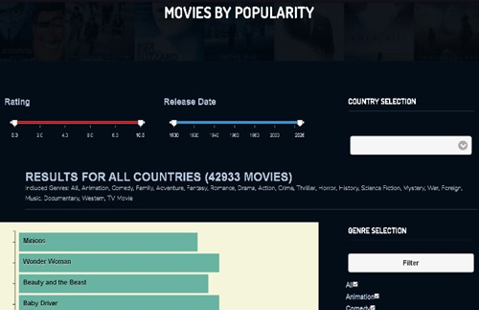Furthermore, we improved the usability by allowing navigation between pages simply by using a navigation bar or interacting with the graphs. As such, clicking on a country in the choropleth map would redirect to the page with the donut chart where the specific data for the selected country would be shown. Finally, clicking on each arc would redirect to the final page, taking into consideration the selected genre and country.

Some new filters were also added, these included filters by release date, rating, genre, and country.

## **Functional prototype**

The functional prototype is similar to the low fidelity prototype but with some improvements, as it has the feedback from the usability tests applied.

So, every page now had mouseover tooltips with information about the hovering aspect. The goal with the tooltips was to add more information to the page without being visually cluttered.

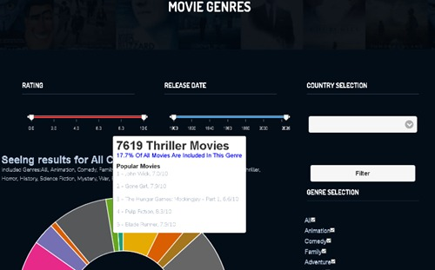Figure 5 – World Movie Production page (First Version)

Figure 6 – Movies Genres page (First Version)

Figure 7 – Popular Movies page (First Version)

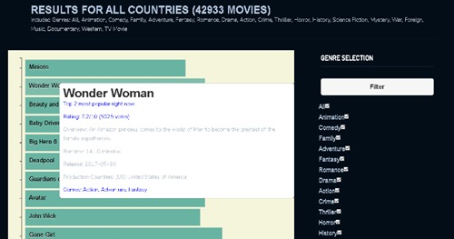

Figure 8 - Popular Movies page – tooltip detailed (First Version)

## **Evaluation and changes in the prototype**

After testing the prototype with the users some aspects to improve were clear:

* Adding a front page to the website with a preview of the graphs and their use.
* Add captions to the popular movies bar chart for a more clear and quick understanding.
* Change the layout of the filters, putting them close together.
* Adding more information to the pages.
* Some users did not associate the ‘Filter’ button as being necessary to apply the selected filters, due to its disposition, this was a major problem as it reduced the usability of the platform, as such, we associated it with the recognition rather than recall heuristic with a severity rating of 4.
* Too much information in the last tooltip
* No sorting in the genres on the right

As such, considering this feedback, some changes were implemented.

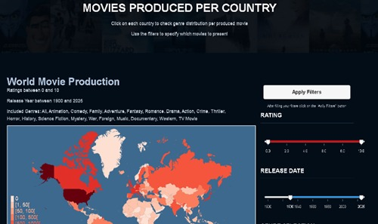

Figure 9 – World Movie Production page (Final Version)

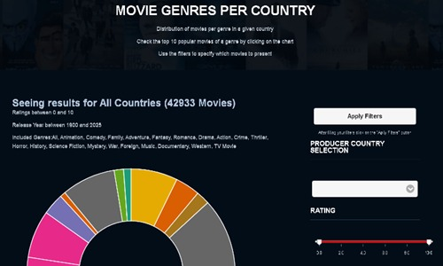

Figure 10 – Movies Genres page (Final Version)

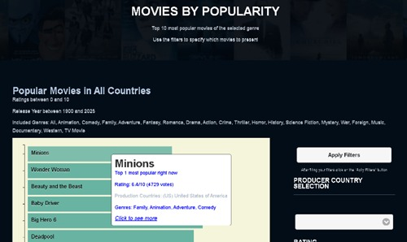

Figure 11 – Popular Movies page (Final Version)

As it can be seen, the filter disposition has changed and is now on the right, with the ‘Apply Filter’ button over them. Furthermore, both the genres and country lists are now sorted. Much more information is now available with a small description under the page title. Less information is now displayed in the tooltip of the movies by popularity section.

# Conclusion and Future Work

In conclusion, this project was very interesting to make, we learned more about d3.js and some fun facts about movies.

Regarding the future work, some aspects we would like to implement were:

* Add an initial web page introducing the platform
* Adding a bar chart to expose the differences of the production countries.
* Being possible to zoom in on the choropleth map.
* Add more possible interactions with the Bar Chart (for example, get the 20th least popular movies)

References

(Popular Blocks, s.d.)

(Build custom maps, s.d.)

(Stackoverflow, s.d.)